# KUBERNETES PROJECT WITH NODEPORT SERVICE

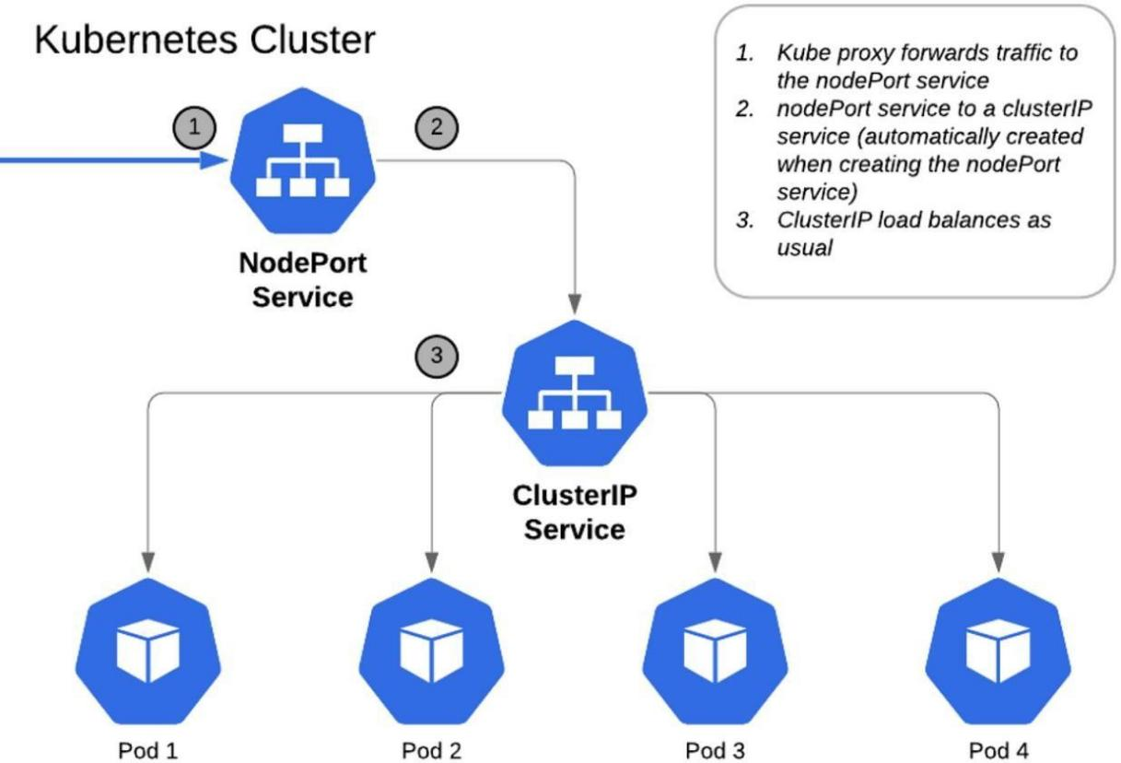

**Files and Configurations Used in This Project**

1. **NGINX Configuration**
   * NGINX Deployment with 3 Replicas
   * Expose in NodePort Service at Port 30007
2. **Database Configuration**
   * MySQL Headless
   * MySQL Persistent Volume (PV)
   * MySQL StatefulSet
3. **Secrets and Configurations**
   * MySQL Secrets
   * MySQL ConfigMaps
   * Service Account for Secrets and ConfigMaps
   * Read-Only Roles for Secrets and ConfigMaps
   * Read-Only Role-Binding for Secrets and ConfigMaps
4. **Monitoring and Logging**
   * DaemonSet (Prometheus)
   * Prometheus RBAC
   * Prometheus NodePort Exposed on Port 30090
   * Promtail DaemonSet
   * Loki DaemonSet
   * Loki NodePort Exposed on Port 30091
   * Grafana Daemon with Exposed Port 30080

**Project Summary**

1. **NGINX Deployment and Services**
   * Sabse pehle NGINX web server ko 3 replicas ke saath deploy karna.
   * Phir, NodePort service ka use karke expose karna.
2. **Database Configuration**
   * MySQL StatefulSet deploy karna.
   * Persistent Volume (PV) configure karna taake data storage manage ho sake.
3. **Secrets & ConfigMaps**
   * Security ke liye Secrets (MYSQL Database ka password aur username store karne ke liye
   * ConfigMaps (port, hostname, database name ke liye) ka use.
4. **Security Enhancements**
   * Service Accounts create karna.
   * RBAC roles aur RoleBindings configure karna jo Secrets aur ConfigMaps ke liye read-only access provide karein.
5. **Monitoring & Logging**
   * Prometheus DaemonSet deploy karna, RBAC configure karna aur port 30090 par expose karte hue read-write permissions dena.
   * Promtail ka use karna logs collect karne ke liye.
   * Loki ko logging backend banakar port 30091 par expose karna.
   * Grafana deploy karna jo metrics visualize karega aur port 30080 par expose hoga.

**Understanding Each File**

Is project me hum har YAML aur Configuration file ko samjhenge ki kaise ye Deployment, Networking ko Manage karne, Security implement karne, aur Monitoring Setup karne me madad kar rahi hai.

**Achievements:**

1. **Successfully Deployed NGINX with NodePort Service**

NGINX web server ko 3 replicas ke saath deploy kiya aur NodePort service ka use karke expose kiya, jo direct access allow karta hai specific nodes ke through.

1. **Persistent & Secure MySQL Database**

StatefulSet aur Persistent Volumes (PV) ka use karke MySQL database ko secure aur reliable banaya, taake data loss na ho.

1. **Secrets & ConfigMaps Implementation**

Sensitive information jaise database credentials, hostname, aur configuration settings securely manage kiye.

1. **RBAC-based Access Control**

Service Accounts, RBAC roles, aur RoleBindings implement kiye jo Secrets aur ConfigMaps ke liye read-only access provide karte hain, taake security maintain ho.

1. **Monitoring & Logging Setup**

Prometheus, Loki, aur Grafana ka use karke complete observability stack setup kiya jo system ki health aur performance track karne me madad karta hai.

Note: Sabse pehle EKS Cluster ki installation karni hai, jaise hum pehle Installation part mein kar chuke hain. Agar tumne EKS setup nahi kiya hai, toh neeche diye gaye URL ko kholo aur EKS Cluster ka setup complete karo.

URL :

[https://github.com/Faikhan147/Kubernetes/blob/main/03-Installations/03-EKS-Cluster-Creation.docx](hh)

# PROJECT TYPE 1-->(Stockholm Region Select Karo)

## Part 1: EKS Cluster Creation and Setup

### Step 1: AWS Login aur EKS Cluster Create Karna

* 1. **AWS login karo**
  2. **Search bar mein "EKS" likho** aur open karo
  3. **"Create Cluster"** pe click karo
  4. **Custom configuration select karo** aur **"EKS Auto Mode - New" disable karo**
  5. **Cluster Configuration**
     1. **Cluster Name:** Faisal name karo ---> (Aapka Name Likho)
     2. **Cluster IAM Role:** AmazonEKSAutoClusterRole select karo
  6. **Scroll down karo, "Secrets encryption" enable karo** aur **KMS key select karo**
  7. **Next** pe click karo

YE KUCH ISTARHA LAGEGA

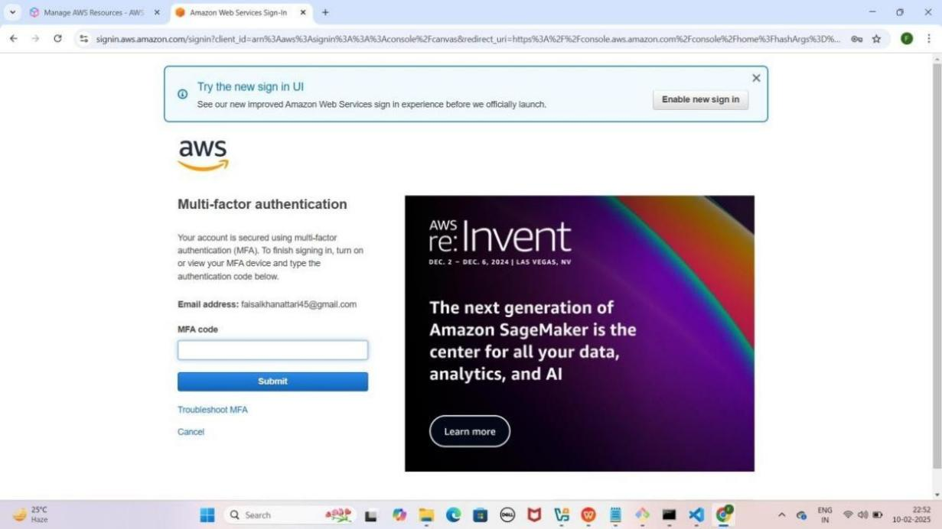

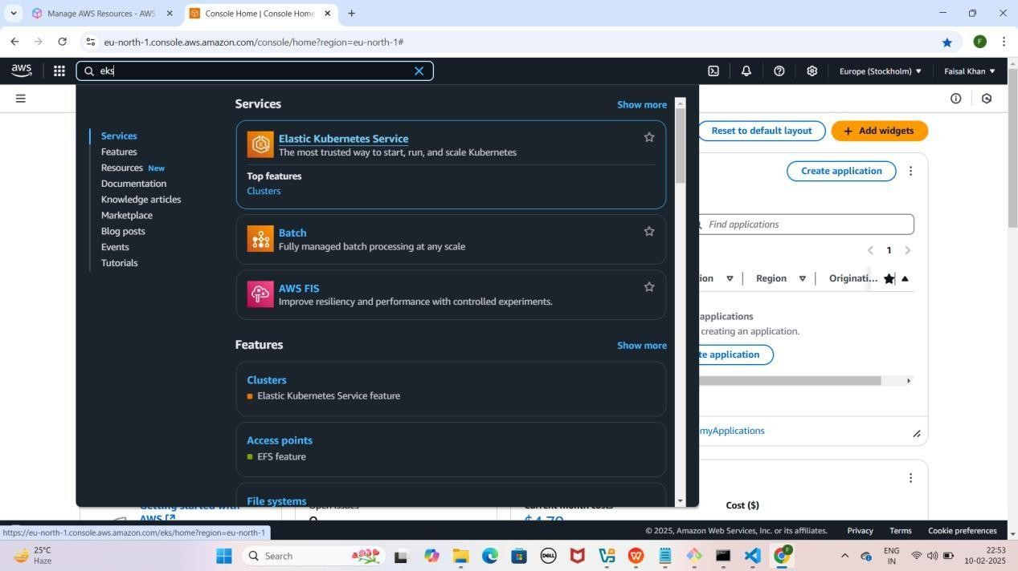

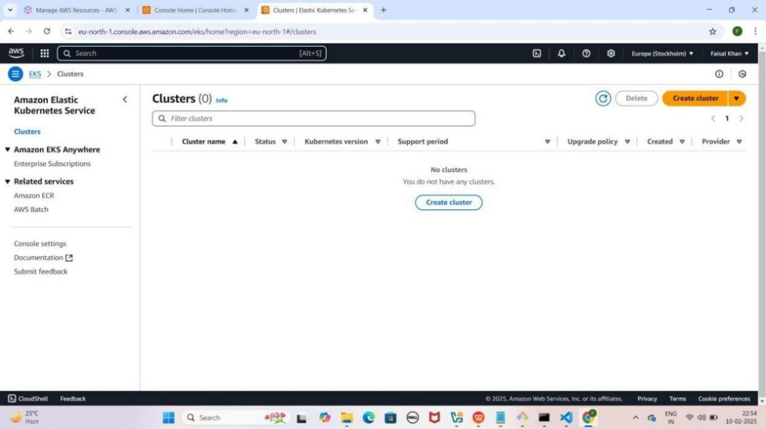

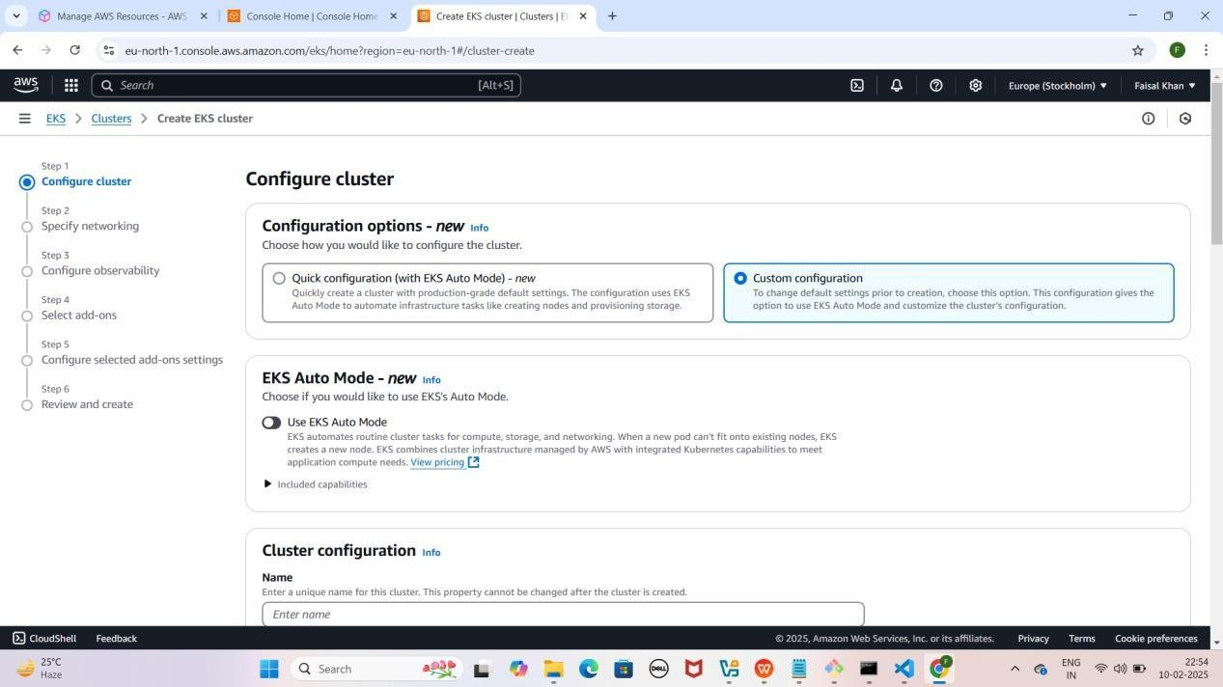

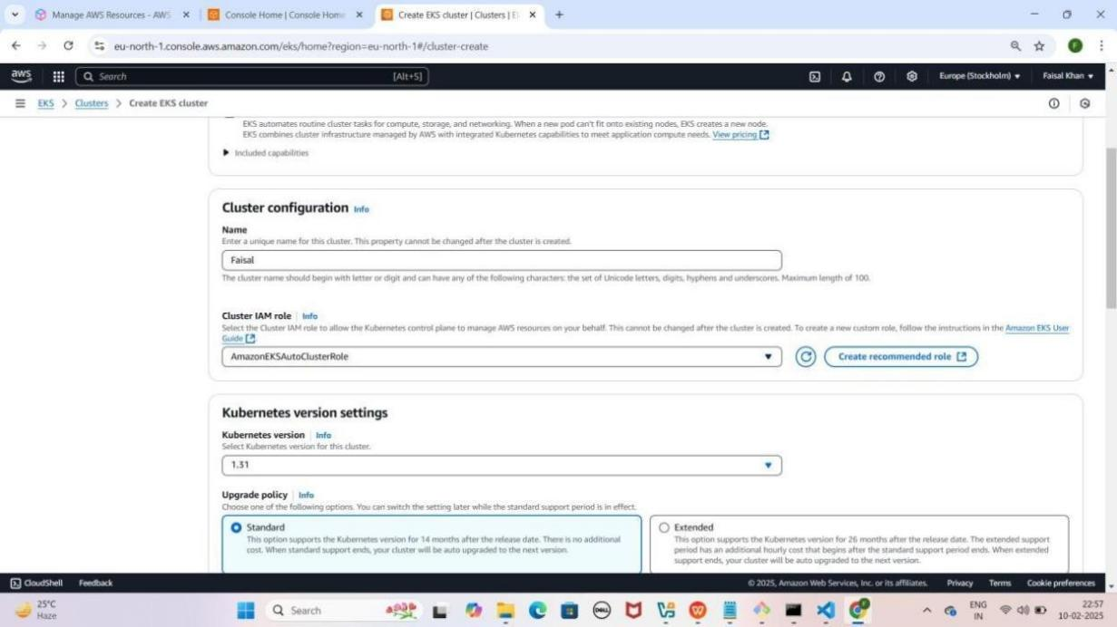

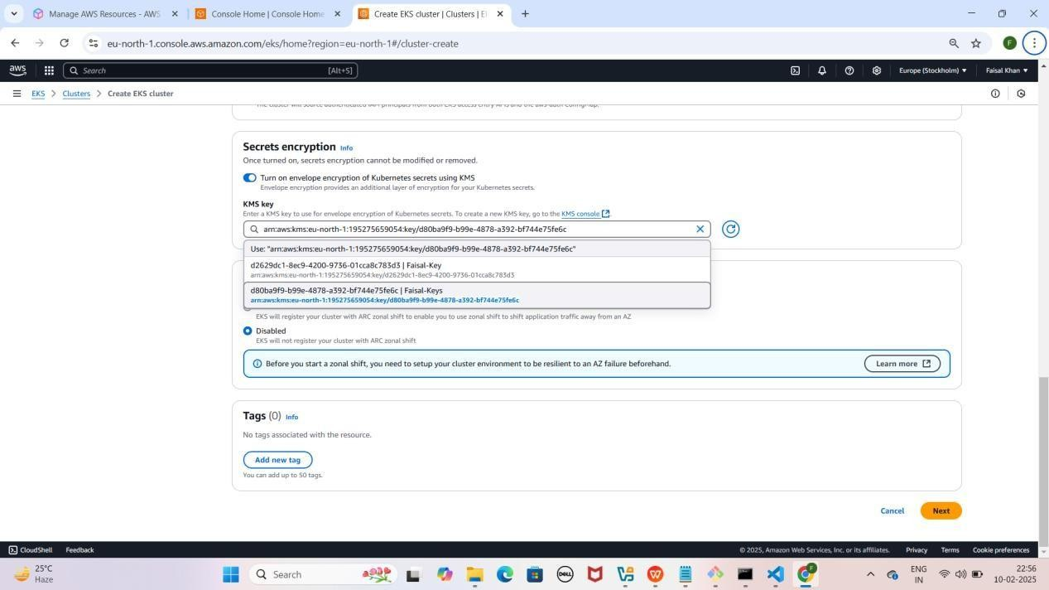

### Step 2: Networking Configuration

1. **Specify networking section mein jao**
2. **"Additional Security Groups - Optional"** mein **"ALL-TRAFFIC- ALLOW"** select karo
3. **Next** pe click karo

YE KUCH ISTARHA LAGEGA

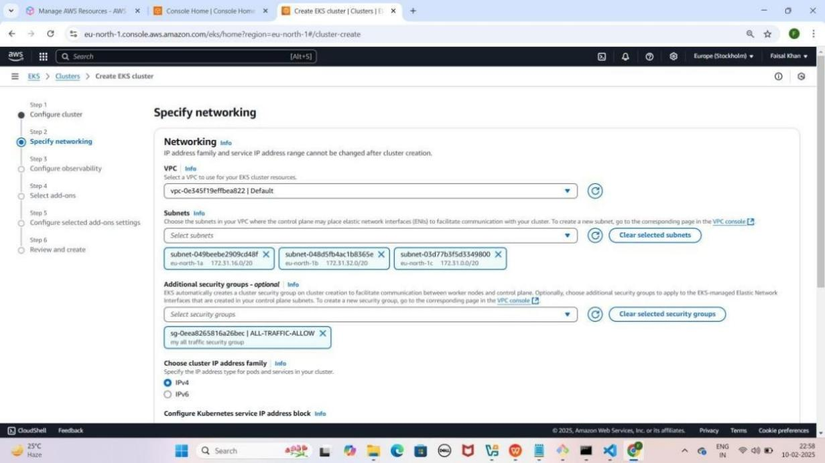

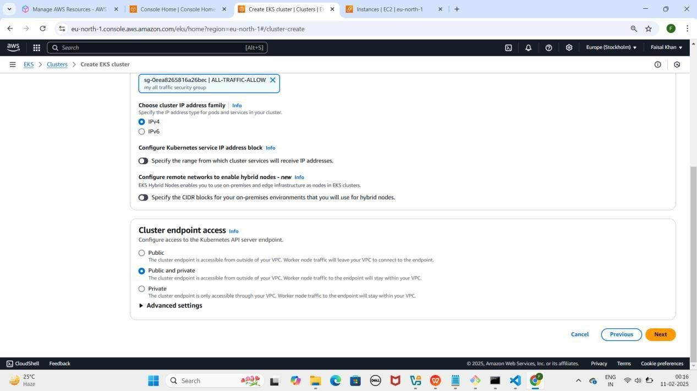

### Step 3: Observability Configure Karna

1. **"Configure observability" section** mein
2. **"Control Plane Logs" enable karo**
3. **Next** pe click karo

YE KUCH ISTARHA LAGEGA

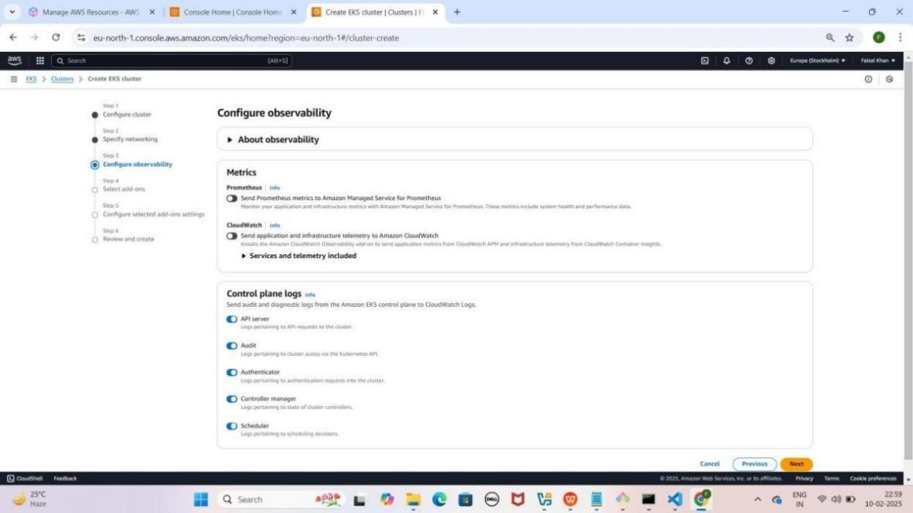

### Step 4: Add-ons Configure Karna

1. **"Select add-ons" section** mein kuch default selected add-ons honge, unko waise hi rehne do
2. **Next** pe click karo
3. **"Amazon VPC CNI" section mein**
4. **"Pod Identity IAM Role for Service Account: PODS-ROLE"** select karo
5. **Next** pe click karo

YE KUCH ISTARHA LEGEGA

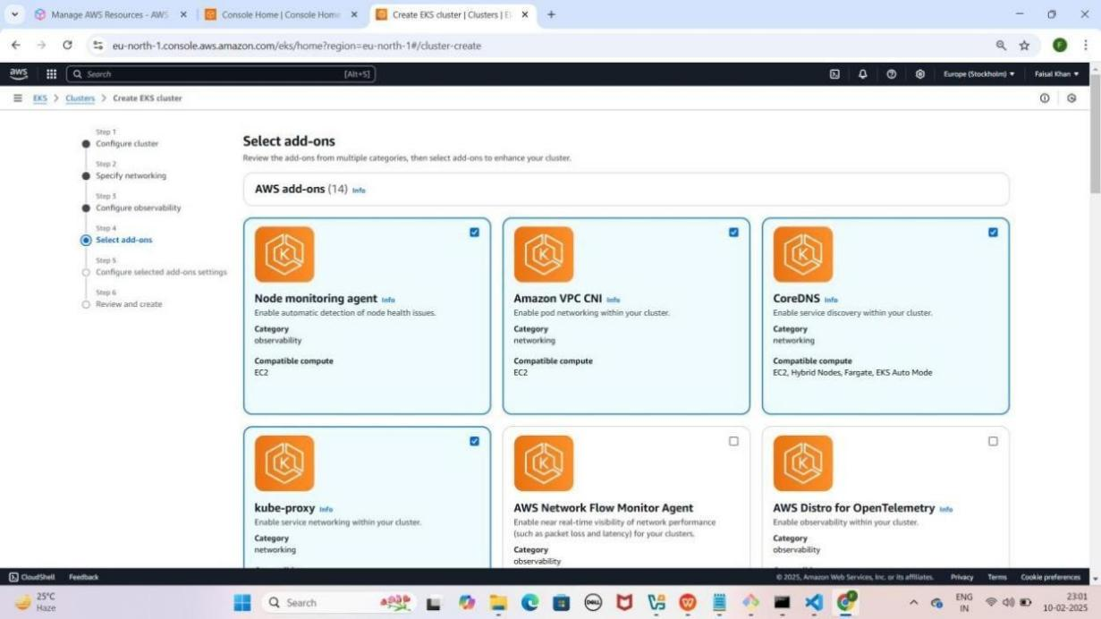

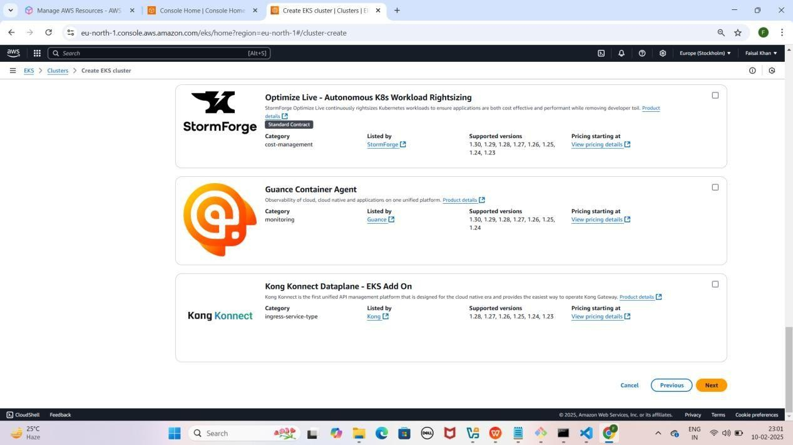

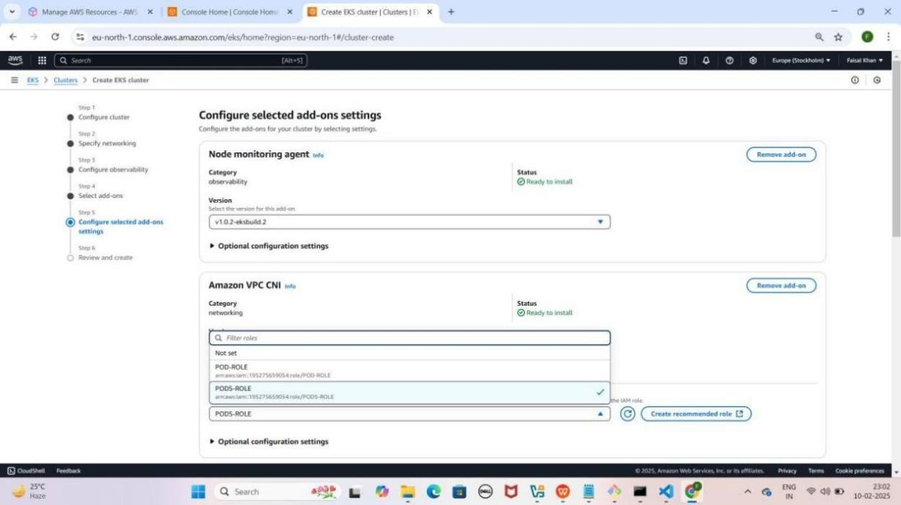

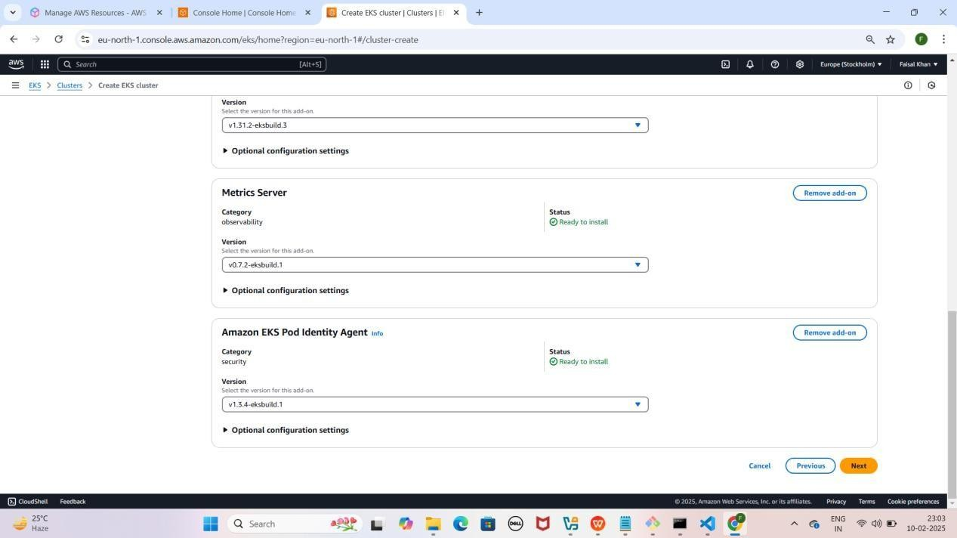

### Step 5: Cluster Create Karna

1. **"Review and Create" section mein scroll down karo** aur **"Create" pe click karo**
2. **"Clusters" section mein jao, Status "Creating" hoga**
3. **15-20 min tak wait karo** aur **har 5 min baad refresh karo**
4. Jab **status "Active" hojaye**, tab next step karo

YE KUCH ISTARHA LAGEGA

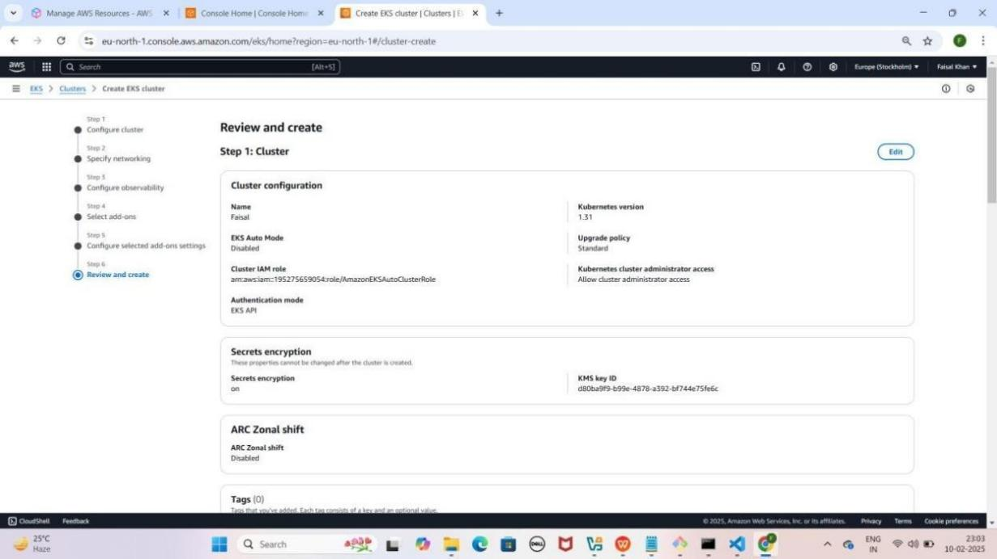

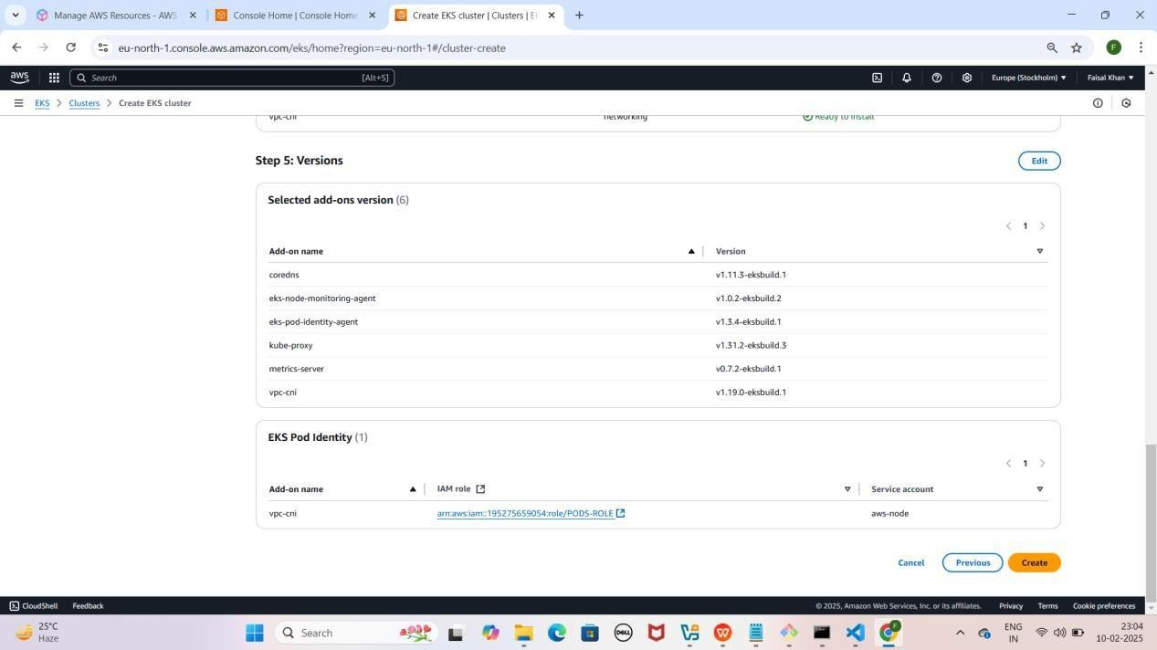

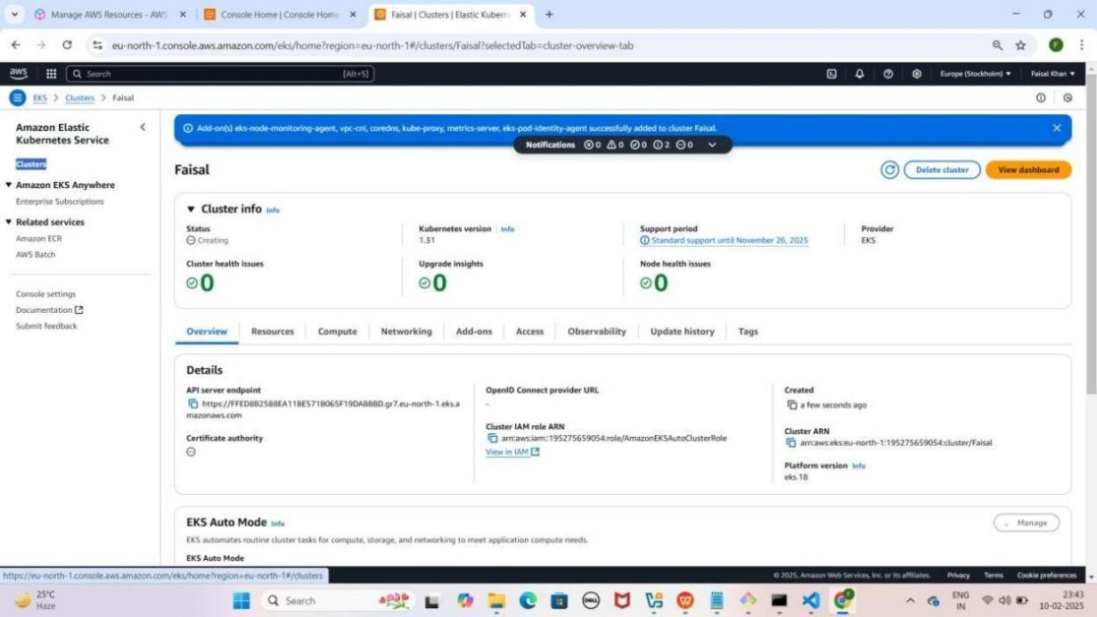

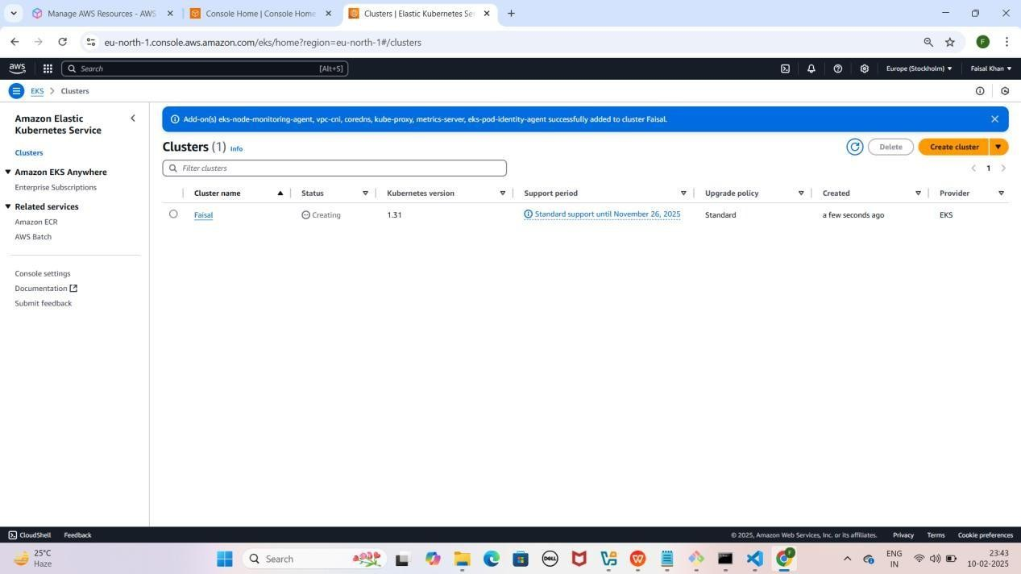

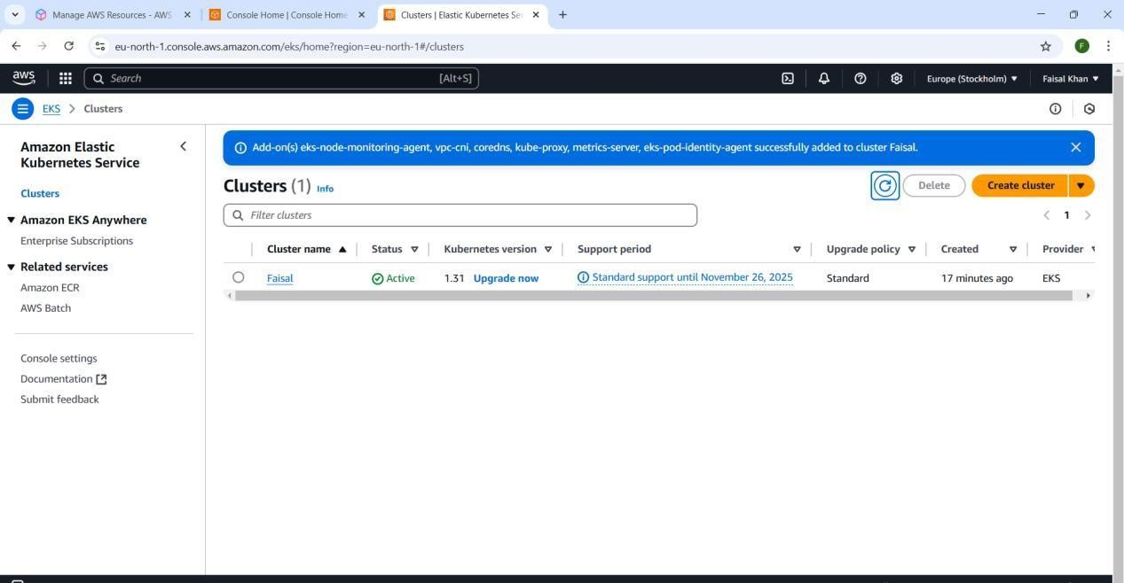

### Step 6: Node Group Create Karna

1. **Cluster open karo, "Compute" section mein jao**
2. **"Add Node Group" pe click karo**
3. **Node Group Configuration**
   * **Node Group Name:** Faisal-Node name karo
   * **Node IAM Role:** AmazonEKSAutoNodeRole select karo
4. **Next** pe click karo

YE KUCH ISTARHA LAGEGA

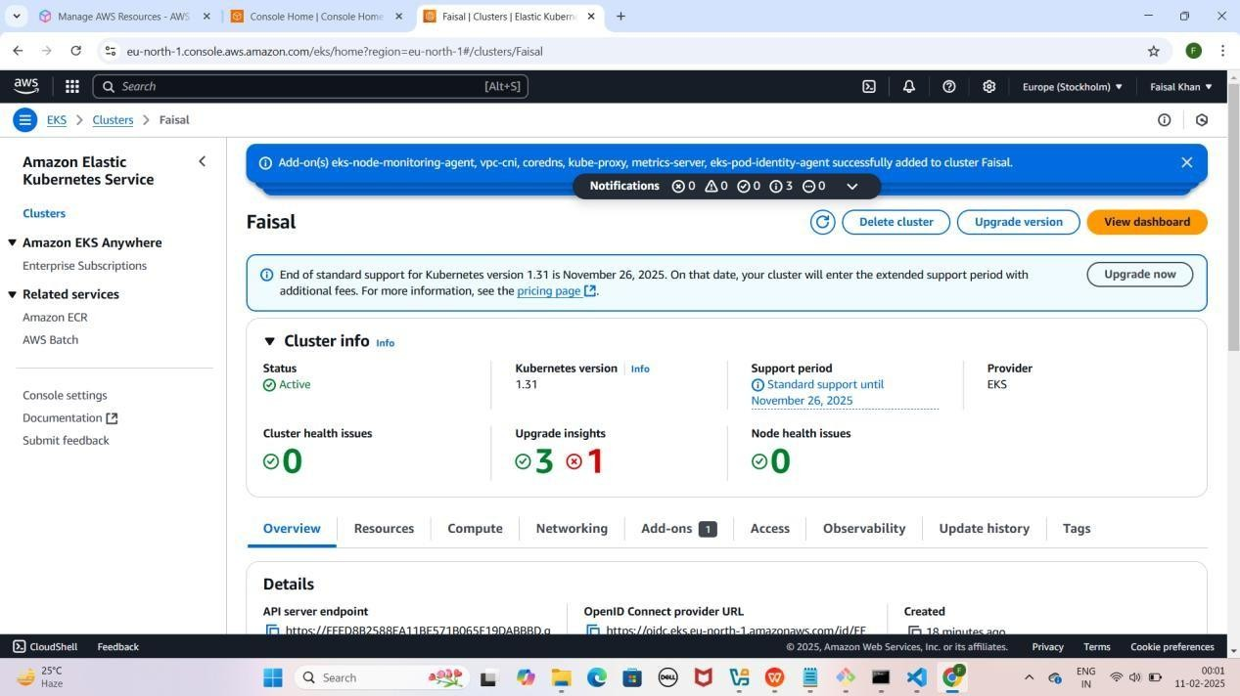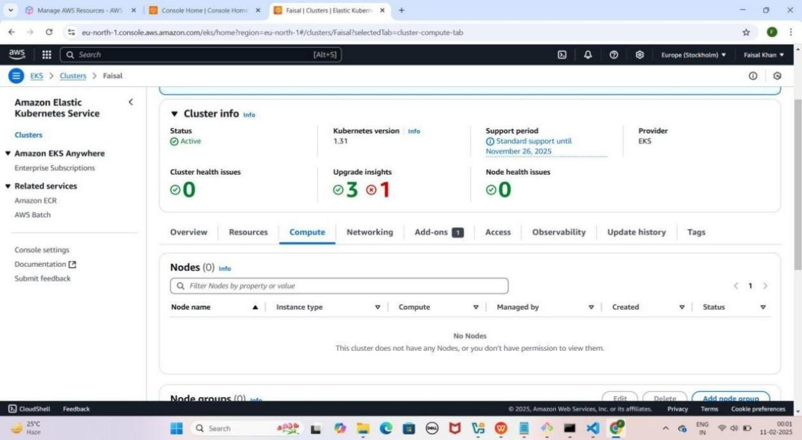

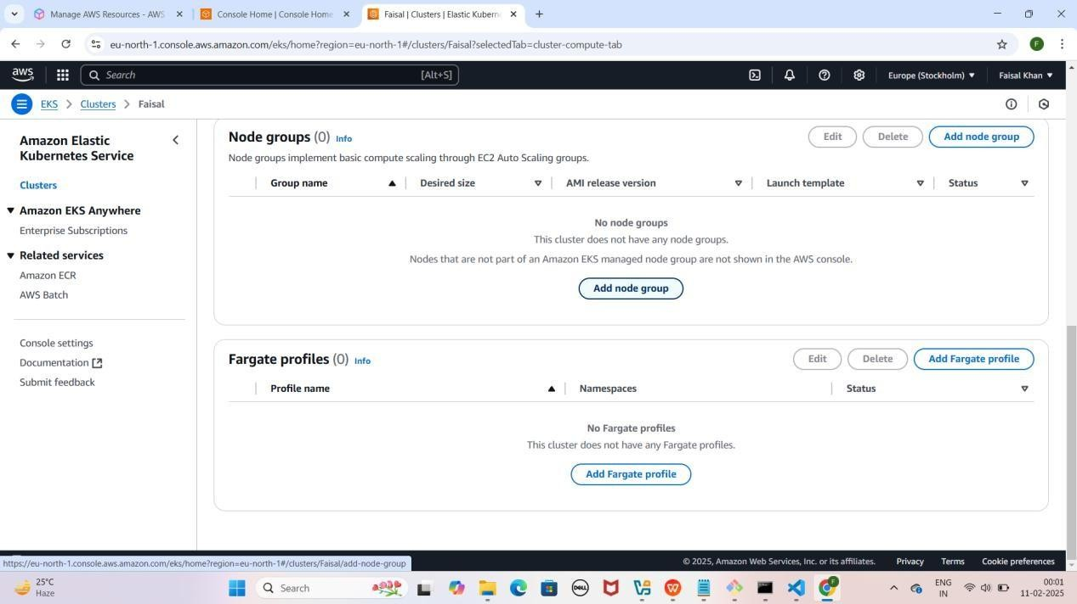

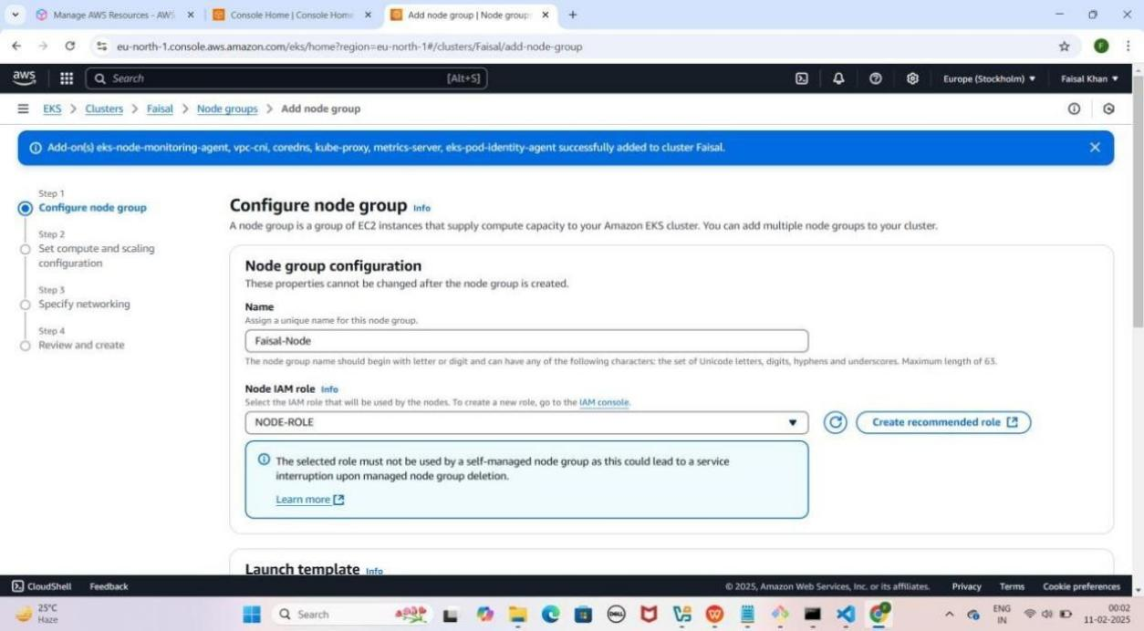

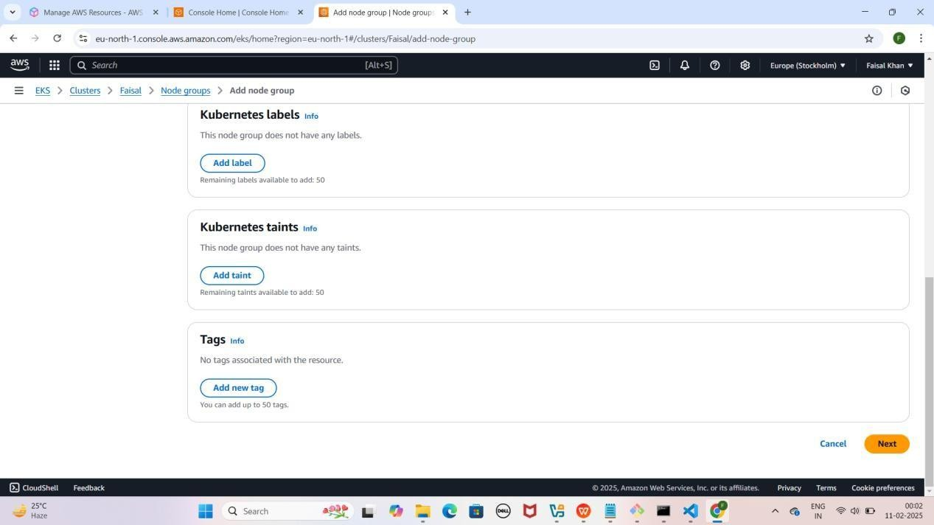

### Step 7: Compute aur Scaling Configuration

1. **"Set Compute and Scaling Configuration" section**
   * **"t3.medium" remove karo** aur **"t3.large" add karo**
   * **Disk Size:** 100 GiB set karo
   * **Desired Size, Minimum Size, Maximum Size:** 1 rakho
   * **"Node Auto Repair" enable karo**
2. **Next** pe click karo

YE KUCH ISTARHA LAGEGA

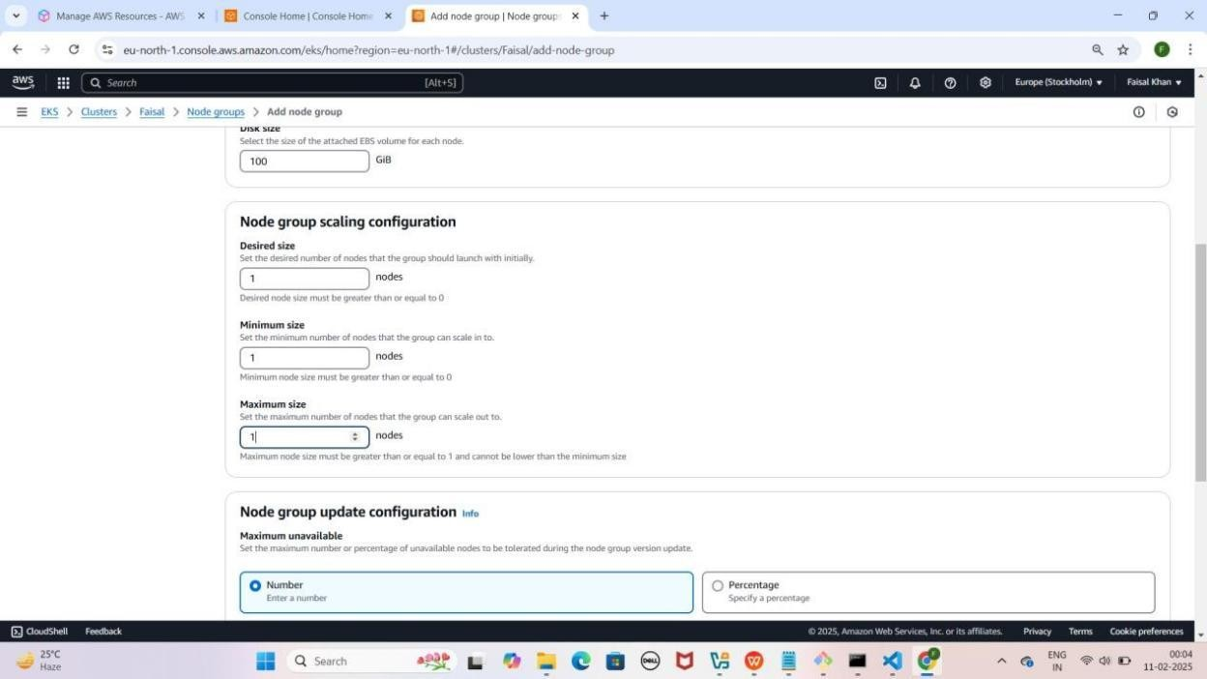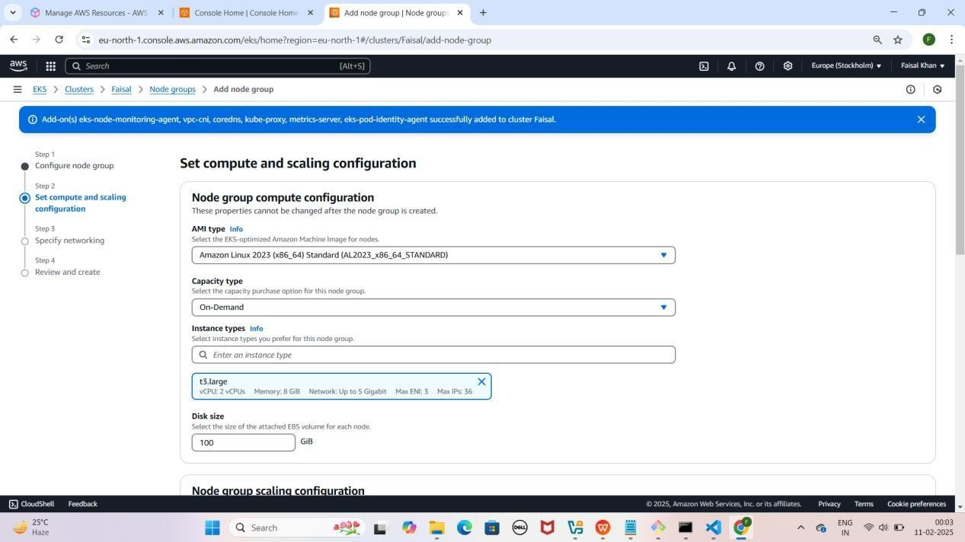

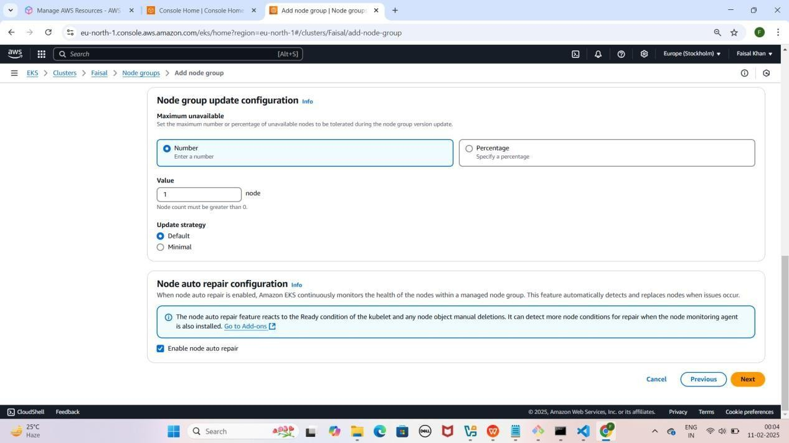

### Step 8: Node Group ki Networking Configure Karna

1. **"Specify Networking" section**
   * **"Configure Remote Access to Nodes" enable karo**
   * **Key Pair select karo**
   * **"Additional Security Groups - Optional" mein "ALL-TRAFFIC- ALLOW" select karo**
2. **Next** pe click karo

YE KUCH ISTARHA LAGEGA

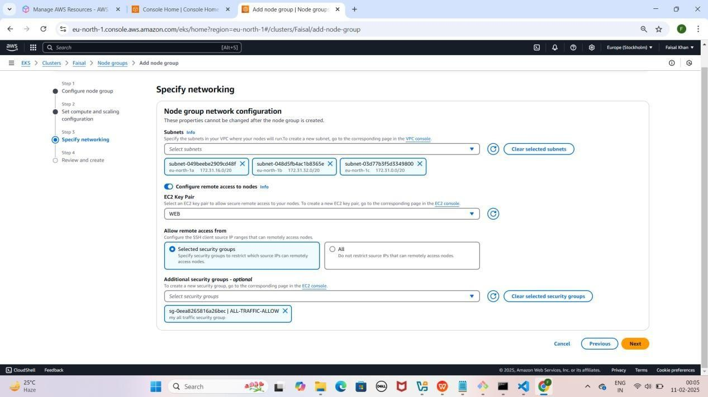

### Step 9: Node Group Review and Create Karna

1. **"Review** and **Create**" **section** mein jao
2. **Scroll Down** karo aur "**Create**" pe **click** karo

YE KUCH ISTARHA LAGEGA

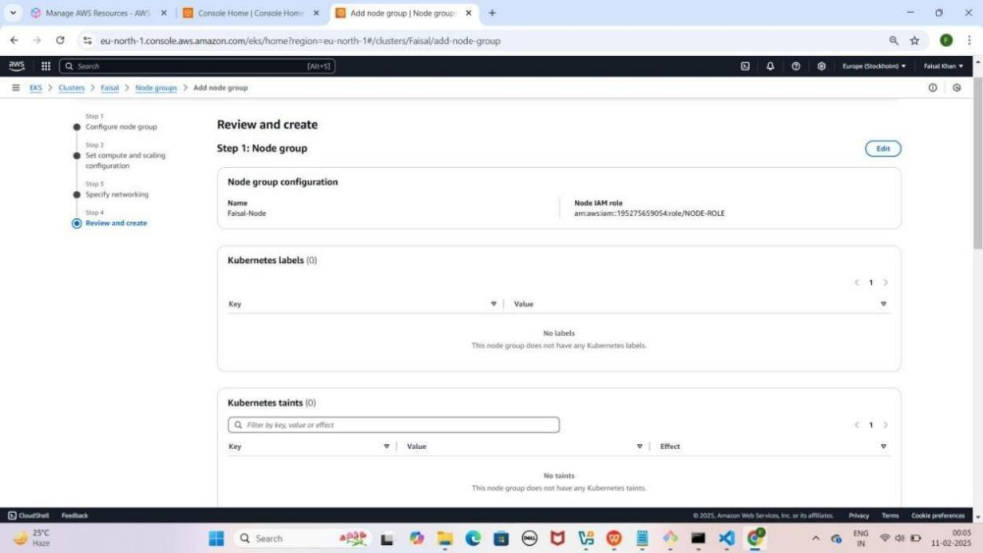

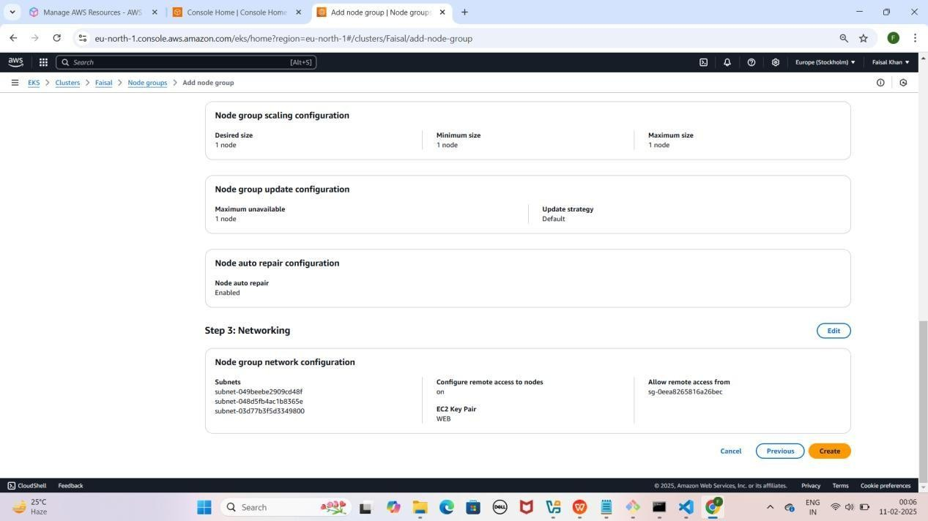

**AWS Console** open karo, search bar mein "**EC2**" likho, **Instances section** mein ek **running instance** nazar aayega, uska name "**Faisal- Node**" karo. ---> (Aapka Name Likho)

YE KUCH ISTARHA LAGEGA

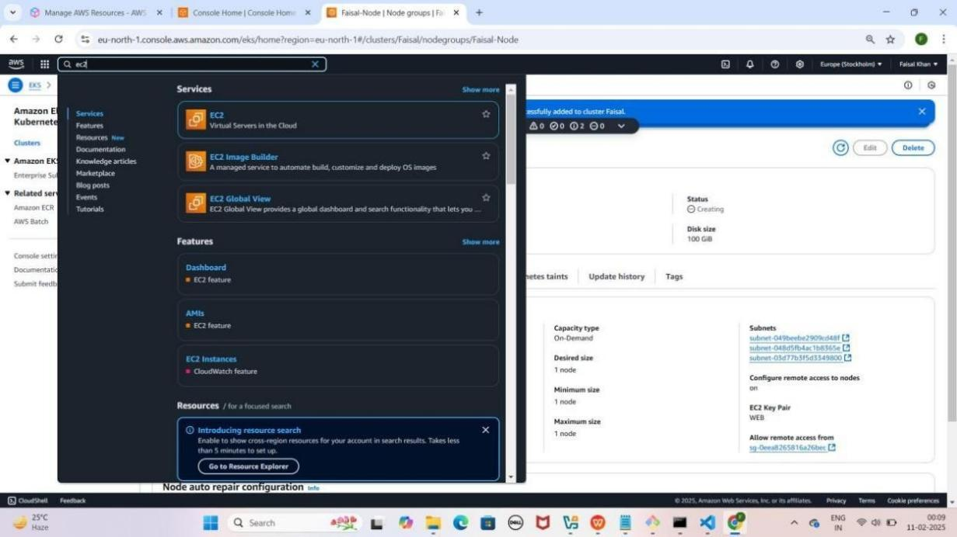

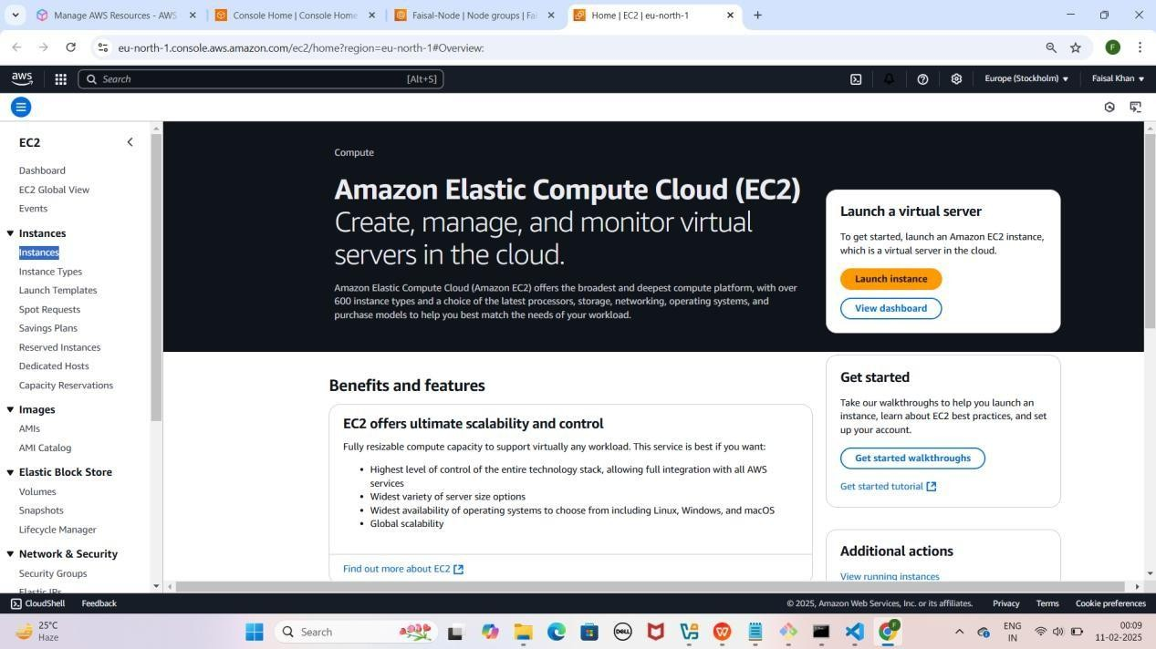

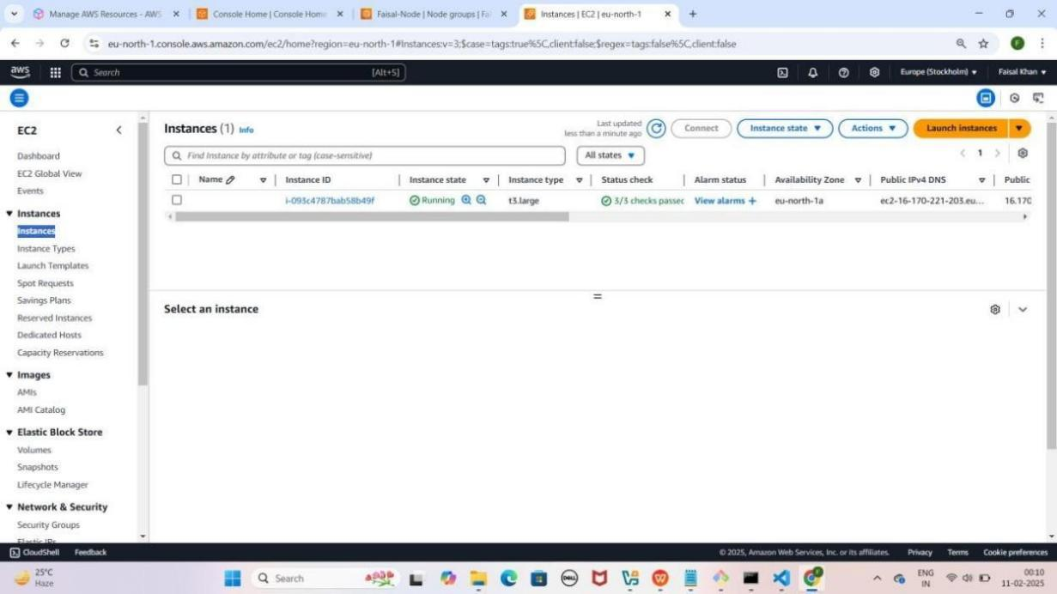

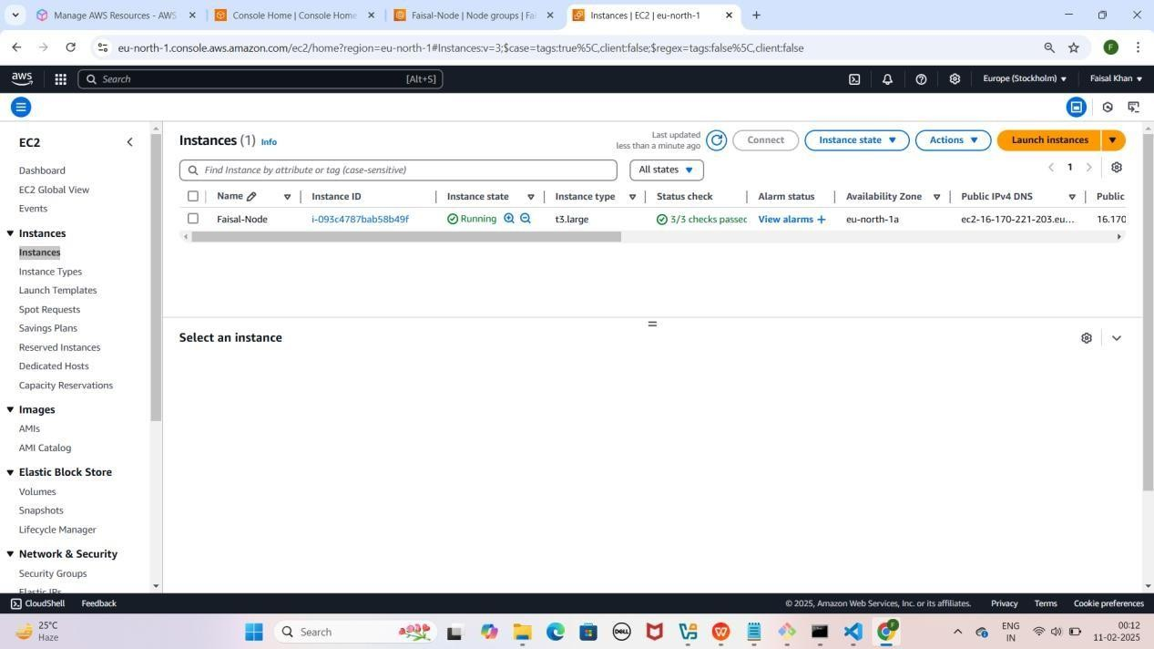

### Step 10: Security Groups Configure Karna EKS Cluster Ke liye

1. **EKS Cluster Security Group**
   * **EKS Cluster** pe jao.
   * **Networking** section mein jao aur **Cluster Security Group** select
   * **Edit Inbound Rules** pe click karo.
   * **Default rule** delete karo aur naya rule add karo:
     + **Type:** All Traffic
     + **Source:** Anywhere IPv4
2. **Save Rules** pe **click** karo.

YE KUCH ISTARHA LAGEGA

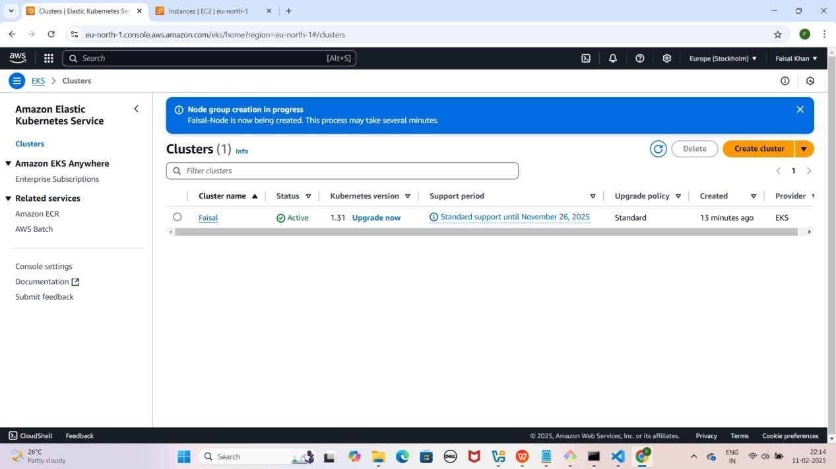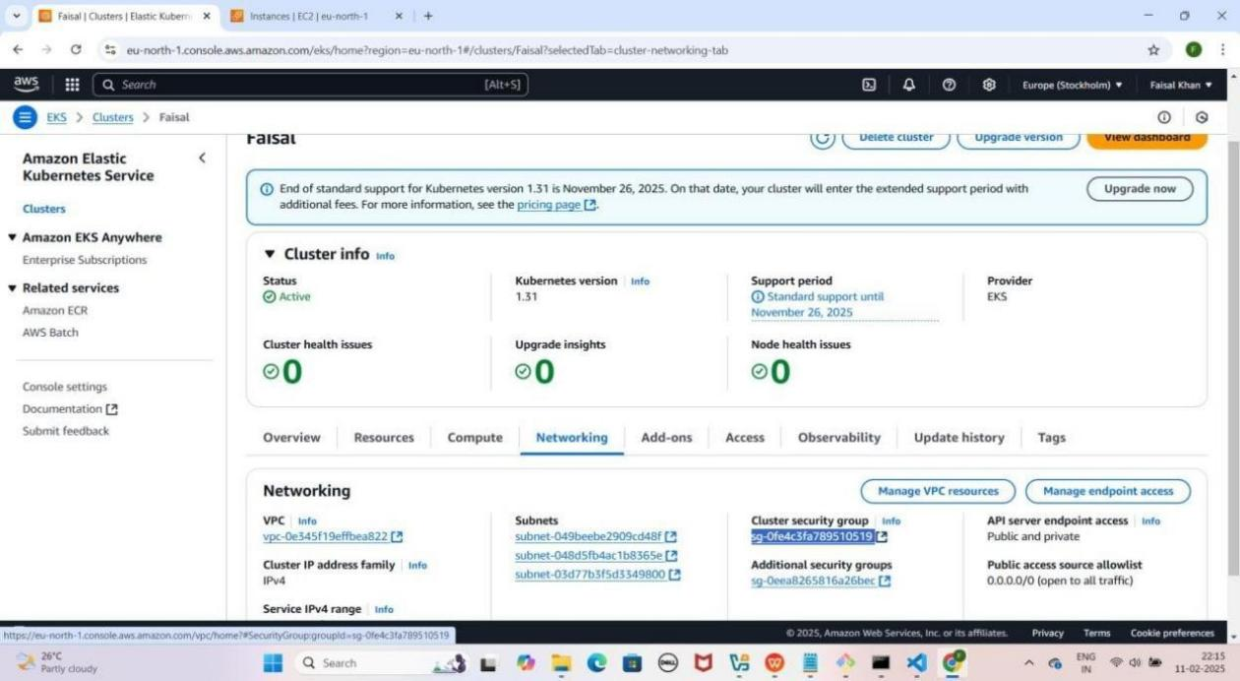

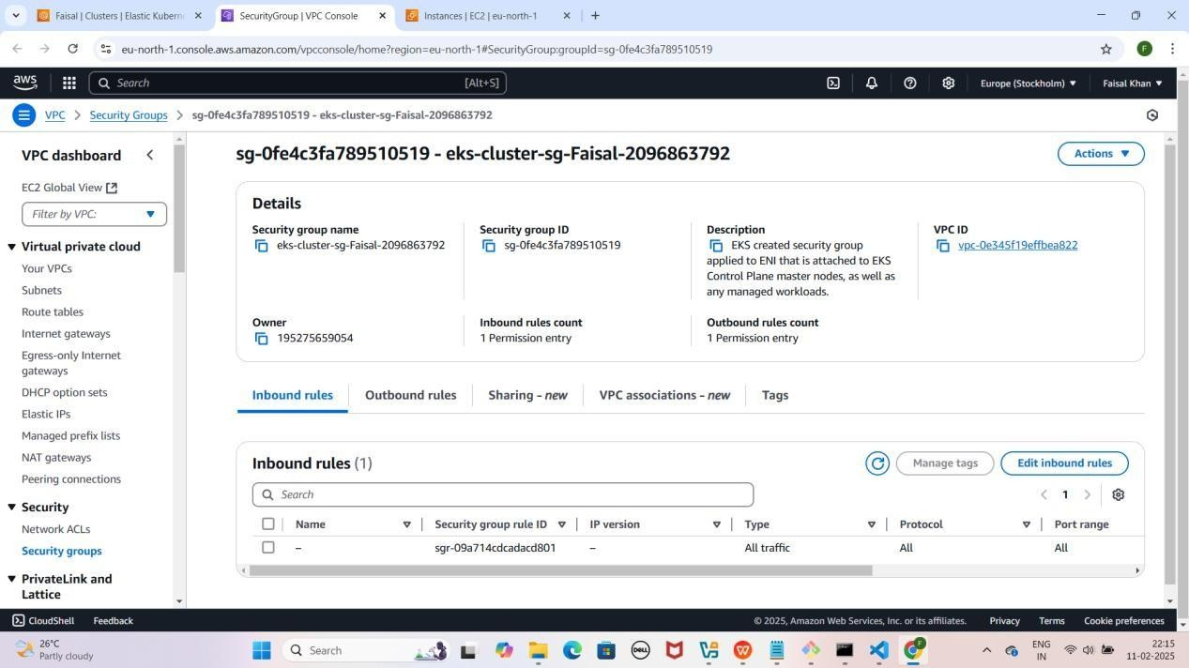

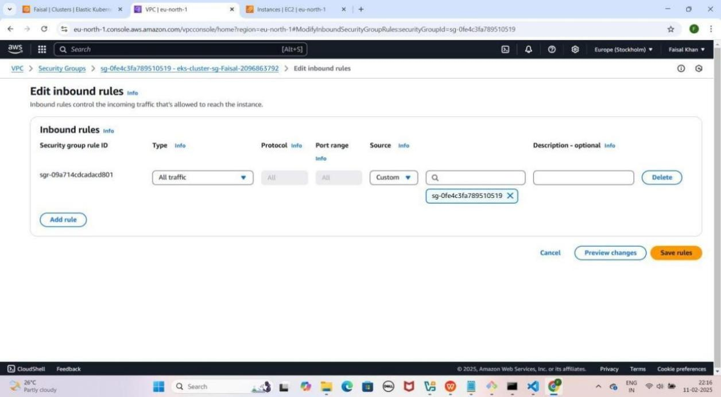

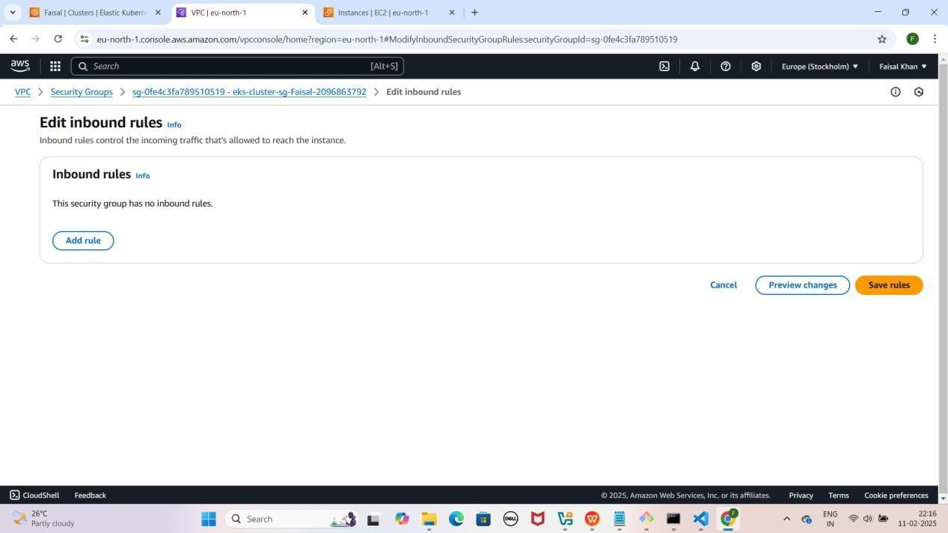

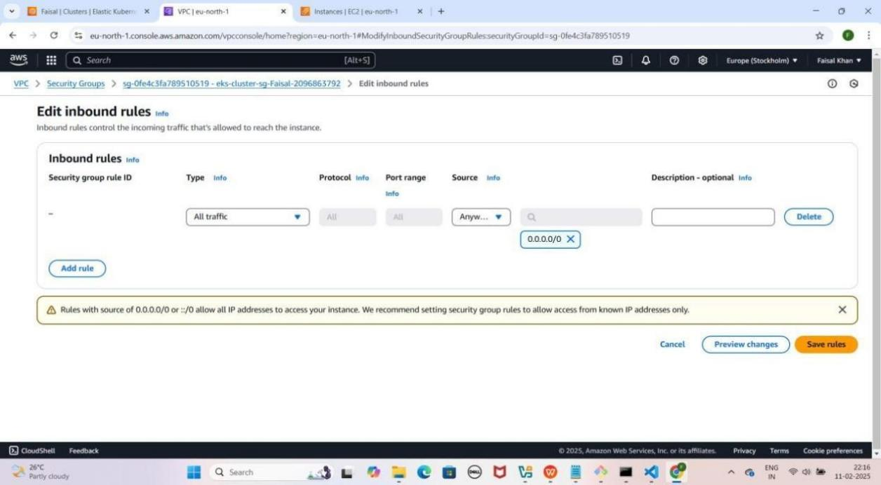

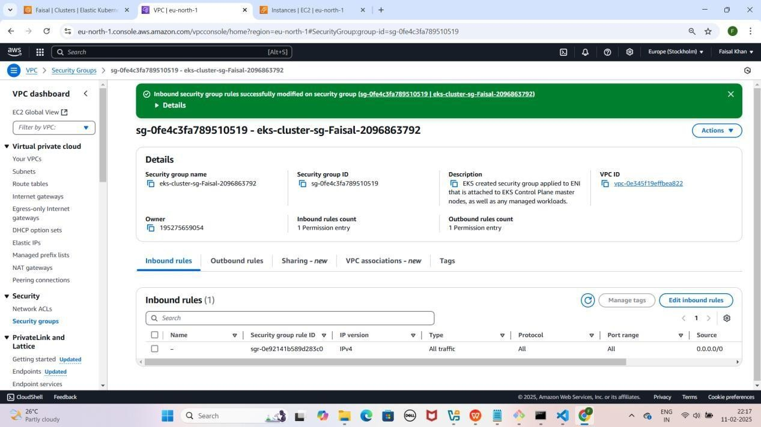

### Step 11: Security Groups Configure Karna EKS Cluster Node Ke liye

1. **EKS Cluster Node Security Group**
   * **EC2 Instances** section mein jao.
   * **"Faisal-Node" instance** select karo.
   * **Security section mein scroll down karo aur Outbound Rules pe click karo.**
   * **Security Group ID** pe click karo.
   * **Edit Inbound Rules** pe click karo.
   * **Default rule** delete karo aur naya rule add karo:
     + **Type:** All Traffic
     + **Source:** Anywhere IPv4
2. **Save Rules** pe click karo.

YE KUCH ISTARHA LAGEGA

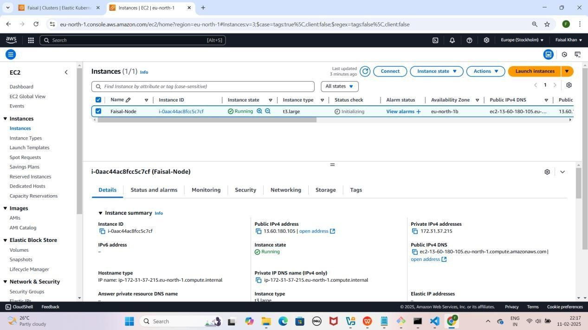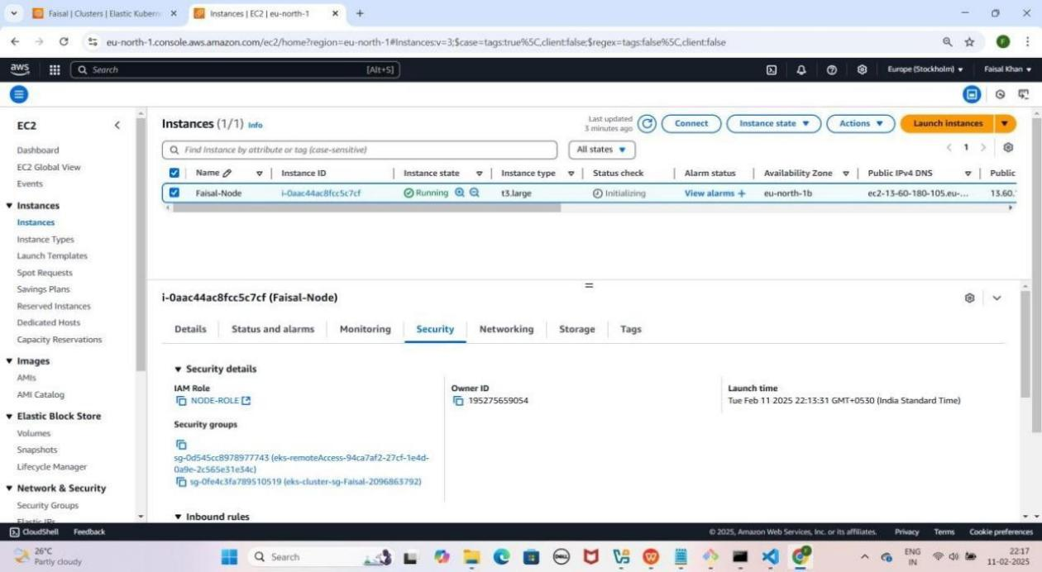

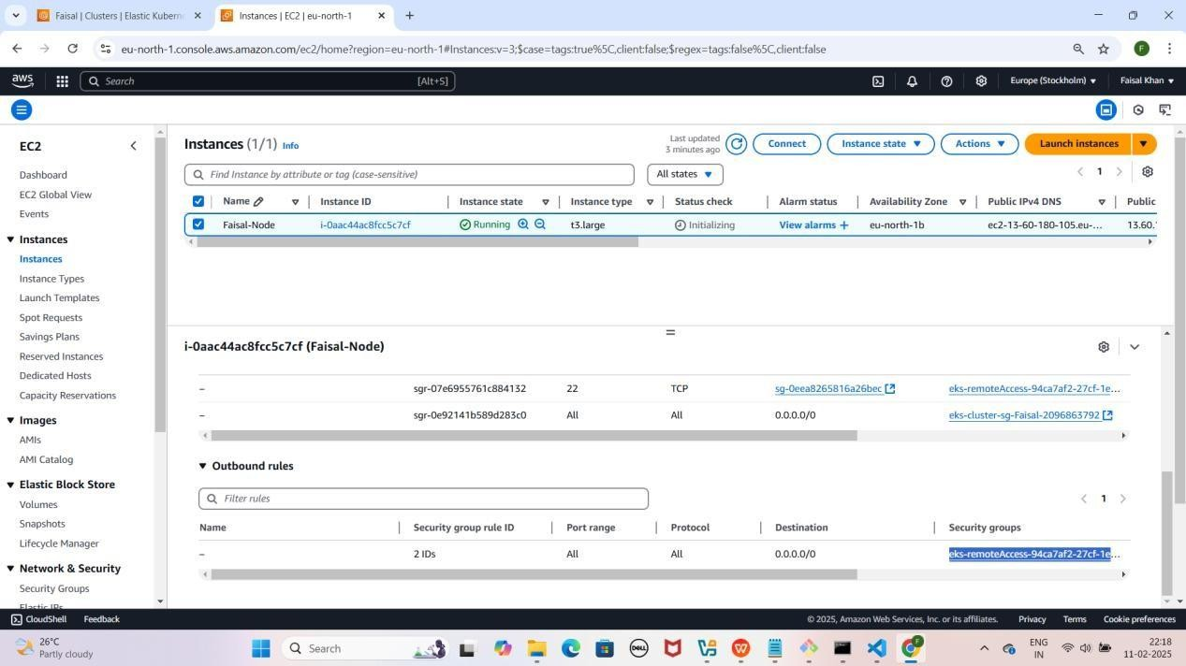

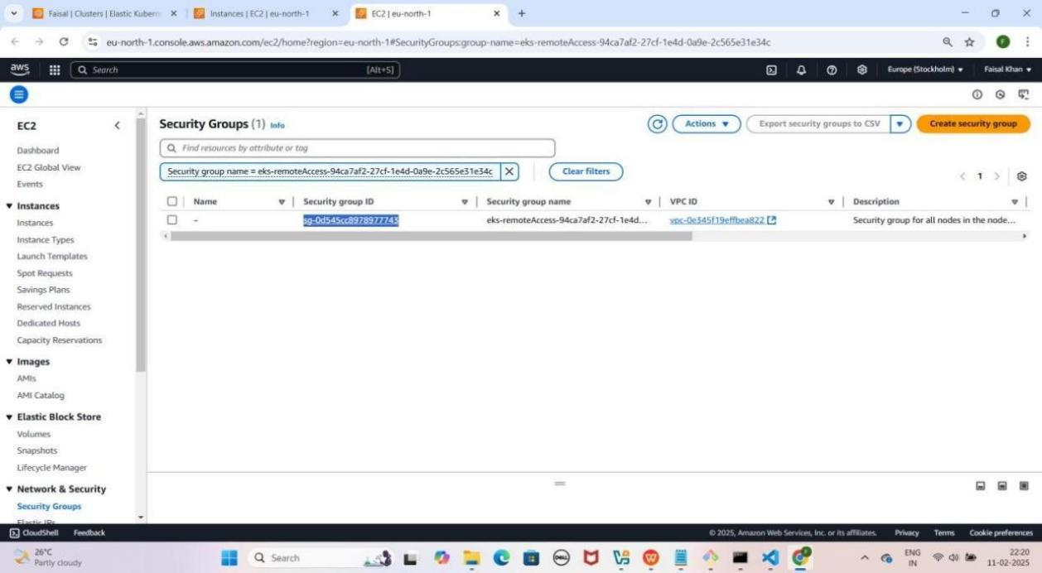

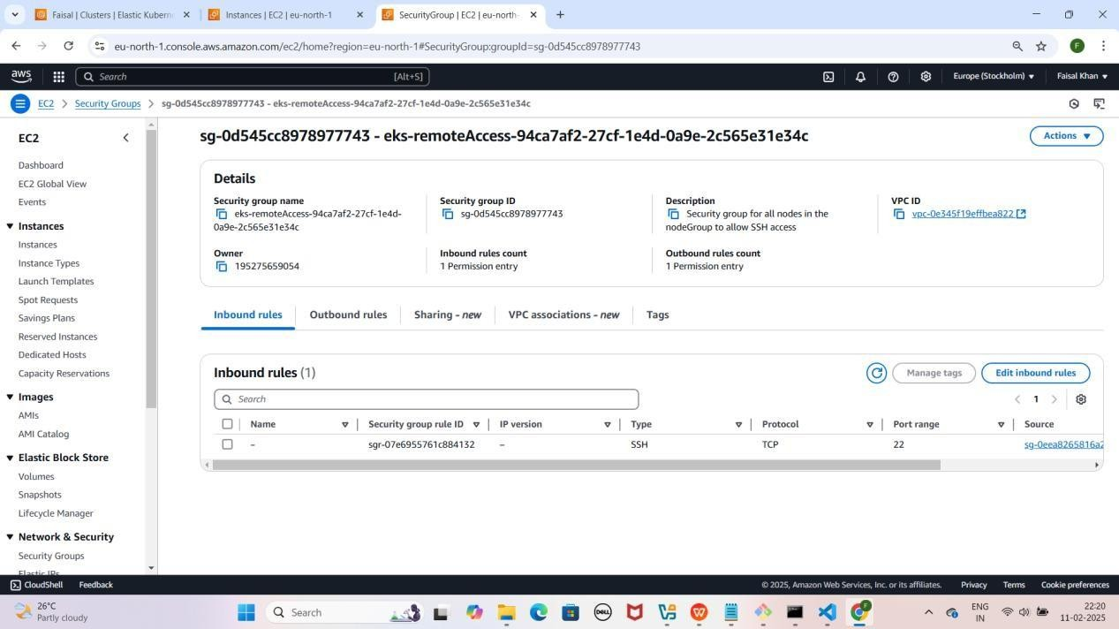

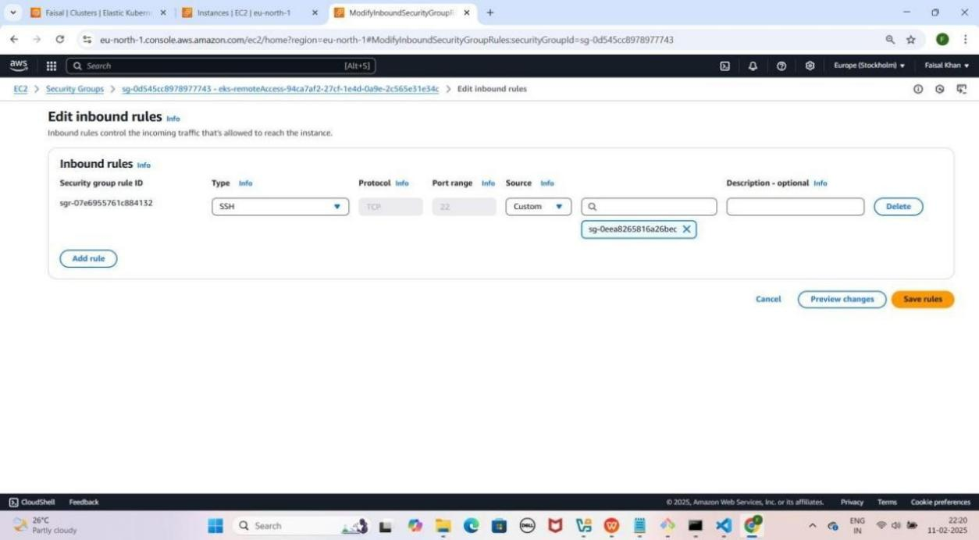

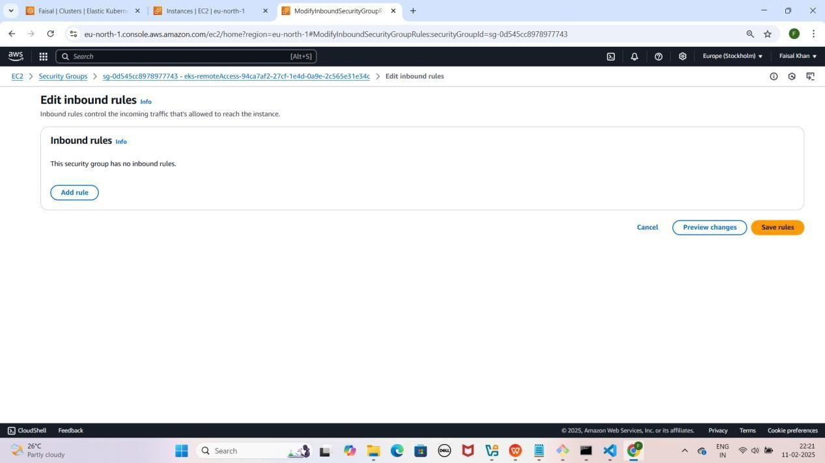

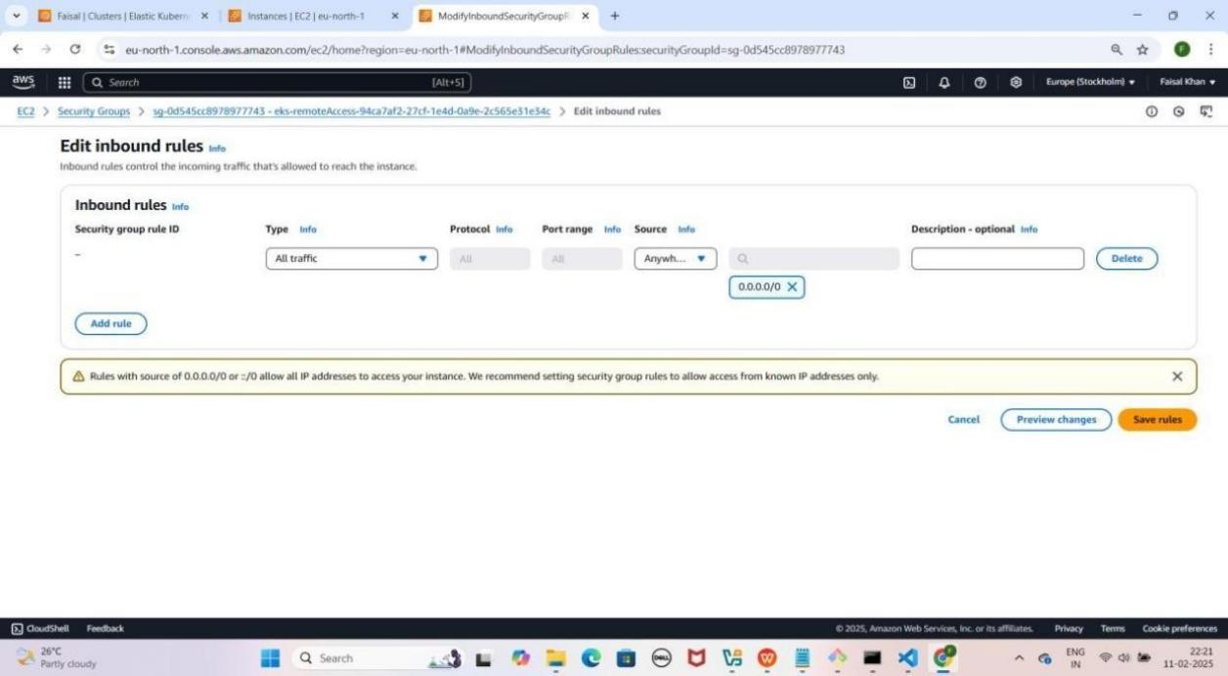

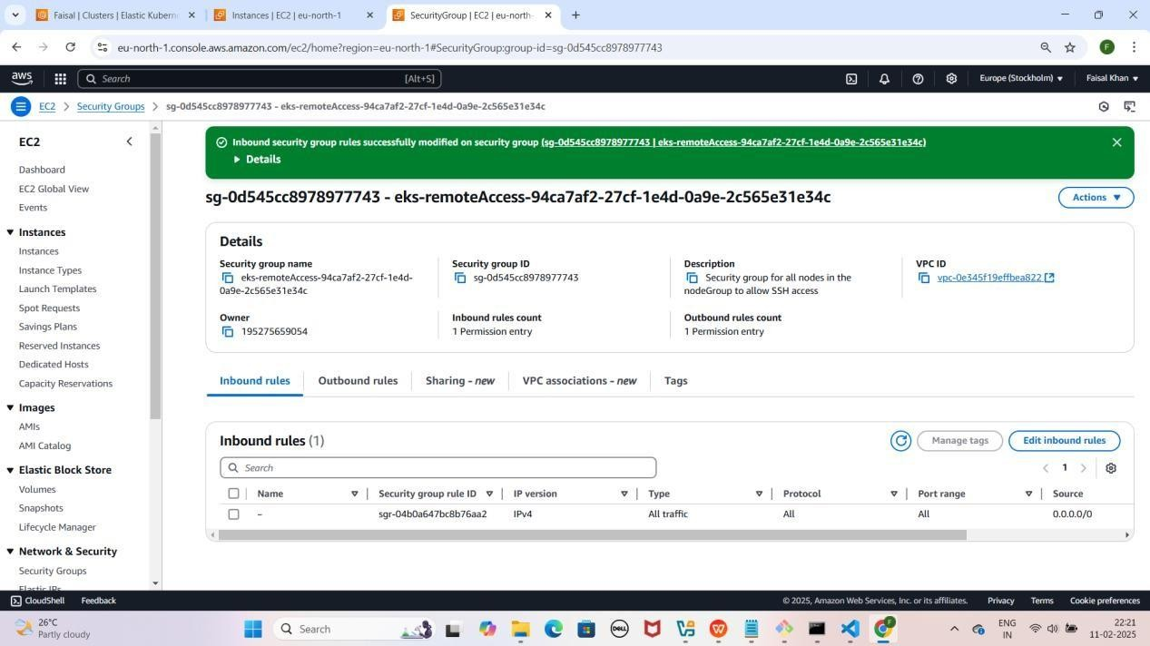

### Step 12: Project Ki GitHub Repository Clone Karein

1. **Laptop Mein Documents Folder Mein Jao**

YE KUCH ISTARHA LEGAGA

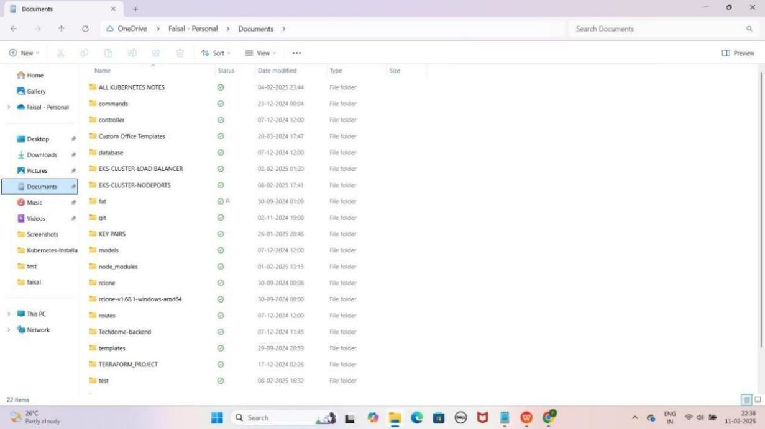

1. **PowerShell Ko "Run as Administrator" Open Karo**

YE KUCH ISTARHA LAGEGA

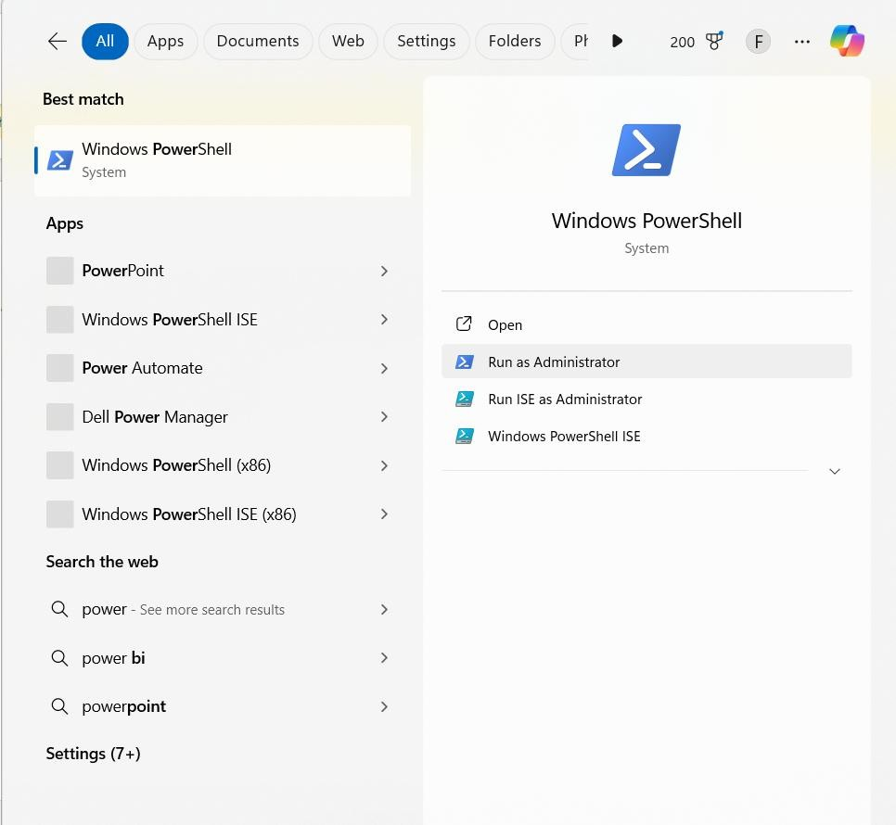

1. **PowerShell me cd command ka use karke Documents folder ka path paste karein.**

Jaisa ki mere case me, path kuch aisa hai

cd C:/Users/faisa/OneDrive/Documents

YE KUCH ISTARHA LAGEGA

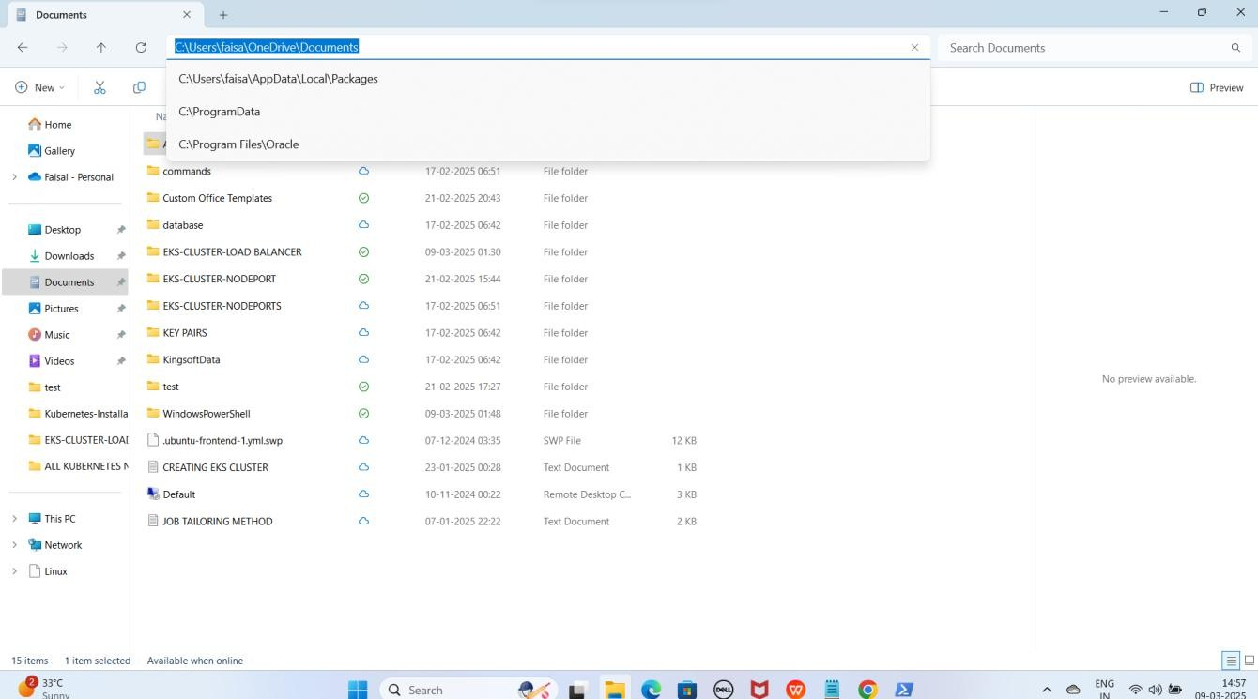

NOTE: Isse aap Documents folder me Navigate ho jaoge.

1. **GitHub Repository Clone Karo**

As it is niche diya gaya URL copy karo aur PowerShell me paste karo:

git clone https://github.com/Faisalkhan45/EKS-CLUSTER-NODEPORT.git

YE KUCH ISTARHA LAGEGA

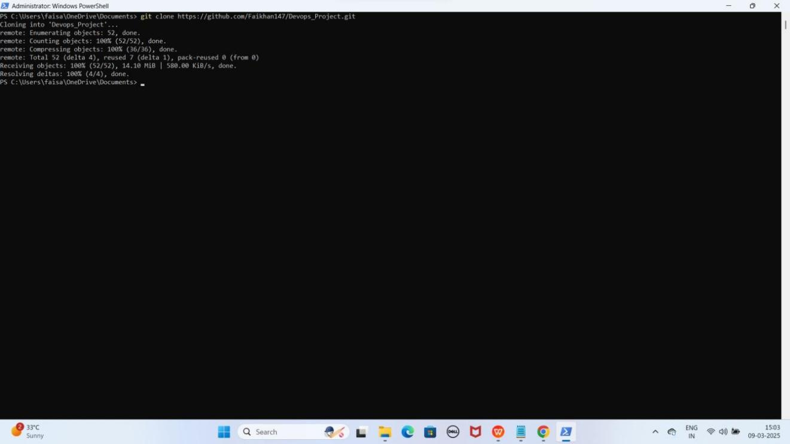

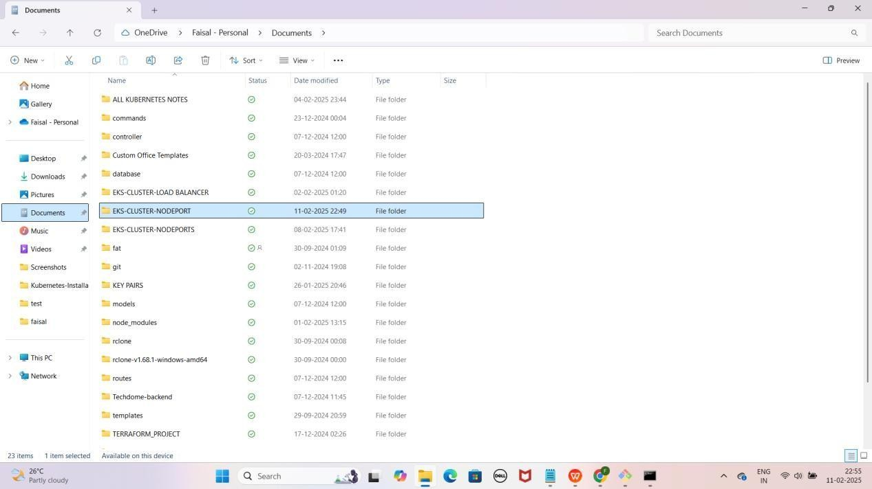

NOTE: Repository clone hone ke baad, aapko "EKS-CLUSTER-NODEPORT" naam ka folder Documents me dikhega

1. **EKS-CLUSTER-NODEPORT Folder Me Jao PowerShell me cd command ka use karo aur apna path paste karo**

Jaise ki mere case me path kuch aisa hoga

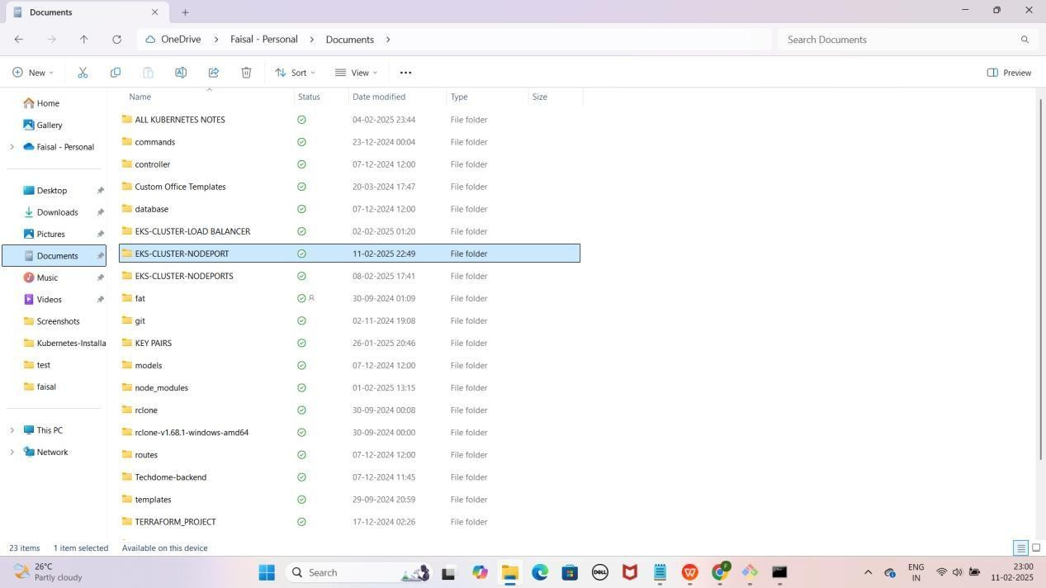cd C:\Users\faisa\OneDrive\Documents\EKS-CLUSTER-NODEPORT YE KUCH ISTARHA LAGEGA

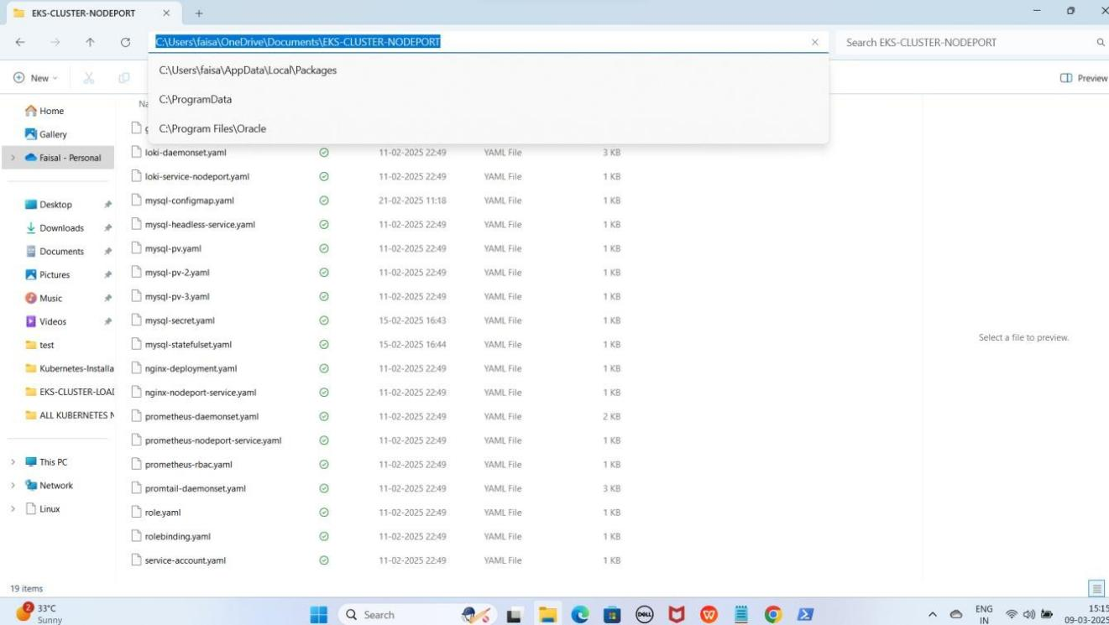

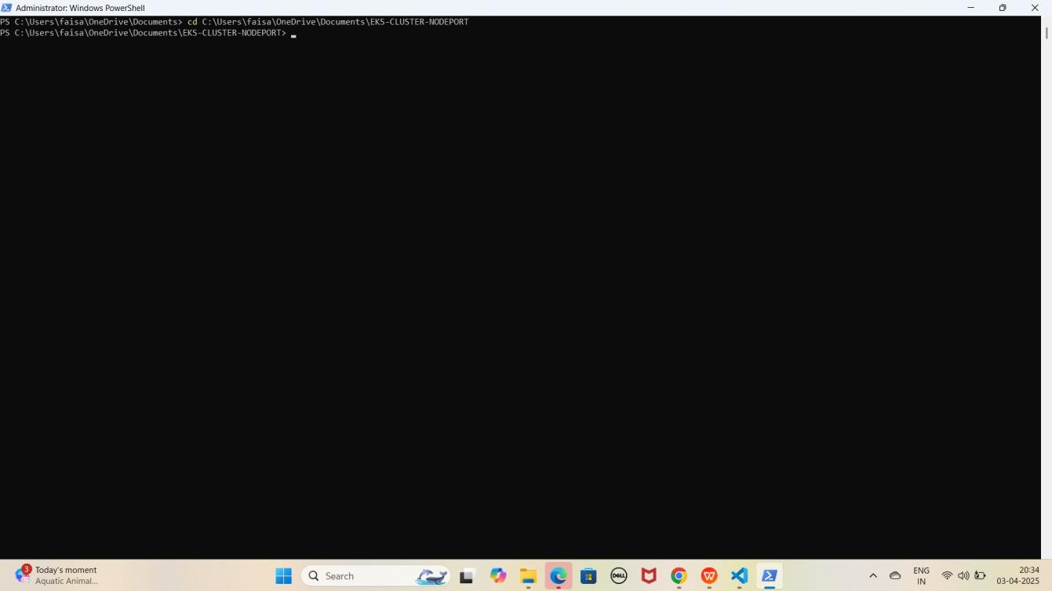

NOTE: Is command se aap PowerShell me EKS-CLUSTER-NODEPORT folder me Navigate ho jaoge.

### Step 13: AWS CLI Configure Karo

1. **Configure karne ke liye ye command run karo**

aws configure

YE KUCH ISTARHA LAGEGA

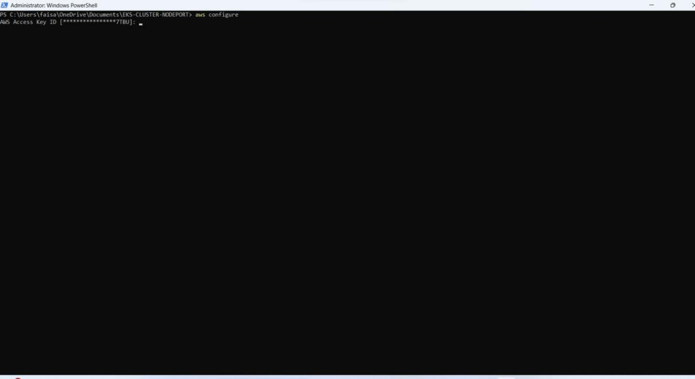

1. **Details Enter Karo**
   * **AWS Access Key ID**: XXXXXXXXXXXXXXXX
   * **AWS Secret Access Key**: XXXXXXXXXXXXXXXXXXXXXX
   * **Default Region**: eu-north-1
   * **Output Format**: text

YE KUCH ISTARHA LAGEGA

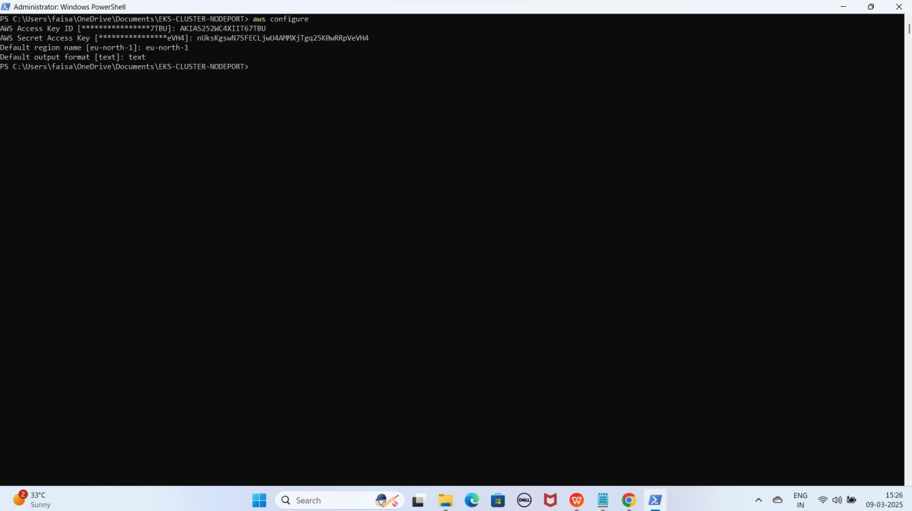

1. **EKS Clsuter se Connect karne ke liye ye command run kariye**

aws eks update-kubeconfig --name Faisal --region eu-north-1

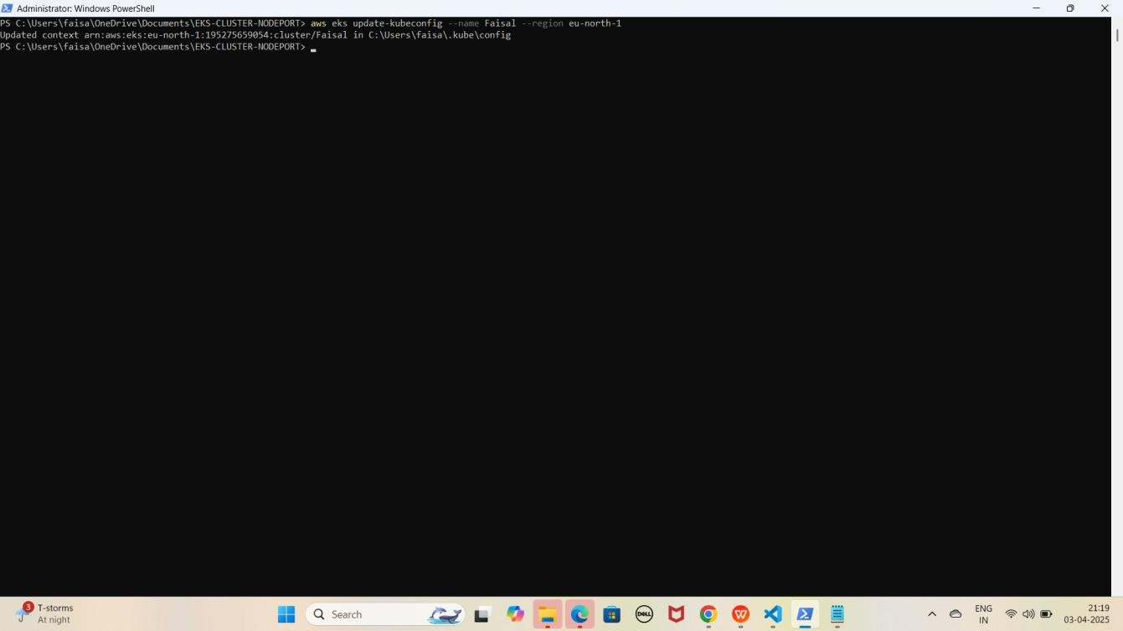YE KUCH ISTARHA LAGEGA

NOTE: Yaha par Faisal mere cluster ka name hai aap ke case me cluster ka name alag hosakta hai to according to your cluster name command aapke cluster name se Replace karo or ye hum Stockholm region me karrahe hai

### Step 14: Nodes Check Karna

1. Check Karo Ke Node Sahi Se Ready Hai Ya Nahi

kubectl get nodes

YE KUCH ISTARHA LAGEGA

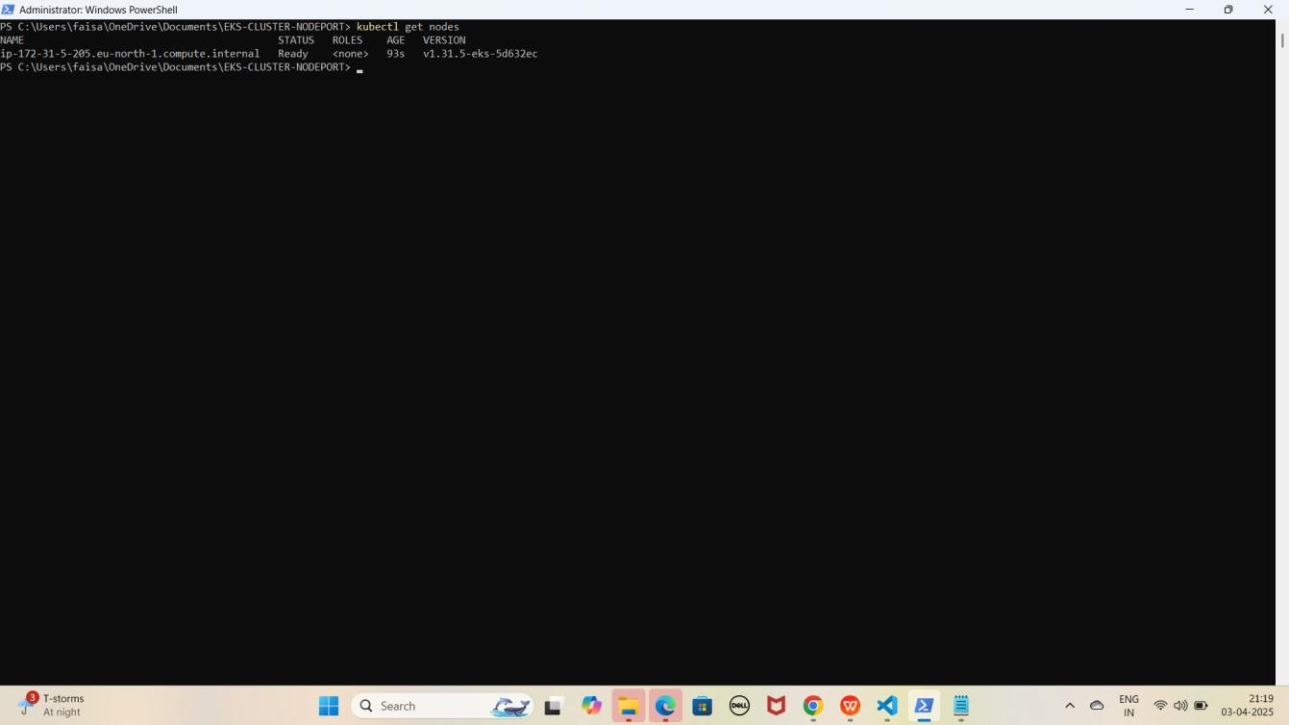

NOTE: Agar Output Mein Node "Ready" STATUS Mein Hai To Setup Complete Hai.

## Part 2: Nginx pods and Service Deployment

### Step 1: nginx-deployment.yaml File Ka Kaam

Yeh **file NGINX ke 3 replicas create** karne ke liye use hoti hai. Isko

**Kubernetes Deployment** ke andar likha jata hai.

JAISE KI:-

apiVersion: apps/v1 kind: Deployment metadata:

name: nginx-deployment spec:

replicas: 3 # 3 replicas for high availability selector:

matchLabels:

app: nginx template:

metadata:

labels:

app: nginx spec:

containers:

- name: nginx

image: nginx:latest # Latest Nginx image ports:

- containerPort: 80 # Expose port 80 in the container

### Deployment Apply Karo

kubectl apply -f nginx-deployment.yaml

YE KUCH ISTARHA LAGEGA

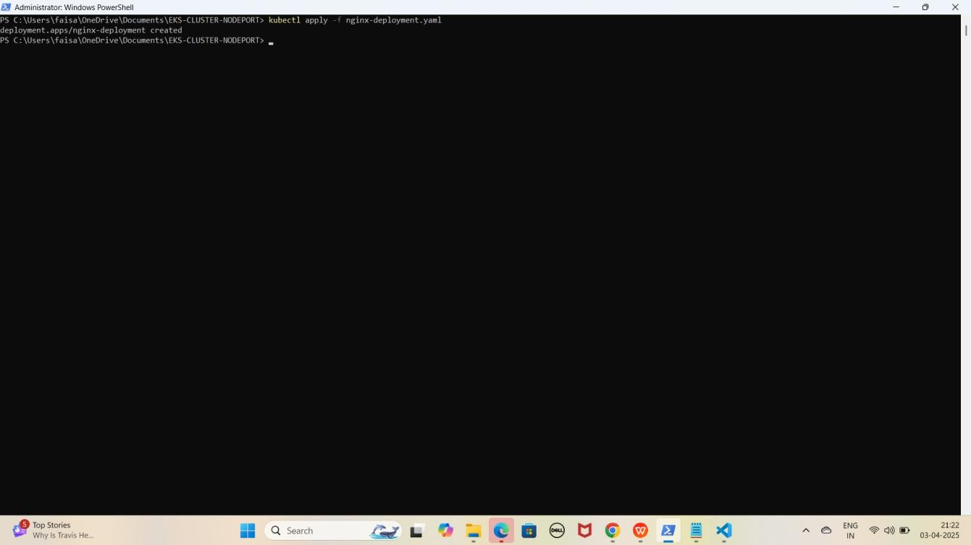

### Step 2: nginx-nodeport-service.yaml File Ka Kaam

Yeh **file NGINX pods** ko **expose** karne ke liye use hoti hai. Isme **NodePort service** define ki jati hai jo **NGINX pods** ko port **30007** par **access** karne ki ijazat deti hai.

JAISE KI:-

apiVersion: v1 kind: Service metadata:

name: nginx-service spec:

selector:

app: nginx ports:

- port: 80 # Port inside the cluster

targetPort: 80 # Port to forward traffic to in the container

nodePort: 30007 # External port on which the service will be accessible type: NodePort # Type set to NodePort to expose externally

### Nginx Service Apply Karo

kubectl apply -f nginx-nodeport-service.yaml

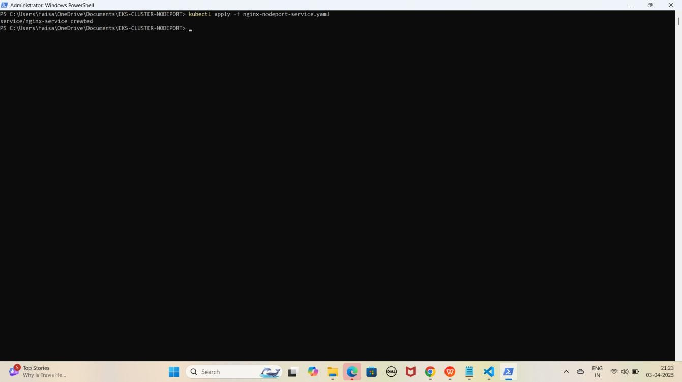YE KUCH ISTARHA LAGEGA

1. **Pods check karne ke liye ye command run kariye**

kubectl get pods

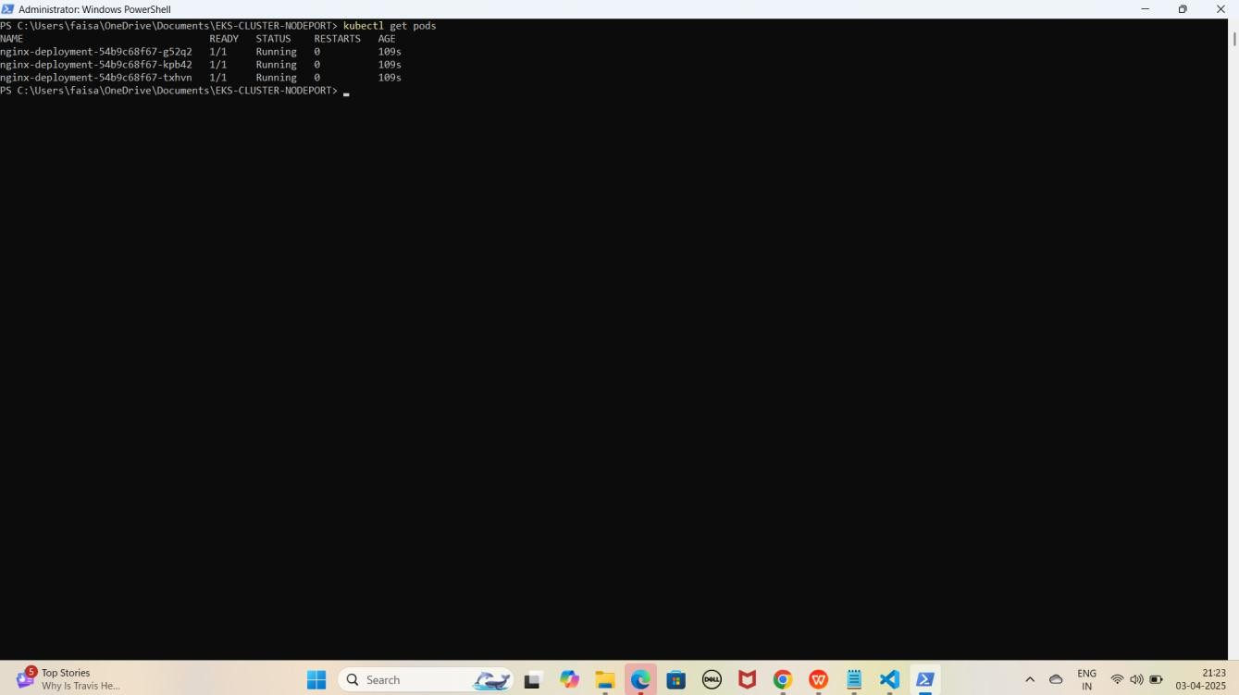YE KUCH ISTARHA LAGEGA

NOTE: Agar STATUS Running show karraha hai to sab kuch sahi hai

1. **Serives check karne ke liye ye commad run kariye**

kubectl get services

YE KUCH ISTARHA LAGEGA

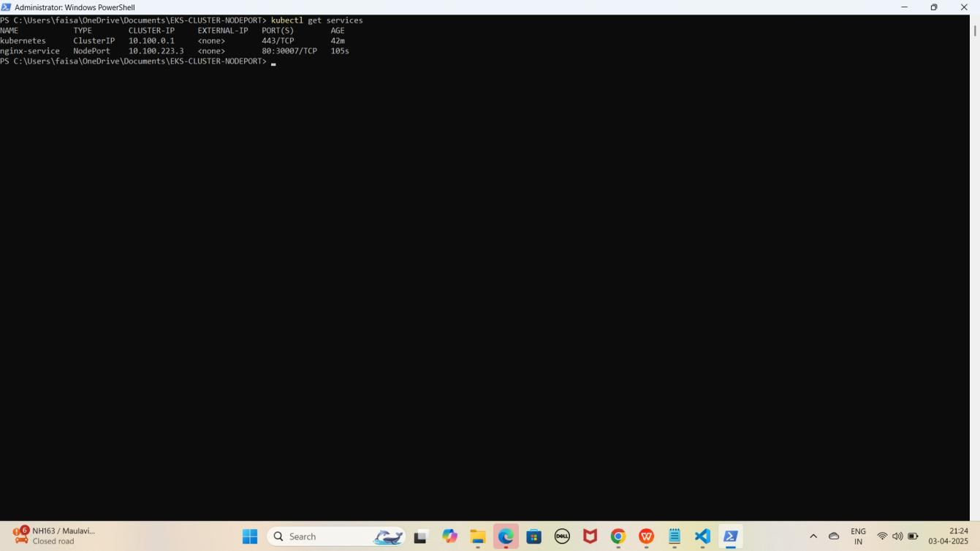

NOTE: Ab aapka Nginx expose ho chuka hai aapke EKS Node ka Public IP Address lekar with Nodeport browser me run kariye. Jaise ki mere case me kuch aisa hoga

NGINX NodePort Address :

[http://EKS-Node-Public IP:30007](h)

YE KUCH ISTARHA LAGEGA

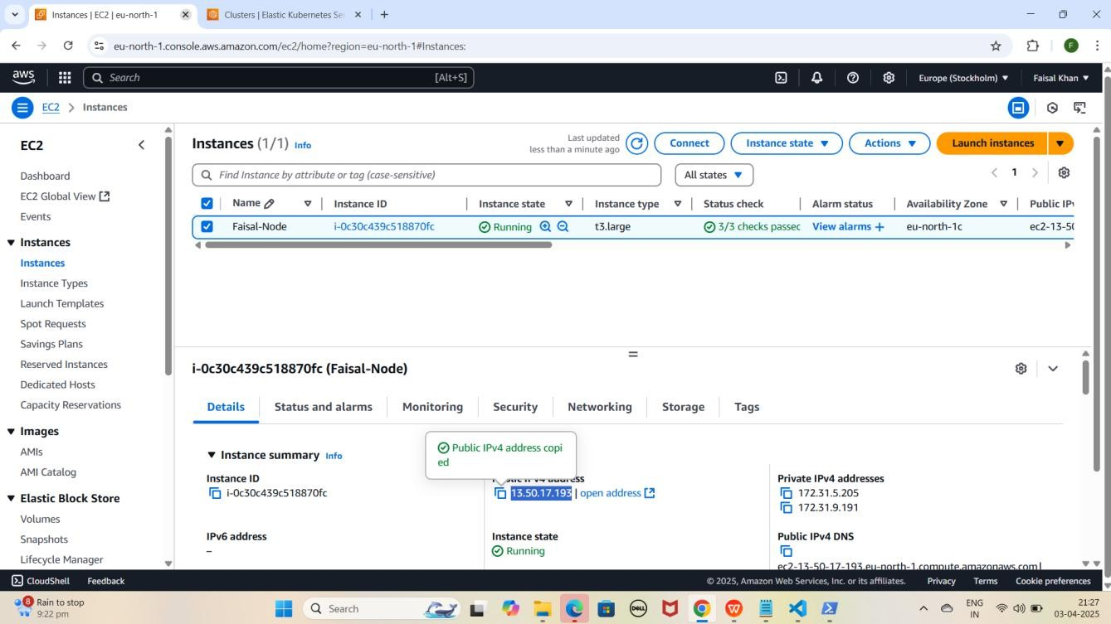

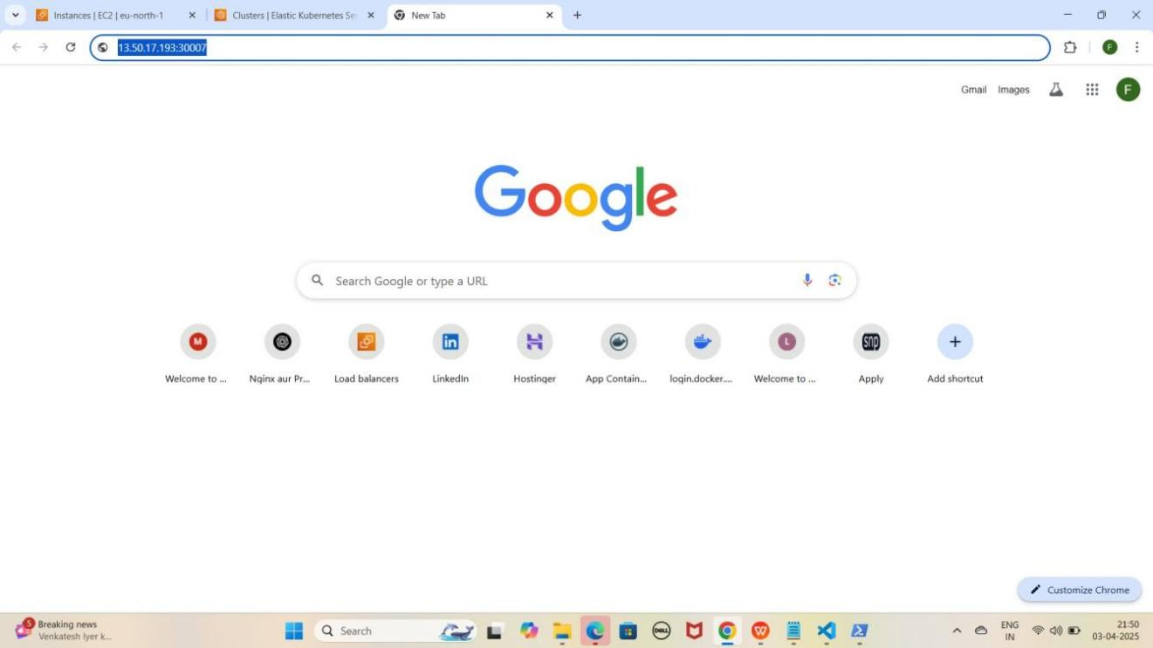

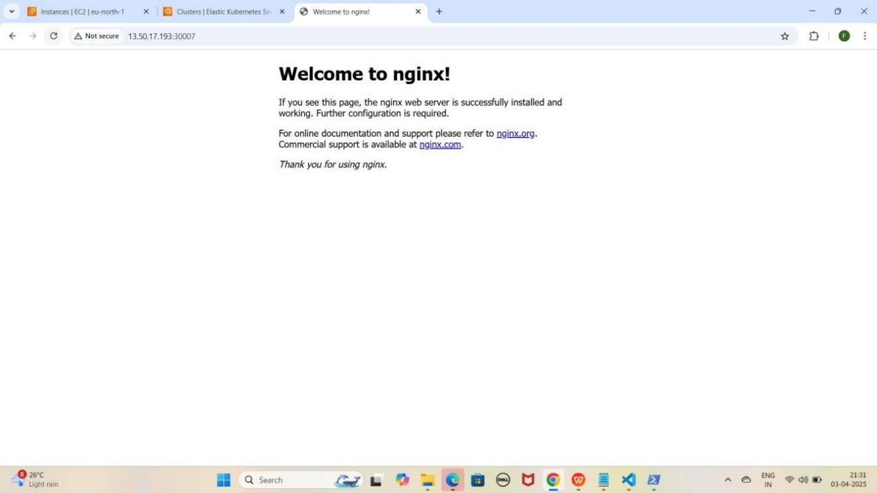

## Part 3: Registering a Domain Name on Hostinger (From Sign-Up to Purchase)

### Step 1: Domain Name Provider Choose Karo

* Tumhe **GoDaddy, AWS (Route 53), ya Hostinger** jaisa **domain**

provider chahiye

* Main yahan **Hostinger** use kar raha hoon

### Step 2: Hostinger Pe Domain Search Karo

* **Google** pe jao aur **"Hostinger"** search karo
* **"Domains"** pe click karo
* Search bar me apna desired **domain** likho (Jaise:

mohdfaisalkhan.tech)

* (Aapke Name se Search Karo)
* **Search button** pe **click** karo

YE KUCH ISTARHA LAGEGA

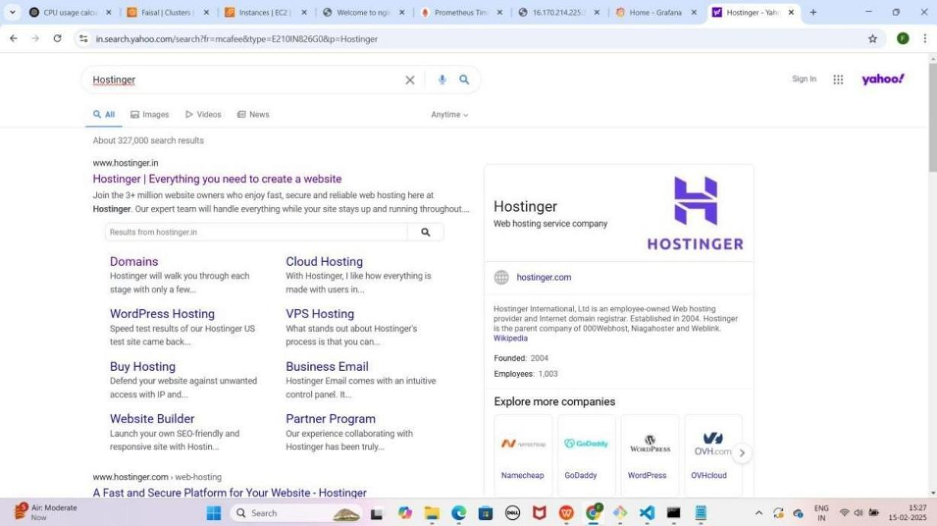

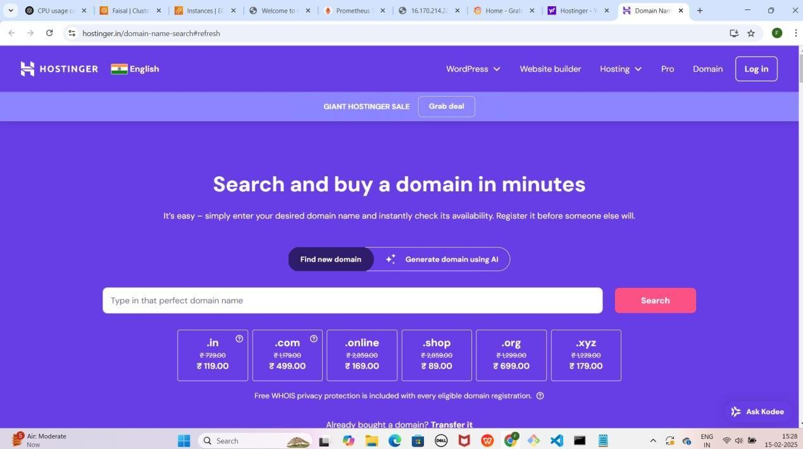

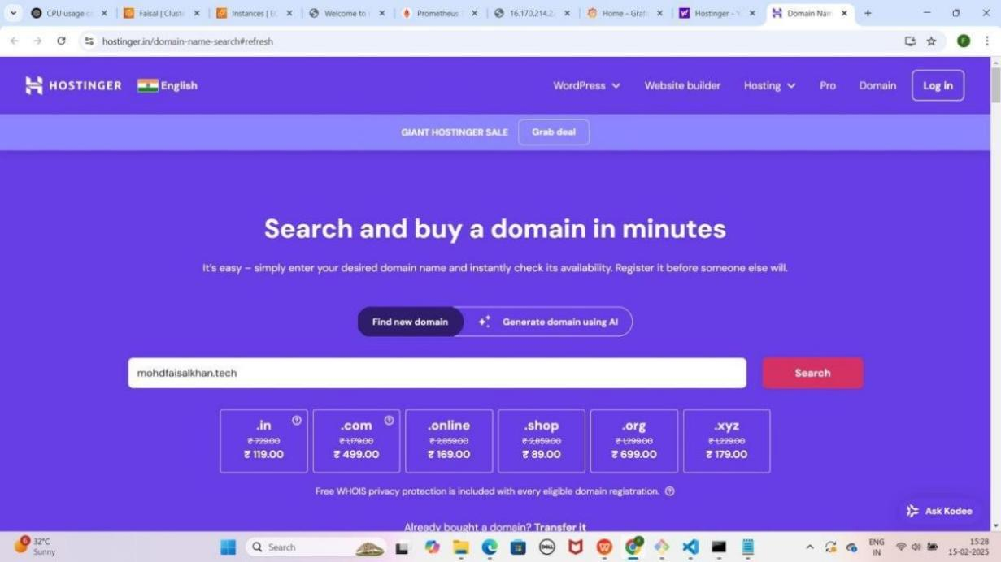

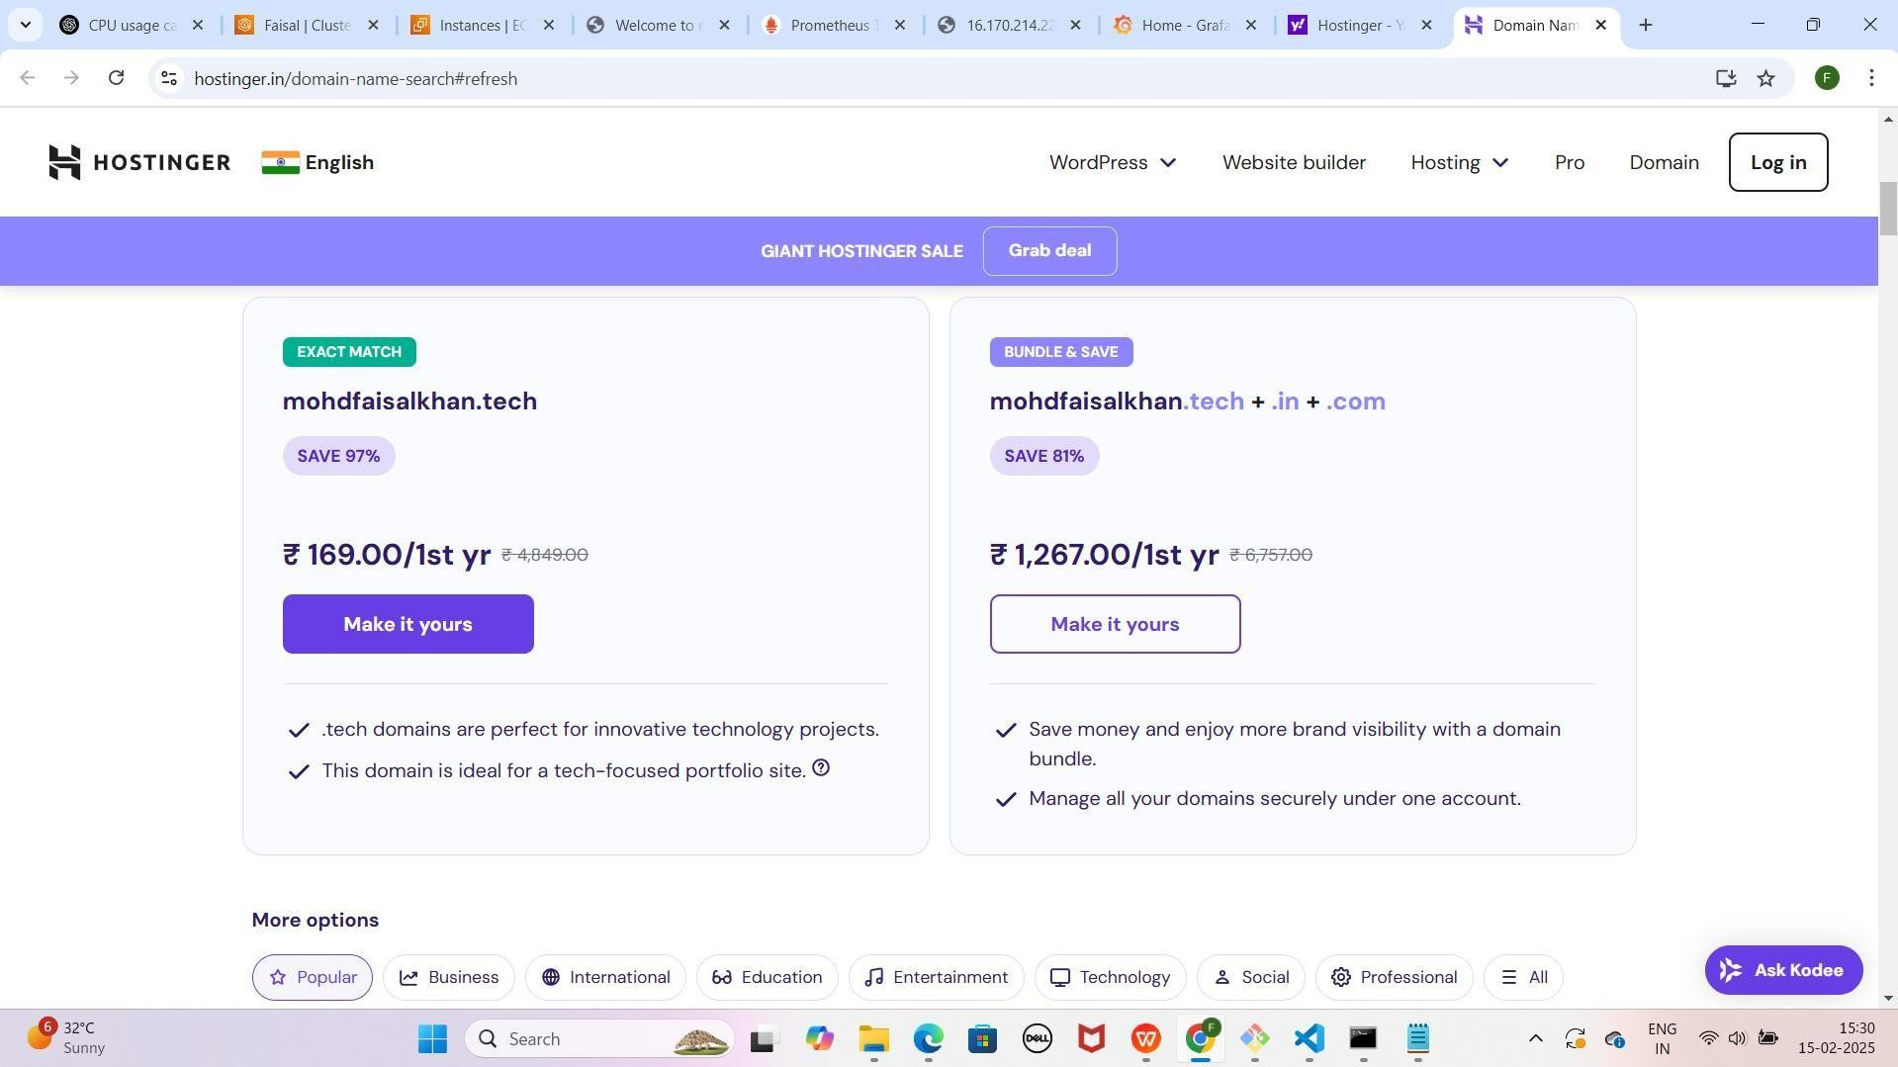

### Step 3: Domain Select Karo

* **"Make it Yours"** pe click karo
* 1-year period select karo
* **Continue** button pe click karo

YE KUCH ISTARHA LAGEGA



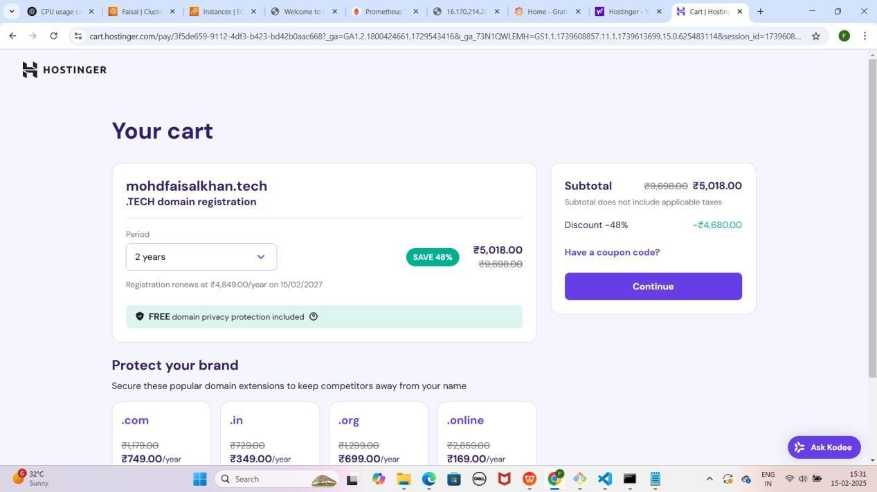

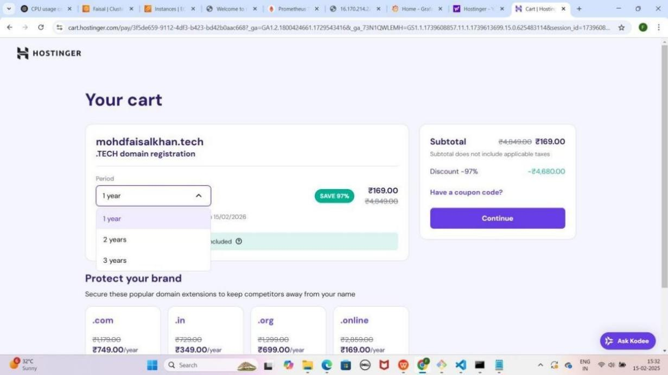

### Step 4: Account Create Karo

* **Create an Account Page** pe **Email** aur **Password** enter karo then continue pe click karo
* **Billing Address** details fill karo
* **Continue** button pe click karo

### Step 5: Payment Complete Karo Or Login Karke Domain Registration Complete Karo

* **UPI** option select karo Submit payment pe click karo or upi payment complete karo
* **Order Summary** dekho, phir **Continue** pe click karo
* **QR Code** scan karo aur **PhonePe, Paytm,** ya **Google Pay** se payment complete karo

YE KUCH ISTARHA LAGEGA

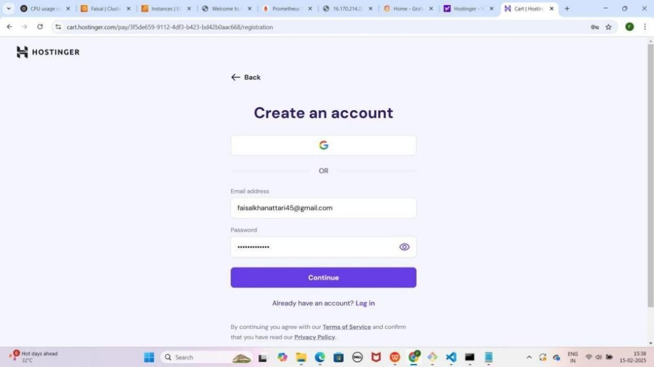

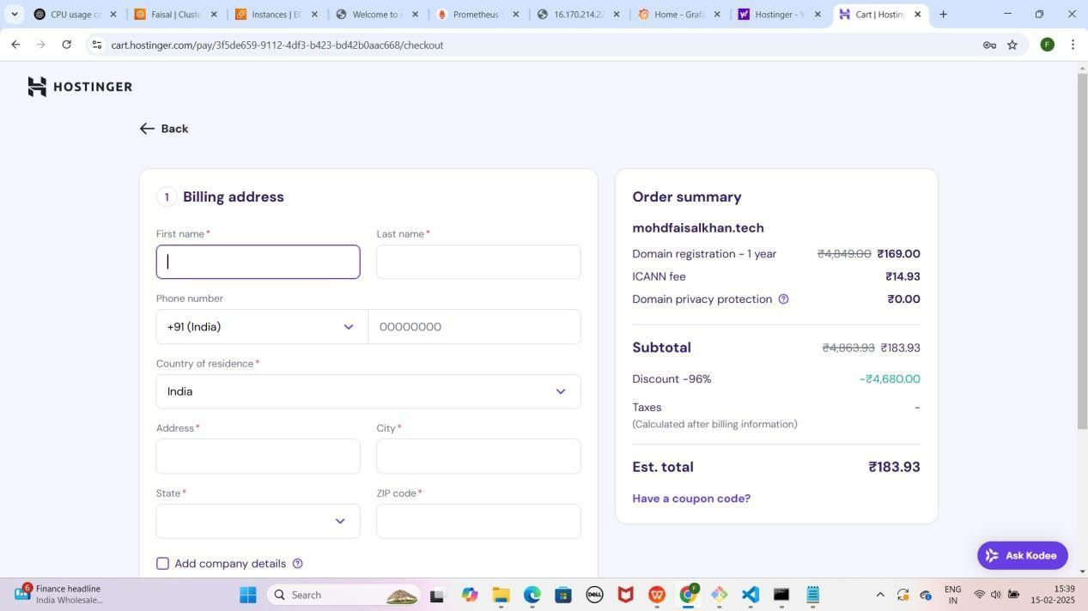

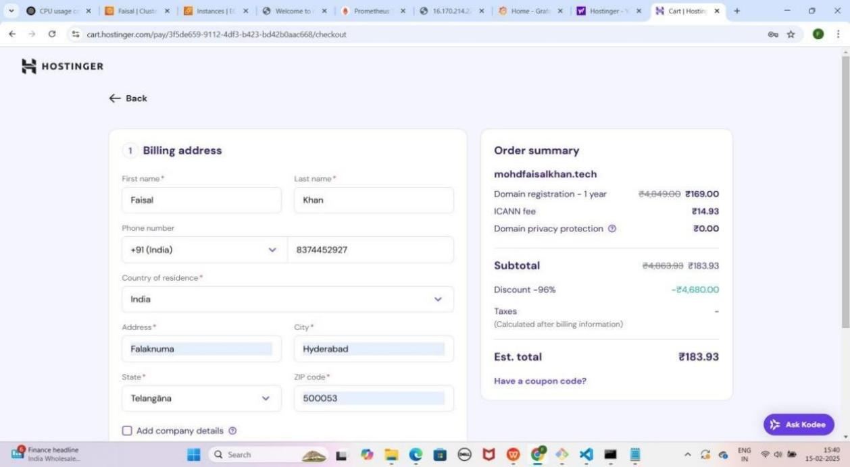

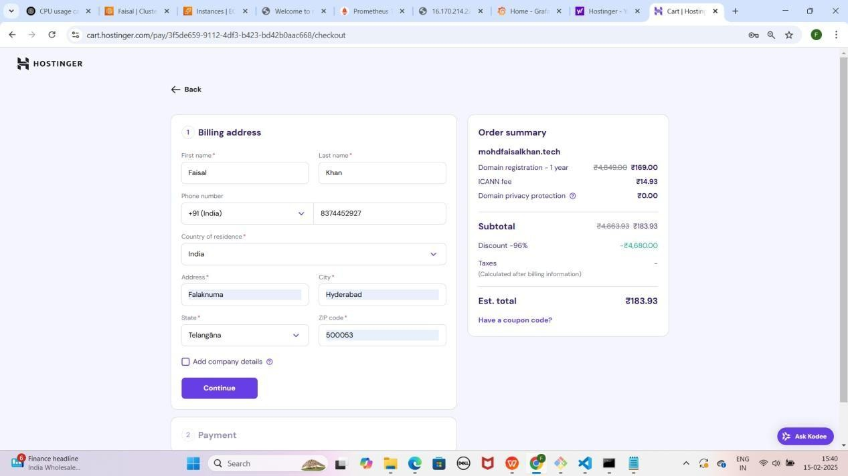

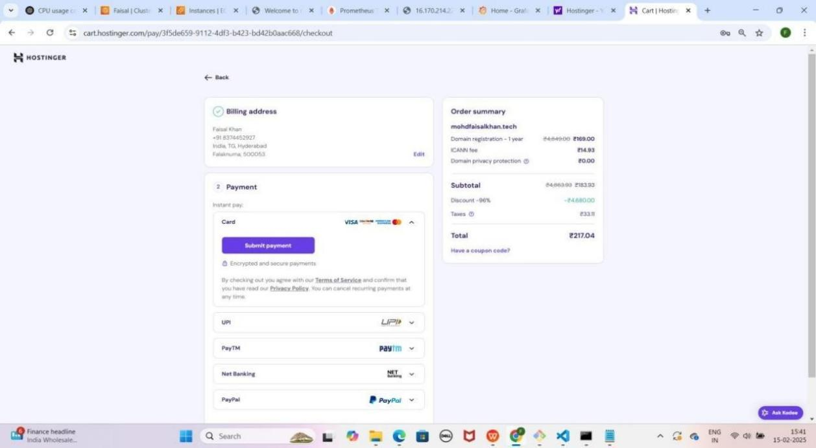

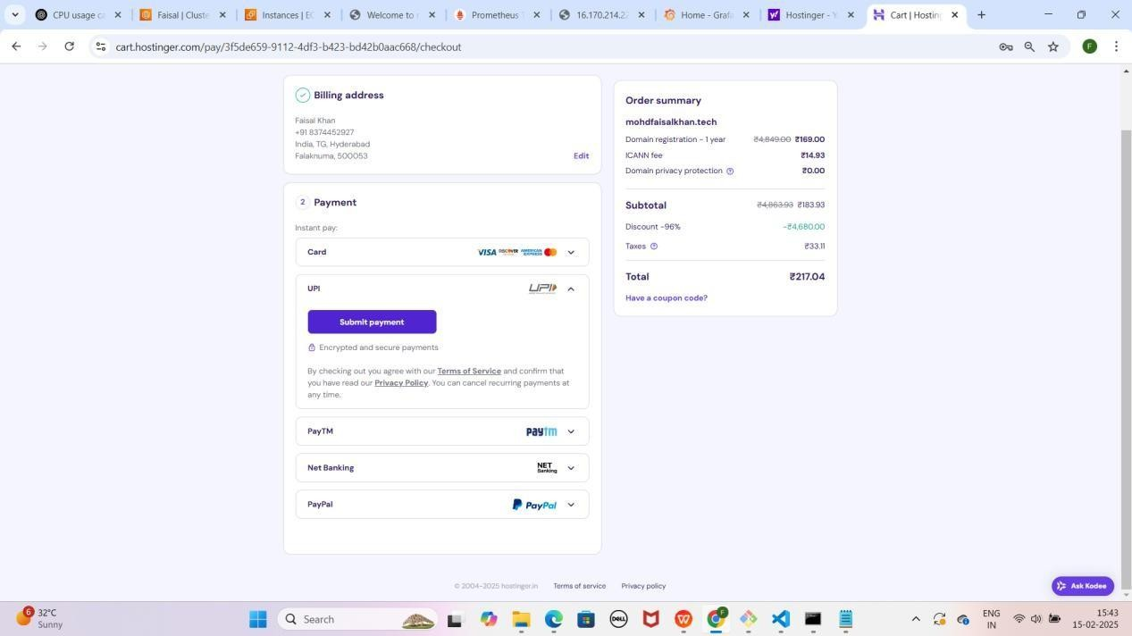

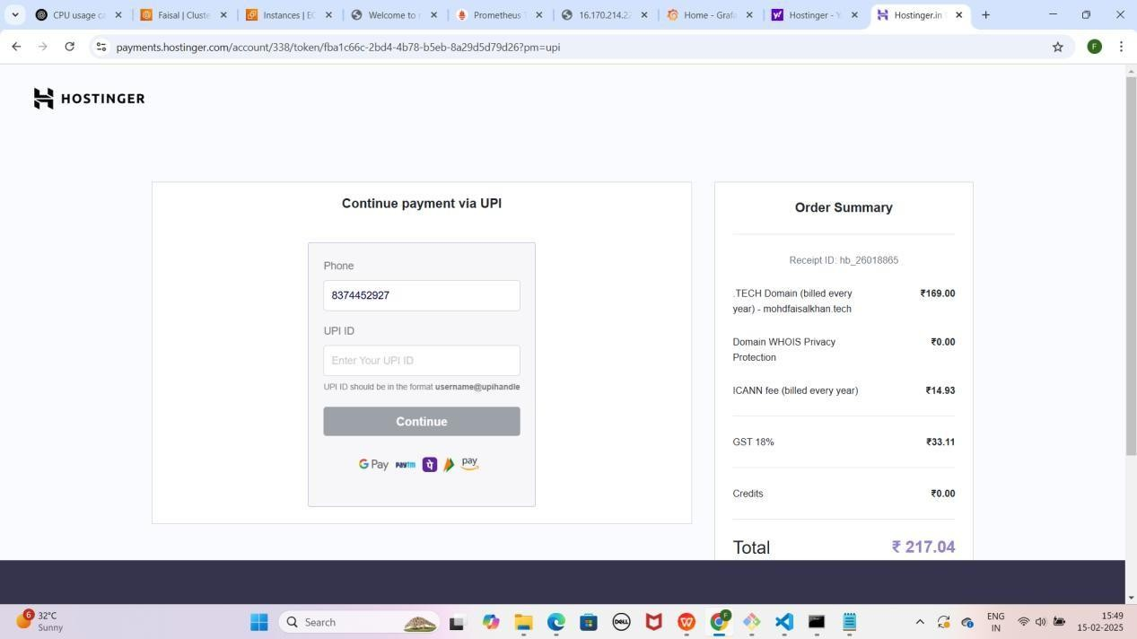

Note: Aapko neeche wala pop-up milega, tension mat lo, aap bas "Auto Pay" kar do, lekin baad mein aap isey PhonePe ke settings se cancel kar sakte ho. Abhi ke liye "Continue" pe click karo.

YE KUCH ISTARHA LAGEGA

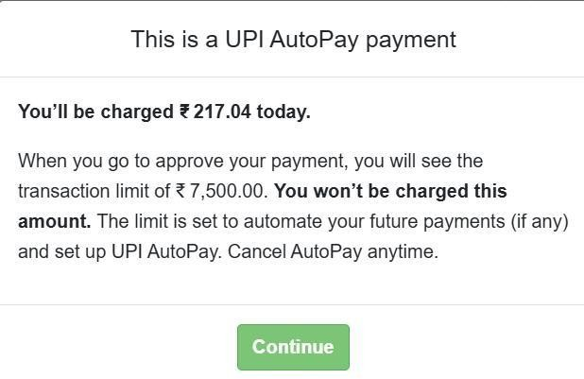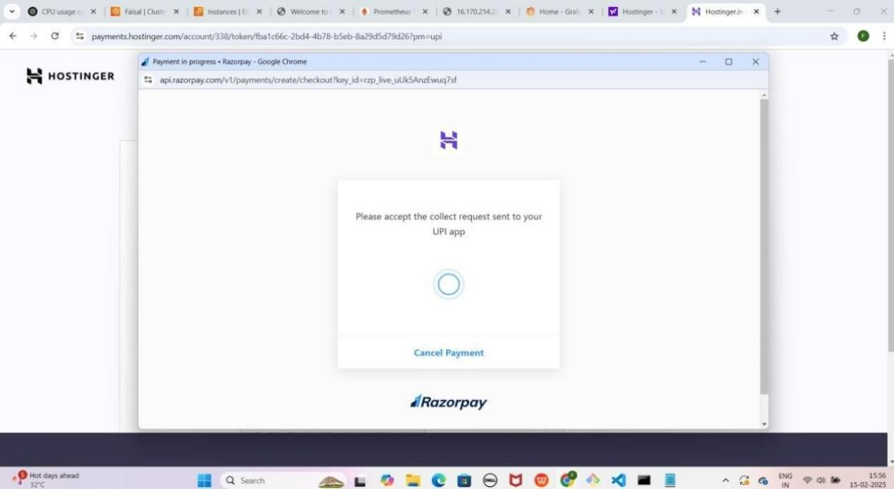

* **PhonePe** open karo aur **payment** complete karo
* **Browser** me new tab open karo aur **Google** me **Hostinger** search karo
* **Hostinger website** pe jao aur "**Domains**" pe **click** karo
* **Top right** corner pe "**Log in**" pe **click** karo
* 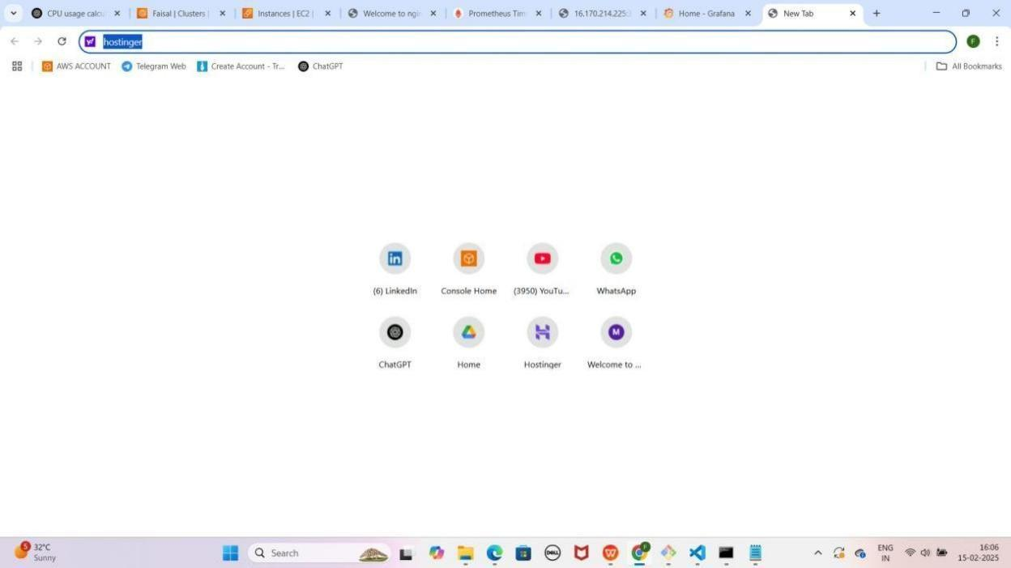**Email aur password enter** karo jo tumne pehle set kiya tha YE KUCH ISTARHA LAGEGA

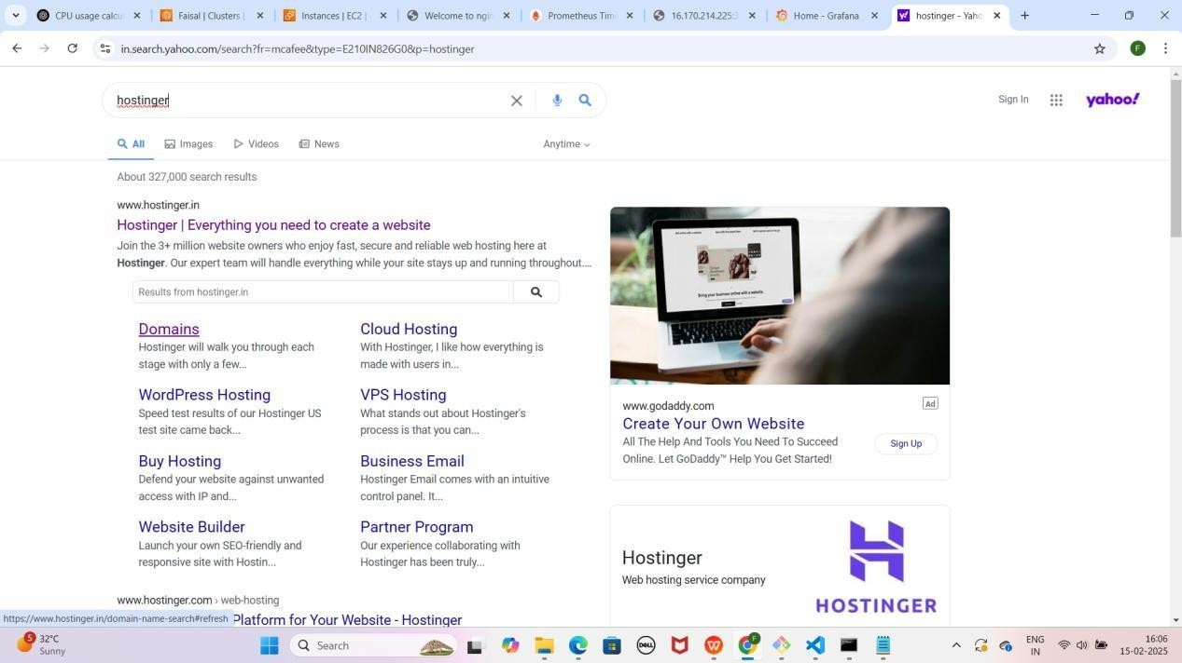

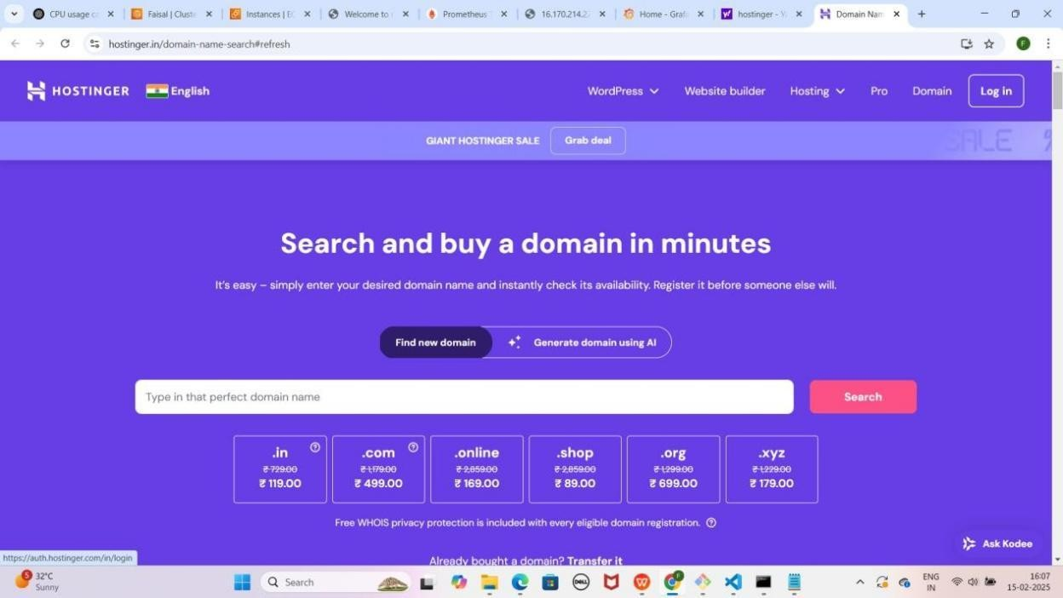

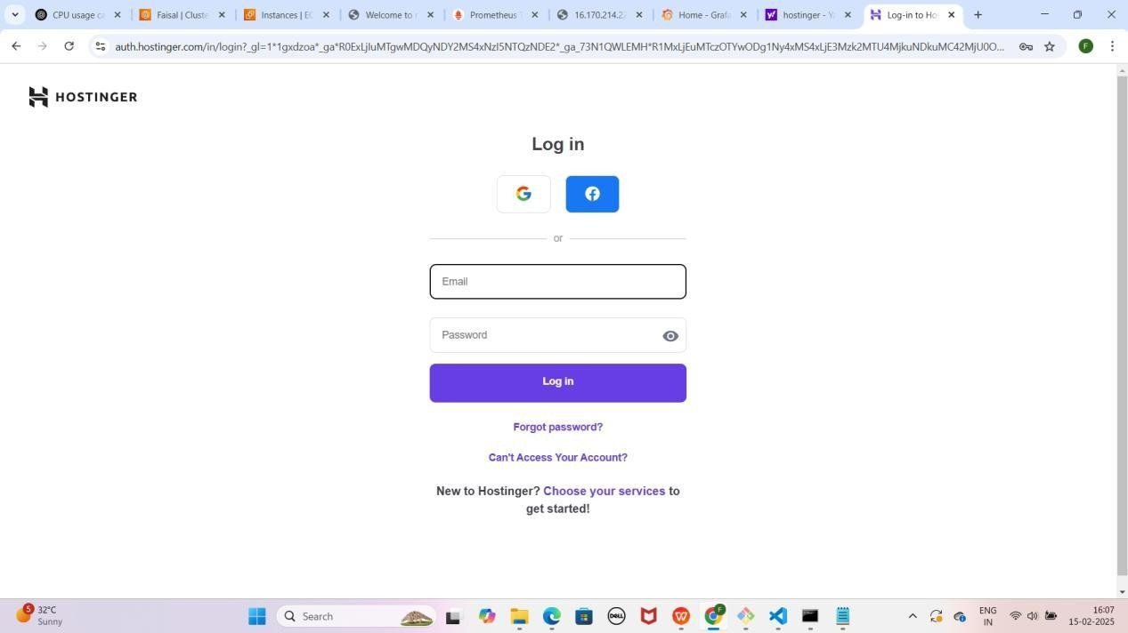

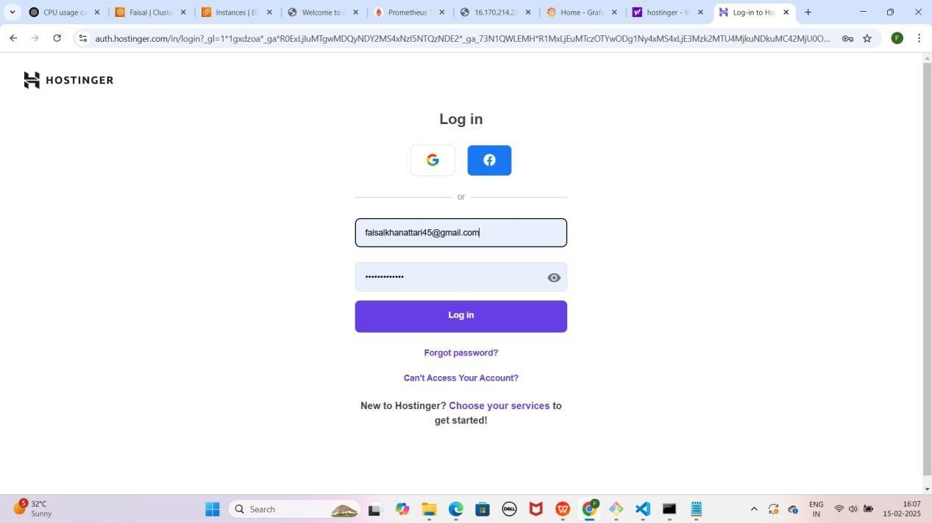

* **Login** karne ke baad tumhe **"Register your domain mohdfaisalkhan.tech"** ka option milega
* **"Next Step"** pe click karo
* **"Finish Registration"** pe click karo
* Tumhara **domain registration complete ho jayega**

YE KUCH ISTARHA LAGEGA

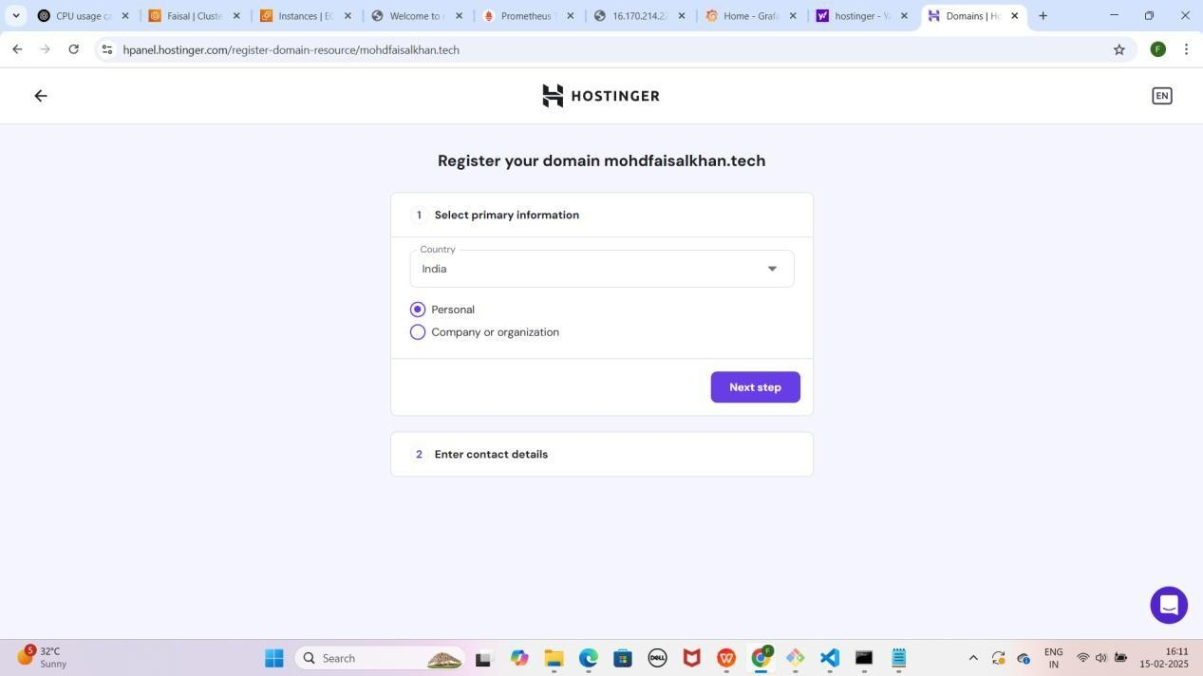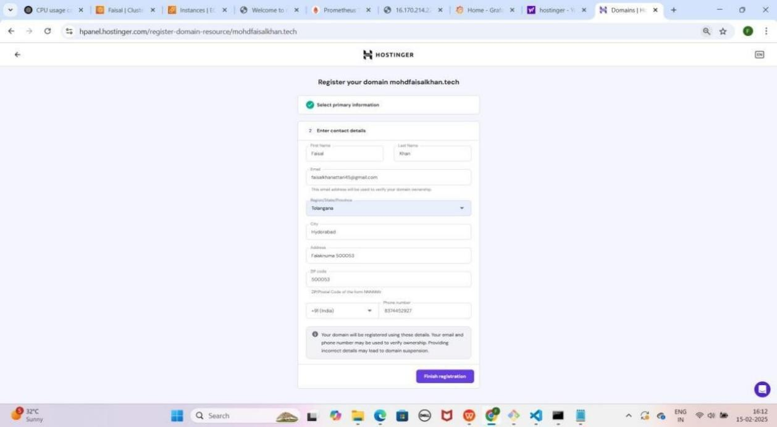

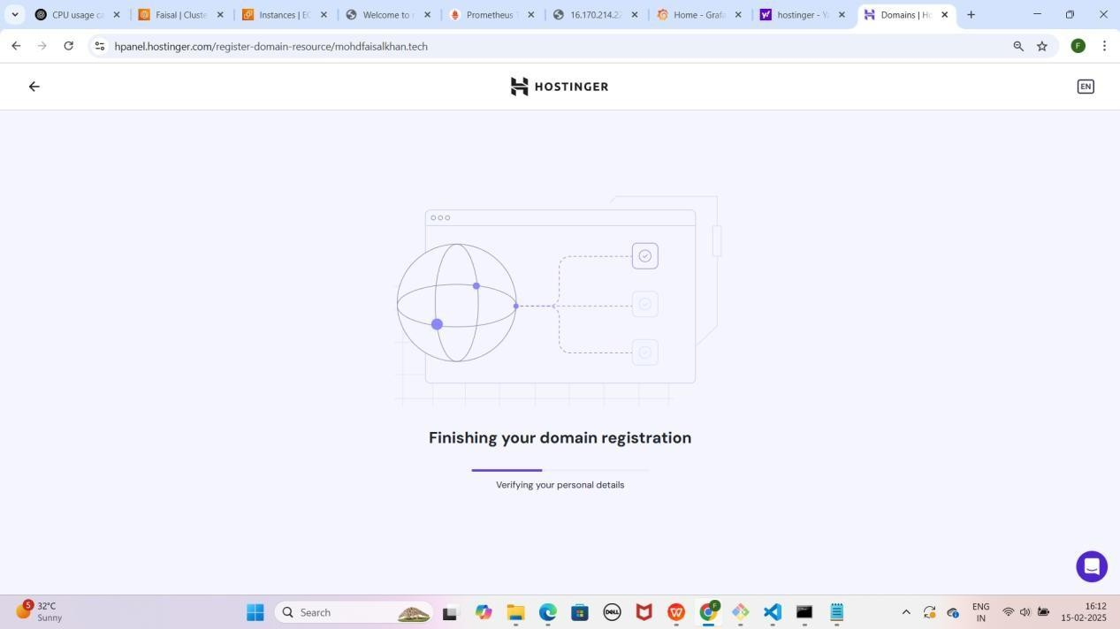

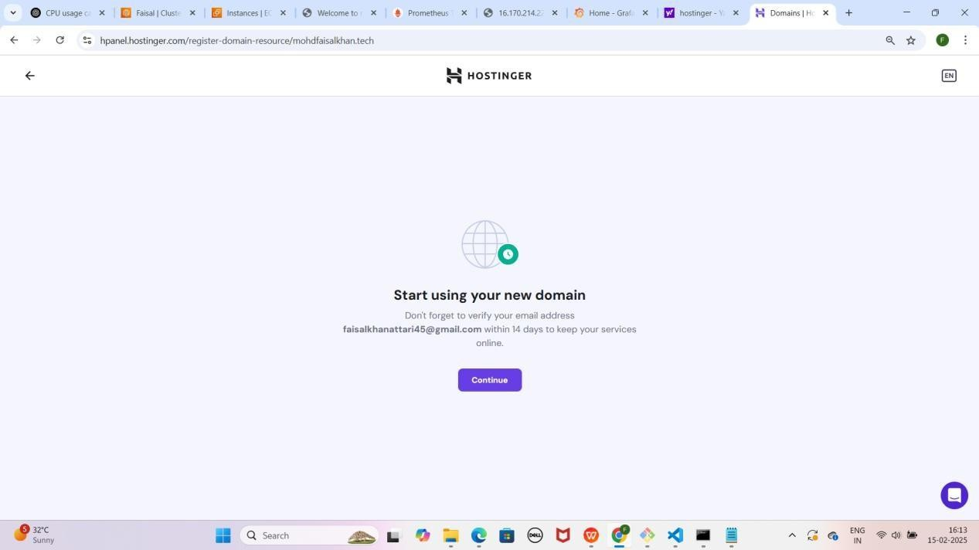

NOTE: Continue pe click karo

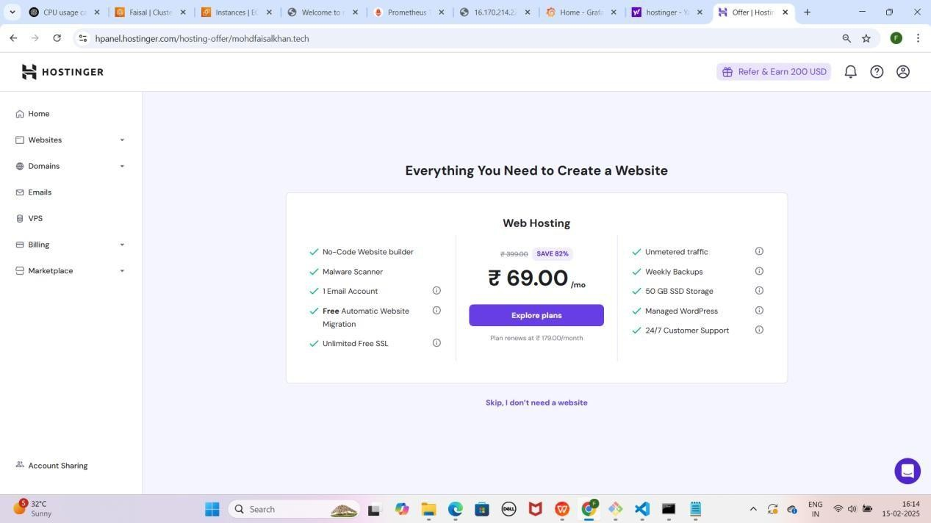YE KUCH ISTARHA LAGEGA

### Step 6: Hostinger Me Domains Section Me Navigate Karo

* **Hostinger** mein Dashboard page dikhega
* Phir **Domains** pe click karo.
* **Domain Portfolio** mein apni domain **mohdfaisalkhan.tech** ko select karo.

YE KUCH ISTARHA LAGEGA

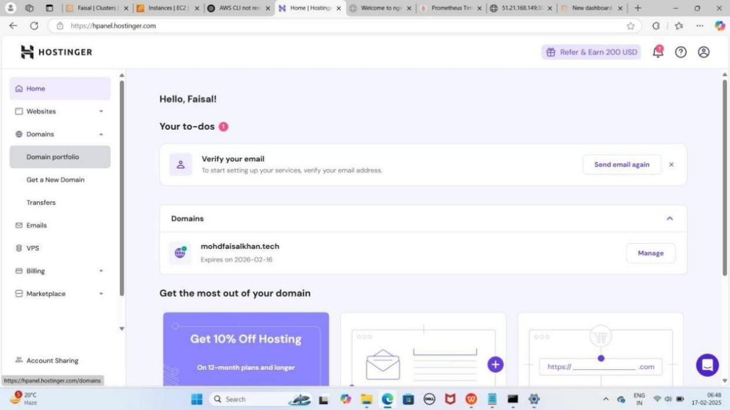

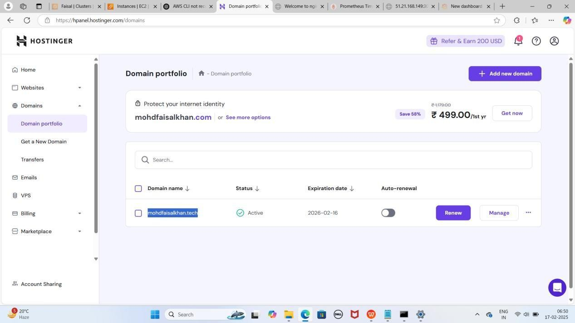

### Step 7: Hostinger Me DNS/Nameservers Section Me Navigate Karo

* Apni **domain** ko select karne ke baad, **DNS/Nameservers** pe **click**

karo.

* Yahan ek **page** khul jayega jahan tumhe **DNS records add** karna hoga.

YE KUCH ISTARHA LAGEGA

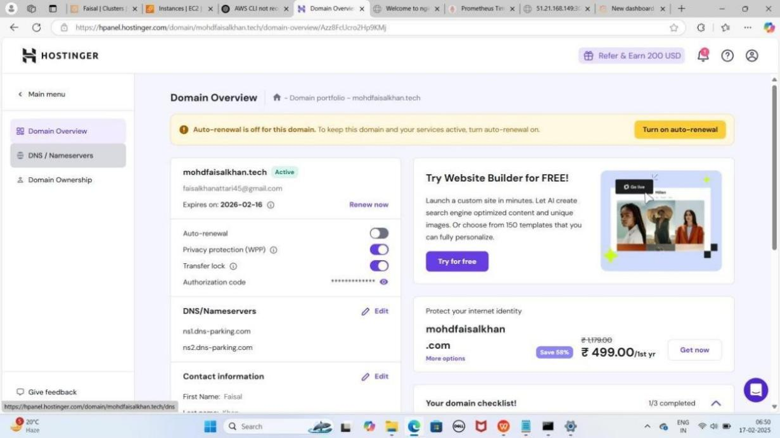

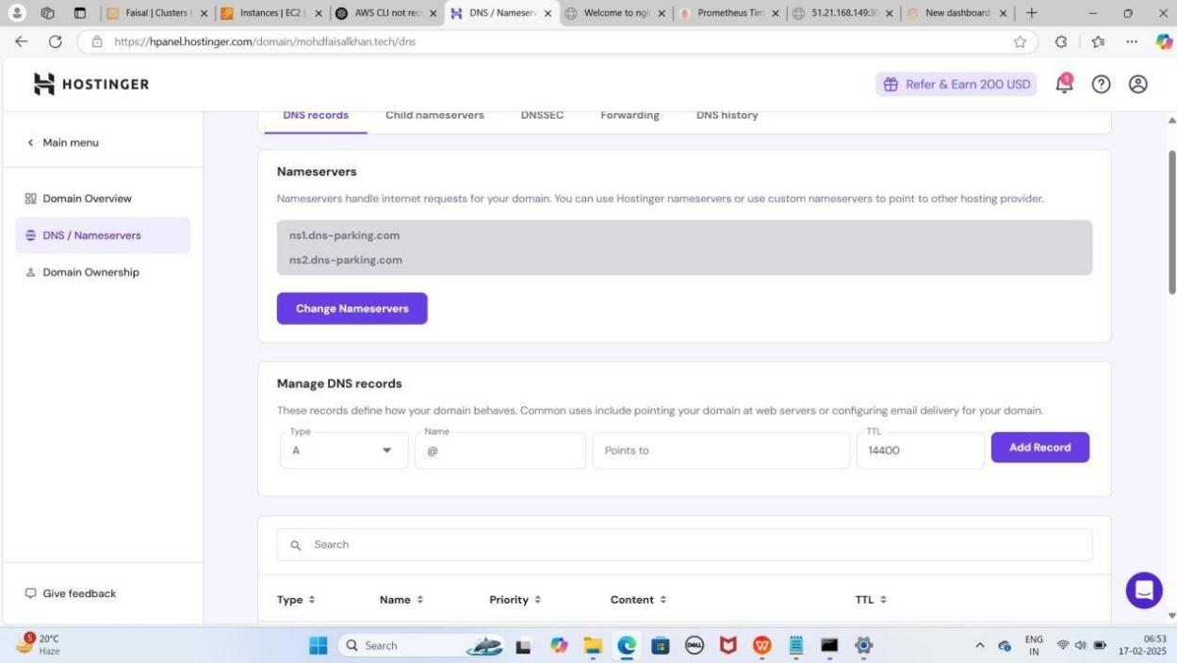

## Part 4: Configuring DNS on Hostinger for NodePort

### Step 1: A Record Add Karna (EKS Cluster Node Se Connect Karne Ke Liye)

1. Pehle EKS Node Ka IP Address Copy Karo.
2. Naya A Record Add Karo:
   * **Type:** A
   * **Name:** @
   * **Points to:** Tumhara EKS Node ka IP Address
   * **TTL:** 14400
3. Add Record pe Click Karo.

NOTE : Add Record karne ke baad DNS Record created successfully karke Pop-up ayega

### Step 2: A Record Add Karna (WWW ke liye)

1. Pehle EKS Node Ka IP Address Copy Karo.
2. Naya A Record Add Karo:
   * **Type:** A
   * **Name:** www
   * **Points to:** Tumhara EKS Node ka IP Address
   * **TTL:** 14400
3. Add Record pe Click Karo aur Confirm Karo.

NOTE : Add Record karne ke baad Confirm pe click karne ke baad DNS Record created successfully karke Pop-up ayega

YE KUCH ISTRAHA LAGEGA

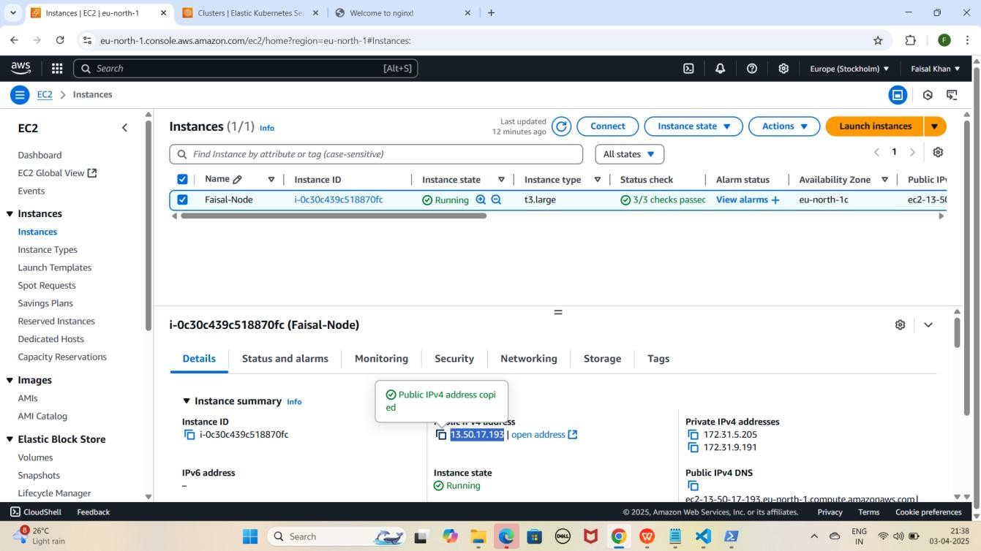

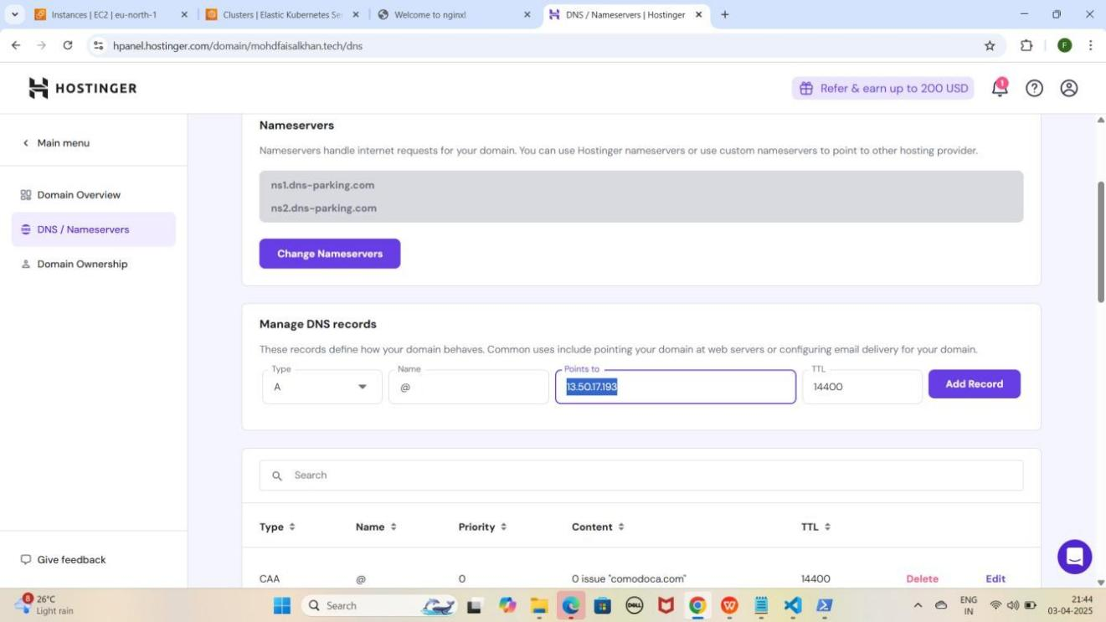

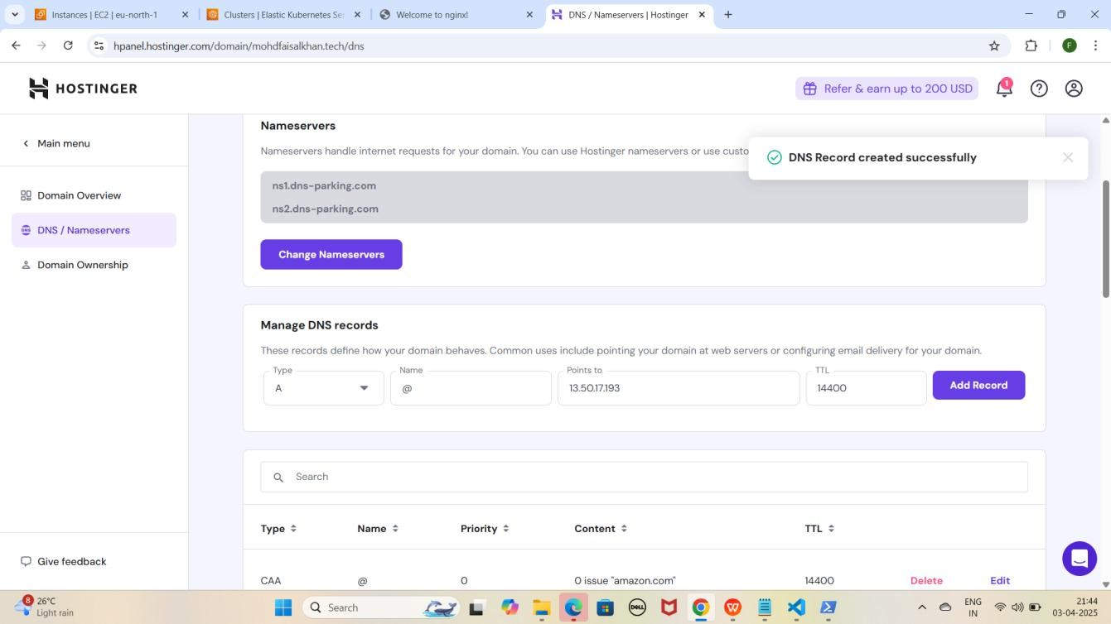

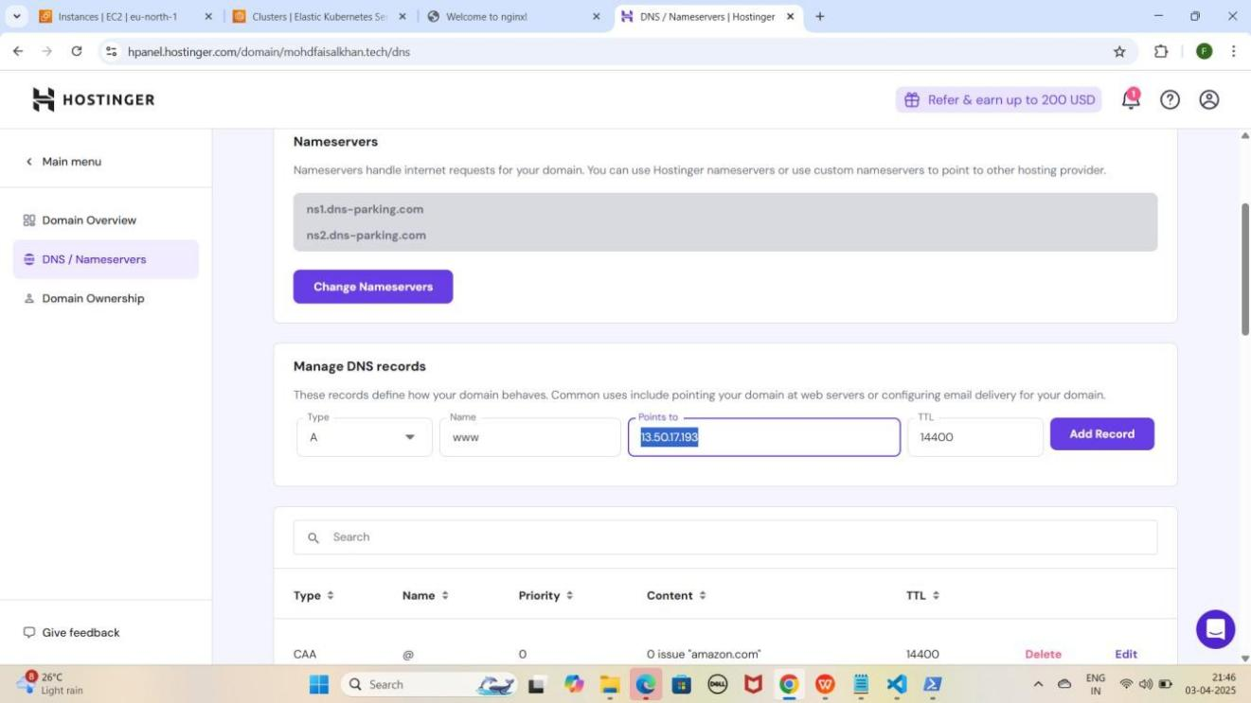

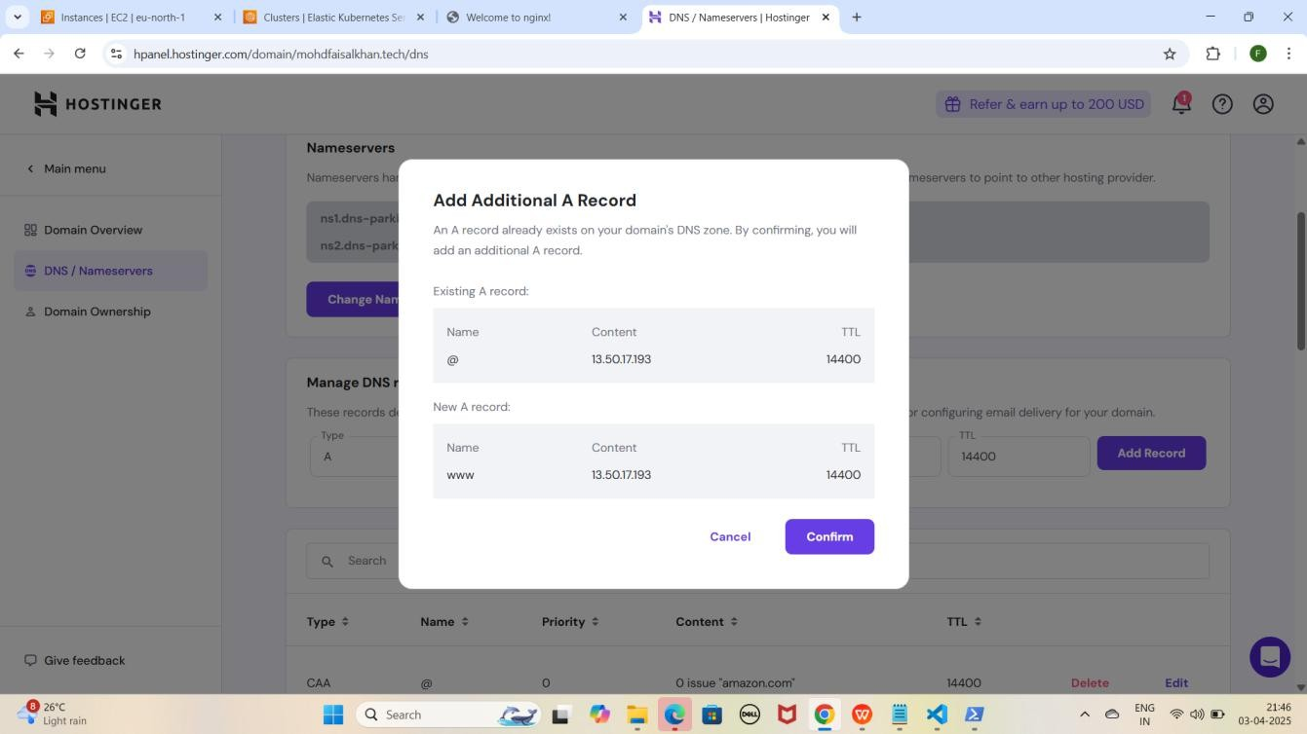

NOTE : Add Additional A Record karke Pop-up ayega Confirm pe click karo.

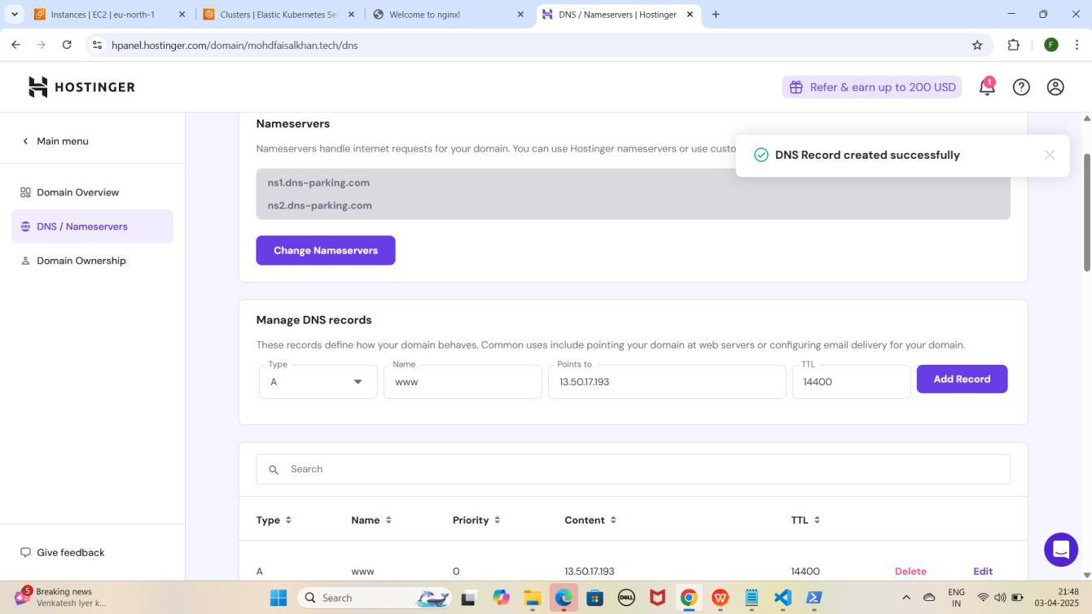

NOTE: Jab tum EKS Node ke liye records add kar loge, toh kuch der baad apni application ko in URLs par access kar paoge. Ye process 15-20 minutes ya usse zyada bhi le sakta hai

### Step 3: Records Add Karne Ke Baad Website Ko Domain Name Ke Through NodePort Se Access Karna

1. **Apni NGINX application ko Domain Name Ke Through NodePort Se Access Karo**
   * **Nginx:** [http://mohdfaisalkhan.tech:30007](k)

YE KUCH ISTARHA LAGEGA

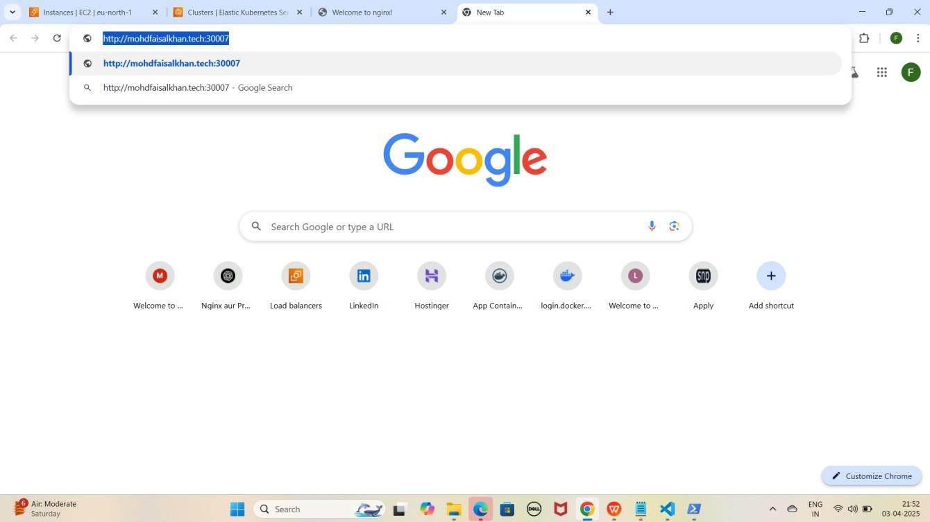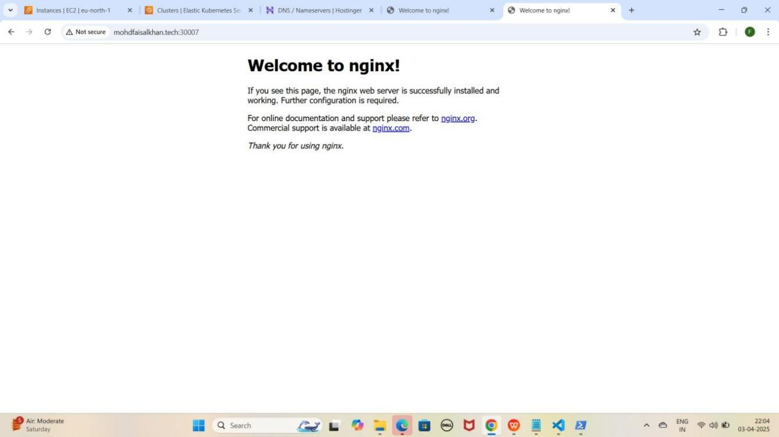

1. **Apni NGINX application ko www wale Domain Name Ke Through NodePort Se Access Karo**
   * **Nginx:** [http://www.mohdfaisalkhan.tech:30007](k)

YE KUCH ISTARHA LAGEGA

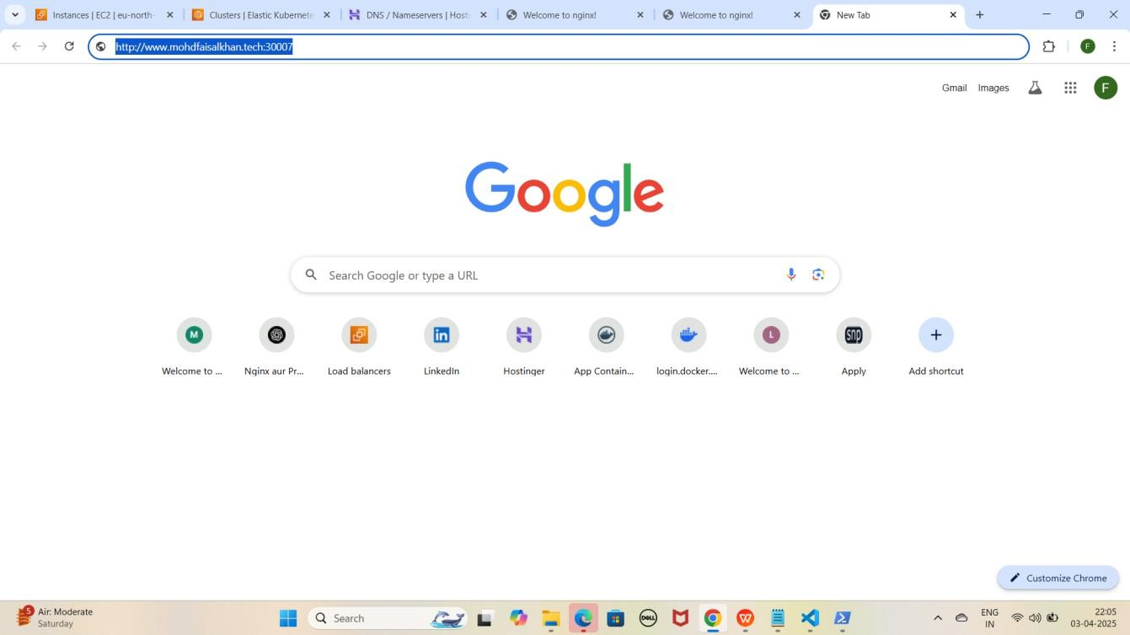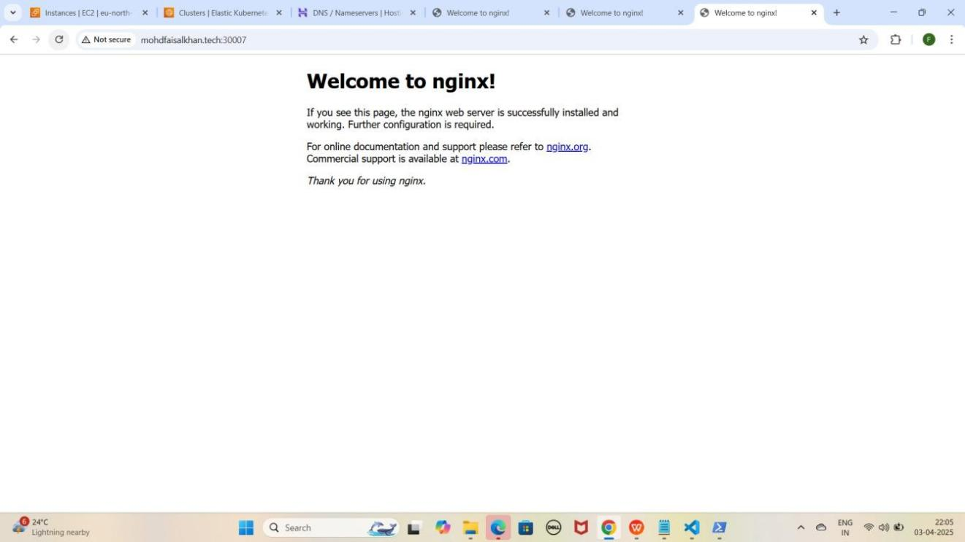

## Part 5: MySQL Secrets and ConfigMap Configuration

### Step 1: mysql-secrets.yaml File Ka Kaam

Ye **file username aur password ko securely store** karne ke liye use hoti hai. Kyunki **Secrets secure hoti hain**, is wajah se hum **Base64 encoding** ka use karke **username aur password** ko **encrypt** kar dete hain.

MYSQL ka username aur password encode karna:-

1. **Windows ke WSL (Windows Subsystem for Linux) ka use kar ke hum Base64 encoding kar sakte hain. wsl type karein aur yeh commands run karein**

wsl

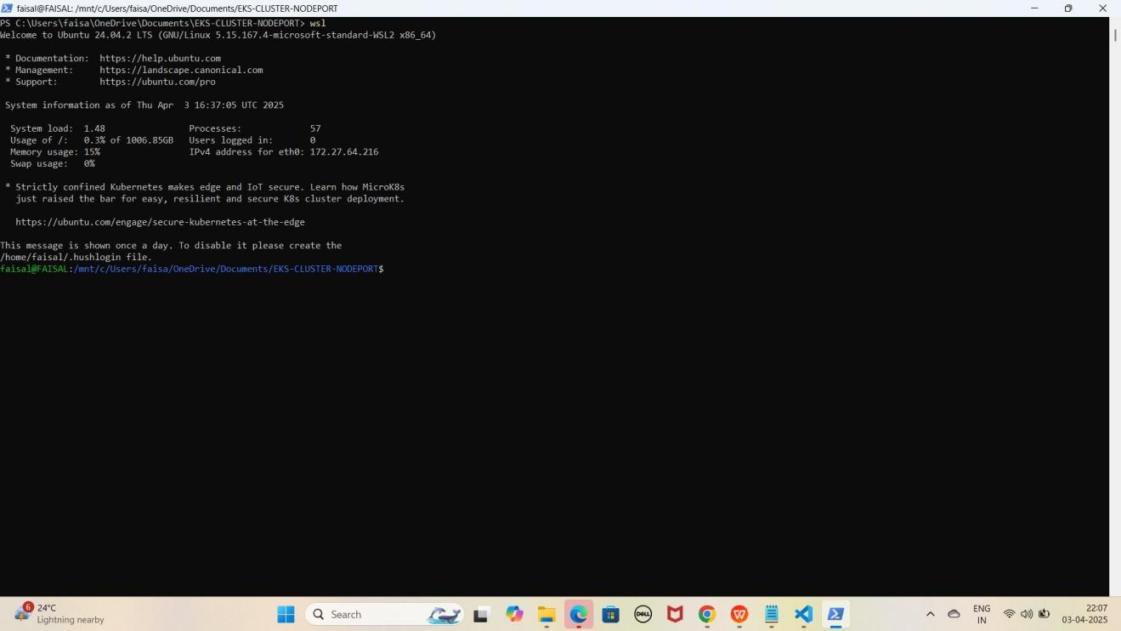YE KUCH ISTARHA LAGEGA

1. **Username encode karein**
   * echo -n Faisal Khan | base64
2. **Password encode karein**
   * echo -n Faisalkhan35@| base64

YE KUCH ISTARHA LAGEGA

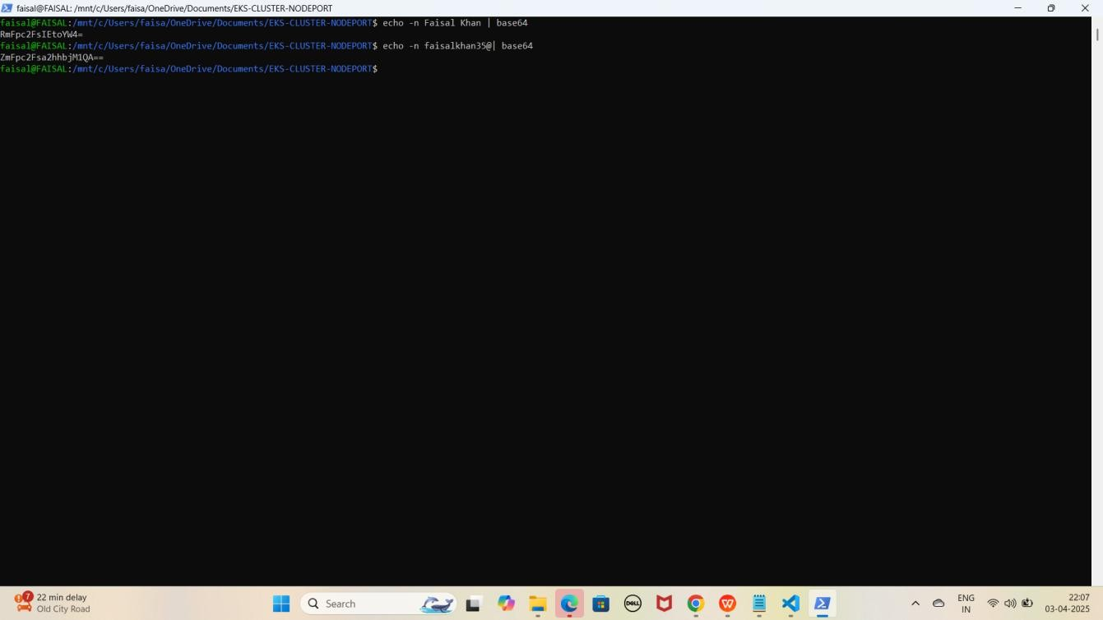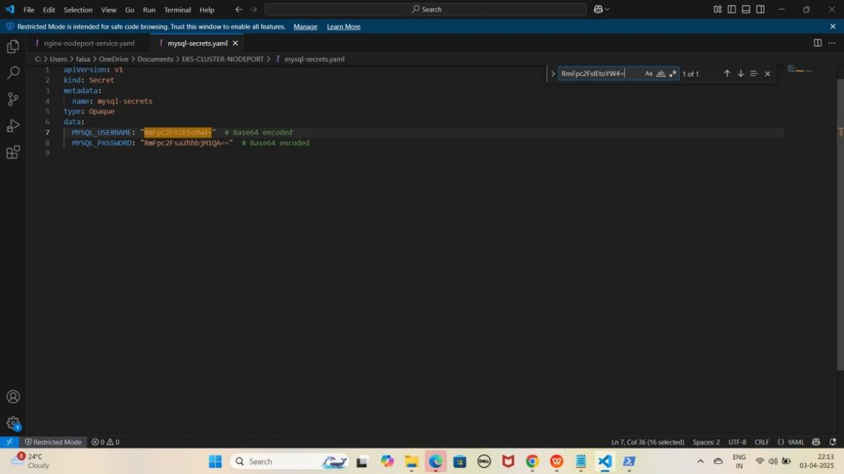

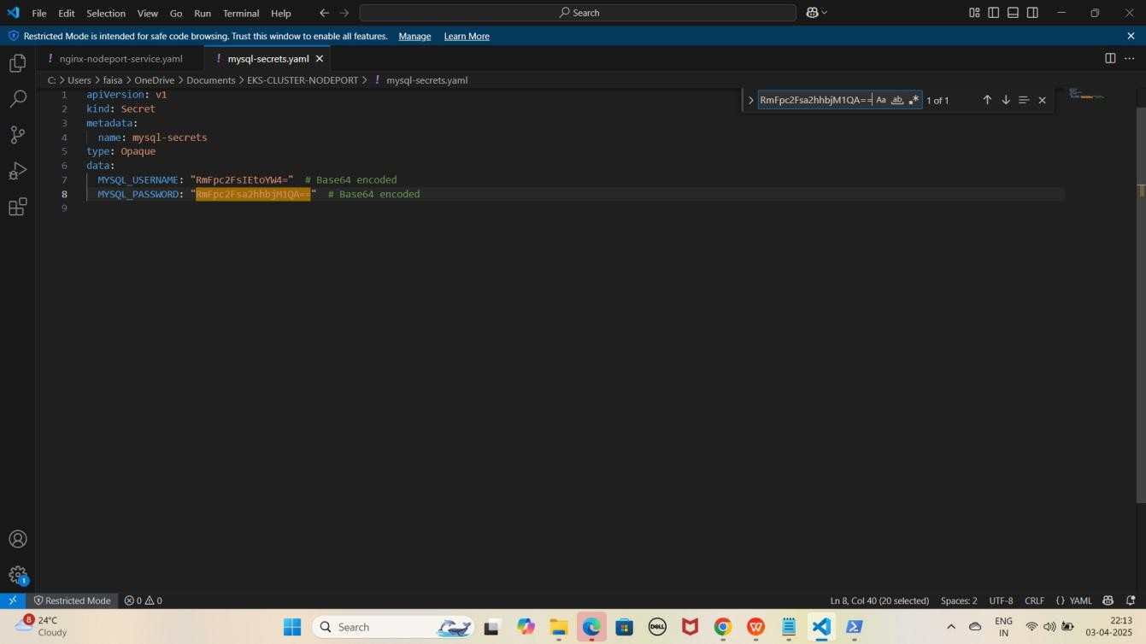

NOTE: Ye command aapko Base64 encoded values degi, jo hum mysql- secrets.yaml file me store karenge. Lekin aapko apne Username aur Password ke hisaab se mysql-secrets.yaml file update karni hogi.

JAISE KI:-

apiVersion: v1 kind: Secret metadata:

name: mysql-secrets type: Opaque

data:

MYSQL_USERNAME: "RmFpc2FsIEtoYW4=" # Base64 encoded MYSQL_PASSWORD: "RmFpc2Fsa2hhbjM1QA==" # Base64 encoded

Agar aap encoded username aur password ko wapas original form me laana chahte hain, toh WSL me yeh commands run karein

1. **Username decode karein**
   * echo -n 'RmFpc2FsIEtoYW4=' | base64 --decode
2. **Password decode karein**
   * echo -n 'RmFpc2Fsa2hhbjM1QA==' | base64 --decode

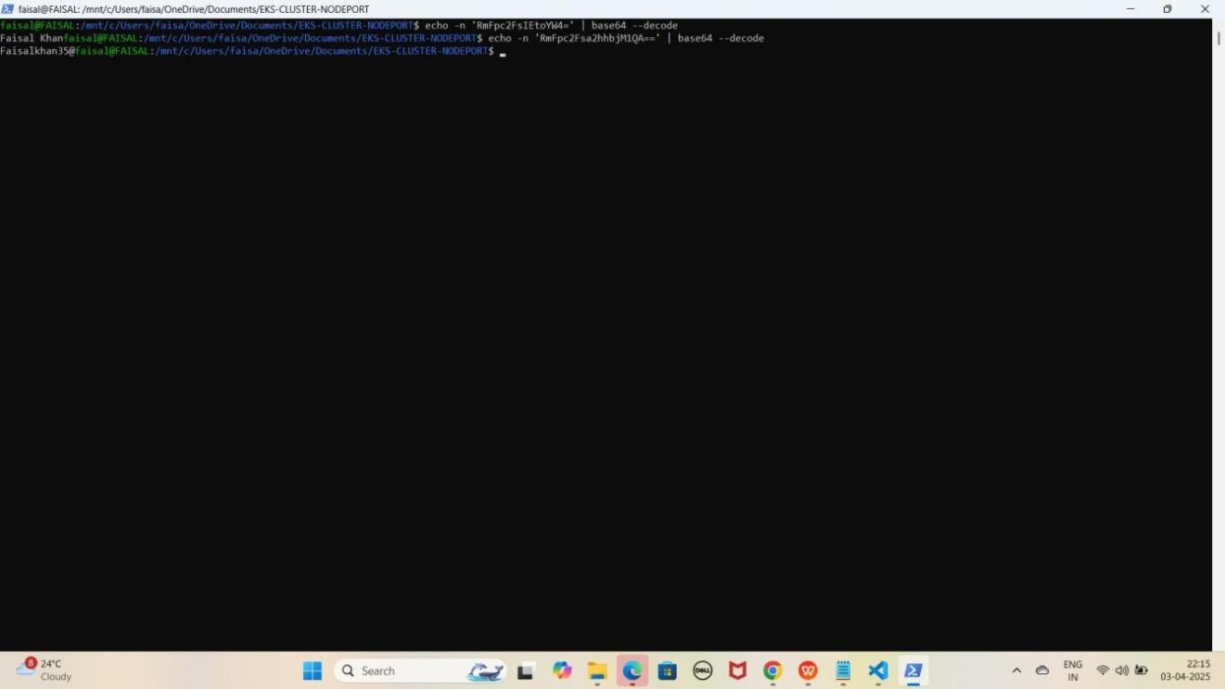YE KUCH ISTARHA LAGEGA

1. **Ab WSL se exit hogao exit hone ke liye exit type karo**

exit

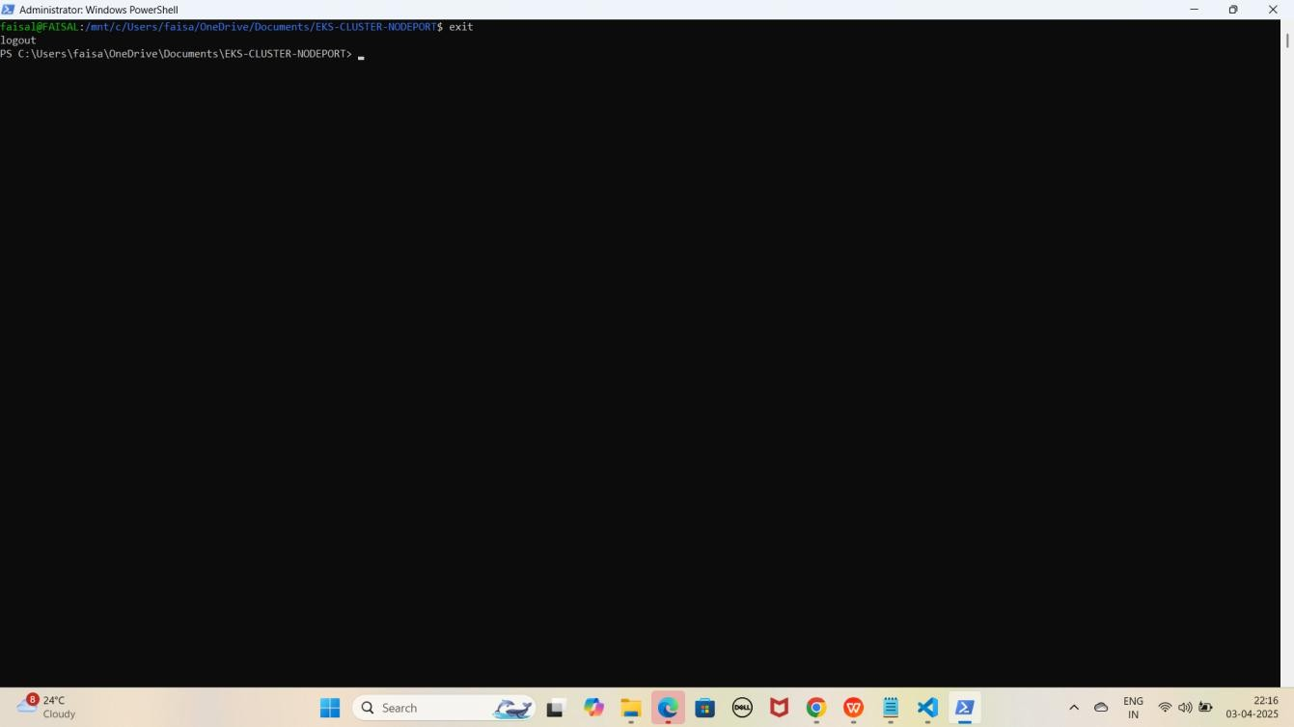YE KUCH ISTARHA LAGEGA

### Secret Apply Karo

kubectl apply -f mysql-secrets.yaml

YE KUCH ISTARHA LAGEGA

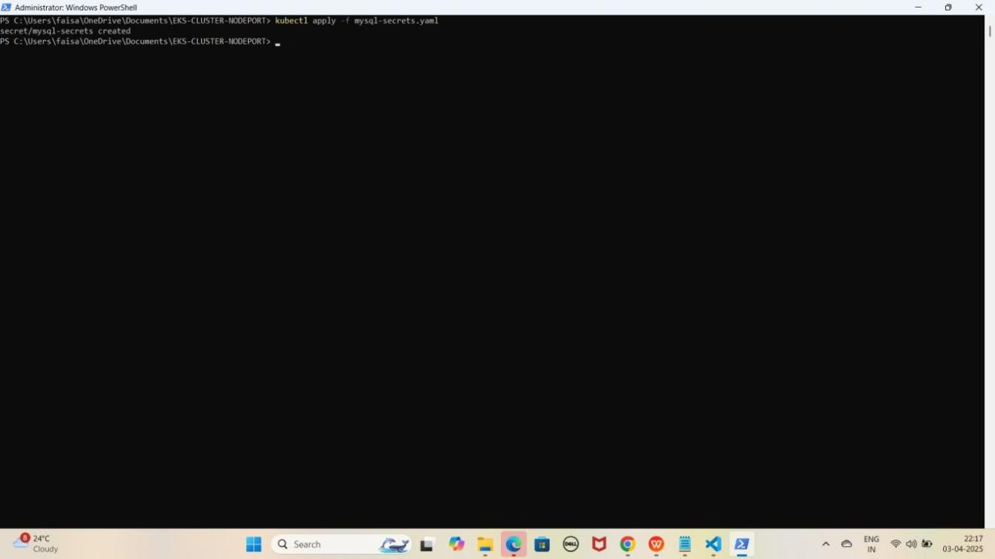

### Step 2: mysql-configmap.yaml File Ka Kaam

Yeh file **non-sensitive data** store karne ke liye use hoti hai, jaise

* **Database ka naam**
* **Host ka naam (hostname)**
* **Port number**

Isko **Kubernetes ConfigMap** ke andar likha jata hai.

JAISE KI:-

apiVersion: v1 kind: ConfigMap metadata:

name: mysql-configmap data:

MYSQL_DATABASE: "faisal-db" MYSQL_HOST: "mysql-headless-service" MYSQL_PORT: "3306"

### ConfigMap Apply Karo

kubectl apply -f mysql-configmap.yaml

YE KUCH ISTARHA LAGEGA

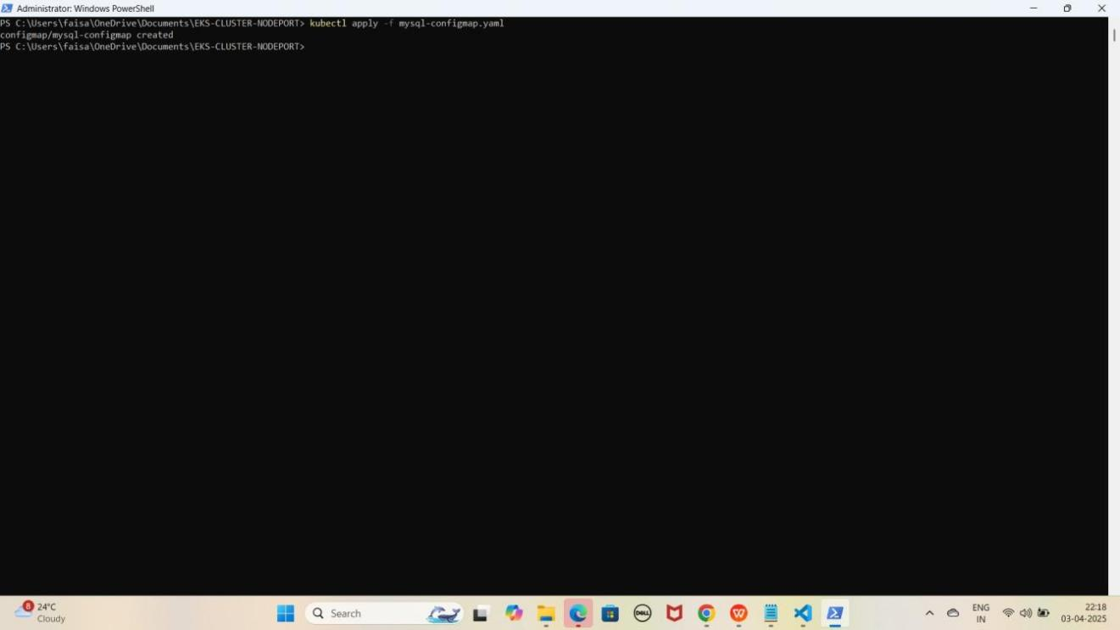

### Step 3: service-account.yaml File Ka Kaam

Yeh **file Secrets aur ConfigMaps** ko access karne ke liye **permissions** dene ke liye use hoti hai. Isko **Kubernetes Service Account** banane ke liye likha jata hai.

JAISE KI:-

apiVersion: v1 kind: ServiceAccount metadata:

name: service-account

### Service Account Apply Karo

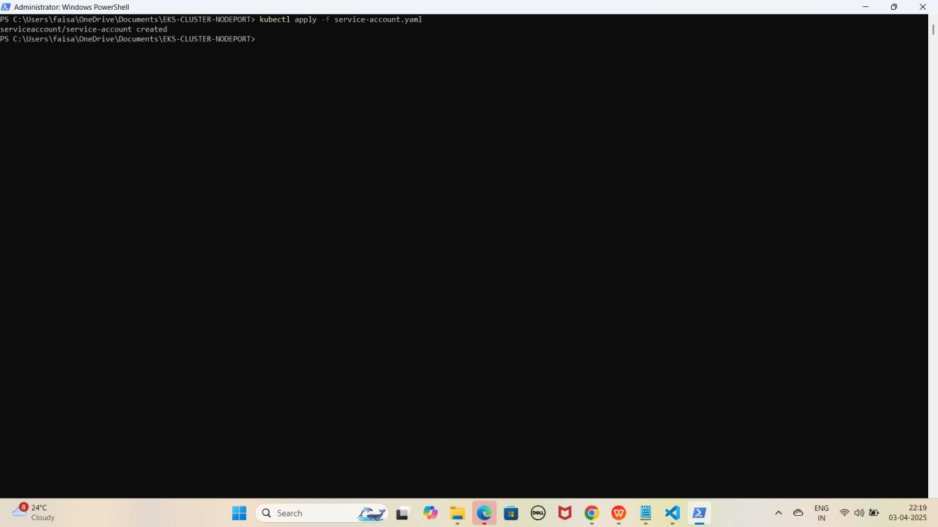kubectl apply -f service-account.yaml YE KUCH ISTARHA LAGEGA

### Step 4: role.yaml File Ka Kaam

Yeh **file Secrets aur ConfigMaps** ke liye **read-only permissions** define karne ke liye use hoti hai. Isko **Kubernetes Role** banane ke liye likha jata hai.

JAISE KI:-

apiVersion: rbac.authorization.k8s.io/v1 kind: Role

metadata:

name: read-role rules:

* apiGroups: [""]

resources: ["secrets", "configmaps"] verbs: ["get", "list"]

* apiGroups: [""] resources: ["pods"] verbs: ["get", "list"]
* apiGroups: [""] resources: ["events"] verbs: ["get", "list"]
* apiGroups: [""] resources: ["endpoints"] verbs: ["get", "list"]

### Role Apply Karo

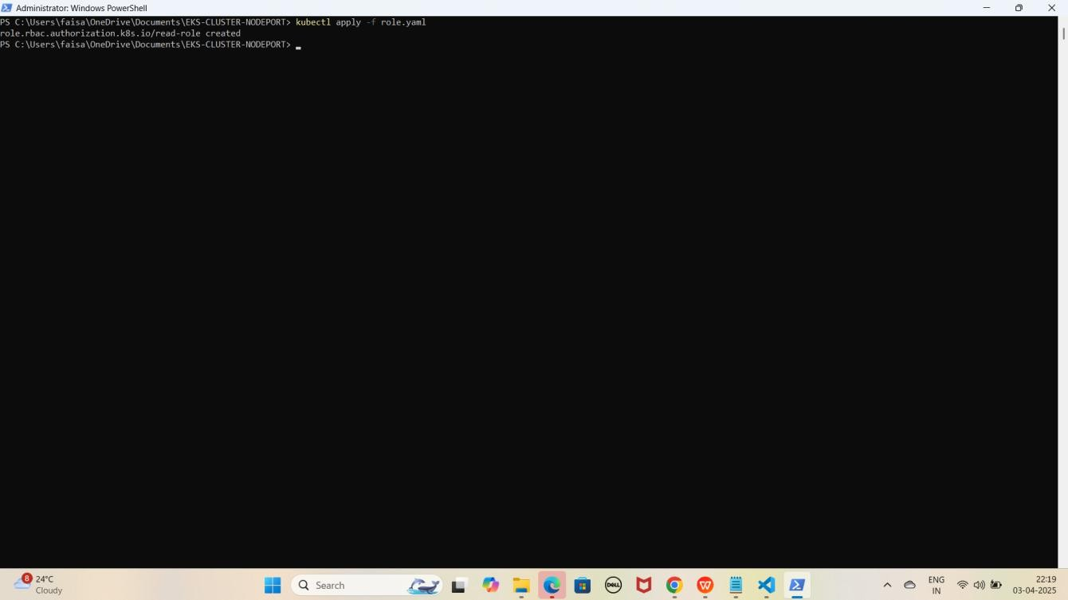kubectl apply -f role.yaml YE KUCH ISTARHA LAGEGA

### Step 5: rolebinding.yaml File Ka Kaam

Yeh file **Service Account** ko **Secrets aur ConfigMaps** ke liye **read-only permissions assign** karne ke liye use hoti hai. Isko **Kubernetes RoleBinding** banane ke liye likha jata hai.

JAISE KI:-

apiVersion: rbac.authorization.k8s.io/v1 kind: RoleBinding

metadata:

name: read-write-only-binding subjects:

- kind: ServiceAccount name: service-account namespace: default

roleRef:

kind: Role name: read-role

apiGroup: rbac.authorization.k8s.io

### RoleBinding Apply Karo

kubectl apply -f rolebinding.yaml

YE KUCH ISTARHA LAGEGA

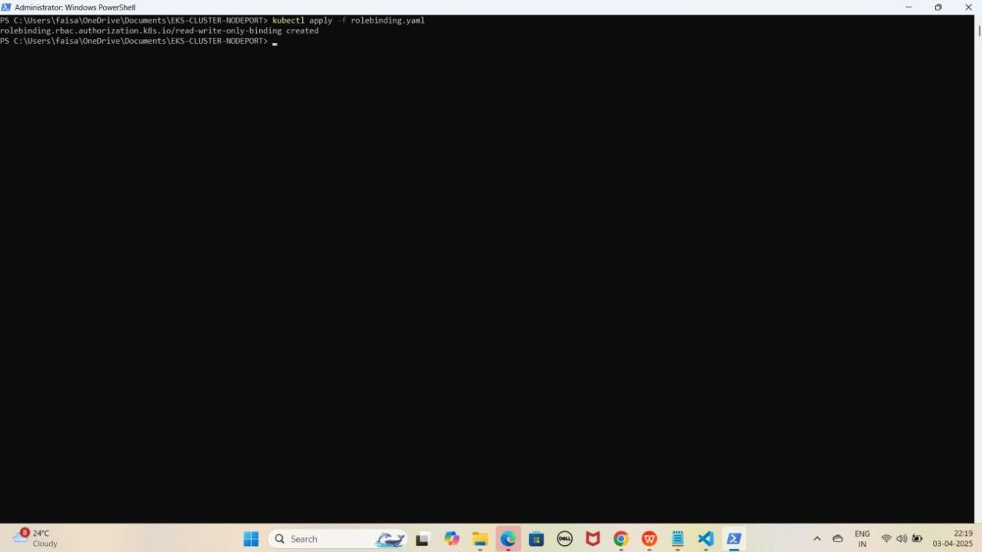

## Part 6: MYSQL Database Pods and Services Deployment

### Step 1: mysql-headless-service.yaml File Ka Kaam

Yeh **file MySQL pods** ke beech **data synchronization** aur **sharing** ke liye use hoti hai. Isko **Kubernetes Headless Service** ke taur par define kiya jata hai.

JAISE KI:-

apiVersion: v1 kind: Service metadata:

name: mysql-headless-service spec:

clusterIP: None # Makes it a headless service selector:

app: mysql ports:

- name: mysql port: 3306

targetPort: 3306

### Headless Service Apply Karo

kubectl apply -f mysql-headless-service.yaml

YE KUCH ISTARHA LAGEGA

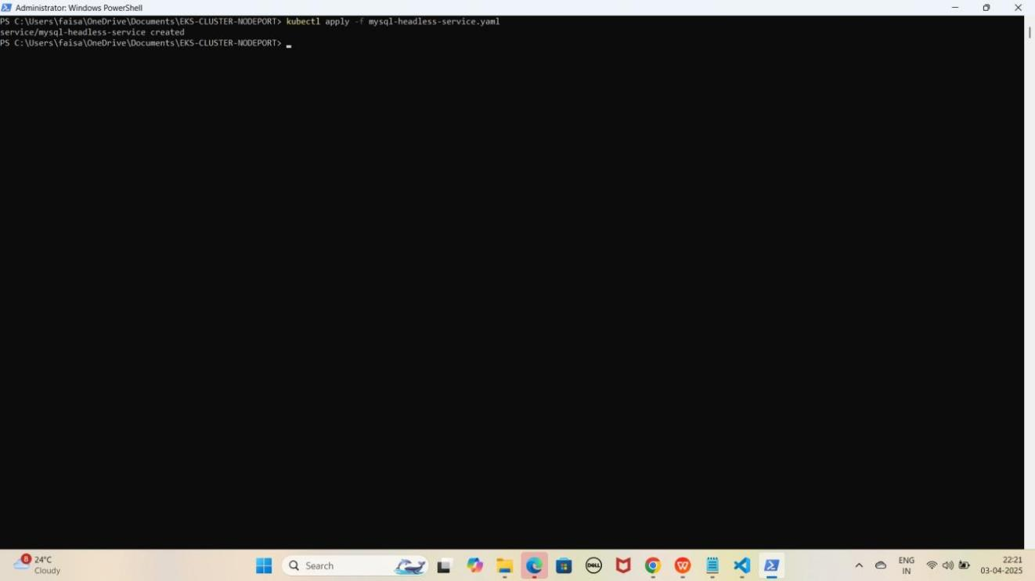

### Step 2: mysql-pv.yaml File Ka Kaam

Yeh **file cluster** mein ek **static volume** banane ke liye use hoti hai. Isko **Kubernetes** Persistent Volume (PV) create karne ke liye likha jata hai. Hum **3 PV** create karenge kyunki next step mein **StatefulSet 3 database pods** banayega, jinko **storage** ki zaroorat hogi.

JAISE KI:-

apiVersion: v1

kind: PersistentVolume metadata:

name: mysql-pv spec:

capacity:

storage: 5Gi accessModes:

- ReadWriteOnce persistentVolumeReclaimPolicy: Retain hostPath:

path: "/mnt/mysql-data"

apiVersion: v1

kind: PersistentVolume metadata:

name: mysql-pv-2

spec:

capacity:

storage: 5Gi accessModes:

- ReadWriteOnce persistentVolumeReclaimPolicy: Retain hostPath:

path: /mnt/data/mysql2

apiVersion: v1

kind: PersistentVolume metadata:

name: mysql-pv-3 spec:

capacity:

storage: 5Gi accessModes:

- ReadWriteOnce persistentVolumeReclaimPolicy: Retain hostPath:

path: /mnt/data/mysql-3

**Persistent Volumes Apply Karo** kubectl apply -f mysql-pv.yaml kubectl apply -f mysql-pv-2.yaml kubectl apply -f mysql-pv-3.yaml

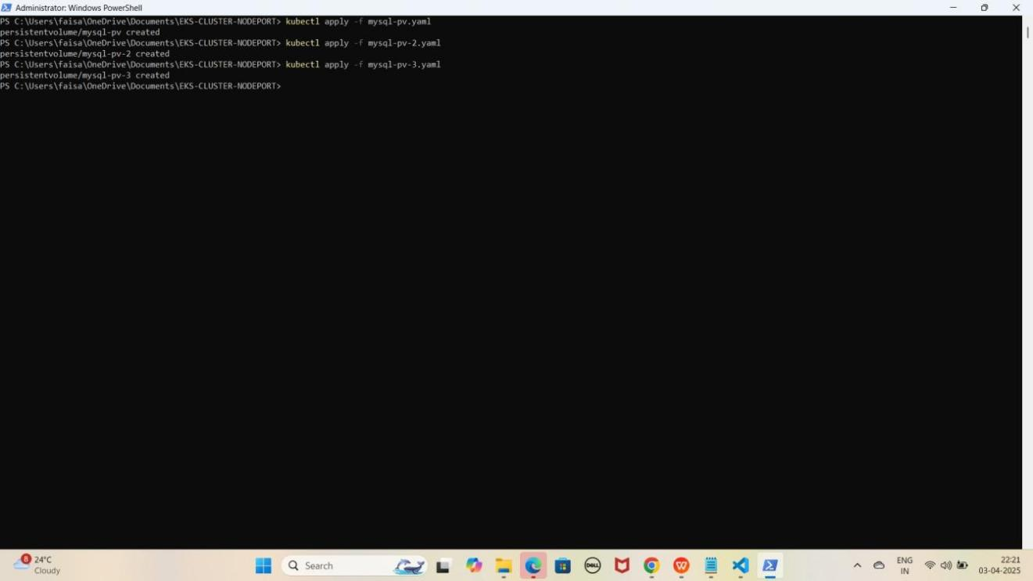YE KUCH ISTARHA LAGEGA

### Step 3: mysql-statefulset.yaml File Ka Kaam

Yeh **file database** ke liye use hoti hai jisme hum **MySQL ke 3 replicas** define karte hain. Isme **Persistent Volume Claim (PVC)** use hoti hai jo **StatefulSet** ke **deployments** ko **Persistent Volume (PV)** se connect karti hai.

JAISE KI:-

apiVersion: apps/v1 kind: StatefulSet metadata:

name: mysql spec:

serviceName: "mysql-headless-service" # Links to the headless service replicas: 3 # Number of MySQL replicas

selector:

matchLabels:

app: mysql template:

metadata:

labels:

app: mysql spec:

containers:

* name: mysql

image: mysql:8.0 # MySQL 8.0 image ports:

* + containerPort: 3306 env:
  + name: MYSQL_ROOT_PASSWORD

valueFrom: secretKeyRef:

name: mysql-secrets key: MYSQL_PASSWORD

volumeMounts:

* + name: mysql-data mountPath: /var/lib/mysql

volumeClaimTemplates:

- metadata:

name: mysql-data spec:

accessModes:

- ReadWriteOnce resources:

requests: storage: 5Gi

### StatefulSet Apply Karo

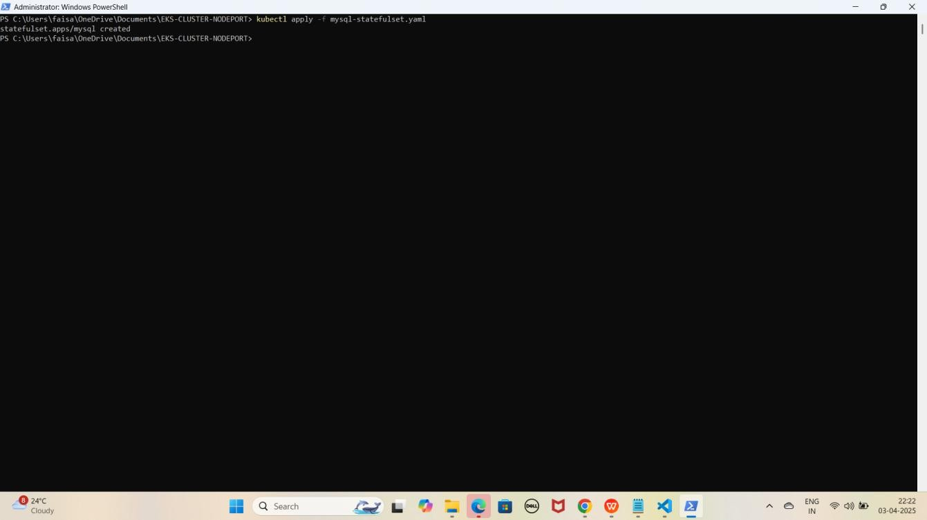kubectl apply -f mysql-statefulset.yaml YE KUCH ISTARHA LAGEGA

1. **Pods check karne ke liye ye command run kariye**

kubectl get pods

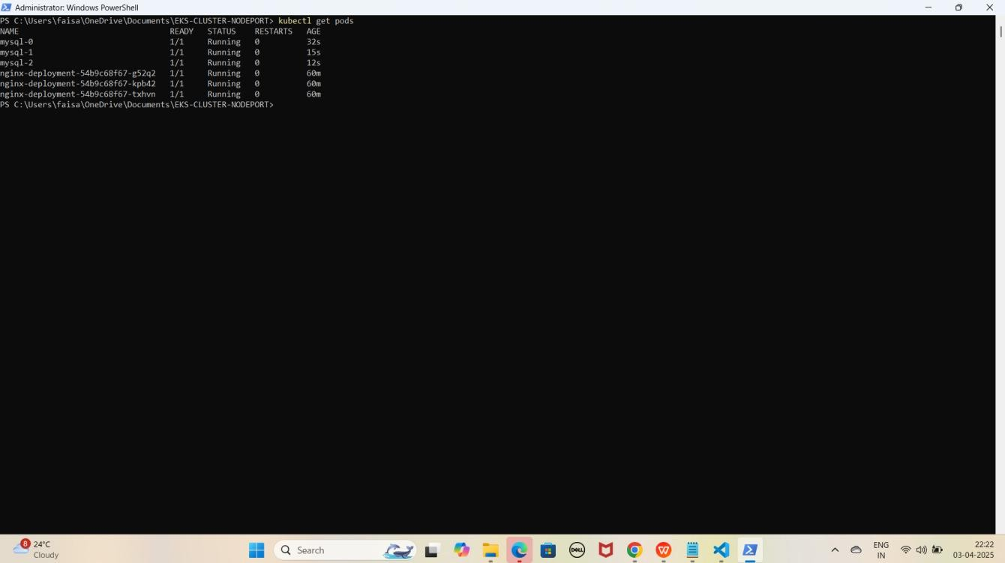YE KUCH ISTARHA LAGEGA

NOTE: Agar sabhi Pods ka STATUS Running show karraha hai to sab kuch sahi hai

1. **Serives check karne ke liye ye commad run kariye**

kubectl get services

YE KUCH ISTARHA LAGEGA

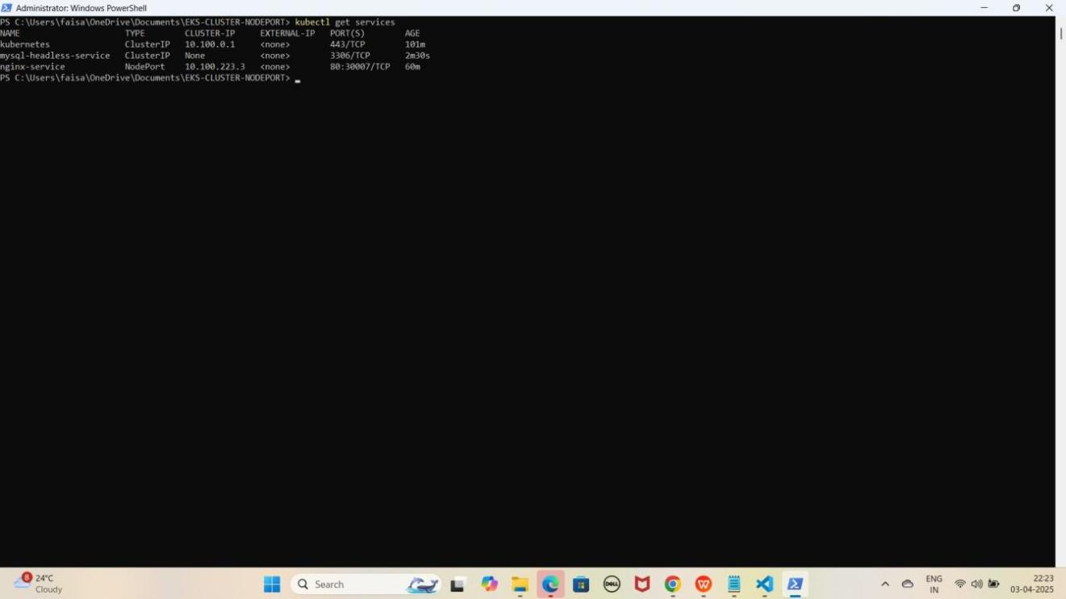

## Part 7: Accessing MySQL Database in EKS Cluster

### Step 1: MySQL Database Access Karo

1. **Pod ke andar jane ke liye ye command run karo**

kubectl exec -it mysql-0 -- /bin/bash

YE KUCH ISTARHA LAGEGA

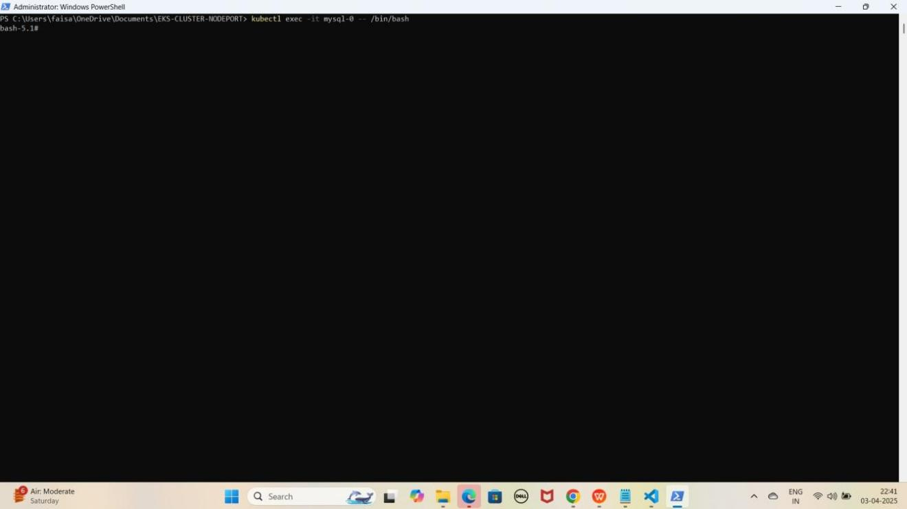

1. **MySQL database se connect karne ke liye ye command kuch istarha hogi**

mysql -u root -p

YE KUCH ISTARHA LAGEGA

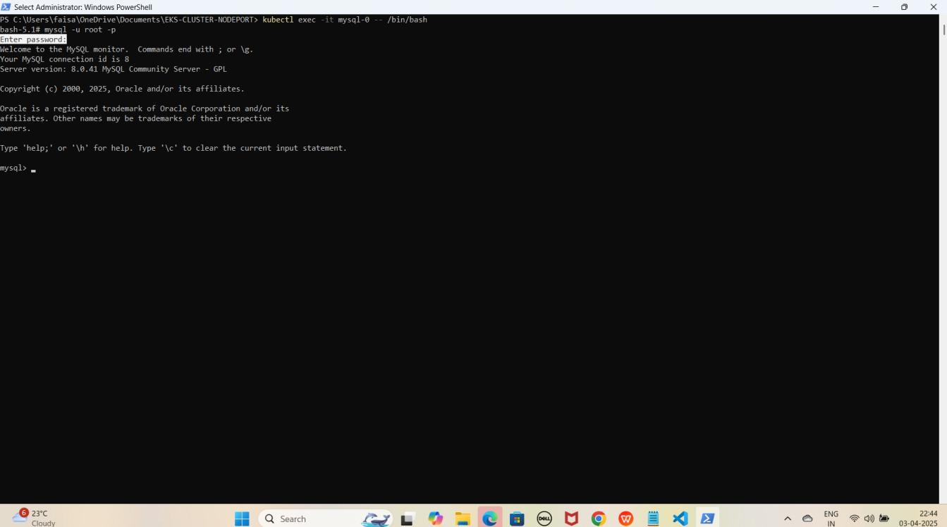

Note: Jab aap se password maanga jaaye, to wahi password use karein jo pehle Base64 encode karke mysql-secrets.yaml file me store kiya gaya tha. Maine ‘Faisalkhan35@’ diya tha, lekin password enter karte waqt yeh screen par show nahi hoga.

1. **Database create karne keliye ye command run karo**

CREATE DATABASE faisal_db; YE KUCH ISTARHA LAGEGA

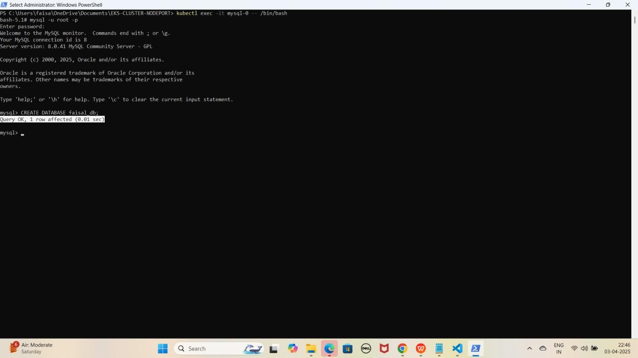

1. **Databases check karne ke liye ye command run kariye**

SHOW DATABASES;

YE KUCH ISTARHA LAGEGA

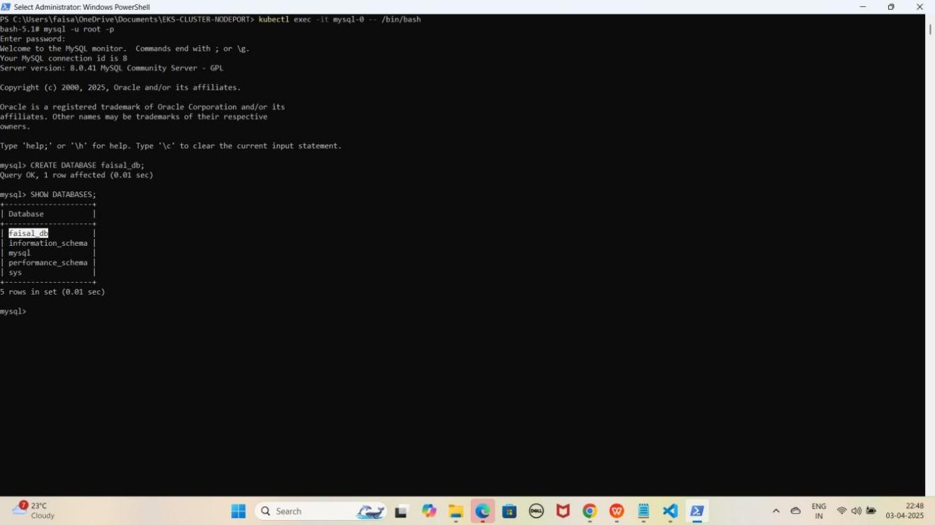

1. **Ab MYSQL database se exit hoagaye exit hone ke liye exit type kariye**

exit

YE KUCH ISTARHA LAGEGA

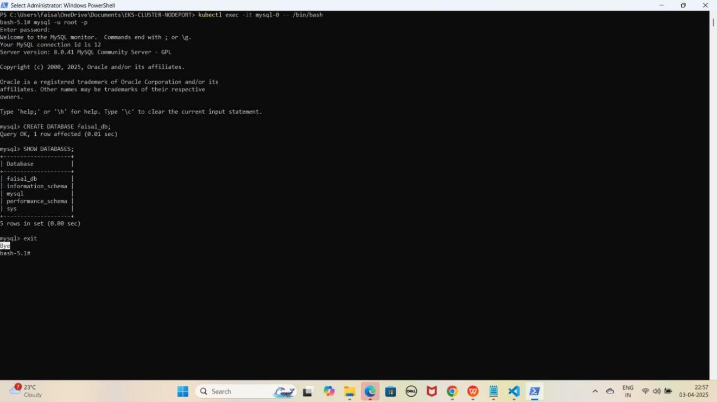

1. **Ab MYSQL database Pod se bhi exit hoagaye exit hone ke liye exit type kariye**

exit

YE KUCH ISTARHA LAGEGA

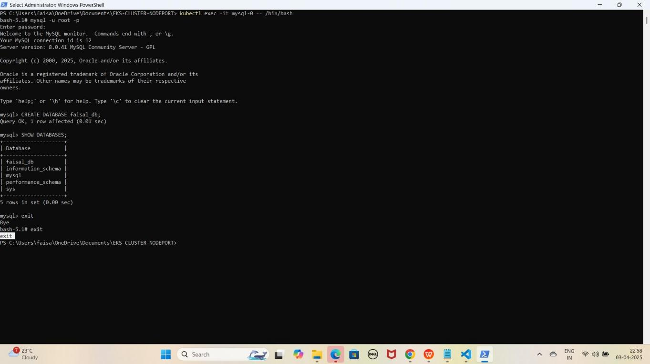

NOTE : Aapko faisal_db naam ka database dikhega, aur isi tarah aap mysql-1 aur mysql-2 ke liye bhi access kar sakte hain.

## Part 8: Monitoring Using Prometheus and Loki With Grafana

Kubernetes me ek naya namespace 'monitoring' create karna hoga.

Namespace create karne ke liye ye command run kariye

kubectl create namespace monitoring

YE KUCH ISTARHA LAGEGA

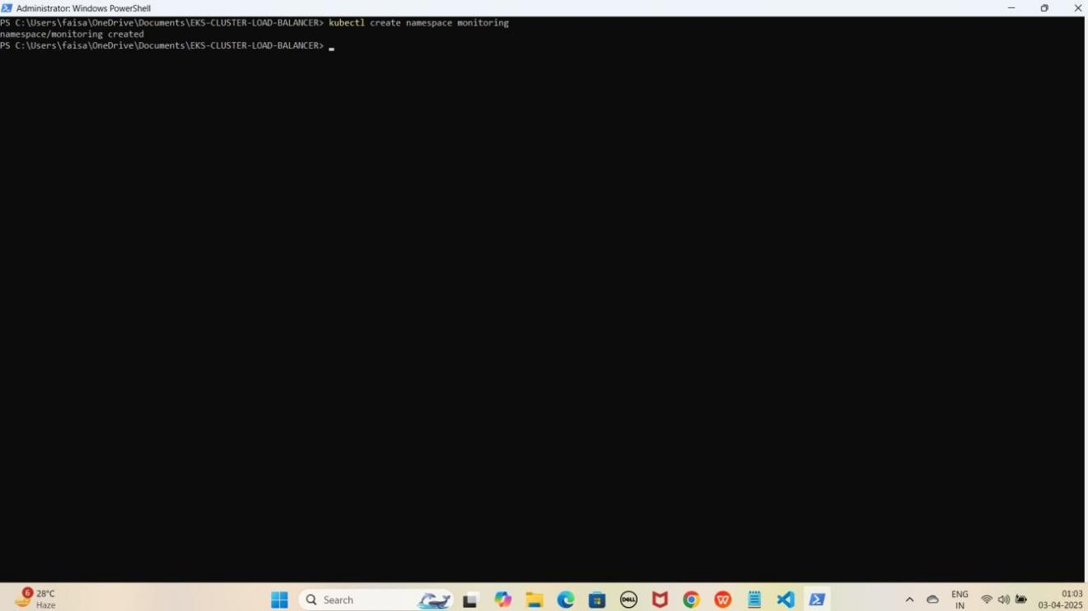

### Step 1: prometheus-daemonset.yaml File Ka Kaam

Yeh **file Prometheus monitoring tool deploy** karne ke liye use hoti hai. Isko **cluster ka CPU usage, memory, aur network monitor** karne ke liye **Kubernetes DaemonSet** ke andar likha jata hai.

JAISE KI:-

apiVersion: apps/v1 kind: DaemonSet metadata:

name: prometheus namespace: monitoring

spec:

selector:

matchLabels:

app: prometheus template:

metadata:

labels:

app: prometheus spec:

containers:

* name: prometheus

image: prom/prometheus:v2.31.1 args:

* + "--config.file=/etc/prometheus/prometheus.yml"
  + "--storage.tsdb.path=/prometheus"
  + "--web.enable-lifecycle" volumeMounts:
  + name: prometheus-config mountPath: /etc/prometheus
  + name: prometheus-storage mountPath: /prometheus

volumes:

* name: prometheus-config configMap:

name: prometheus-config

* name: prometheus-storage emptyDir: {}

---

apiVersion: v1 kind: ConfigMap metadata:

name: prometheus-config namespace: monitoring

data:

prometheus.yml: | global:

scrape_interval: 15s # Default scrape interval for all jobs

scrape_configs:

# Kubernetes Nodes Service Discovery for Node Exporters

* job_name: 'kubernetes-nodes' kubernetes_sd_configs:
  + role: node # Specify the role as 'node' relabel_configs:
  + source_labels: [ meta_kubernetes_node_name] # Scrape metrics from nodes target_label: kubernetes_node
  + source_labels: [ meta_kubernetes_node_label_kubernetes_io_hostname] # Include the

node hostname as a label

target_label: kubernetes_hostname

# Kubernetes Pods Service Discovery (for scraping Kubernetes pods)

* job_name: 'kubernetes-pods' kubernetes_sd_configs:
  + role: pod # Scrape all pods (can be further refined with relabeling) relabel_configs:
  + source_labels: [ meta_kubernetes_pod_label_app] # Use pod labels for further

filtering

target_label: app

### Prometheus DaemonSet Apply Karo

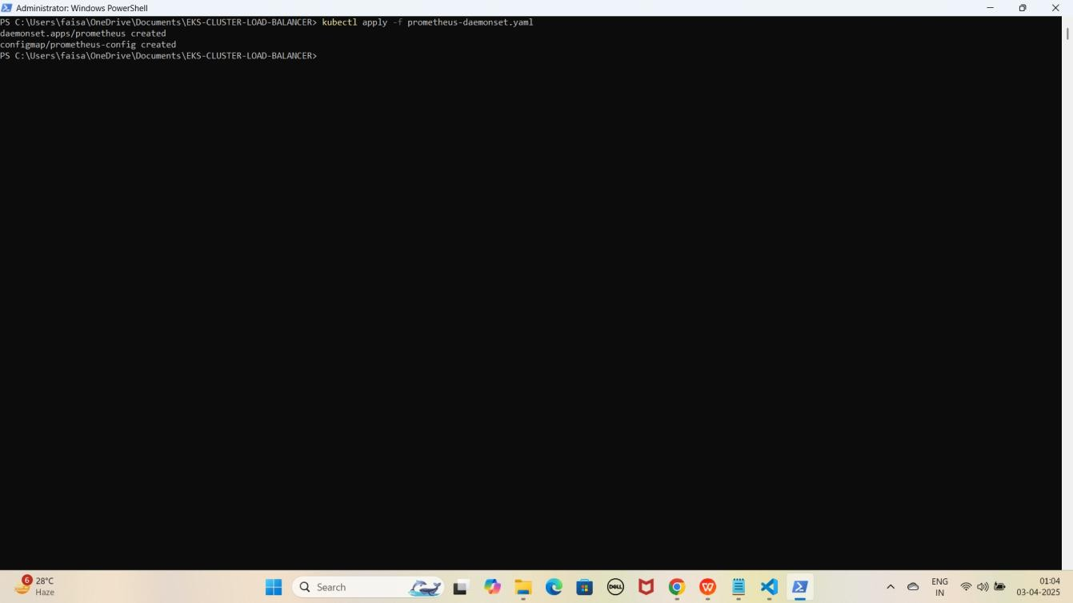kubectl apply -f prometheus-daemonset.yaml YE KUCH ISTARHA LAGEGA

### Step 2: prometheus-rbac.yaml File Ka Kaam

Yeh **file Prometheus** ko required **permissions** dene ke liye use hoti hai, taake woh **cluster** ke **resources** ko **access** kar sake.

JAISE KI:-

apiVersion: rbac.authorization.k8s.io/v1 kind: ClusterRole

metadata:

name: prometheus-scrape-role rules:

* apiGroups: [""]

resources: ["pods", "nodes"]

verbs: ["get", "list", "watch"]

* apiGroups: ["metrics.k8s.io"] resources: ["nodes", "pods"]

verbs: ["get", "list", "watch"]

* apiGroups: ["apps"]

resources: ["deployments", "replicasets", "daemonsets"] verbs: ["get", "list", "watch"]

* apiGroups: ["extensions"] resources: ["ingresses"] verbs: ["get", "list", "watch"]
* apiGroups: [""]

resources: ["services", "endpoints"] verbs: ["get", "list", "watch"]

---

apiVersion: rbac.authorization.k8s.io/v1 kind: ClusterRoleBinding

metadata:

name: prometheus-scrape-role-binding subjects:

* kind: ServiceAccount name: default namespace: monitoring

roleRef:

kind: ClusterRole

name: prometheus-scrape-role apiGroup: rbac.authorization.k8s.io

### Prometheus RBAC Apply Karo

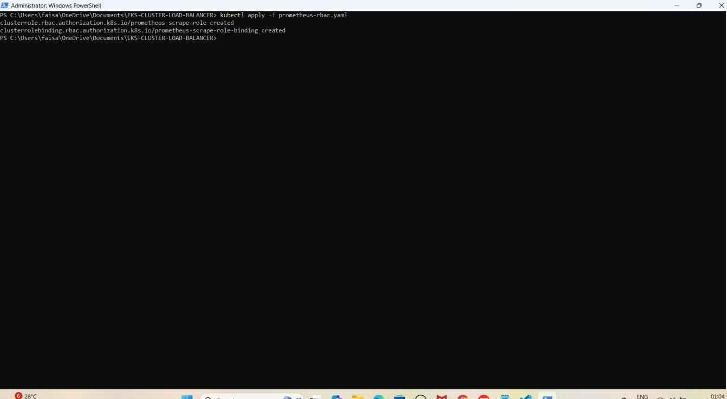kubectl apply -f prometheus-rbac.yaml YE KUCH ISTARHA LAGEGA

### Step 3: prometheus-nodeport-service.yaml File Ka Kaam

Yeh **file Prometheus** ko port **30090** par **NodePort service** ke zariye **expose** karne ke liye use hoti hai, taake hum usko **browser** me **access** kar sakein.

JAISE KI:-

apiVersion: v1 kind: Service metadata:

name: prometheus-server namespace: monitoring

spec:

ports:

- port: 80

targetPort: 9090

nodePort: 30090 selector:

app: prometheus type: NodePort

### Prometheus Service Apply Karo

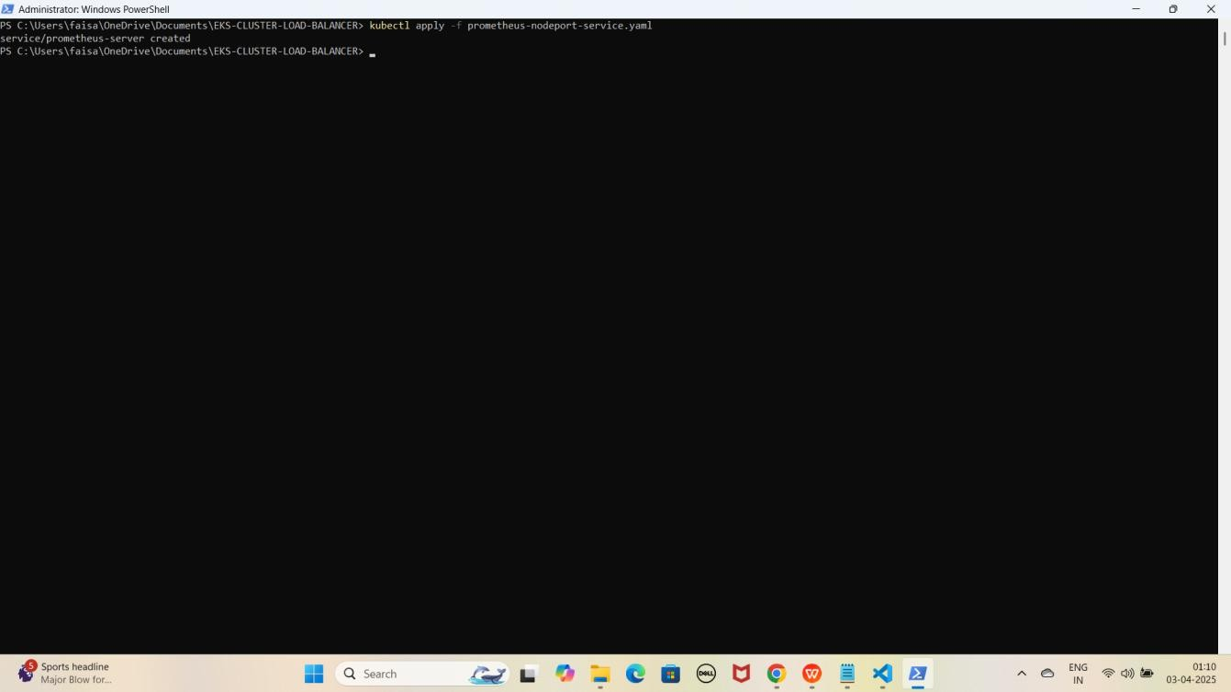kubectl apply -f prometheus-nodeport-service.yaml YE KUCH ISTARHA LAGEGA

1. **Pods check karne ke liye ye command run kariye**

kubectl get pods -n monitoring

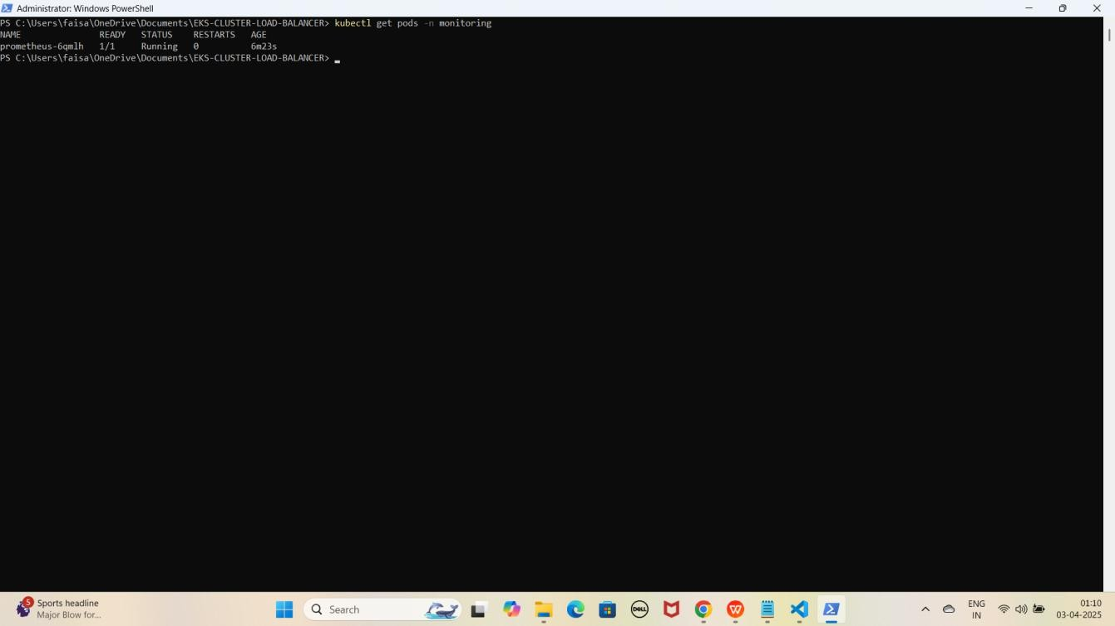YE KUCH ISTARHA LAGEGA

NOTE: Agar STATUS Running show karraha hai to sab kuch sahi hai

1. **Serives check karne ke liye ye commad run kariye**

kubectl get services -n monitoring

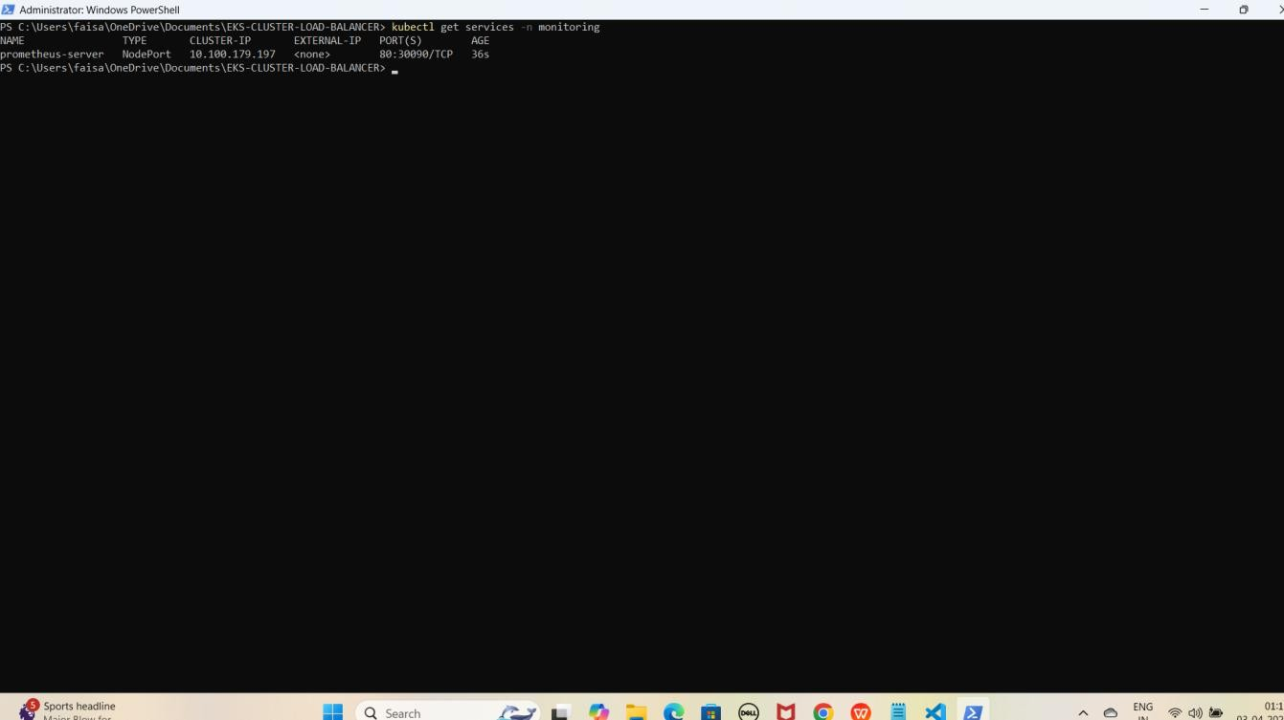YE KUCH ISTARHA LAGEGA

NOTE: Ab aapka Prometheus 30090 port par expose ho chuka hai. Browser me EKS Node ki Public IP ke saath check kariye jaise ki mere case me kuch aisa hoga

**Prometheus:** [http://EKS-Node-Public IP:30090](df)

YE KUCH ISTARHA LAGEGA

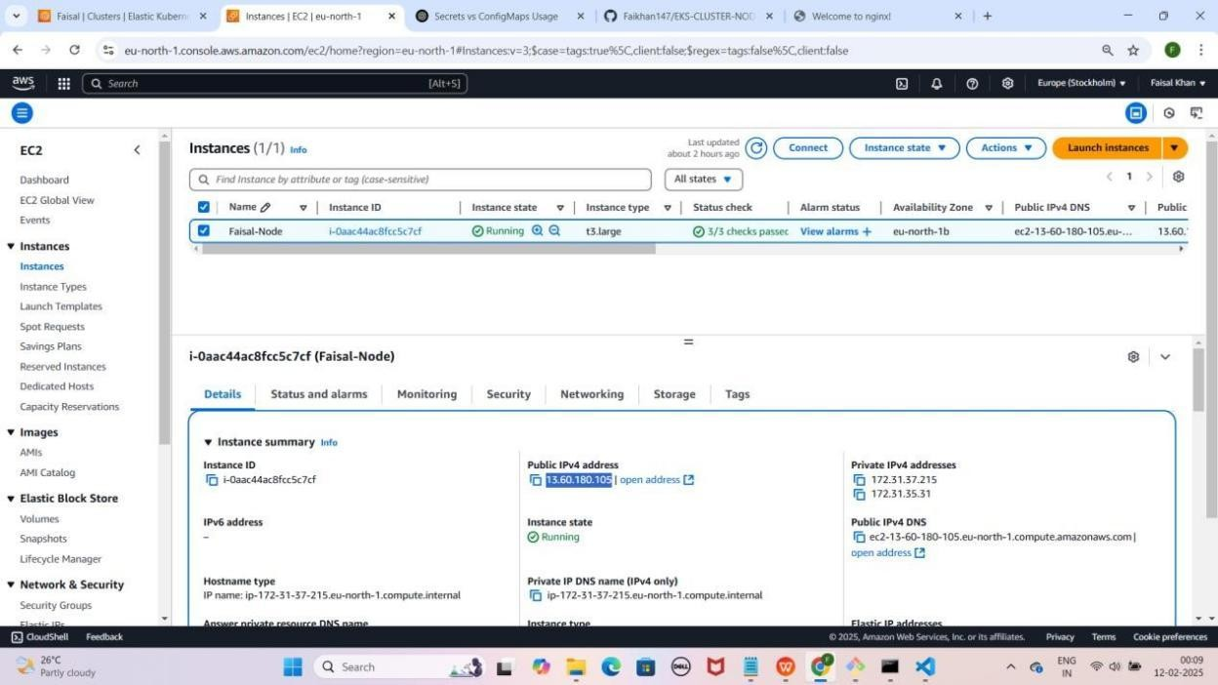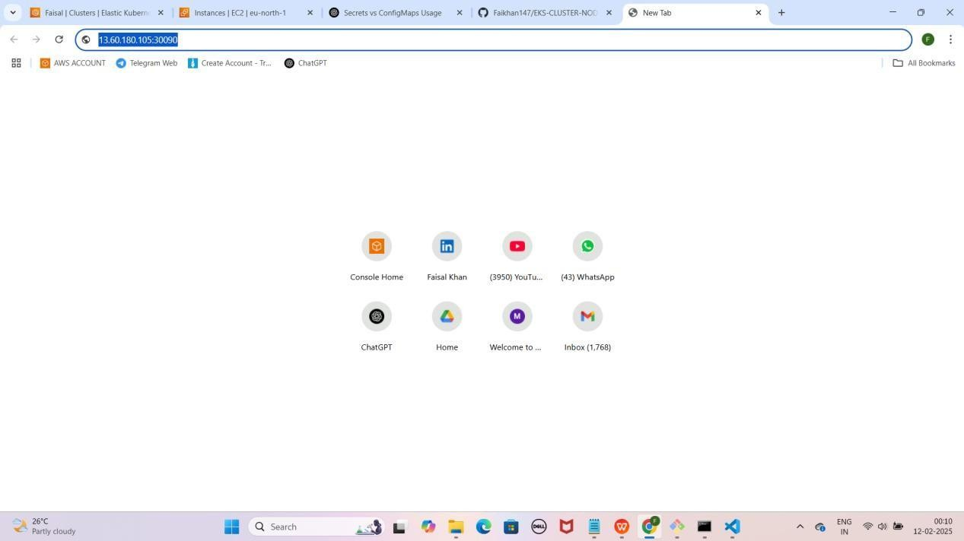

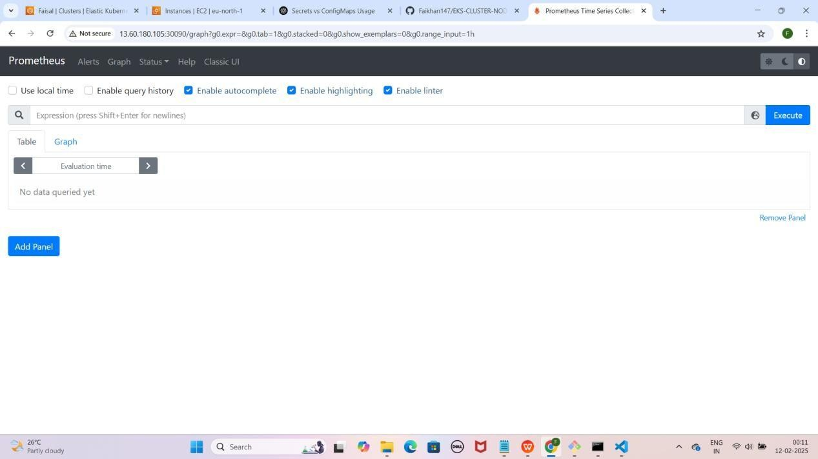

1. **CPU usage check karne ke liye Prometheus me ye command run karein**

rate(process_cpu_seconds_total[30s])

Note: Command Prometheus me paste karne ke baad Execute pe click karein.

YE KUCH ISTARHA LAGEGA

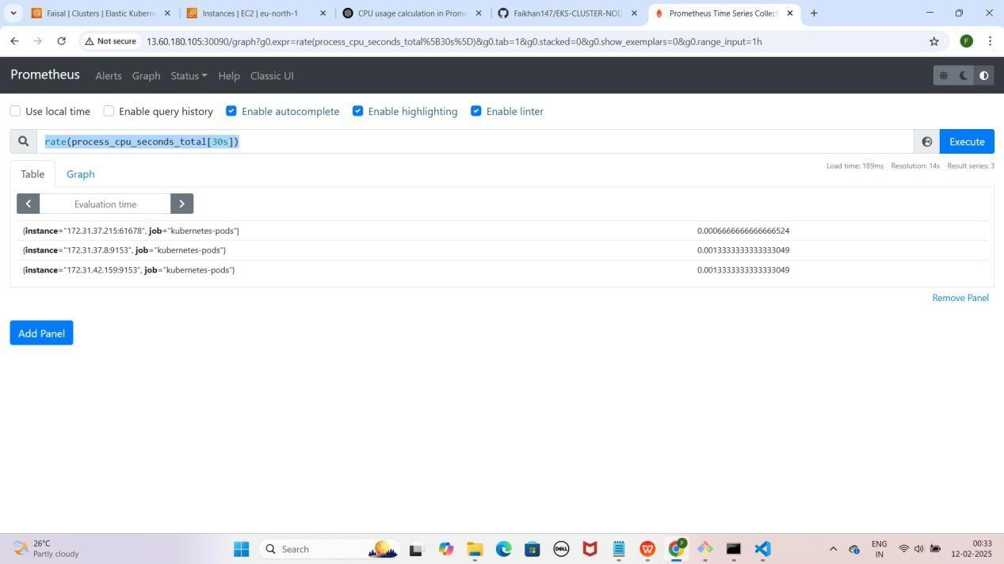

1. **Memory usage check karne ke liye Prometheus me ye command run karein**

process_resident_memory_bytes

Note: Command Prometheus me paste karne ke baad Execute pe click karein.

YE KUCH ISTARHA LAGEGA

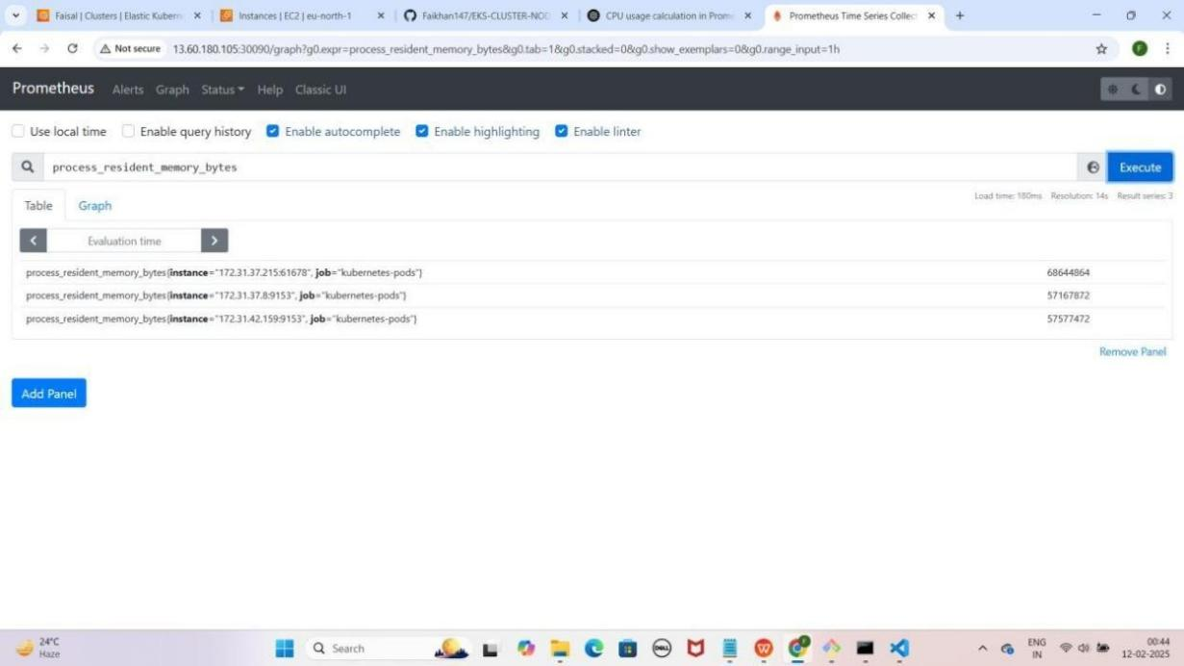

1. **Network Transmit aur Receive Bytes me dekhne ke liye Prometheus me ye commands run karein**
   * **Transmit Bytes:** process_network_transmit_bytes_total
   * **Receive Bytes:** process_network_receive_bytes_total

Note: Command Prometheus me paste karne ke baad Execute pe click karein.

YE KUCH ISTARHA LAGEGA

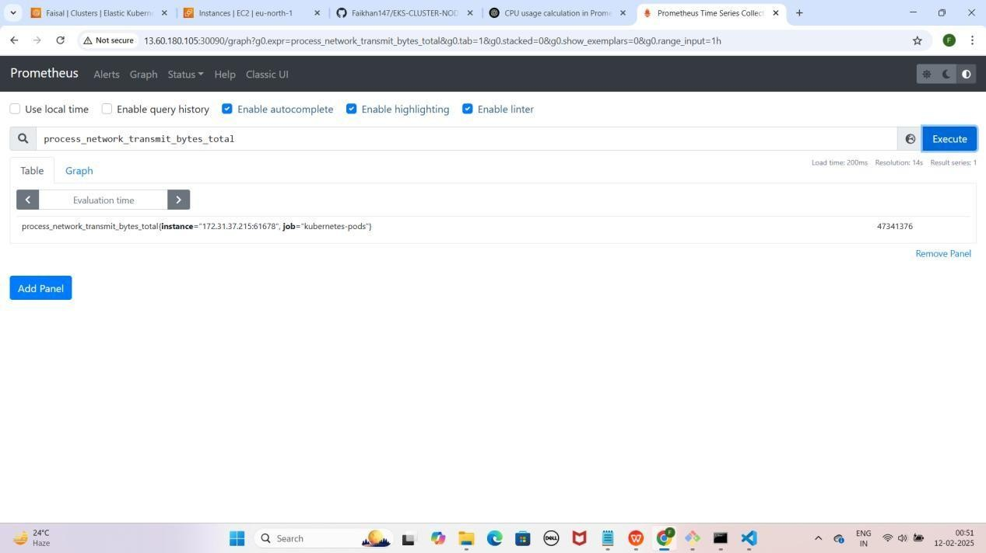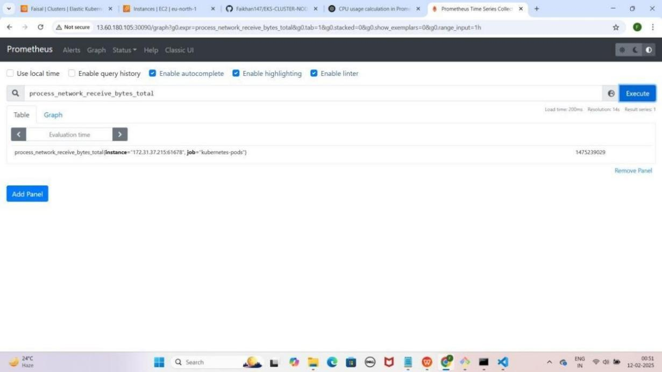

### Step 4: promtail-daemonset.yaml File Ka Kaam

Yeh **file cluster** se **logs collect** karne aur unhe **Loki** par bhejne ke liye use hoti hai.

JAISE KI:-

---

apiVersion: apps/v1 kind: DaemonSet metadata:

name: promtail namespace: monitoring

spec:

selector:

matchLabels:

app: promtail template:

metadata:

labels:

app: promtail spec:

containers:

* name: promtail

image: grafana/promtail:2.3.0 args:

* + "-config.file=/etc/promtail/promtail-config.yaml" volumeMounts:
  + name: promtail-config mountPath: /etc/promtail
  + name: varlogs mountPath: /var/log
  + name: positions mountPath: /run/promtail

resources:

requests:

memory: "128Mi" cpu: "100m"

limits:

memory: "256Mi" cpu: "500m"

readinessProbe:

httpGet:

path: /ready port: 9080

initialDelaySeconds: 5

periodSeconds: 10 livenessProbe:

httpGet:

path: /ready port: 9080

initialDelaySeconds: 10

periodSeconds: 20 securityContext:

runAsUser: 0 # Run as root to allow access to restricted files runAsGroup: 0 # Run as root group

privileged: true # Optional: Uncomment if needed to run in privileged mode volumes:

* name: promtail-config configMap:

name: promtail-config

* name: varlogs hostPath:

path: /var/log

type: DirectoryOrCreate

- name: positions emptyDir: {}

---

apiVersion: v1 kind: ConfigMap metadata:

name: promtail-config namespace: monitoring

data:

promtail-config.yaml: | server:

http_listen_port: 9080

grpc_listen_port: 0

positions:

filename: /run/promtail/positions.yaml

clients:

- url: <http://loki.monitoring.svc.cluster.local:3100/loki/api/v1/push>

scrape_configs:

- job_name: system static_configs:

- targets:

- localhost labels:

job: varlogs

path : /var/log/*.log

- job_name: kubernetes-pods static_configs:

- targets:

- localhost labels:

job: podlogs

path : /var/log/pods/**/*.log

# Additional configurations can be added here if needed

### Promtail DaemonSet Apply Karo

kubectl apply -f promtail-daemonset.yaml

YE KUCH ISTARHA LAGEGA

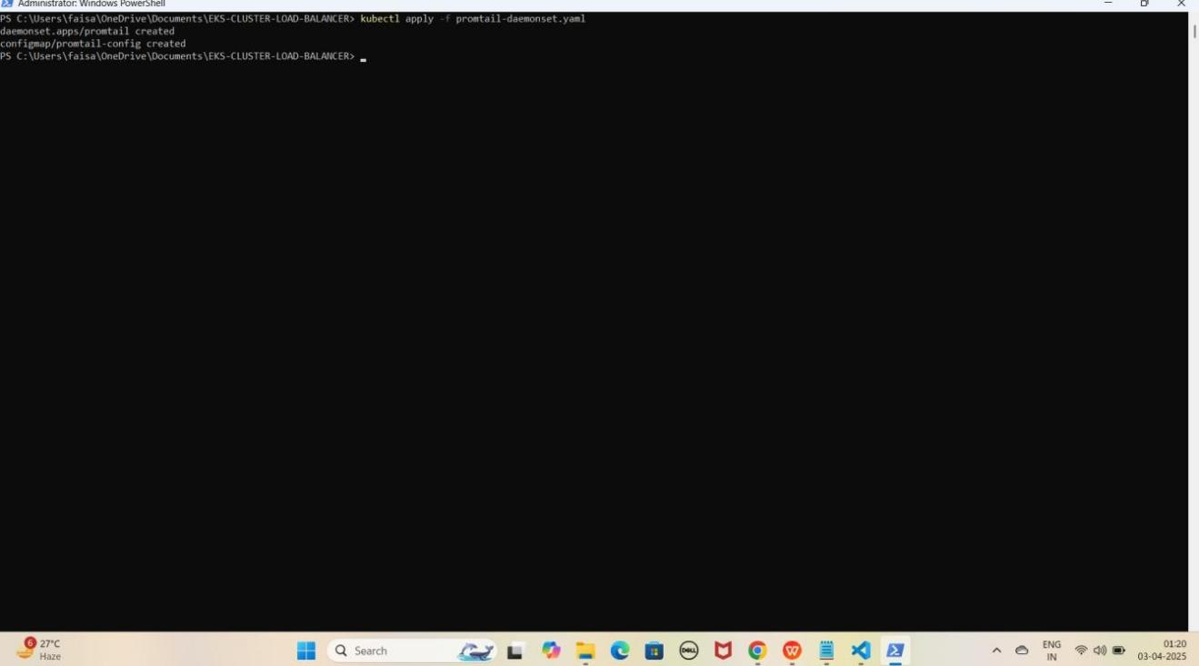

### Step 5: loki-daemonset.yaml File Ka Kaam

Yeh **file Loki** ko ek **logs database** ke taur par **setup** karne ke liye use hoti hai, jo **Promtail** se **logs collect** karke **store** karta hai.

JAISE KI:-

apiVersion: apps/v1 kind: DaemonSet metadata:

name: loki namespace: monitoring

spec:

selector:

matchLabels:

app: loki template:

metadata:

labels:

app: loki spec:

serviceAccountName: loki containers:

* name: loki

image: grafana/loki:2.3.0 args:

* + "-config.file=/etc/loki/loki-config.yaml" ports:
  + containerPort: 3100 name: http

resources:

requests:

cpu: "500m" memory: "512Mi"

limits:

cpu: "1" memory: "1Gi"

volumeMounts:

- name: loki-config

mountPath: /etc/loki/loki-config.yaml subPath: loki-config.yaml

volumes:

- name: loki-config configMap:

name: loki-config items:

- key: loki-config.yaml path: loki-config.yaml

---

apiVersion: v1 kind: ConfigMap metadata:

name: loki-config namespace: monitoring

data:

loki-config.yaml: |

auth_enabled: false # Disable authentication explicitly

server:

http_listen_port: 3100

distributor: ring:

kvstore:

store: inmemory

ingester: lifecycler:

ring:

kvstore:

store: inmemory replication_factor: 1

chunk_idle_period: 5m chunk_retain_period: 30s

max_transfer_retries: 0

schema_config:

configs:

- from: 2020-10-24

store: boltdb-shipper object_store: filesystem schema: v11

index:

prefix: index_ period: 24h

storage_config: boltdb_shipper:

active_index_directory: /loki/index

cache_location: /loki/cache shared_store: filesystem

filesystem:

directory: /loki/chunks

compactor:

working_directory: /loki/compactor shared_store: filesystem compaction_interval: 5m

limits_config: enforce_metric_name: false reject_old_samples: true

reject_old_samples_max_age: 168h

chunk_store_config: max_look_back_period: 0s

table_manager: retention_deletes_enabled: true retention_period: 168h

---

apiVersion: v1 kind: Service metadata:

name: loki namespace: monitoring

spec:

type: ClusterIP ports:

- port: 3100

targetPort: 3100 selector:

app: loki

---

apiVersion: v1 kind: ServiceAccount metadata:

name: loki

namespace: monitoring

### Loki DaemonSet Apply Karo

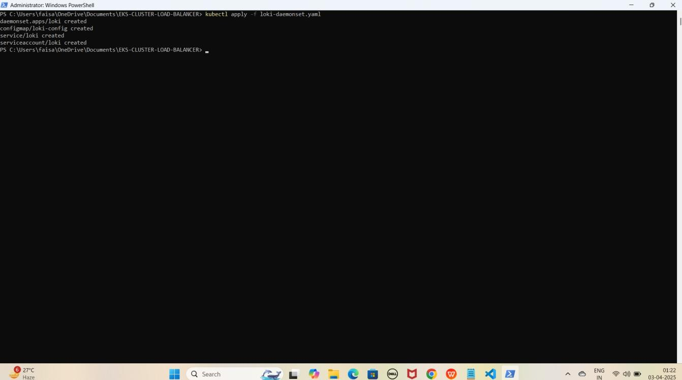kubectl apply -f loki-daemonset.yaml YE KUCH ISTARHA LAGEGA

### Step 6: loki-nodeport-service.yaml File Ka Kaam

Yeh **file Loki** ko **expose** karne ke liye use hoti hai, taake hum **port 30091** ke zariye usko **access** kar sakein. Isko **Kubernetes NodePort Service** ke andar likha jata hai.

JAISE KI:-

apiVersion: v1 kind: Service metadata:

name: loki namespace: monitoring

spec:

ports:

- port: 3100

targetPort: 3100

nodePort: 30091 # This exposes Loki on port 30091 selector:

app: loki type: NodePort

### Loki Service Apply Karo

kubectl apply -f loki-nodeport-service.yaml

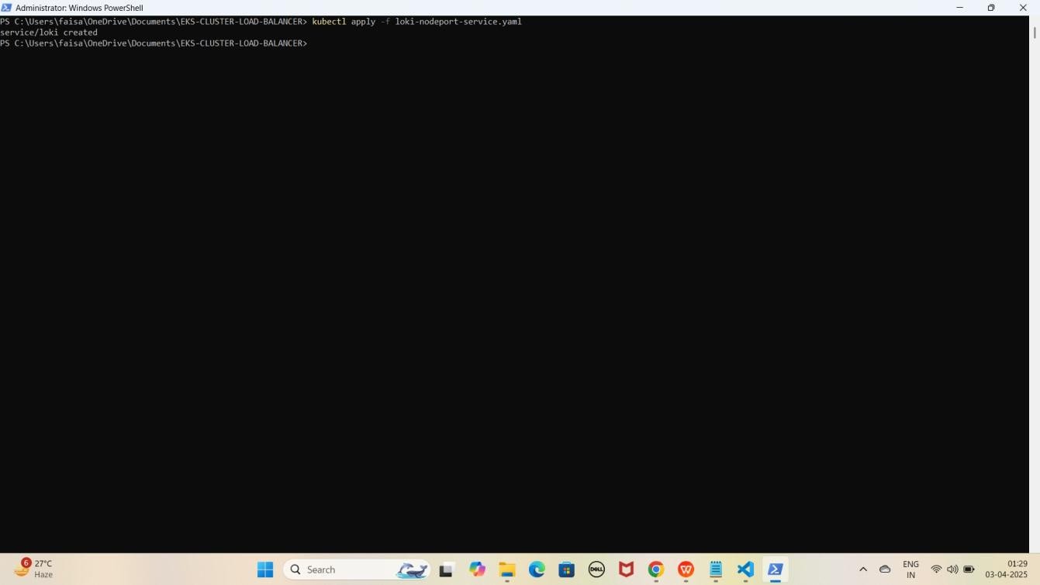YE KUCH ISTARHA LAGEGA

1. **Pods check karne ke liye ye command run kariye**

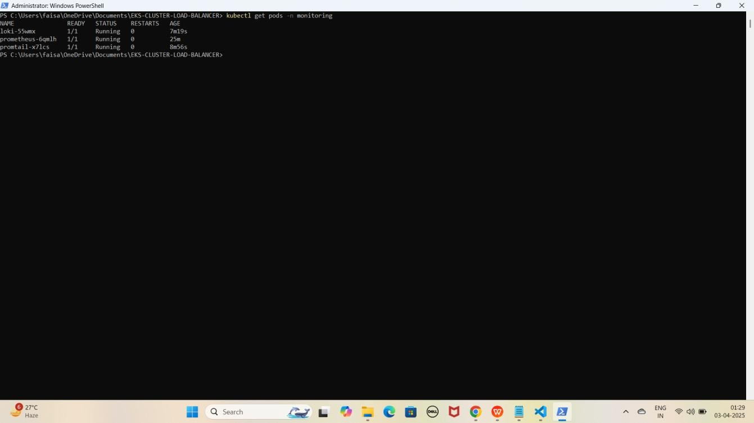kubectl get pods -n monitoring YE KUCH ISTARHA LAGEGA

NOTE: Agar STATE Running show karraha hai to sab kuch sahi hai

1. **Serives check karne ke liye ye commad run kariye**

kubectl get services -n monitoring

YE KUCH ISTARHA LAGEGA

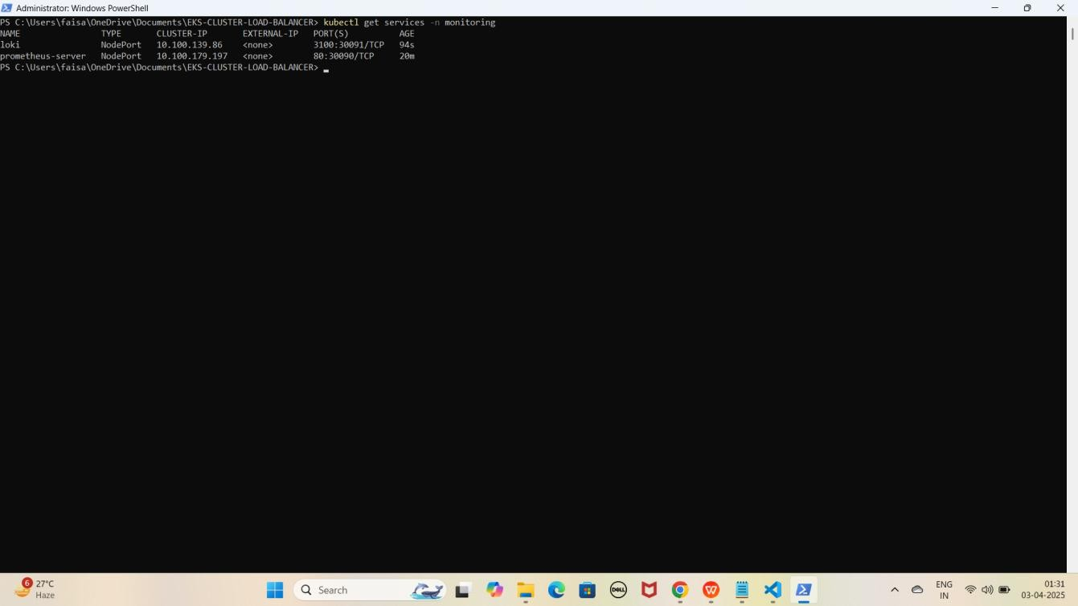

NOTE: Ab aapka Loki 30091 port par expose ho chuka hai. Browser me Cluster Node ki Public IP ke saath check karein jaise ki mere case me kuch aisa hoga.

**Loki:** [http://EKS-Node-Public IP:30091](h)

YE KUCH ISTARHA LAGEGA

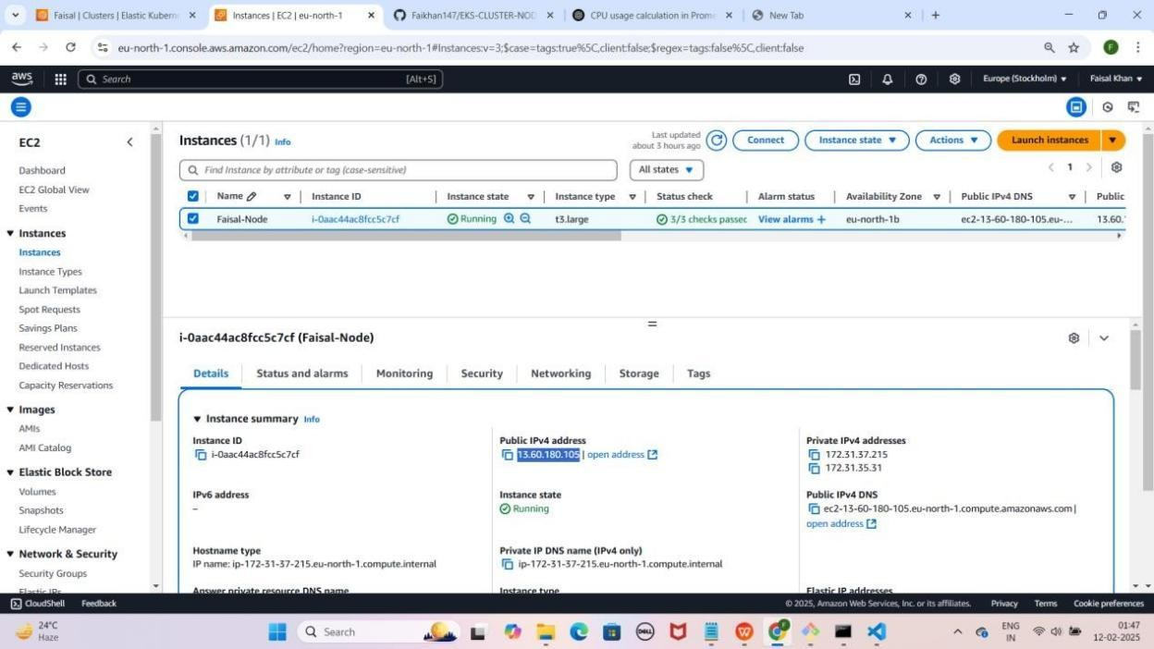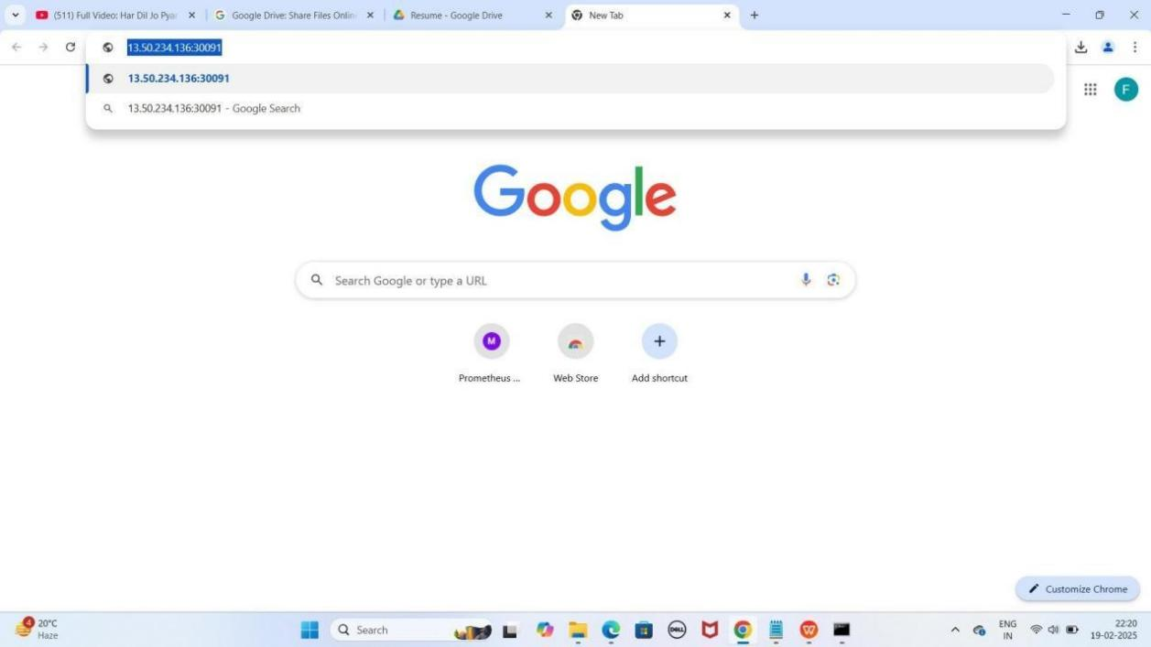

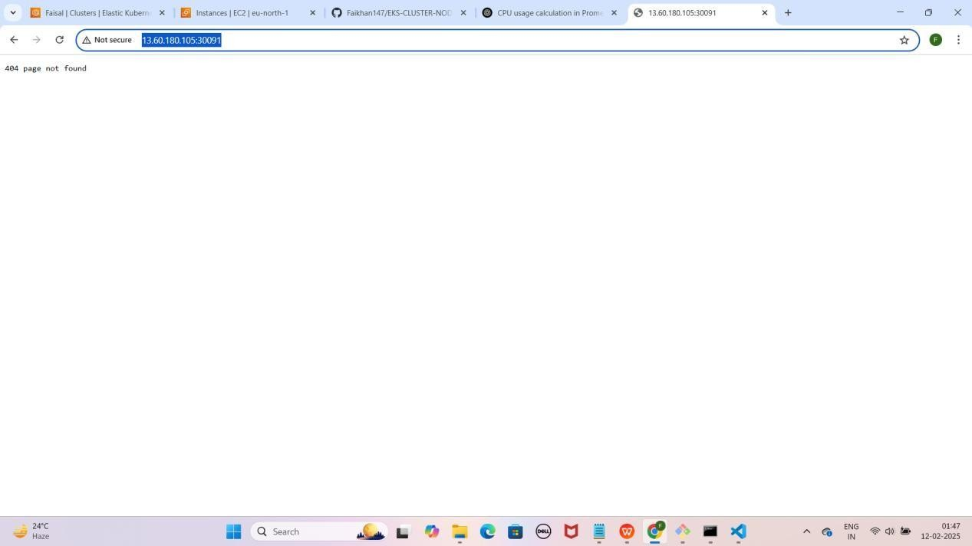

1. Lekin aapko **404 page** not found dikhayga to **/ready** se **check** kariye

**loki** ko jaise ki mere case kuch asisa hoga.

[http://EKS-Node-Public IP:30091/ready](h)

YE KUCH ISTARHA LAGEGA

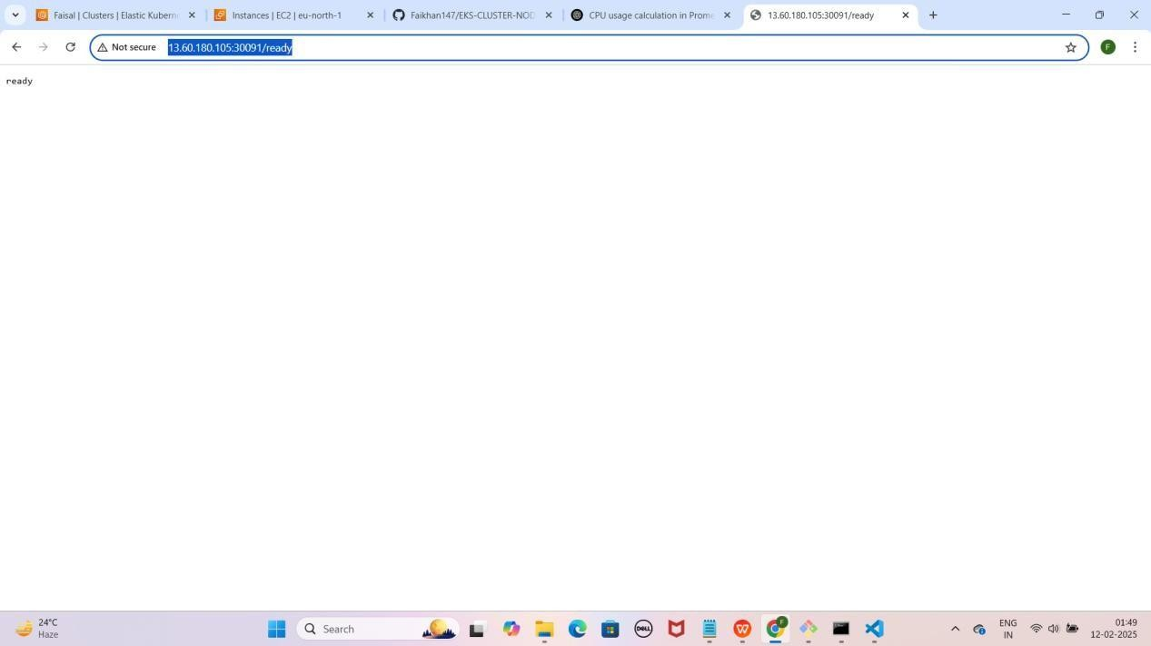

1. Agar aapko **ready show** karraha hai to iska matlab **loki successfully** run horaha hai ab **loki metrics loggs collect** karraha hai **check** karne ke liye

**/metrics** run kariye jaise ki mere case me kuch aisa hoga. [http://EKS-Node-Public IP:30091/metrics](h)

YE KUCH ISTARHA LAGEGA

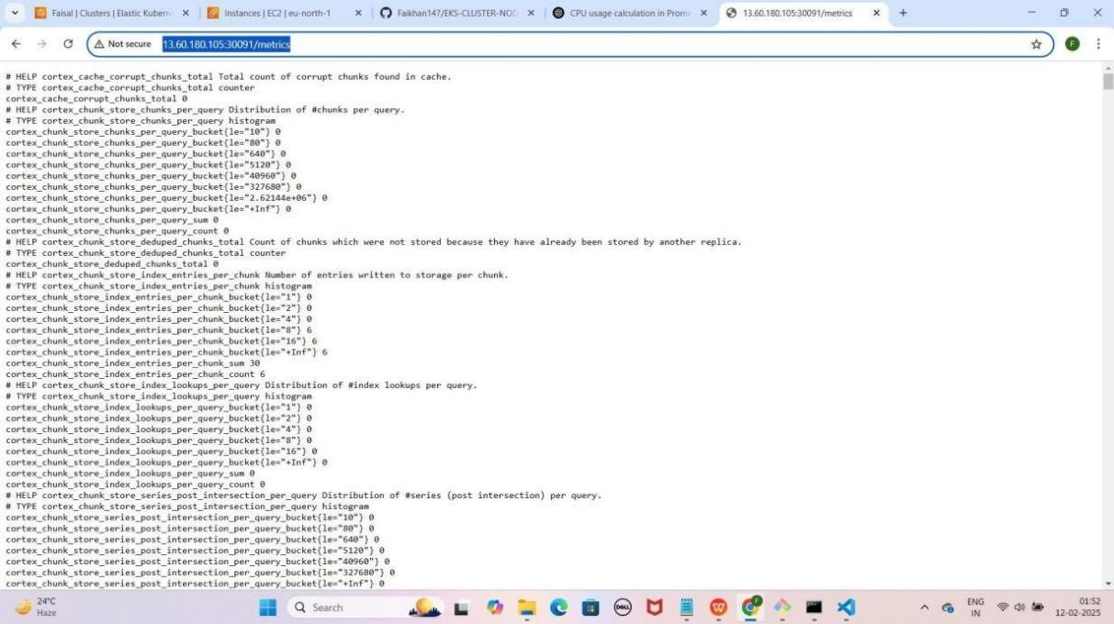

### Step 7: grafana-deployment.yaml File Ka Kaam

Yeh **file Grafana** ko **deploy** karne ke liye use hoti hai, taake hum **Prometheus metrics** aur **Loki logs** ko **visualize** kar sakein. Isme **NodePort Service** bhi use ki gayi hai, jisse **Grafana port 30080** par **expose** hoga.

JAISE KI:-

apiVersion: apps/v1 kind: Deployment metadata:

name: grafana namespace: monitoring

spec:

replicas: 1 selector:

matchLabels:

app: grafana template:

metadata:

labels:

app: grafana spec:

containers:

* name: grafana

image: grafana/grafana:8.3.0 ports:

* + containerPort: 3000 env:
  + name: GF_SECURITY_ADMIN_PASSWORD

value: "admin"

---

apiVersion: v1 kind: Service metadata:

name: grafana namespace: monitoring

spec:

type: NodePort # Change the type from ClusterIP to NodePort ports:

- port: 80

targetPort: 3000

nodePort: 30080 # Specify the NodePort (e.g., 30080, any unused port in the range 30000-32767)

selector:

app: grafana

### Grafana Deployment Apply Karo

kubectl apply -f grafana-deployment.yaml

YE KUCH ISTARHA LAGEGA

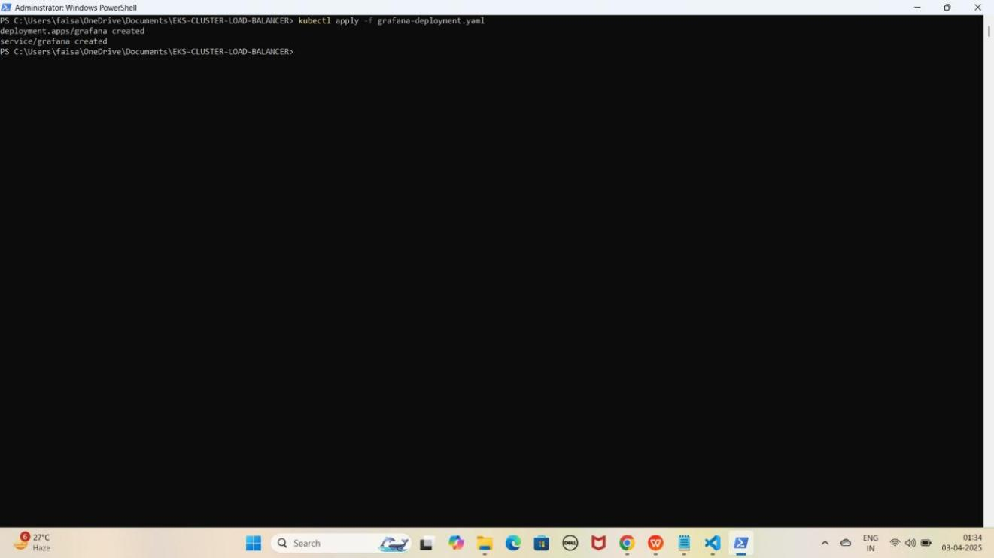

1. **Pods check karne ke liye ye command run kariye**

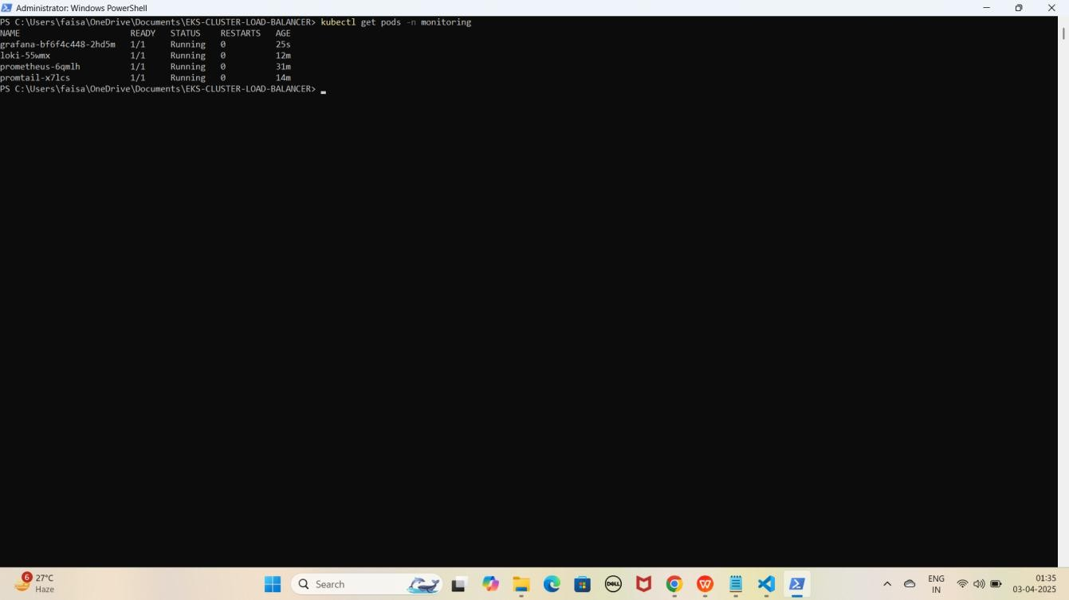kubectl get pods -n monitoring YE KUCH ISTARHA LAGEGA

NOTE: Agar STATE Running show karraha hai to sab kuch sahi hai

1. **Serives check karne ke liye ye commad run kariye**

kubectl get services -n monitoring

YE KUCH ISTARHA LAGEGA

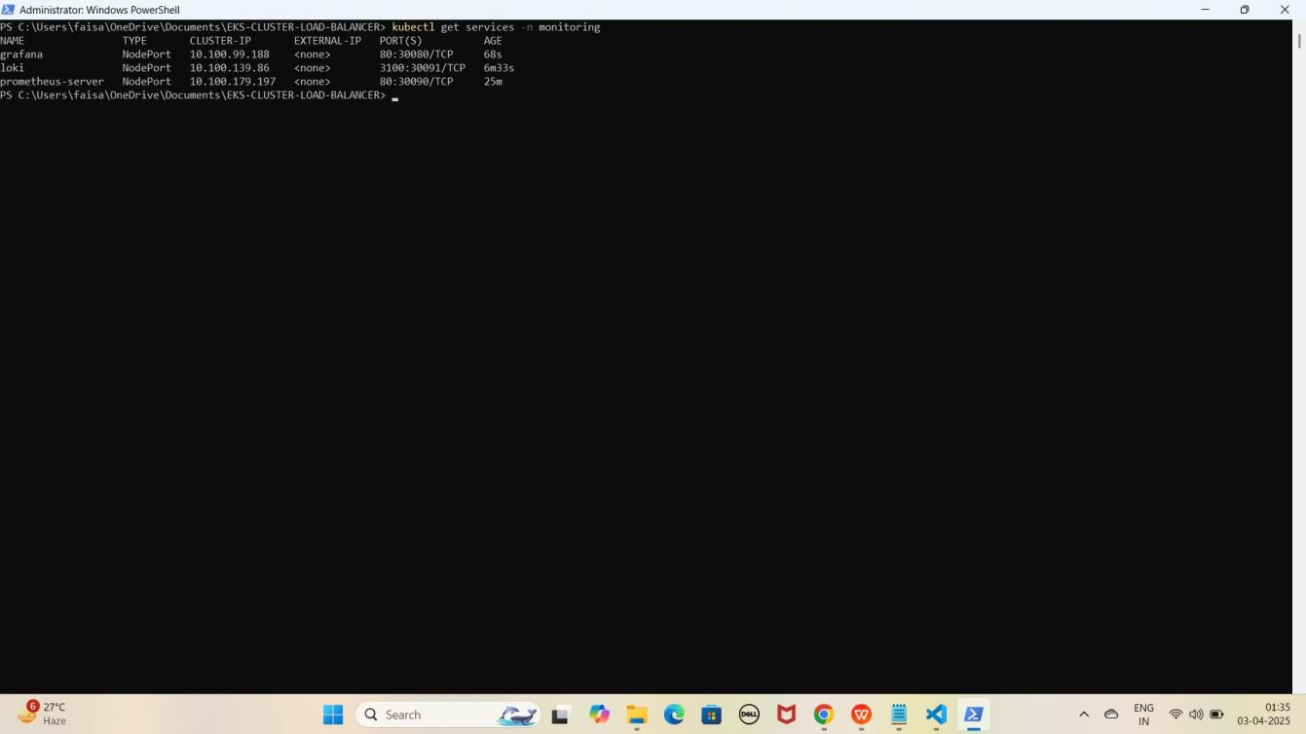

NOTE: Ab aapka Grafana 30080 port par expose ho chuka hai. Browser me Cluster Node ki Public IP ke saath check karein jaise ki mere case me kuch aisa hoga.

**Grafana:** [http://EKS-Node-Public IP:30080](j)

YE KUCH ISTARHA LAGEGA

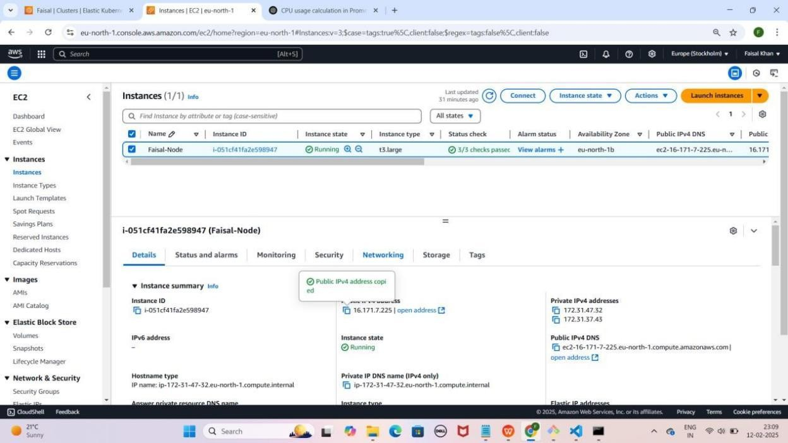

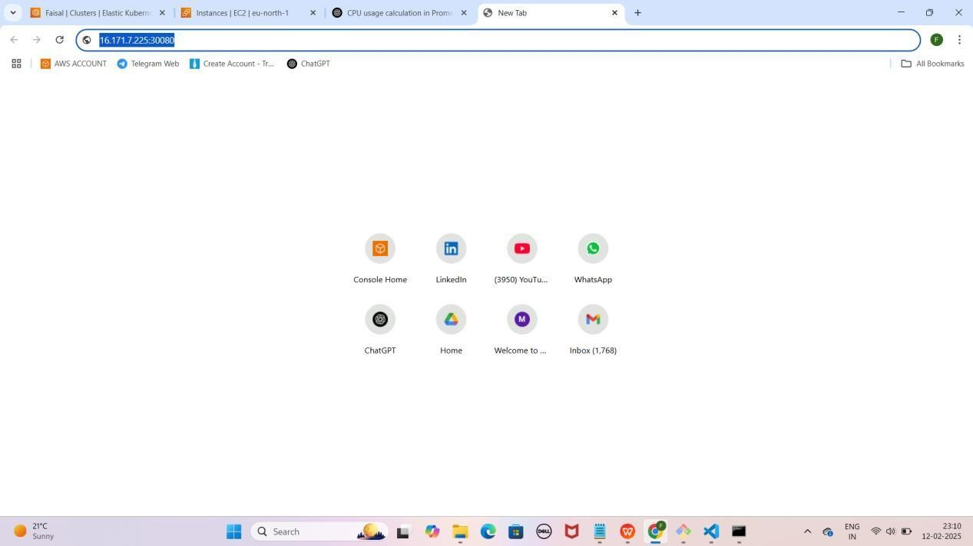

YE KUCH ISTARHA LAGEGA

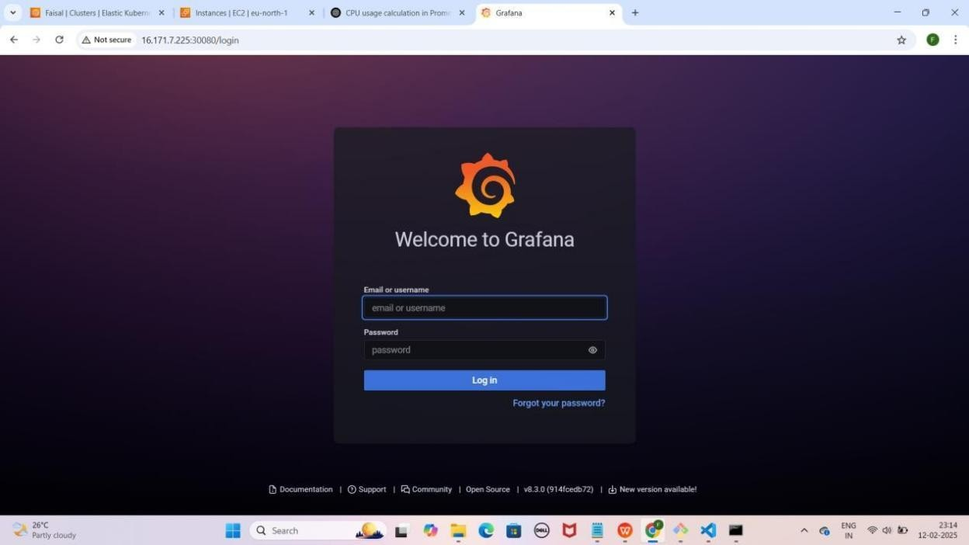

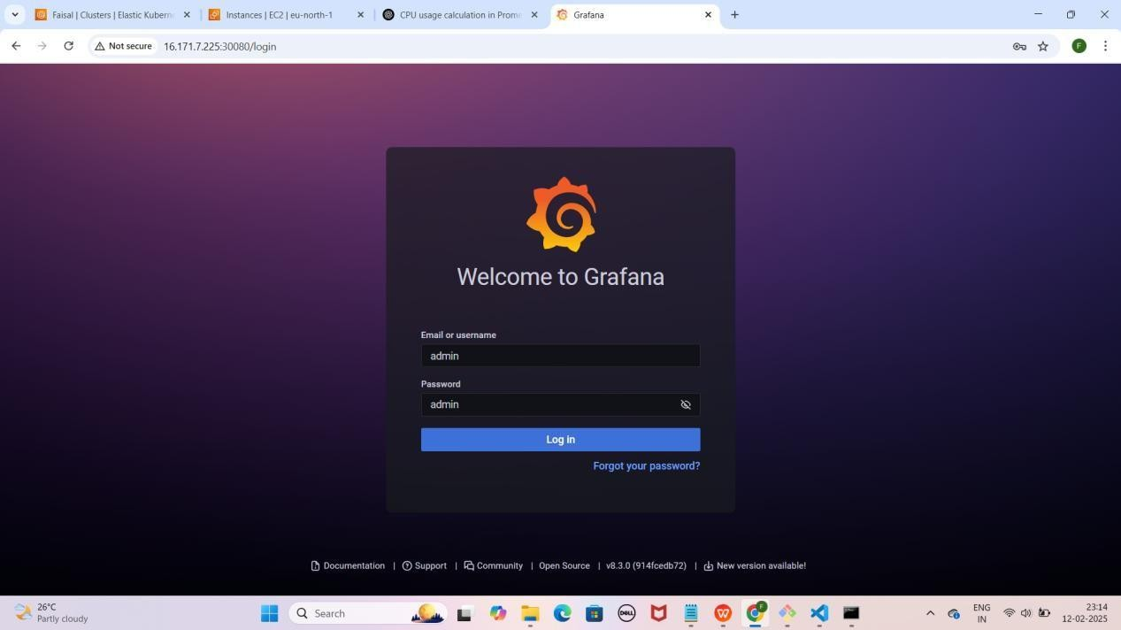

NOTE : Grafana browser me run hone ke baad aapse login ke liye username aur password maangega. Default username aur password admin hota hai. Login ke baad aap apna password change kar sakte hain

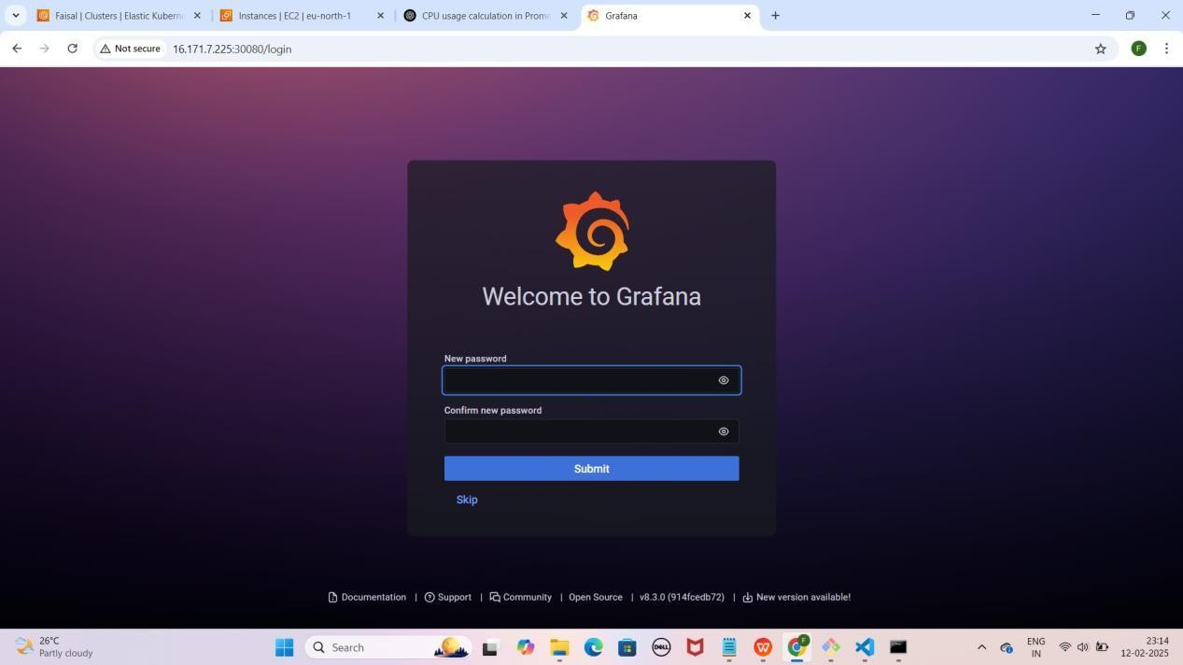

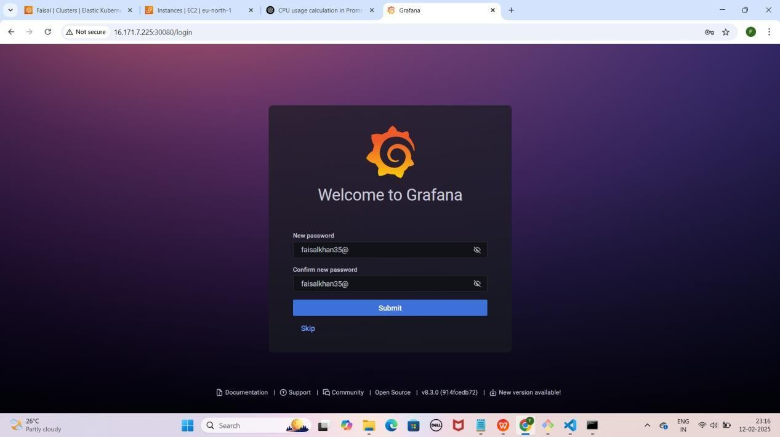

NOTE : Is step par aapko apne pasand ka naya password set karsakte hai.

Yaha mai faisalkhan35@ password set kar raha hoon.Password type karne ke baad Submit par click kariye

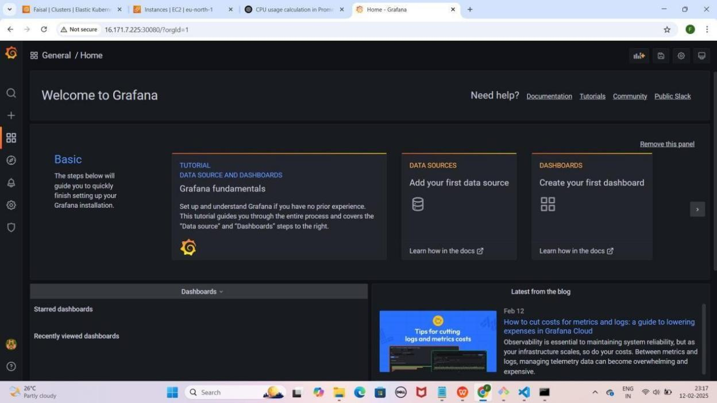

### Step 8: Grafana Mein Prometheus Data Source Add Karna, Queries Add Karna Aur Dashboard Create Karna

* **Grafana dashboard** open karo.
* **Configuration** pe **click** karo, phir **Data Sources select** karo.
* **Add data source** pe **click** karo.
* **Prometheus select** karo.
* **Browser open karo** aur yeh **URL copy** karo:
  + **Mere case me yeh kuch is tarah hogi: [http://EKS-Node-Public](g) [IP:30090/](g)**
  + **Aapke case me Public IP different ho sakti hai.**
* **HTTPS section** me **URL** box me **paste** karo.
* Neeche **scroll** karo aur **"Save & Test"** pe **click** karo.

YE KUCH ISTARHA LAGEGA

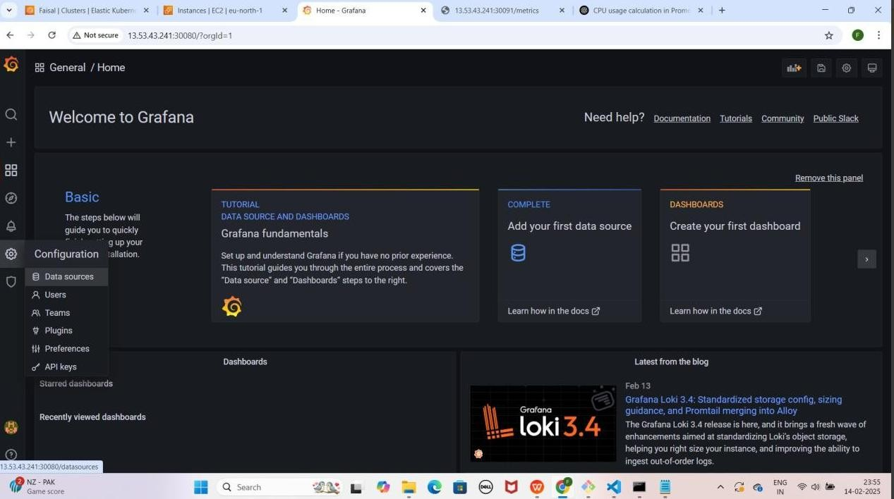

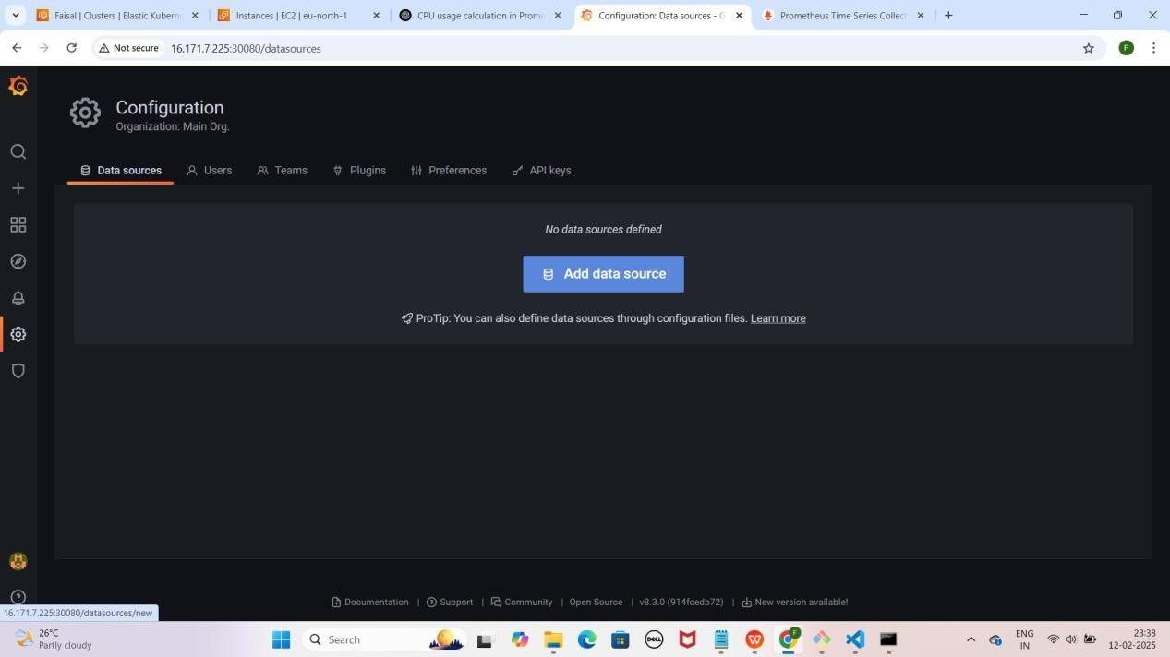

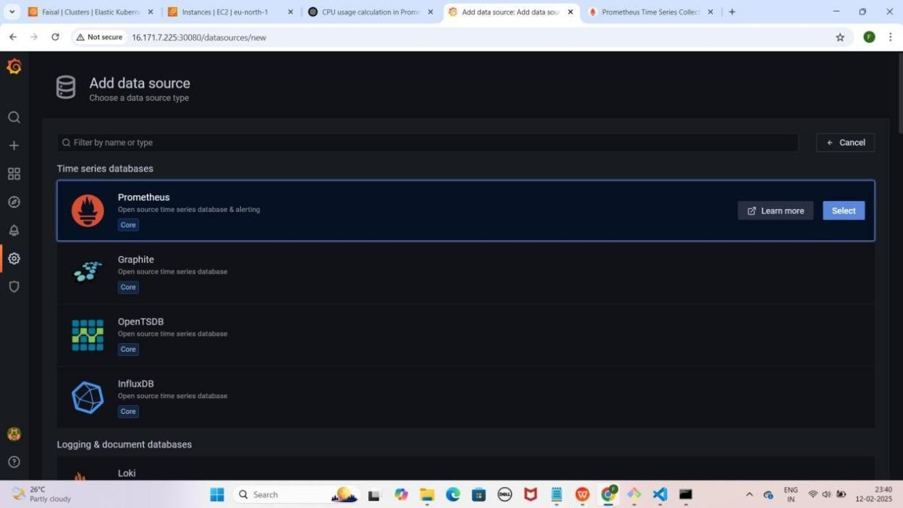

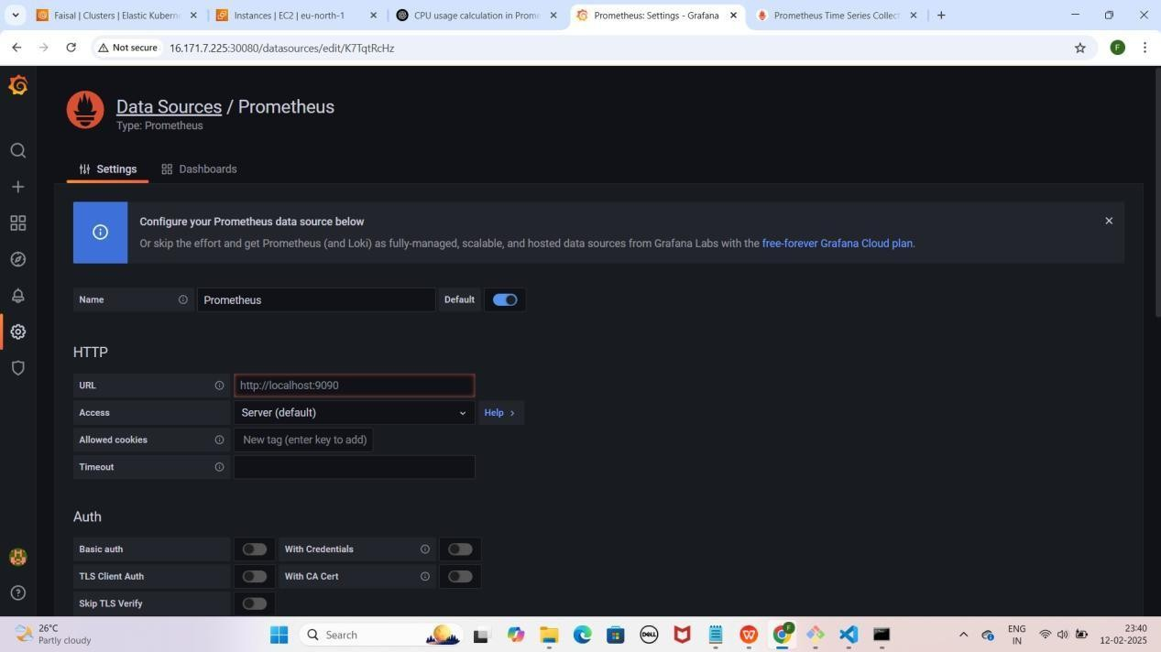

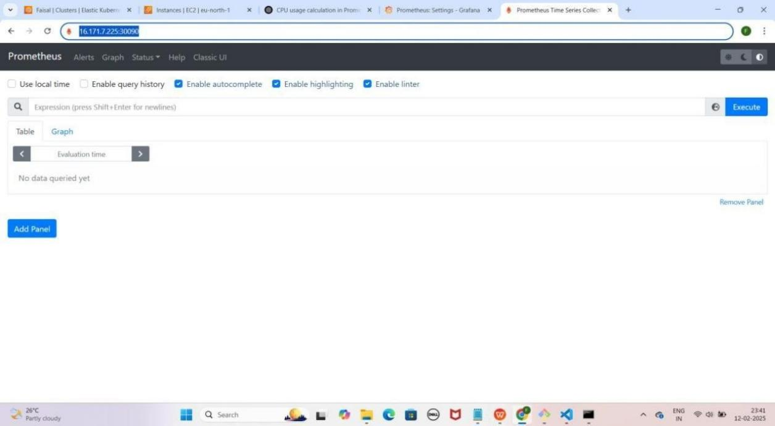

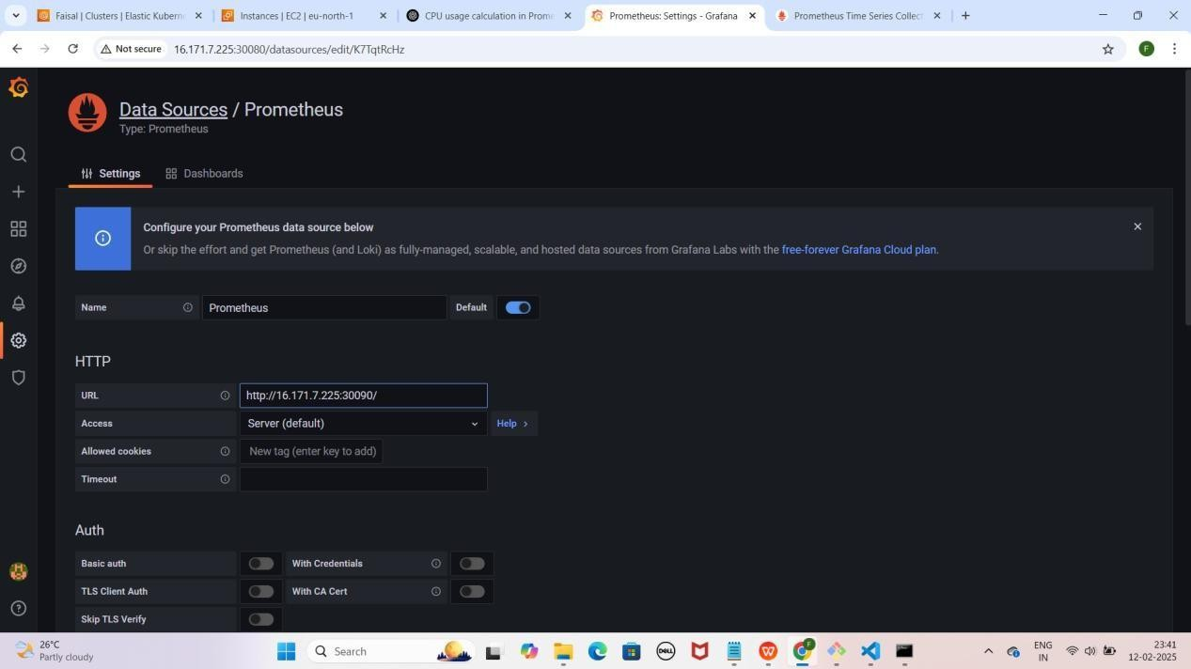

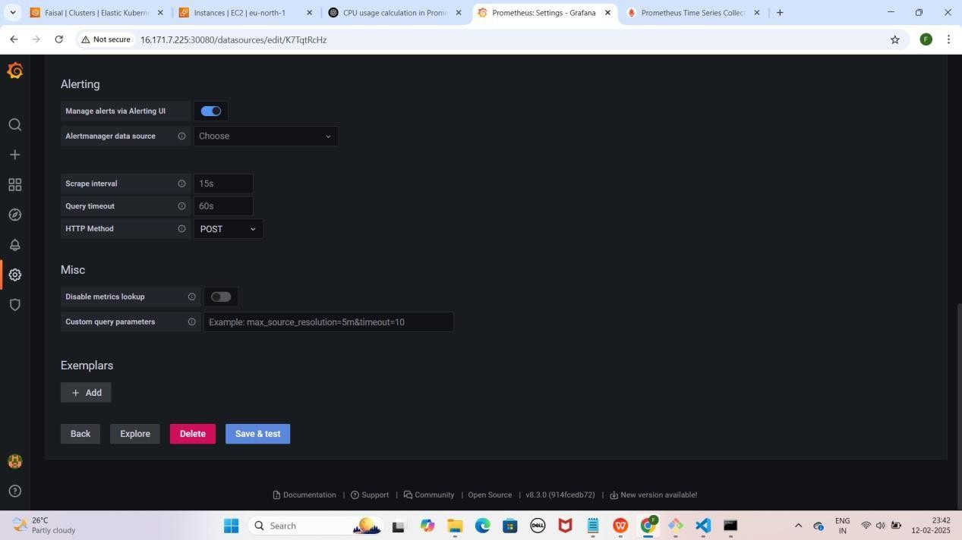

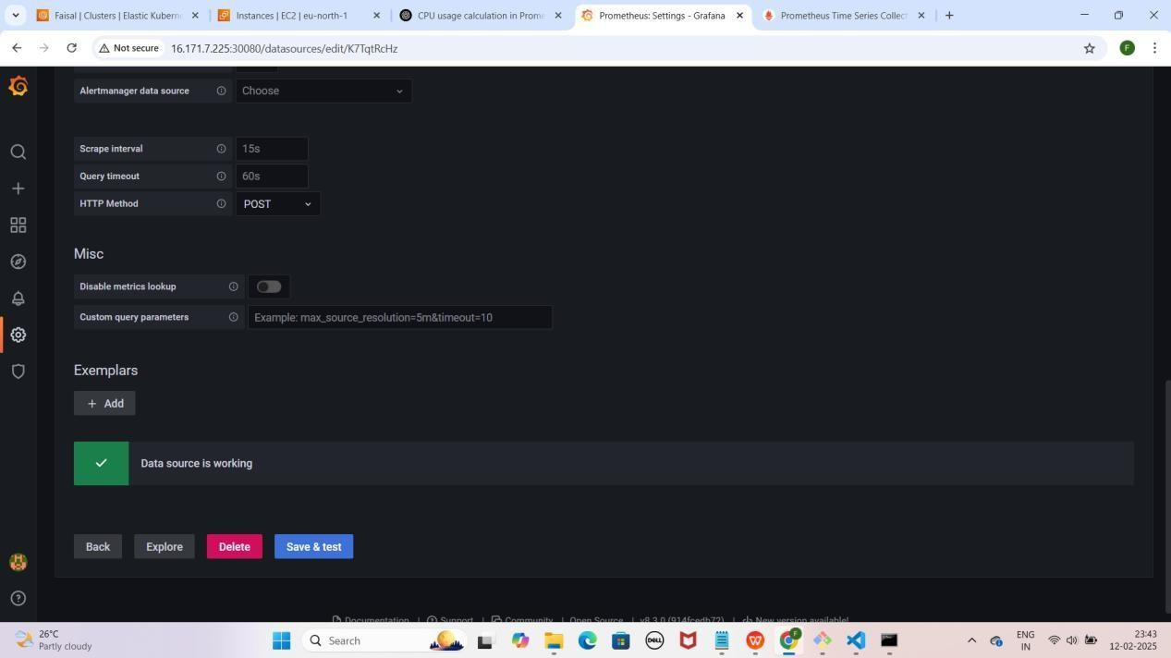

NOTE : Save & test pe click karne ke baad aapko Data source is working karke pop up aayega

* **Prometheus ke Metrics visualize** karne ke liye **"+" (plus) icon** pe click karo.
* **Dashboard** select karo aur **"Add a new panel"** pe click karo.
* **Query section** me **Data Source ko "Prometheus"** select karo.

YE KUCH ISTARHA LAGEGA

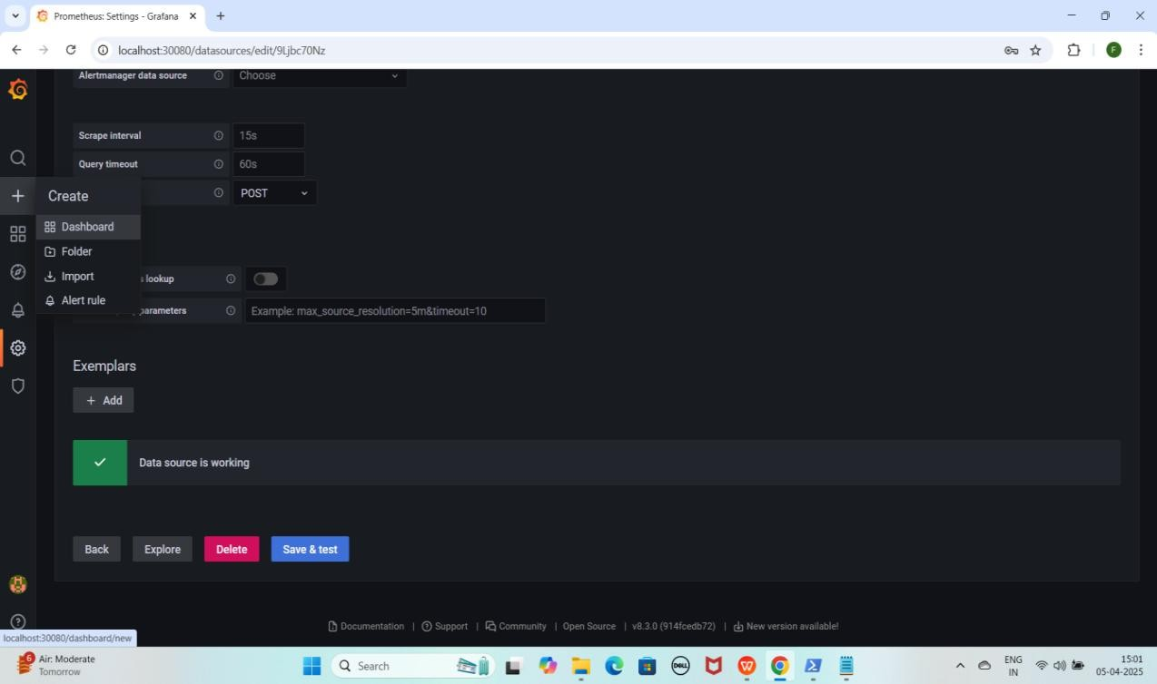

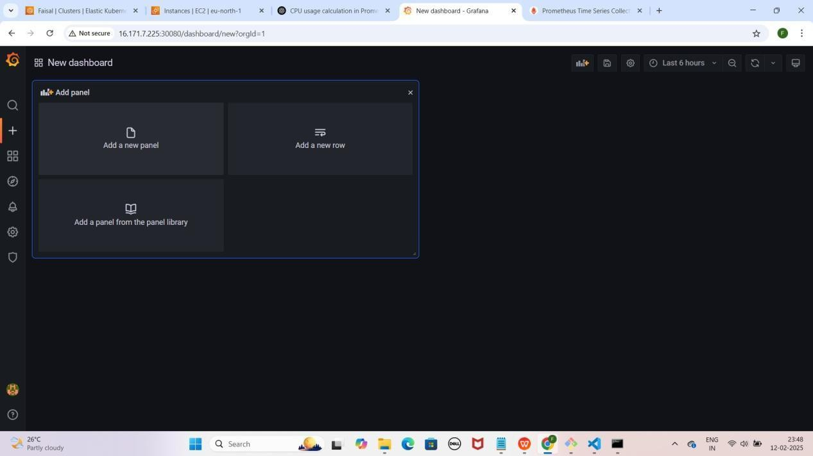

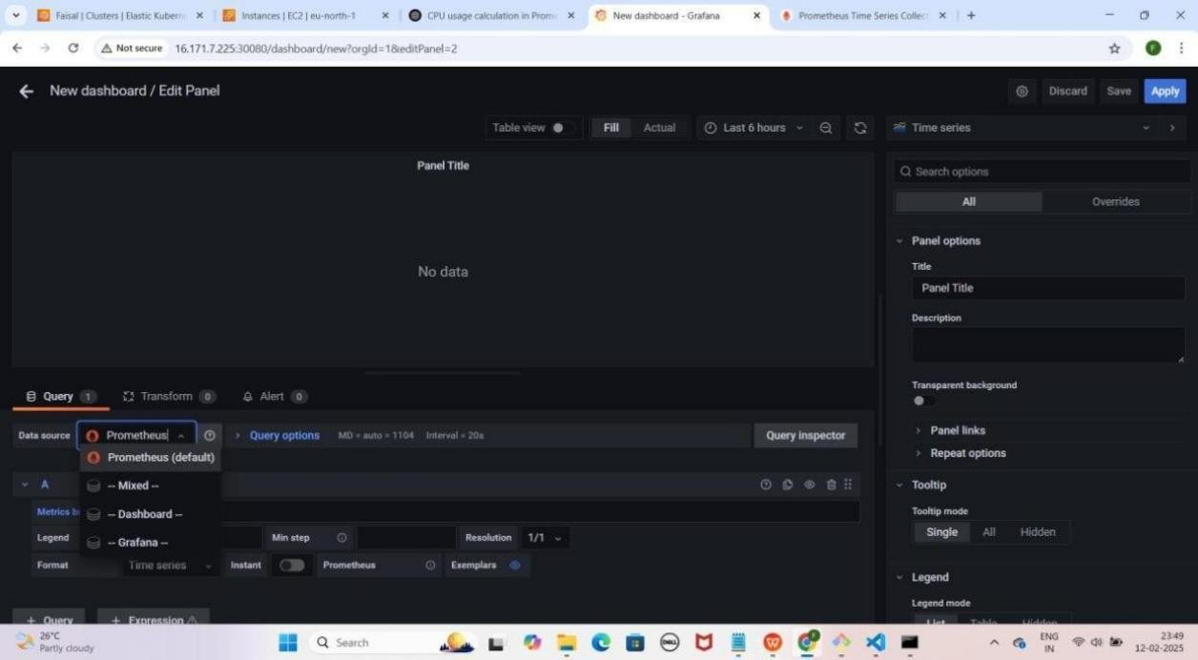

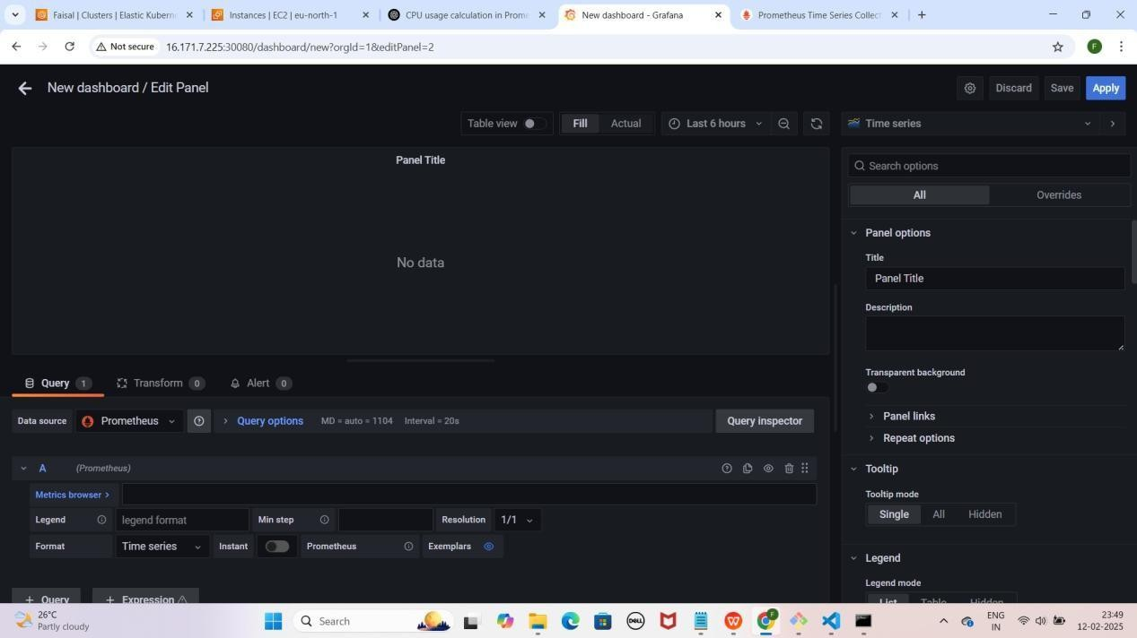

1. **Prometheus ko data source select karne ke baad, CPU Usage dekhne ke liye Metric Browser me yeh query paste karein**

rate(process_cpu_seconds_total[30s])

* + **"Time Series"** pe click karein.
  + **Suggestions** me se **"Dashboard"** select karein jaise maine select kiya hai.

YE KUCH ISTARHA LAGEGA

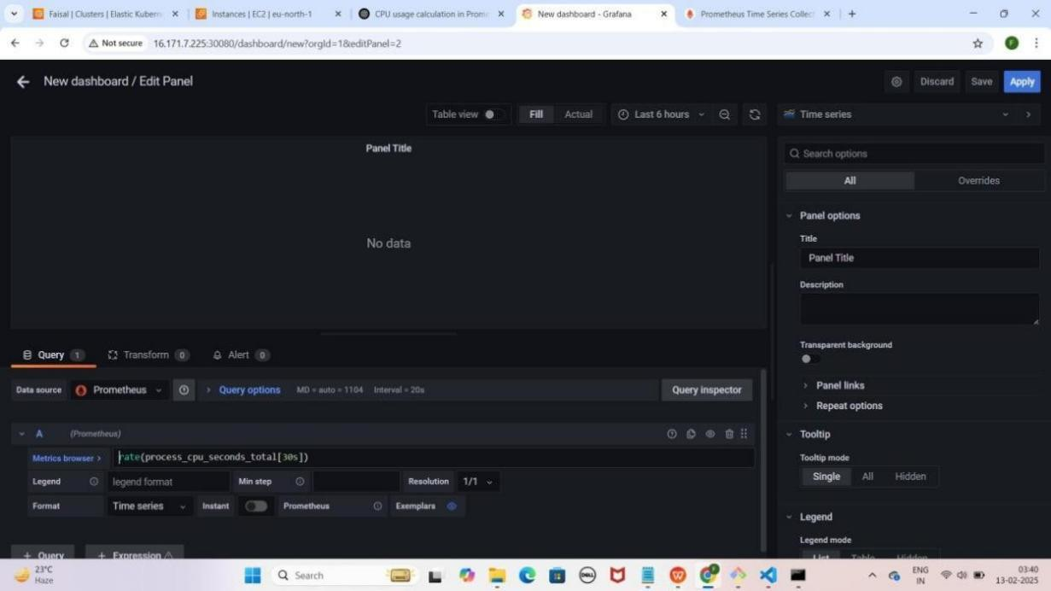

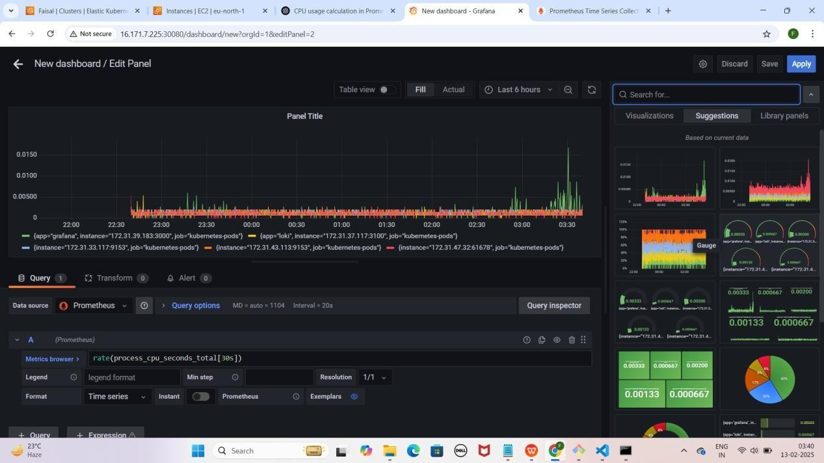

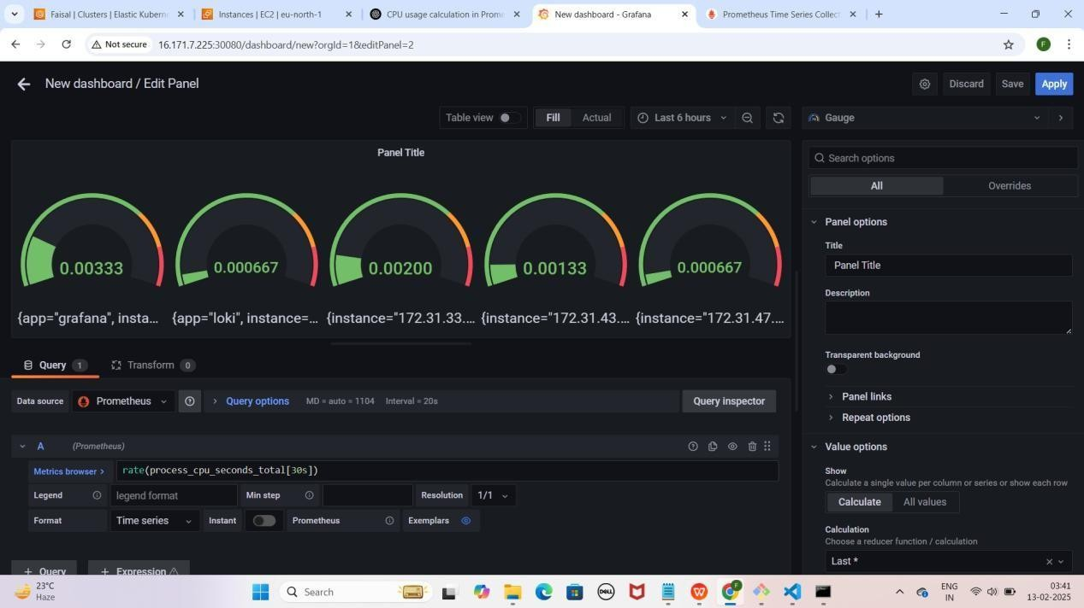

1. **Memory Usage dekhne ke liye "+ Query" par click karein. Yeh query paste karein taake memory usage dekh sakein**

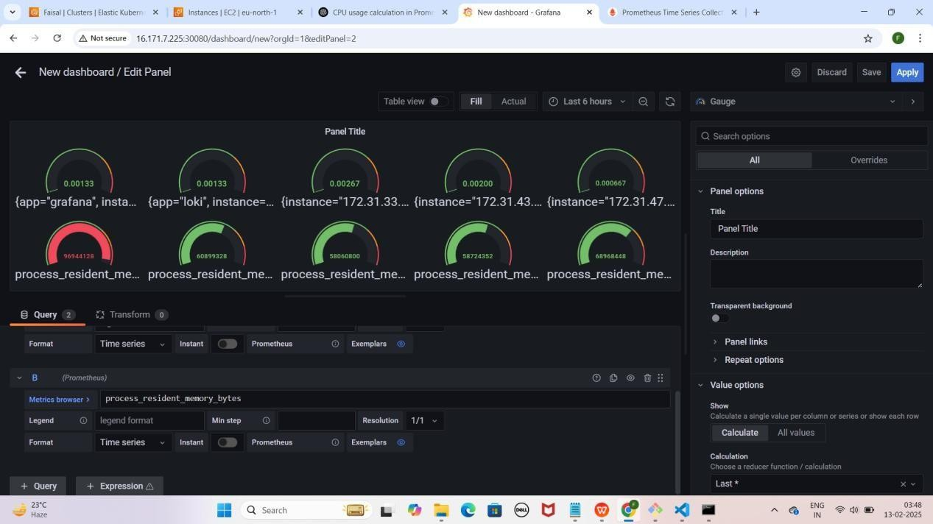process_resident_memory_bytes YE KUCH ISTARHA LAGEGA

1. **Network Transmit dekhne ke liye "+ Query" par click karein. Yeh query paste karein taake network transmit dekh sakein**

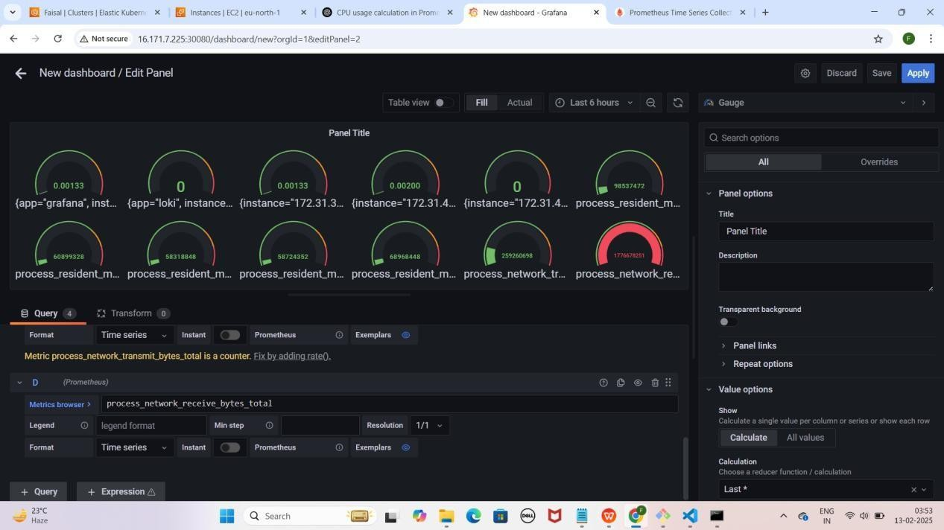process_network_transmit_bytes_total YE KUCH ISTARAH LAGEGA

1. **Network Receive dekhne ke liye "+ Query" par click karein. Yeh query paste karein taake network receive dekh sakein:**

process_network_receive_bytes_total

YE KUCH ISTARHA LAGEGA



NOTE : Itna karne ke baad aap 30 sec ke interval par CPU usage, current Memory Usage aur Network transmit/receive bytes ko Monitor kar sakte hain.

### Step 9: Grafana Mein Loki Data Source Add Karna Aur Dashboard Create Karna

* + **Grafana** open karo aur **Settings** icon pe click karo.
  + **Data Sources** select karo.
  + **Add data source** pe click karo.
  + Search bar me **"Loki"** likho aur **Loki** select karo.
  + Browser open karo aur yeh URL copy karo:
    - **Mere case me yeh kuch is tarah hogi:** [http://EKS-Node-Public](vb) [IP:30091/](vb)
    - **Aapke case me Public IP different ho sakti hai.**
  + **HTTPS section** me URL box me paste karo.
  + Neeche scroll karo aur **"Save & Test"** pe click karo.

YE KUCH ISTARHA LAGEGA



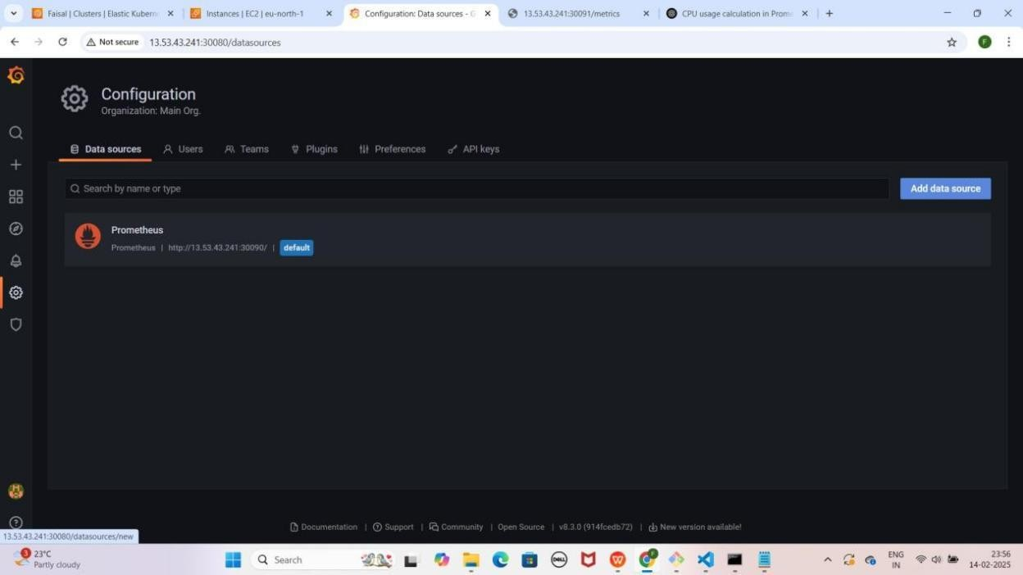

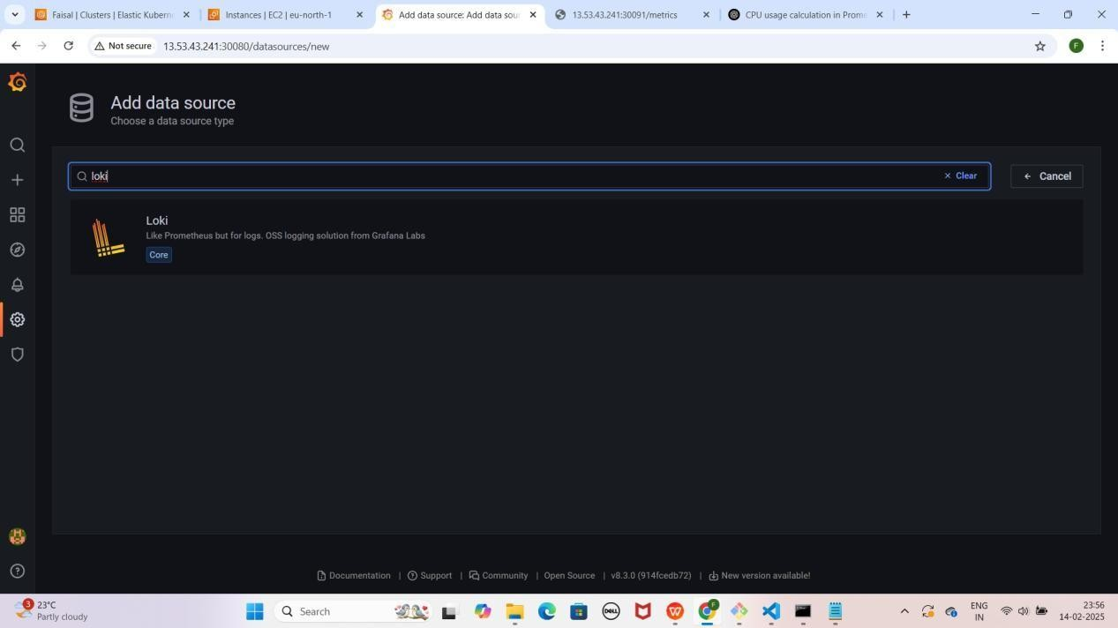

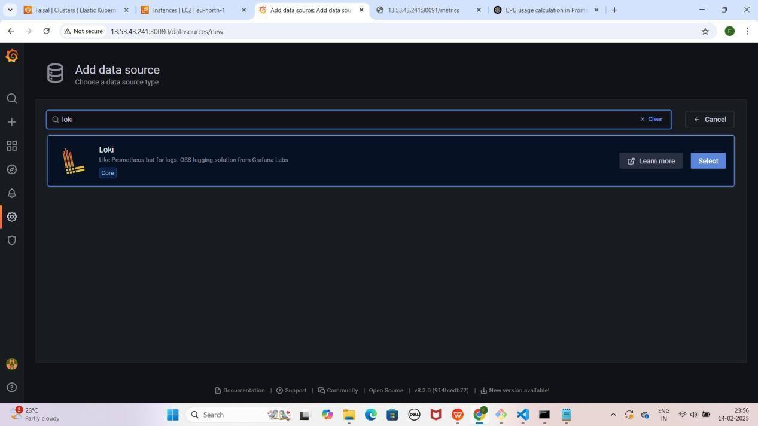

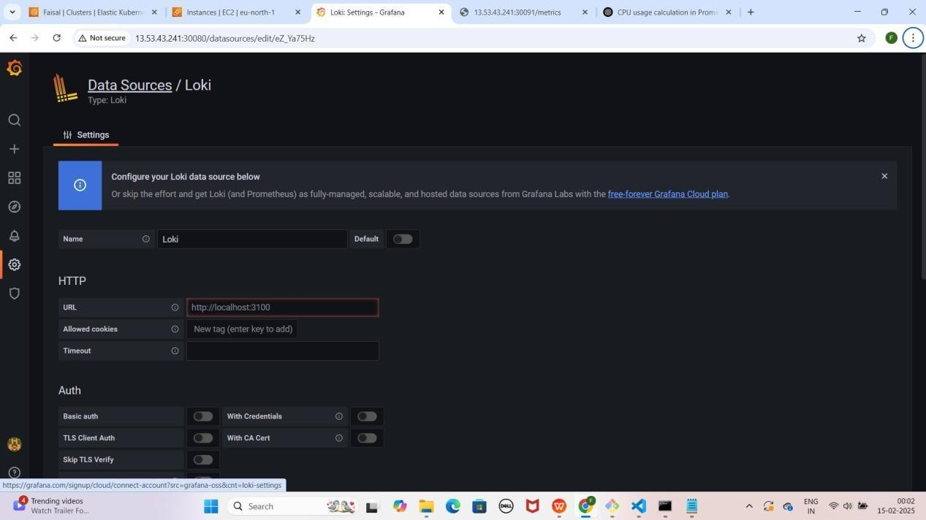

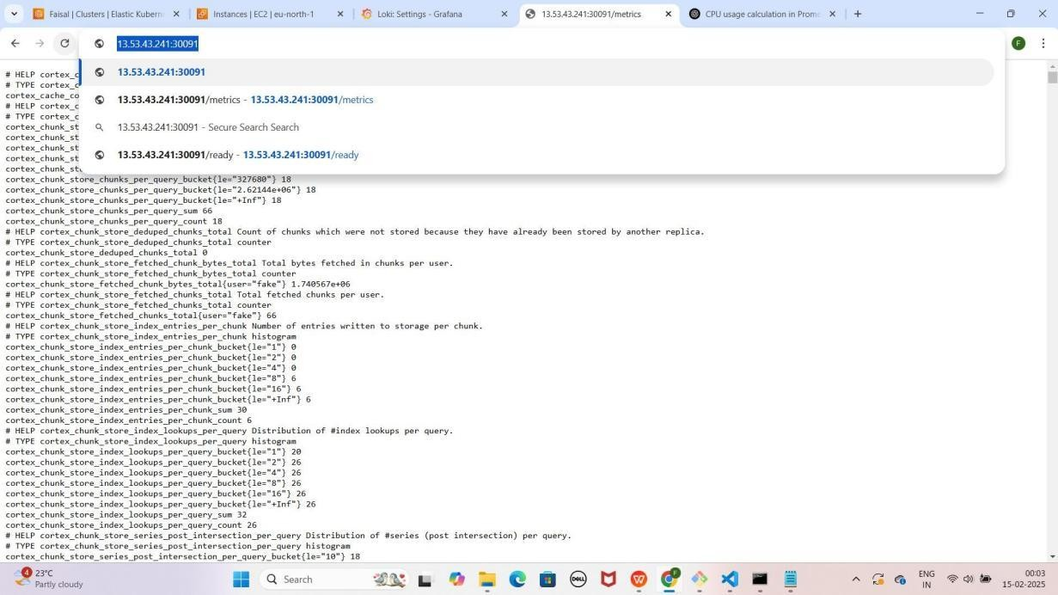

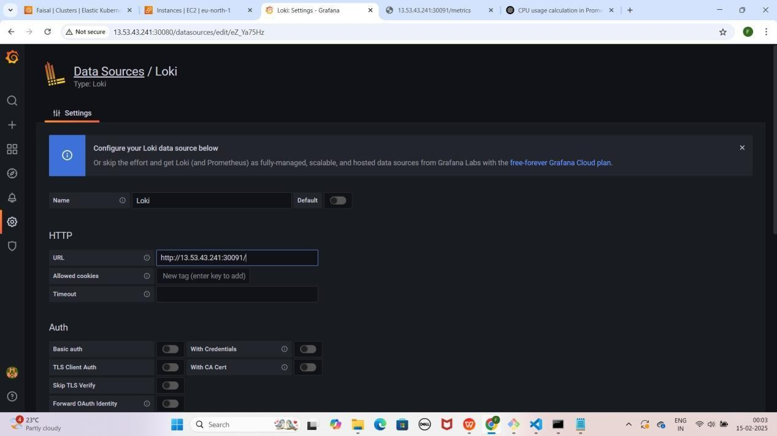

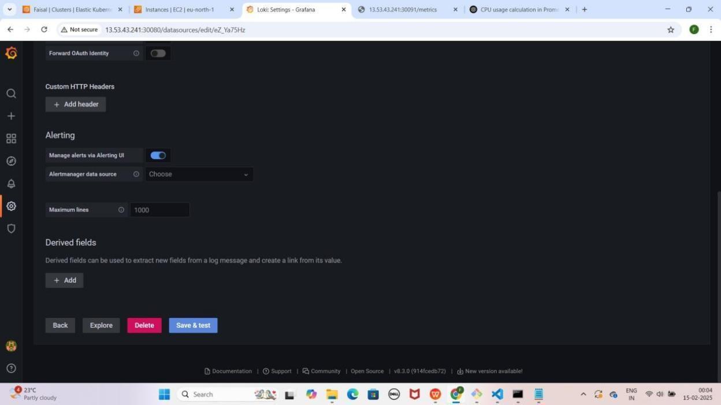

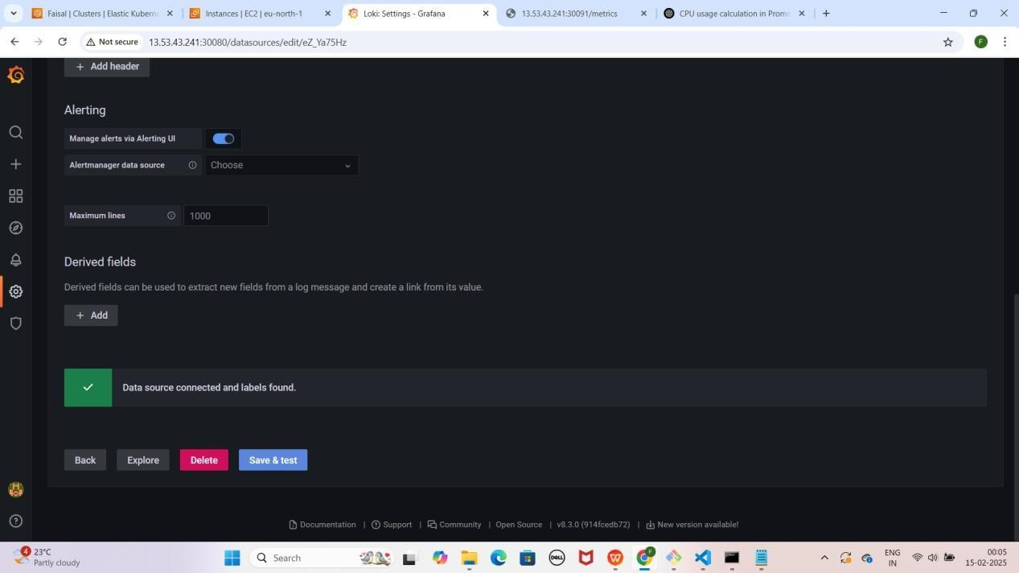

NOTE : Save & test pe click karne ke baad aapko Data source connected and label found karke pop up aayega

* **Loki ke Loggs visualize** karne ke liye **"+" (plus) icon** pe click karo.
* **Dashboard** select karo aur **"Add a new panel"** pe click karo.
* **Query section** me **Data Source ko "Loki"** select karo.

YE KUCH ISTARHA LAGEGA

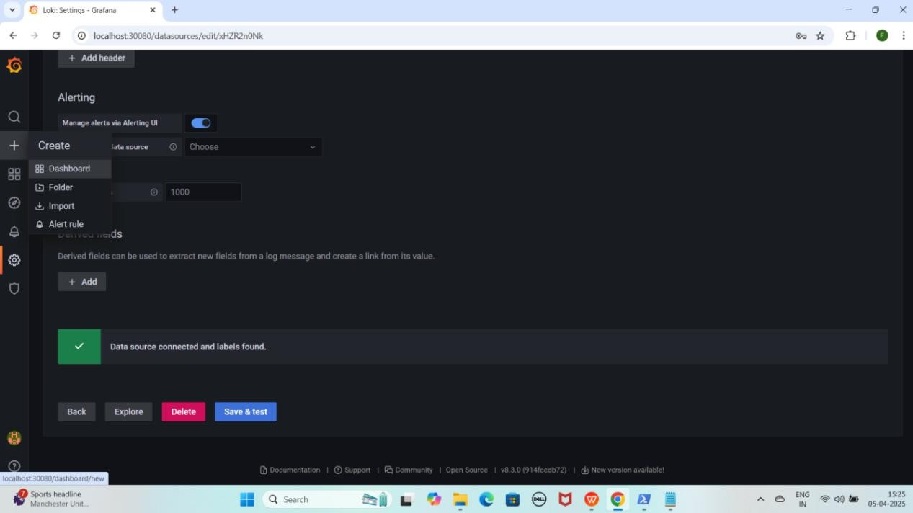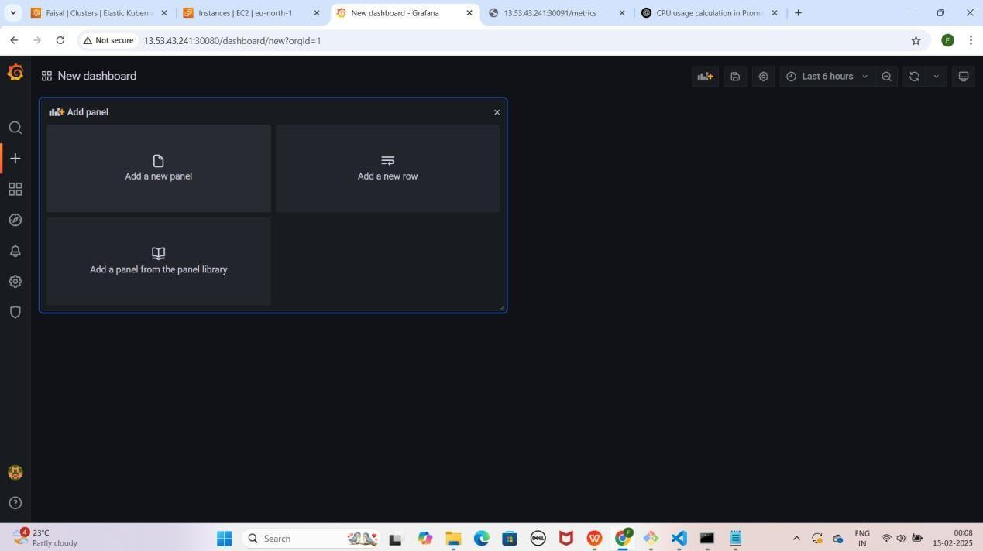

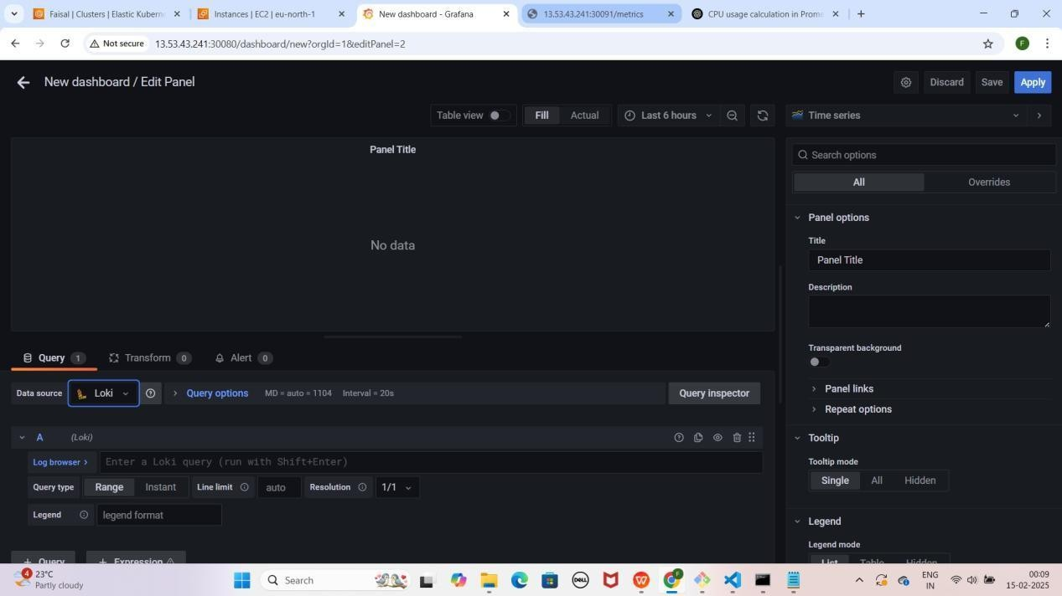

1. **"Log Browser"** pe **click** karo.
2. Pehle **"filename" select** karo, phir **"job"** (jaise ki **varlogs**) **select** karo.
3. 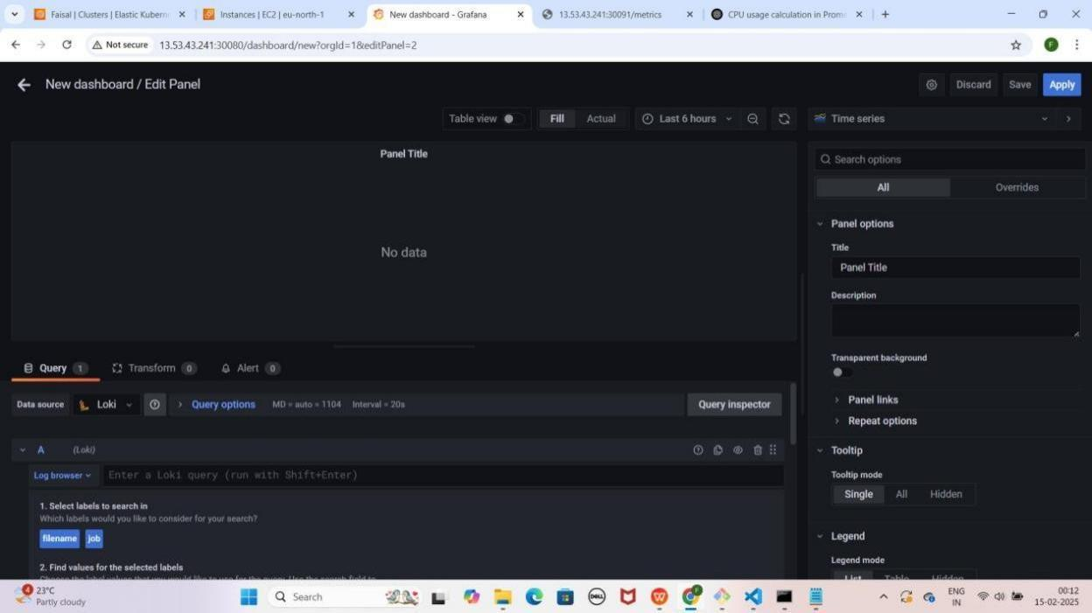Neeche **scroll** karo aur **"Show logs"** pe **click** karo. YEKUCH ISTARHA LAGEGA

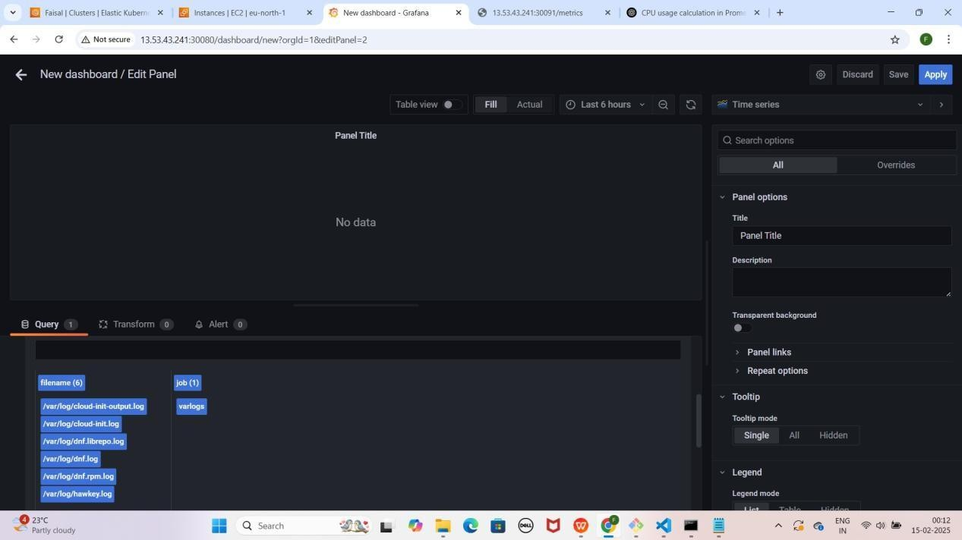

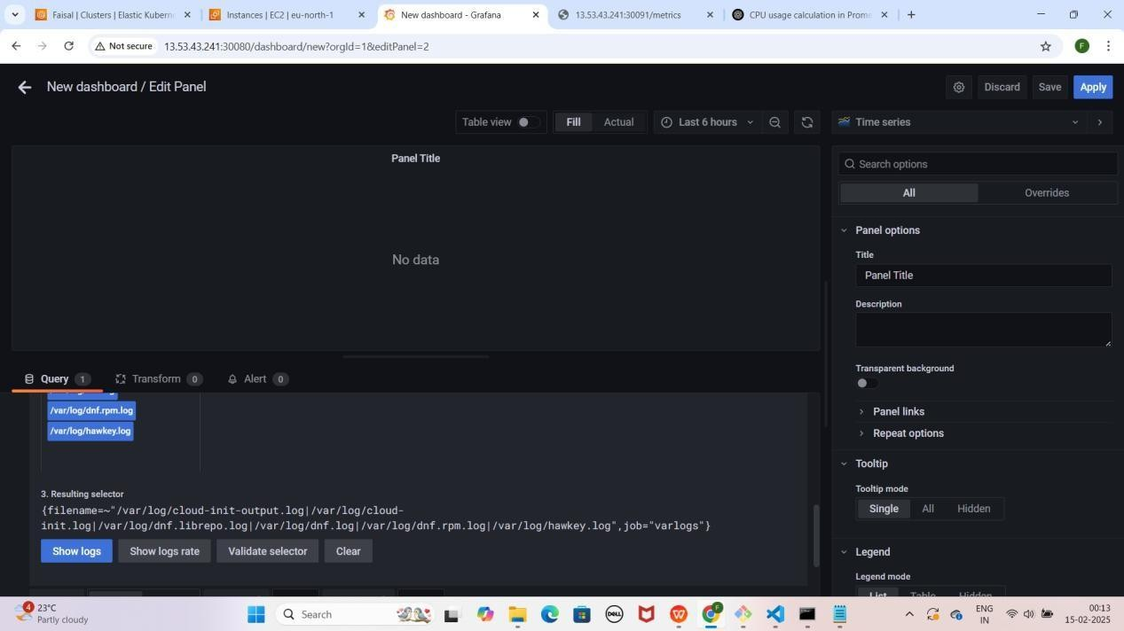

1. **Time Series** pe **click** karo
2. **Suggestions** me jao aur "**Dashboard**" select karo Jaise ki maine kiya hai

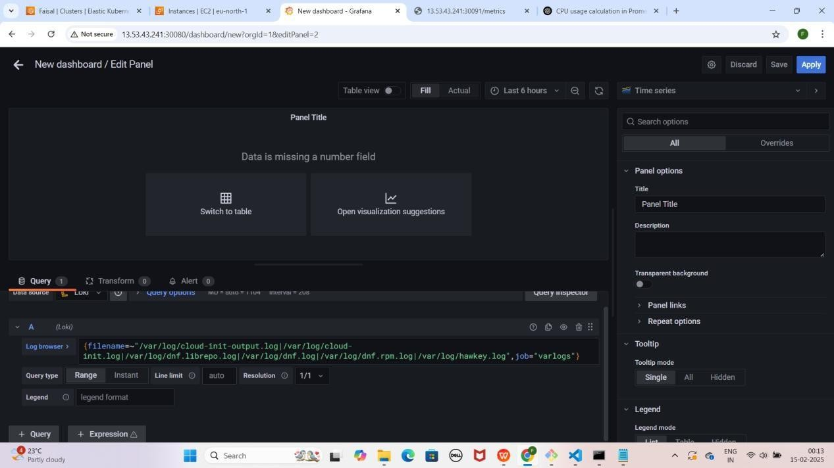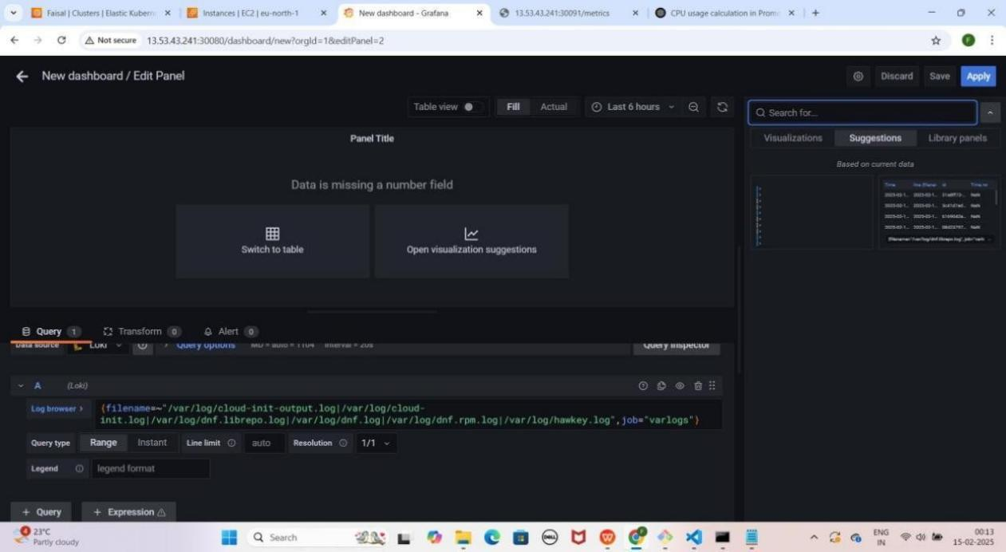YE KUCH ISTARHA LAGEGA

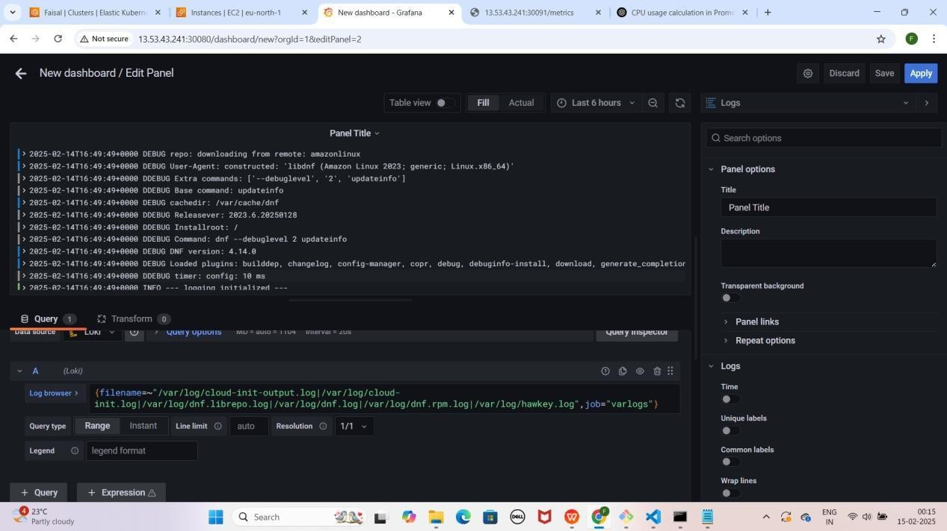

NOTE : Is setup se hum cluster ke saare Logs Monitor kar sakte hain.

## Part 9: Accessing Prometheus, Loki, and Grafana Using a Domain Name

Jab humne **NGINX ke liye domain name configure** kiya tha, tab hum **EKS Node ki Public IP ke liye records add** kar chuke hain.

Ab kyunki **Prometheus, Loki, aur Grafana bhi NodePort se expose** ho chuke hain, isliye **ye bhi same domain name se access ho sakte hain**

### Step 1 : Websites Ko Domain Name Se Access Karna

1. **Apni Prometheus application ko Domain Name aur NodePort ke saath access karo.**
   * **Prometheus:** [http://mohdfaisalkhan.tech:30090](http://mohdfaisalkhan.tech/)

YE KUCH ISTARHA LAGEGA

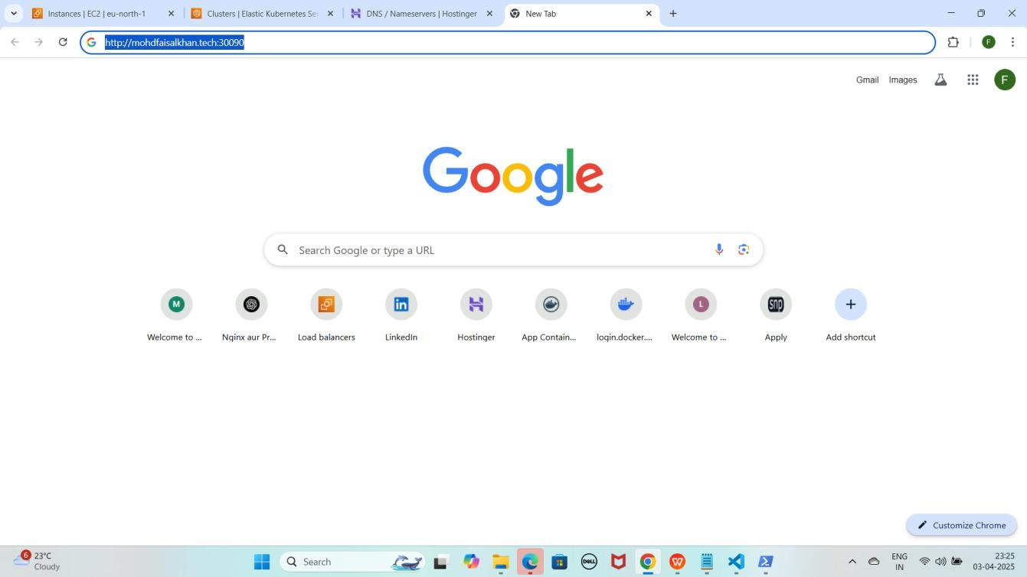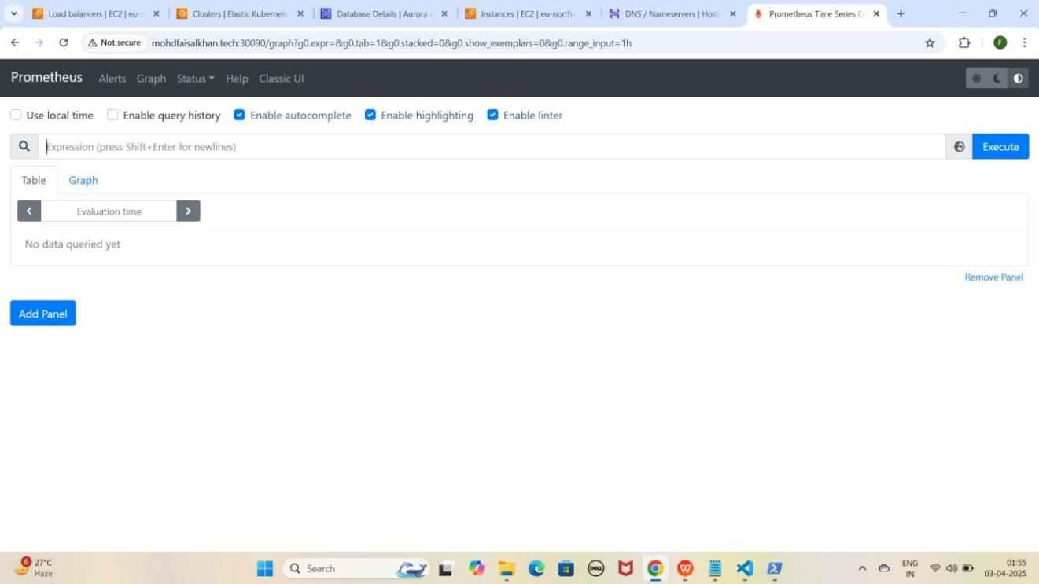

1. **Apni Prometheus application ko WWW Domain Name aur NodePort ke saath access karo**
   * **Prometheus:** [http://www.mohdfaisalkhan.tech:30090](http://www.mohdfaisalkhan.tech/)

YE KUCH ISTARHA LAGEGA

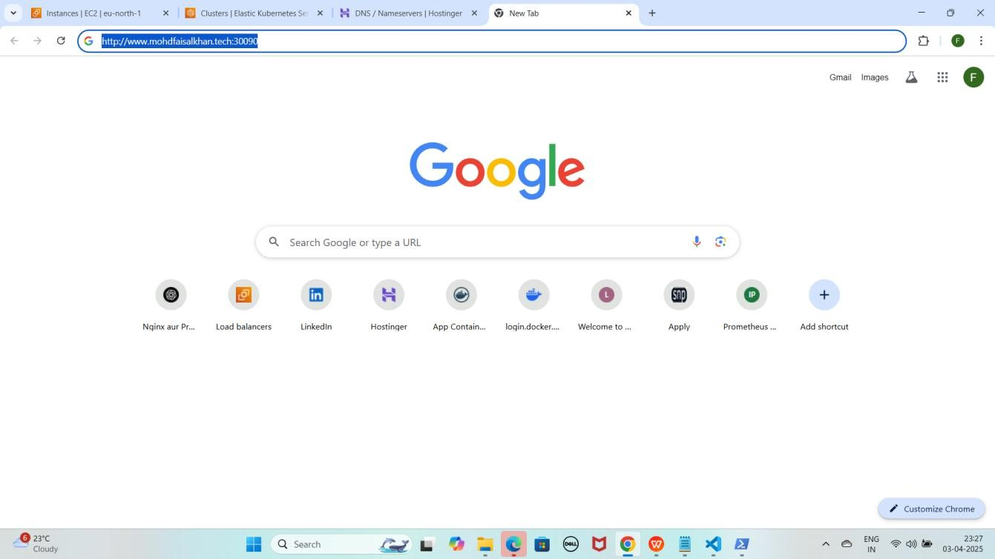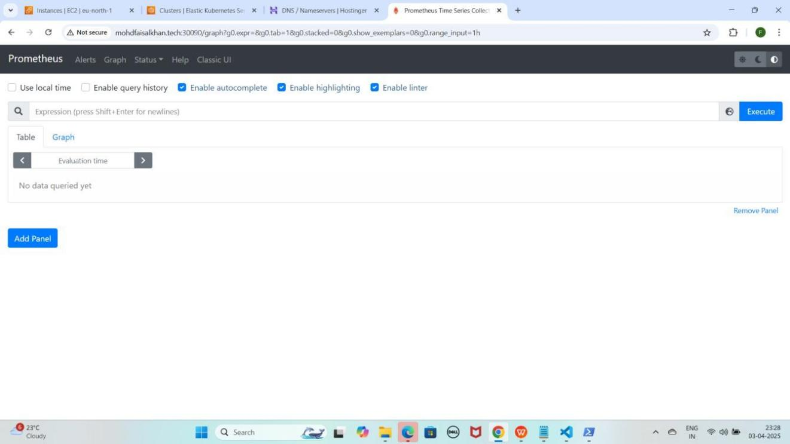

1. **Apni Loki application ko Domain Name aur NodePort ke saath access karo.**
   * **Loki:** [http://mohdfaisalkhan.tech:30091](j)

YE KUCH ISTARHA LAGEGA

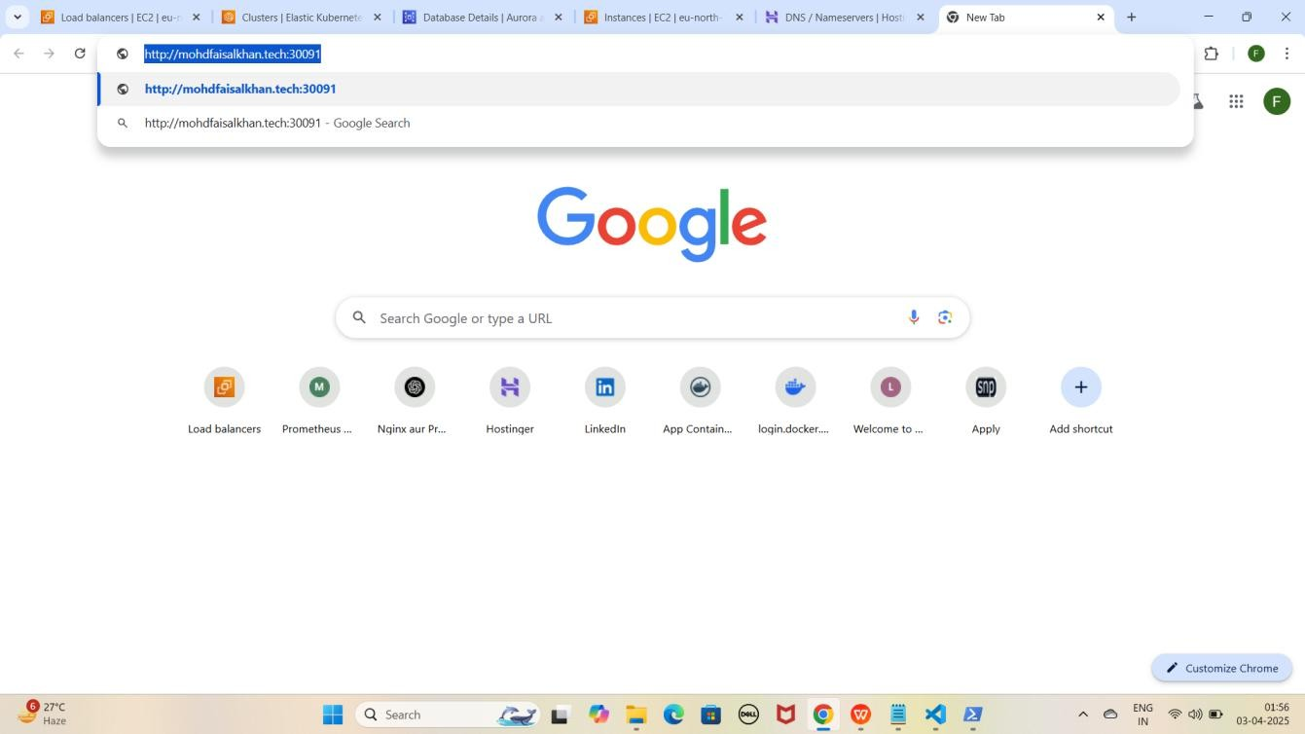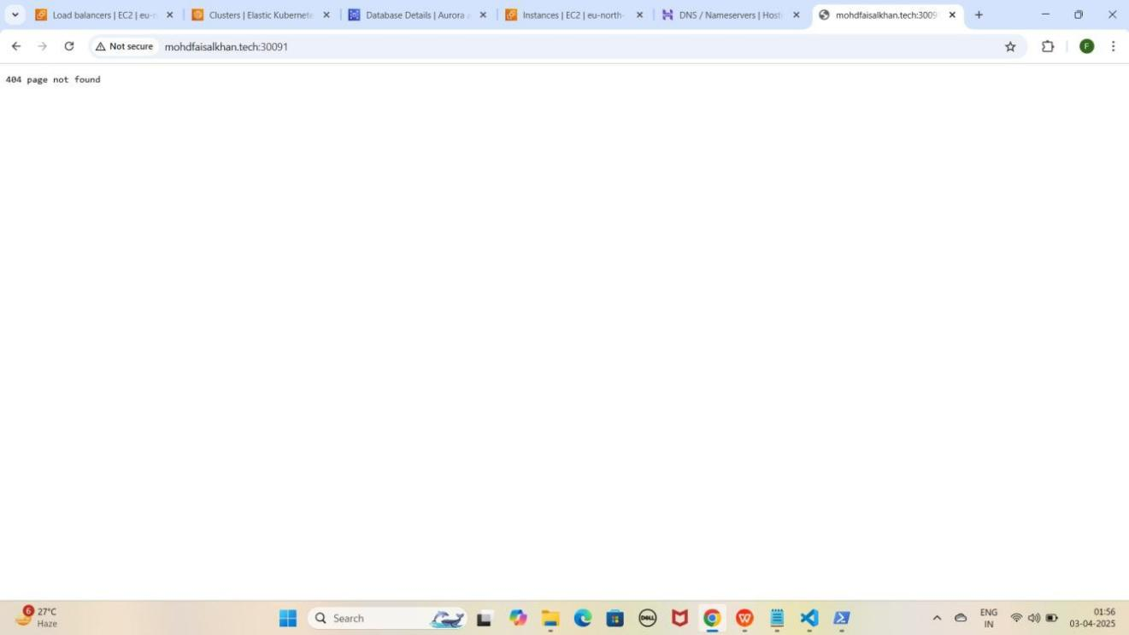

1. Lekin aapko **404 page not found** dikhayga to **/ready** se check kariye

**loki** ko jaise ki mere case kuch asisa hoga. <http://mohdfaisalkhan.tech:30091/ready>

YE KUCH ISTARHA LAGEGA

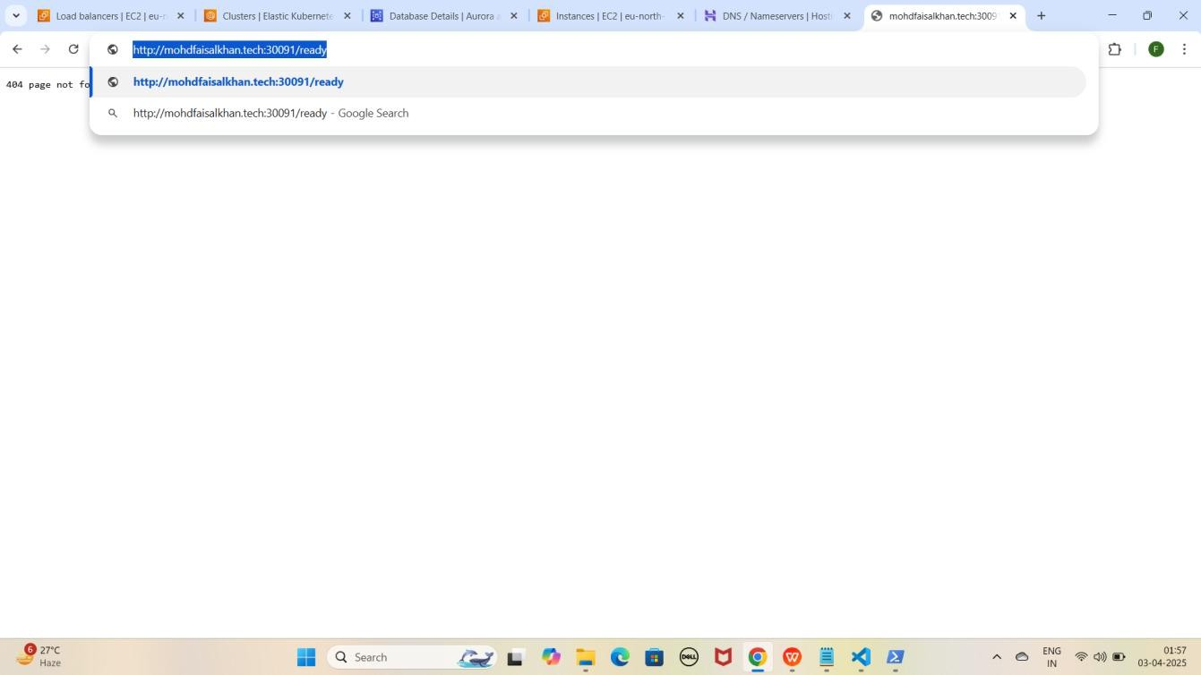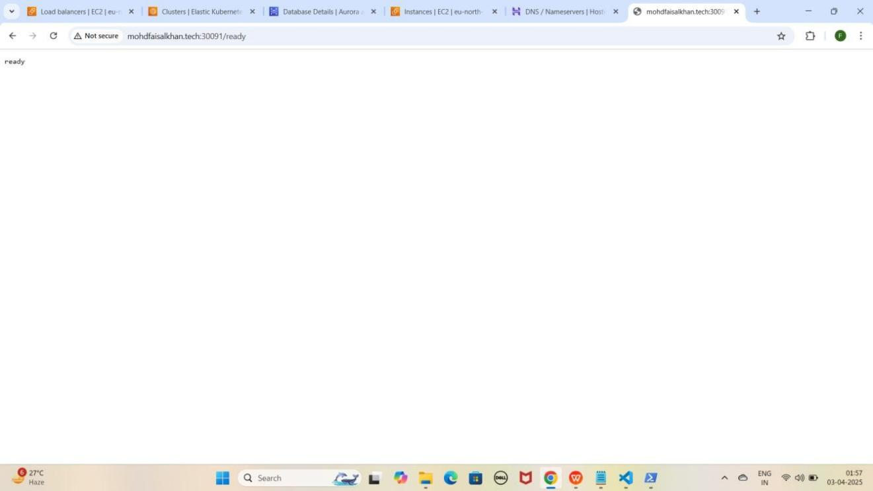

1. Agar aapko **ready show** karraha hai to iska matlab **loki successfully** run horaha hai ab **loki metrics loggs** collect karraha hai check karne ke liye **/metrics** run kariye jaise ki mere case me kuch aisa hoga.

<http://mohdfaisalkhan.tech:30091/metrics>

YE KUCH ISTARHA LAGEGA

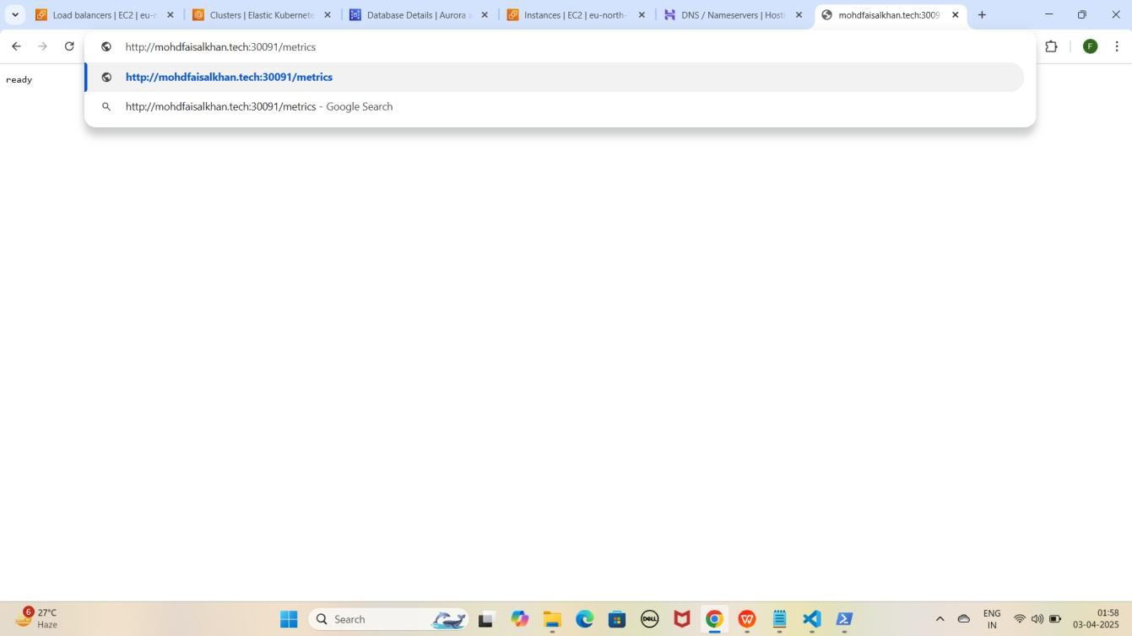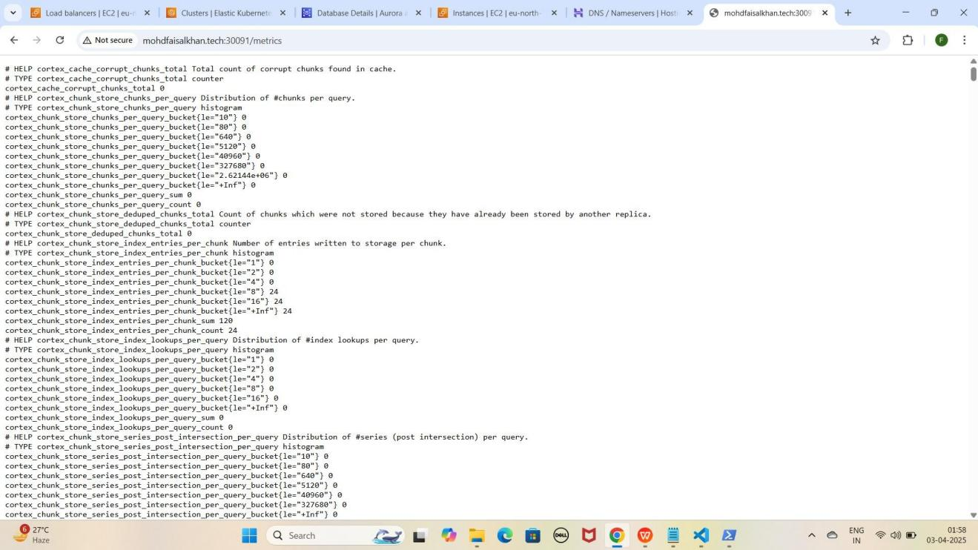

1. **Apni Loki application ko WWW Domain Name aur NodePort ke saath access karo**
   * **Loki:** [http://www.mohdfaisalkhan.tech:30091](j)

YE KUCH ISTARHA LAGEGA

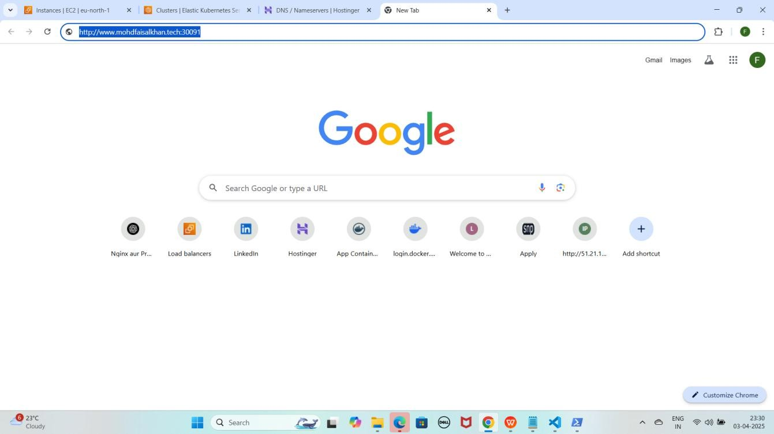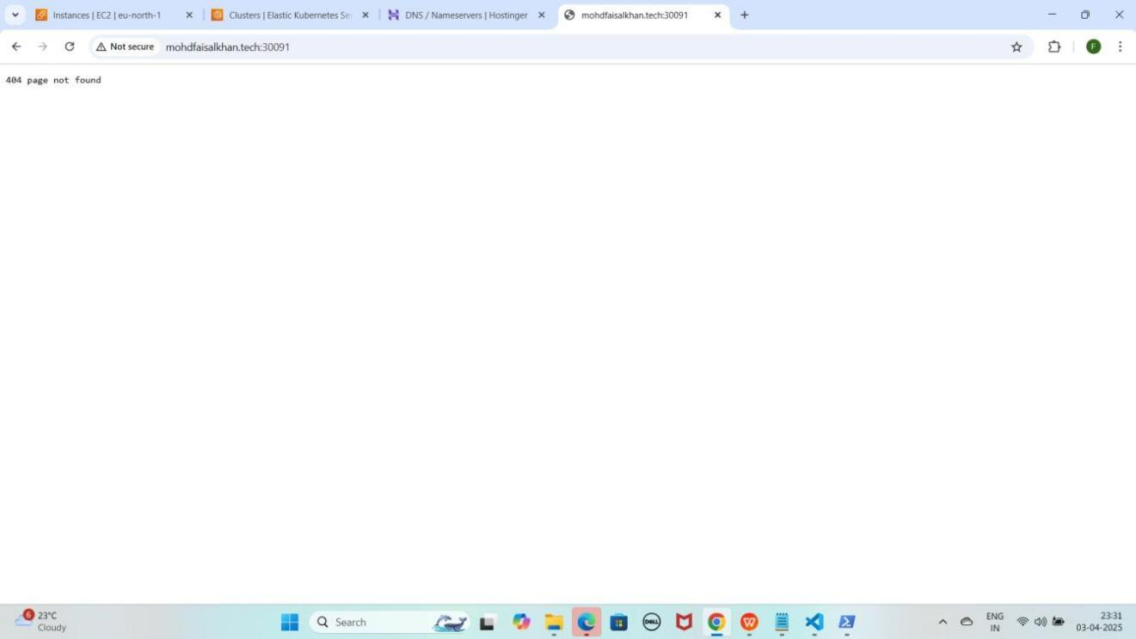

1. Lekin aapko **404 page not found** dikhayga to **/ready** se check kariye

**loki** ko jaise ki mere case kuch asisa hoga. [http://www.mohdfaisalkhan.tech:30091/ready](http://mohdfaisalkhan.tech:30091/ready)

YE KUCH ISTARHA LAGEGA

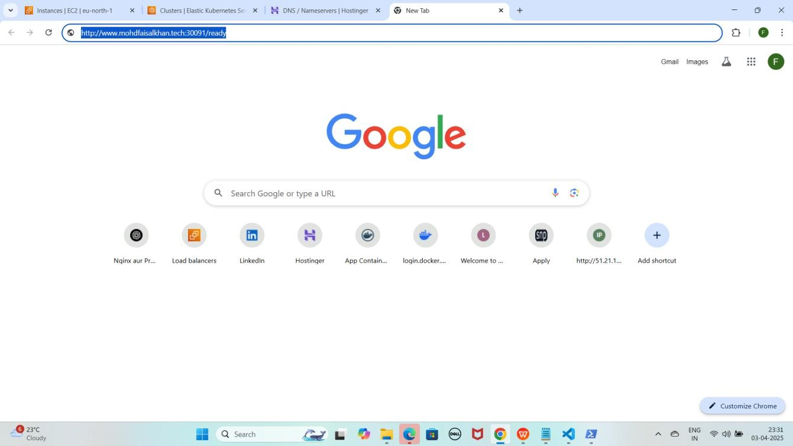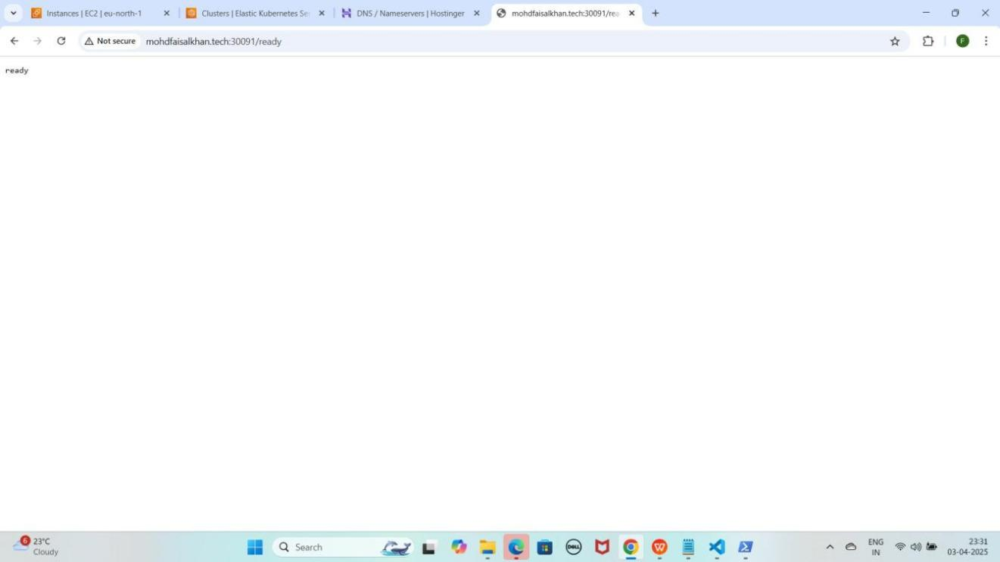

1. Agar aapko **ready** show karraha hai to iska matlab **loki successfully** run horaha hai ab **loki metrics loggs** collect karraha hai check karne ke liye **/metrics** run kariye jaise ki mere case me kuch aisa hoga.

[http://www.mohdfaisalkhan.tech:30091/metrics](http://mohdfaisalkhan.tech:30091/metrics)

YE KUCH ISTARHA LAGEGA

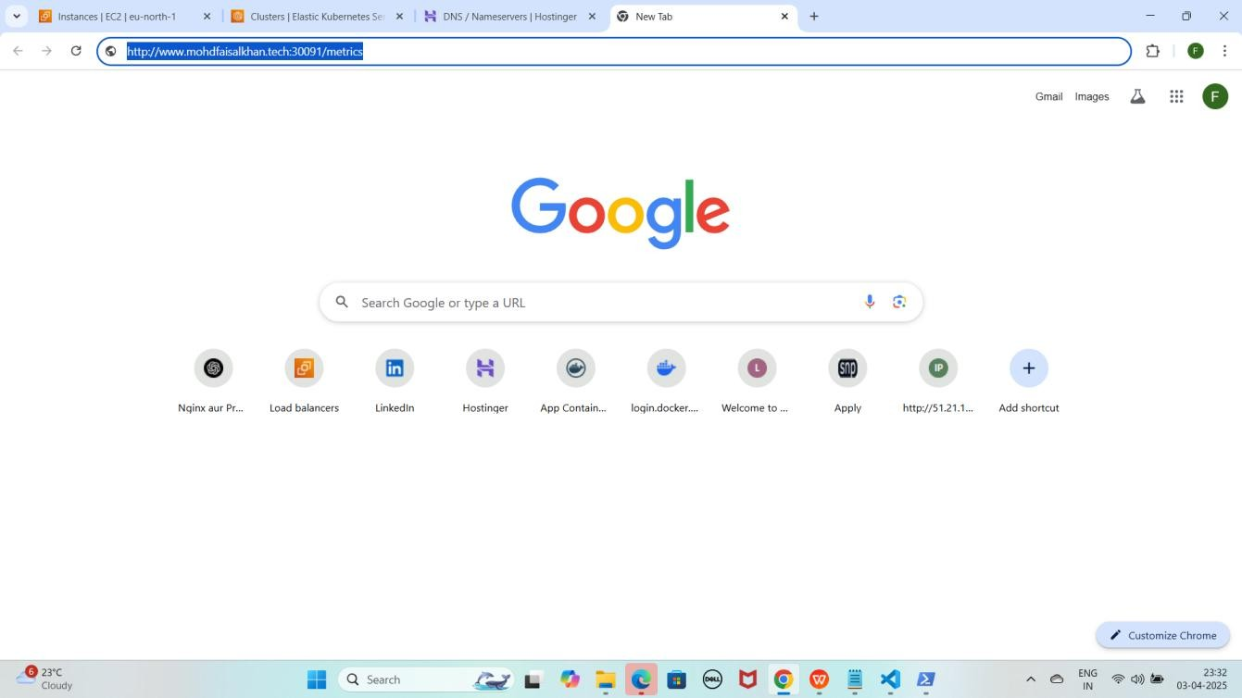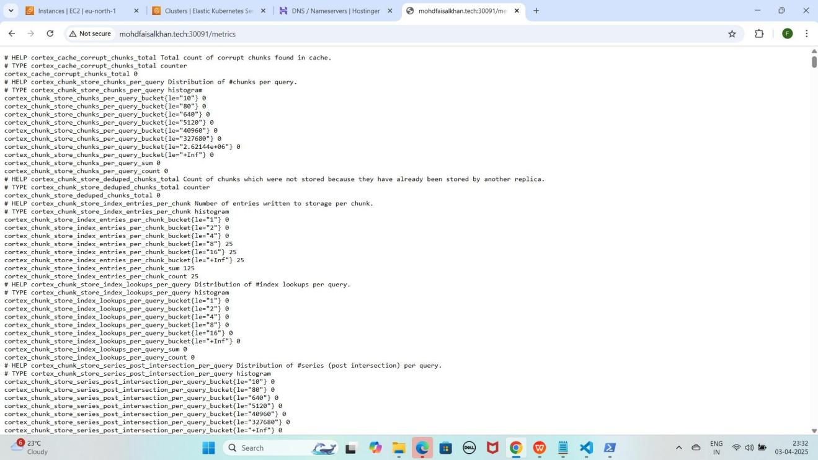

1. **Apni Grafana application ko Domain Name aur NodePort ke saath access karo.**
   * **Grafana:** [http://mohdfaisalkhan.tech:30080](jh)

YE KUCH ISTARHA LAGEGA

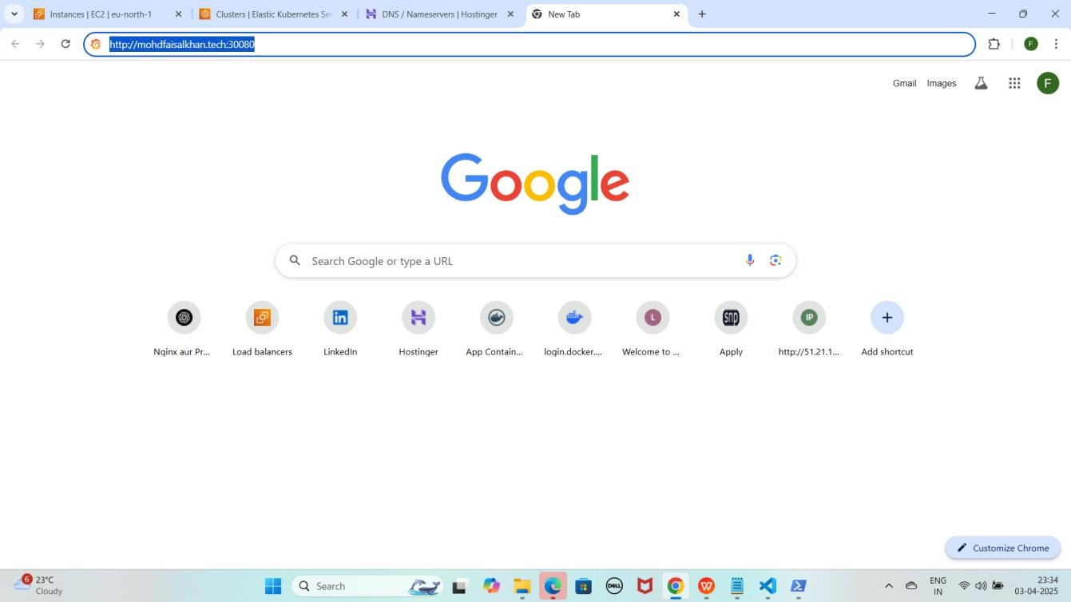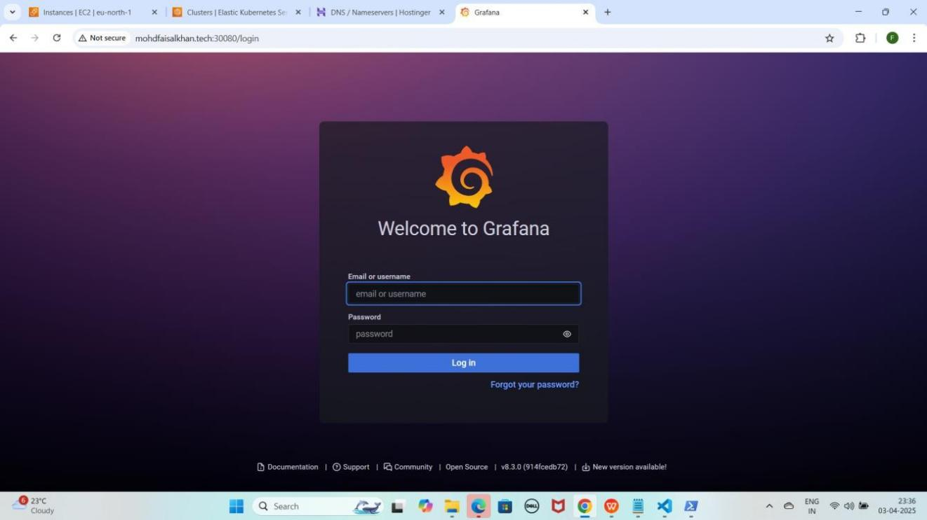

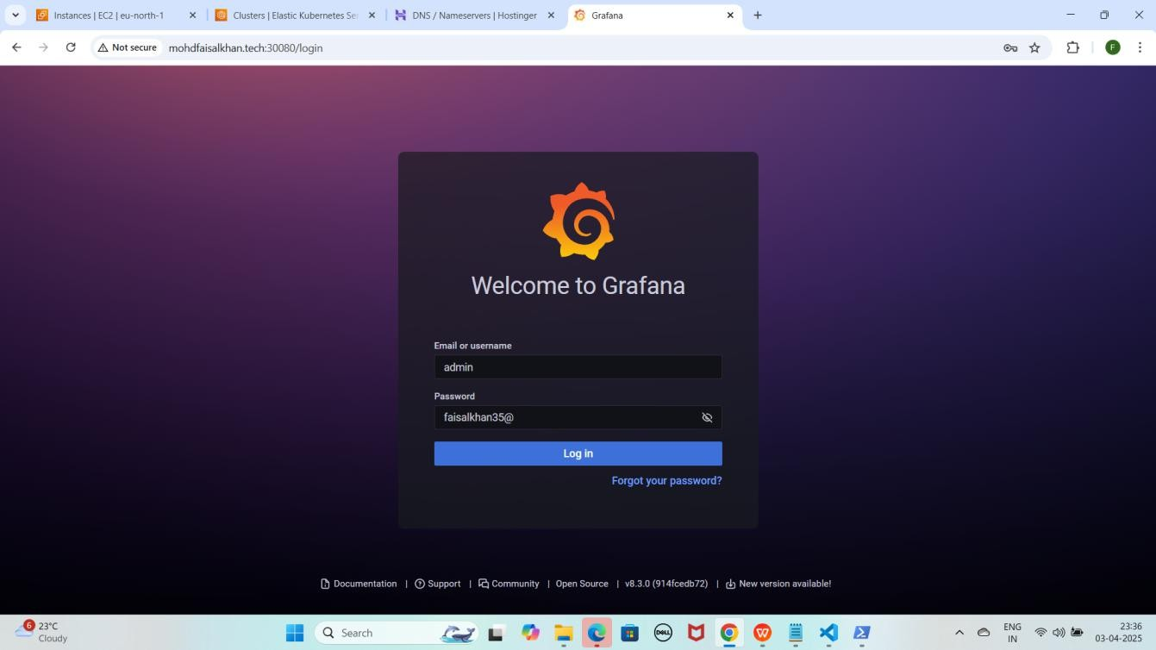

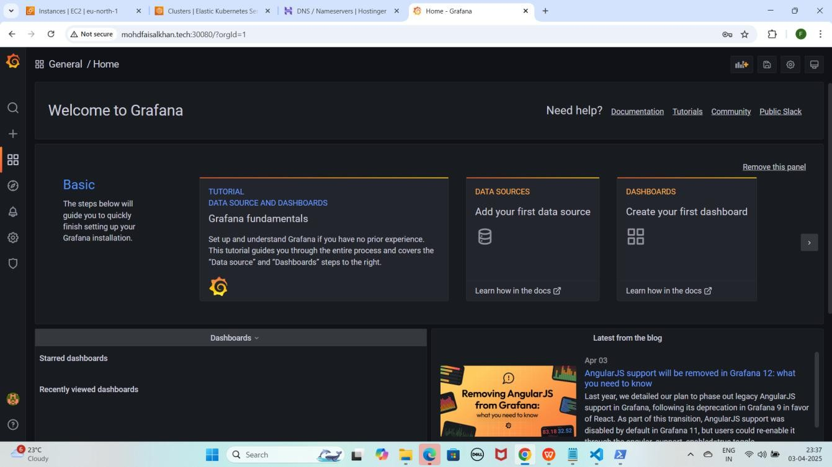

NOTE : Ye wahi password hai jo humne first time Grafana ki Public IP ko NodePort ke saath access karte waqt use kiya tha.

1. **Apni Grafana application ko WWW Domain Name aur NodePort ke saath access karo**
   * **Grafana:** [http://www.mohdfaisalkhan.tech:30080](j)

YE KUCH ISTARHA LAGEGA

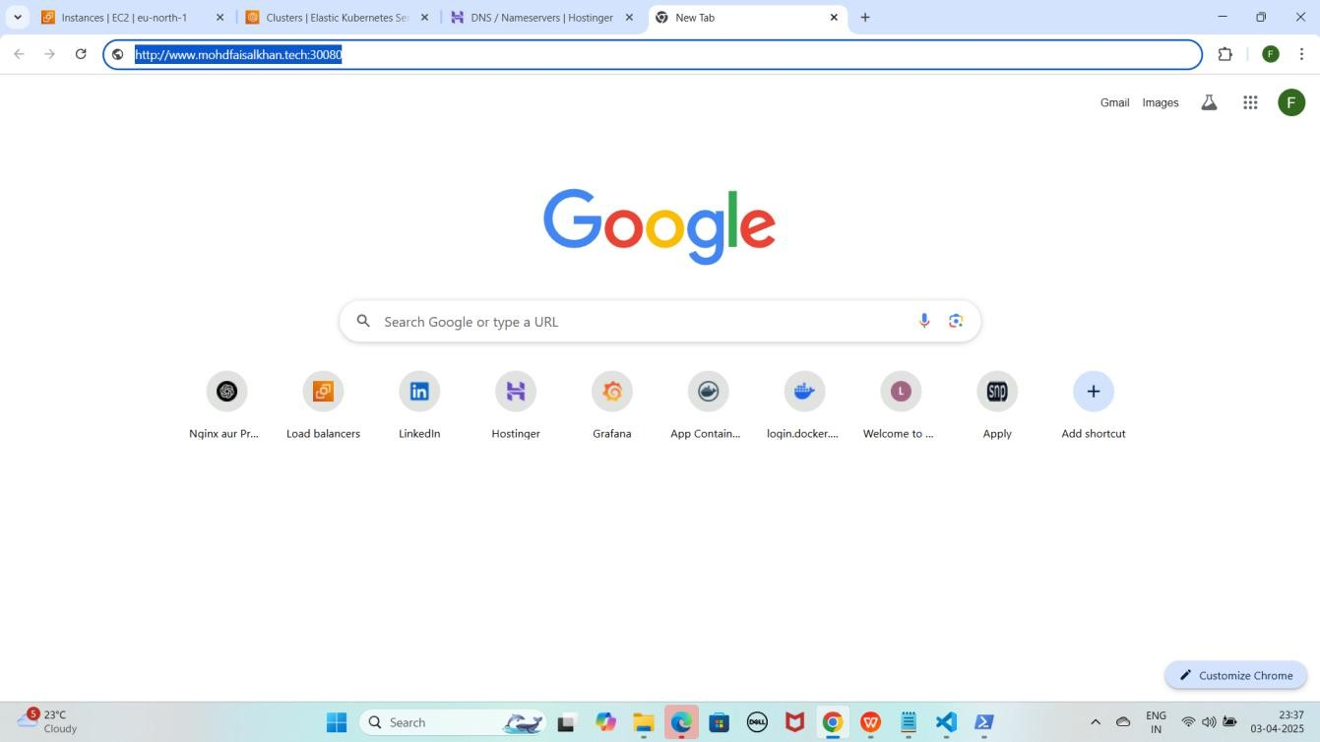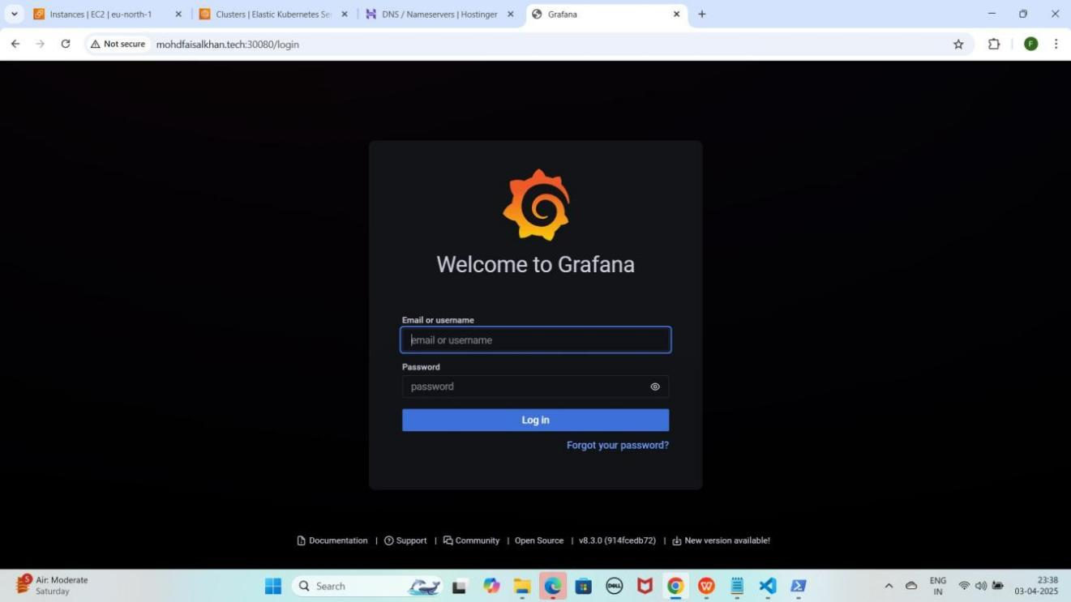

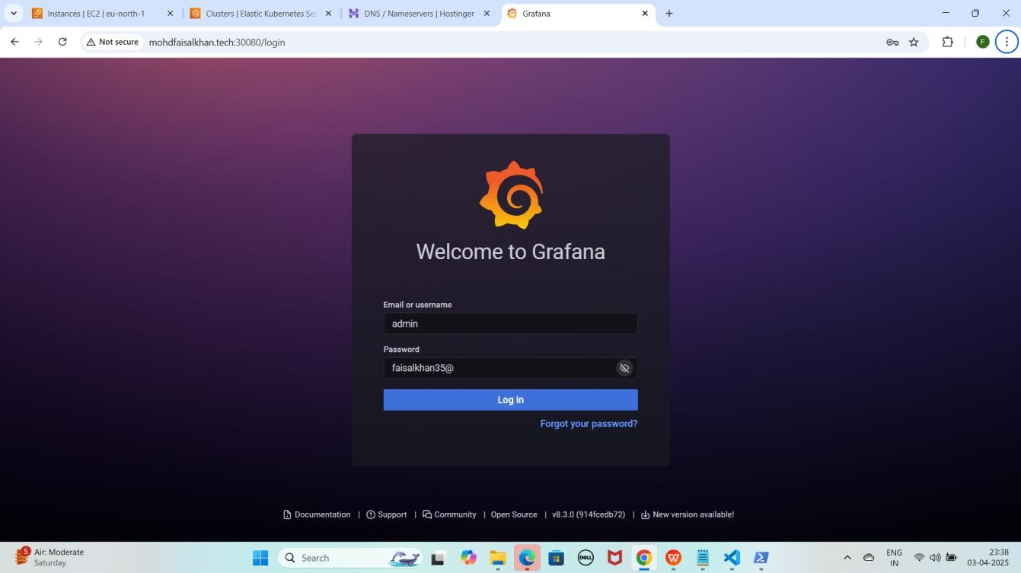

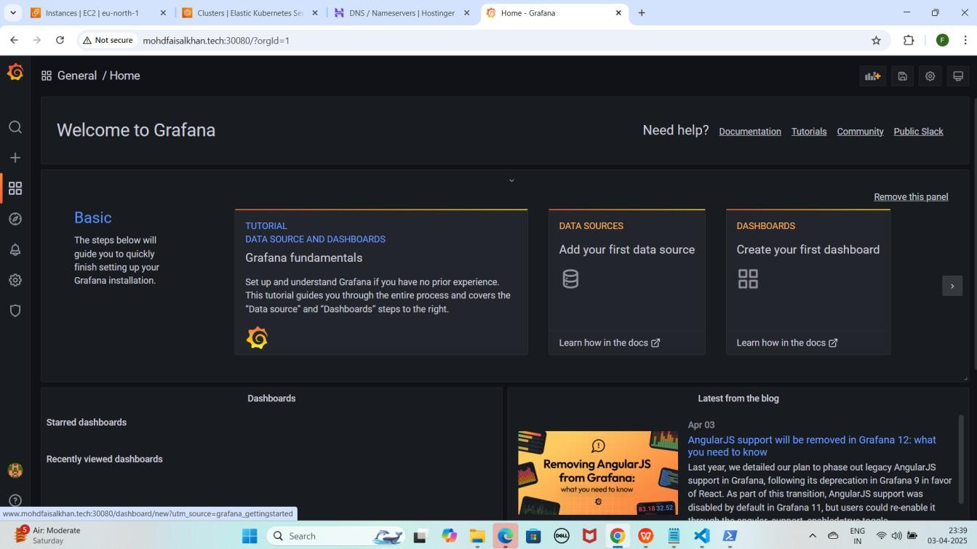

NOTE : Ye wahi password hai jo humne first time Grafana ki Public IP ko NodePort ke saath access karte waqt use kiya tha.

Recommend : Har Step aur Command ko meri Snapshots se Match karein taake Confirm ho sake ke sab kuch sahi tarah se Execute hua hai.

Project Video Demo : [https://youtu.be/faStapXbjcQ](g)

# *****Commands Used in This Project*****

## Part 1: EKS Cluster Creation and Setup

1. **Configure AWS CLI**

aws configure

1. **Enter the following details**

AWS Access Key ID: XXXXXXXXXXXXXXXX

AWS Secret Access Key: XXXXXXXXXXXXXXXXXXXXXX

Default Region: eu-north-1 Output Format: text

1. **Update kubeconfig for your EKS cluster**

aws eks update-kubeconfig --name Faisal --region eu-north-1

1. **Verify the EKS node status**

kubectl get nodes

## Part 2: Nginx pods and Service Deployment

* 1. **Deploy NGINX with Replicas**

kubectl apply -f nginx-deployment.yaml

* 1. **Expose NGINX using NodePort Service**

kubectl apply -f nginx-nodeport-service.yaml

* 1. **Verify Deployments & Services**

kubectl get pods kubectl get services

## Part 5: MySQL Secrets and ConfigMap Configuration

1. **Generate Base64 Encodings For Secrets**

echo -n Faisal Khan | base64 echo -n Faisalkhan35@ | base64

echo -n 'RmFpc2FsIEtoYW4=' | base64 --decode

echo -n 'RmFpc2Fsa2hhbjM1QA==' | base64 --decode

1. **Apply Secrets and ConfigMaps**

kubectl apply -f mysql-secrets.yaml kubectl apply -f mysql-configmap.yaml

1. **Apply RBAC (Role-Based Access Control)**

kubectl apply -f service-account.yaml kubectl apply -f role.yaml

kubectl apply -f rolebinding.yaml

1. **Verify Pods**

kubectl get pods

## Part 6: MySQL Database Pods and Services Deployment

1. **Deploy MySQL Services & Persistent Volumes**

kubectl apply -f mysql-headless-service.yaml kubectl apply -f mysql-pv.yaml

kubectl apply -f mysql-pv-2.yaml kubectl apply -f mysql-pv-3.yaml

1. **Deploy MySQL StatefulSet**

kubectl apply -f mysql-statefulset.yaml

1. **Verify Deployments & Services**

kubectl get pods kubectl get services

## Part 7: Accessing MySQL Database in EKS Cluster

1. **Access MySQL Pod**

kubectl exec -it mysql-0 -- /bin/bash

1. **Login to MySQL**

mysql -u root -p

1. **Create & Verify Database**

CREATE DATABASE faisal_db; SHOW DATABASES;

## Part 8: Monitoring Using Prometheus and Loki With Grafana

1. **Create Monitoring Namespace**

kubectl create namespace monitoring

1. **Deploy Prometheus Components**

kubectl apply -f prometheus-daemonset.yaml kubectl apply -f prometheus-rbac.yaml

kubectl apply -f prometheus-nodeport-service.yaml

1. **Verify Prometheus Pods & Services**

kubectl get pods -n monitoring kubectl get services -n monitoring

1. **Important Prometheus Metrics**

rate(process_cpu_seconds_total[30s]) process_resident_memory_bytes process_network_transmit_bytes_total process_network_receive_bytes_total

1. **Deploy Loki & Promtail**

kubectl apply -f promtail-daemonset.yaml kubectl apply -f loki-daemonset.yaml kubectl apply -f loki-nodeport-service.yaml

1. **Verify Loki & Promtail Pods & Services**

kubectl get pods -n monitoring kubectl get services -n monitoring

1. **Deploy Grafana**

kubectl apply -f grafana-deployment.yaml

1. **Verify Grafana Pods & Services**

kubectl get pods -n monitoring kubectl get services -n monitoring